## Task 1:

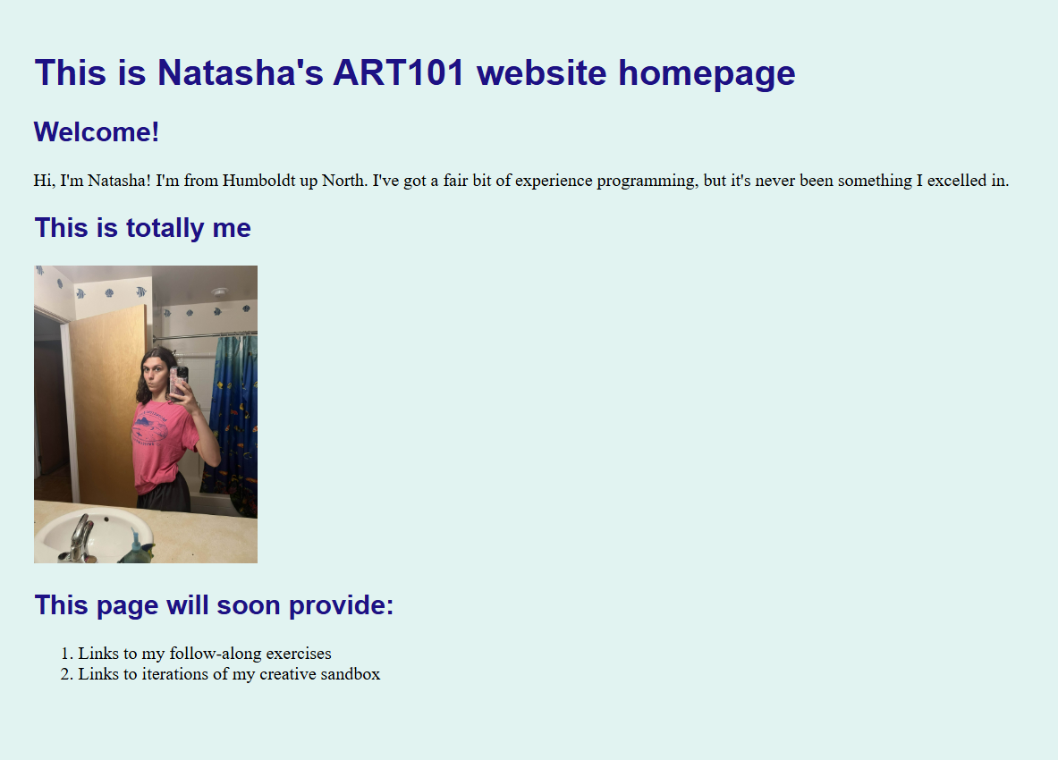

## Task 2:

## Task 3:

**Self-Narration:**

1. **Challenges in Task 1?**Task 1 was incredibly simple. Neither Luna (my lab partner) nor I struggled with setting up the website with the instructions available.
2. **Story of Task 2?**When I saw the words ‘you[r] inner world,’ I knew immediately that I wanted to follow-through. I figured it’d be a good use of my artistic skills as well as programming, and that I could design the image assets necessary. That burst of creativity came at the cost of a bit of downtime, because when I picked up my tablet to start drawing, I found out pretty quickly that it was completely drained and nonfunctional. That being said, I’d only been working on this lab for about an hour with Luna already, so this wasn’t too much of a time sink. It took me maybe about an extra 45 minutes to draw the background and the little character; I don’t regret it!
3. **Experience with lab partner?**Luna and I hopped into a Discord call and screenshared/sent screenshots during our process of html coding. We both found the assignment straight-forward and didn’t need to help one another too much, aside from finding a small syntax error preventing the css file from being called. It was pleasant as ever.