## Task 1

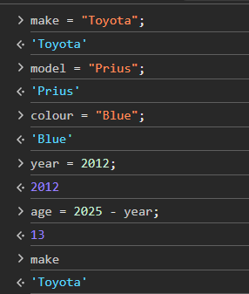

## Task 1 cont.

## Task 2

## Task 3

# [**https://natashamakani.github.io/ART101New/**](https://natashamakani.github.io/ART101New/)

## Task 4

**Task 1 compare + contrast:**  
In comparison with the lecture, we define our variables in the same line of code as we create them, compared to a ‘let catName;’ line followed by ‘catName=”<em> Lazy </em>”. We opt for ‘let catName = “<em> Lazy </em>” style instead.

Both the lecture and the lab define objects, arrays, and perform string conjugations.

**Task 1 overview:**

**Task 2 process:**

**Collaboration:**