Let variable = prompt(“Guess 1-10”) reminds me a lot of Python’s variable = input(“Guess 1-10”), which really helps me understand what’s going on. In terms of formatting and style, I’m pretty close to the lecture- though I have my particular way of making things clean and look nice.

## Task 2

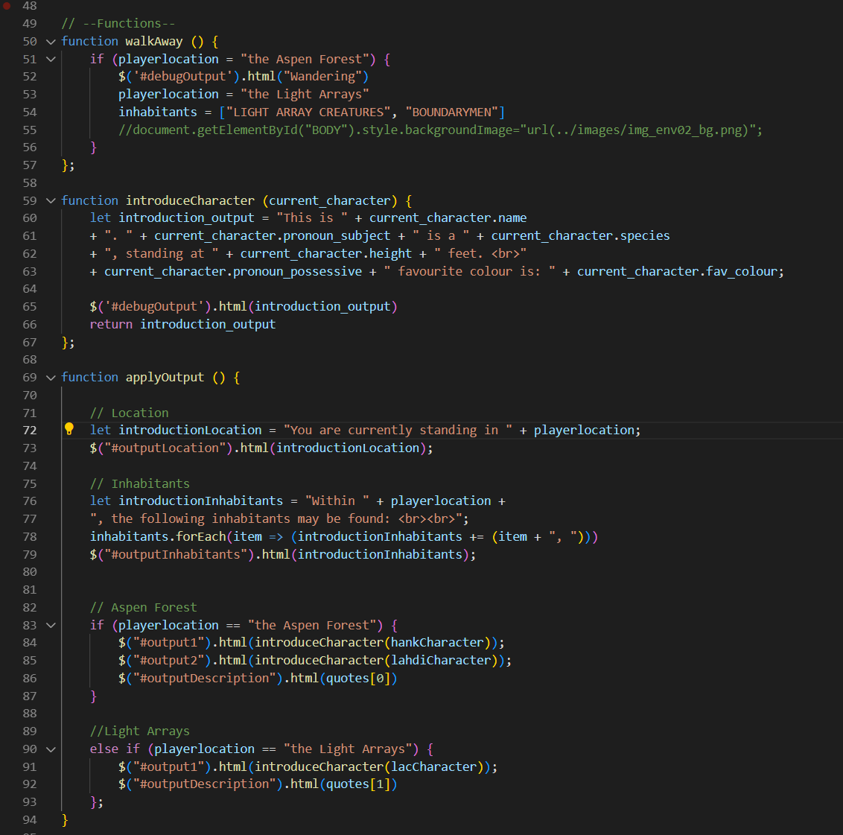

## Task 3

# [**https://natashamakani.github.io/ART101New/**](https://natashamakani.github.io/ART101New/)

## Task 4

1. Task 1 was not particularly challenging. I do not struggle with follow-alongs.

“Let variable = prompt(“Guess 1-10”) reminds me a lot of Python’s variable = input(“Guess 1-10”), which really helps me understand what’s going on. In terms of formatting and style, I’m pretty close to the lecture- though I have my particular way of making things clean and look nice.”

1. I wanted to add another area for the player to travel to, however I struggled with getting the window to update or run the functions. The debugger is giving me errors on a part I know works perfectly fine- lab time it is. I improved a LOT of my code and modularized it to make further implementations easier.
2. Luna and I communicated when we were working on our respective projects, sharing code and WIP images.