Technological Institute of the Philippines

938 Aurora Blvd. Cubao, Quezon City

College of Information Technology Education

IT 004 – Web Systems and Technologies

Preliminary Period

Designing Web Pages using HTML and CSS

|  |  |
| --- | --- |
| Name: Agapito, Mark Artjezreel | Date: 11/12/2022 |
| Program / Section: IT 004-IT21S5 | Instructor: Ms. Roxanne A. Pagaduan |
| Assessment Task: Practice Set No. 1 | |

**Instructions:**

* Provide screenshots to satisfy the requirements.
* Include your FULLNAME in every screenshot.
* Include a brief description in each screenshot.
* Save your work as **SURNAME1_SURNAME2_PS1.DOCX** (Ex. PAGADUAN_ANCHETA_PS1.DOCX and .PDF)

**Overview:**

HTML stands for Hyper Text Markup Language. It is a markup language for creating web pages and other information that can be viewed in a web browser. HTML is not a programming language since it uses a markup tags to describe web pages. HTML tags are used to interpret the content of the page in which the browser reads as the HTML documents and displays them as a web page. HTML tags can come in pairs the first tags for the start and the next tags is for end part and surrounded by <angle-brackets>.

HTML element indicates structure in an HTML document. More specifically, it is an SGML element that meets the requirements of one or more of the HTML Document Type Definitions (DTDs). HTML elements generally consist of three parts: a *start tag* marking the beginning of an element, some amount of *content*, and an *end tag*. Elements may represent headings, paragraphs, hypertext links, lists, embedded media, and a variety of other structures.

Cascading Style Sheets or known as CSS is a style sheet that allows the developer or the user to change and modify the looks and style of the webpage. It is one of the important parts of the webpage that allows the creator of the webpage to easily modify their webpage by accessing the CSS file and the html document that will read the CSS file and change the style and the looks of the webpage accordingly. Updating a webpage can be much easier because only the part that the creator needs to modify is the CSS file and not the whole HTML code and with this it avoids errors caused by editing the html code.

**Requirement:**

1. Create a homepage for the flower shop using HTML and CSS. *(****Note:*** *you can download any related images on the internet)*.
   1. Be creative in designing your homepage using html and css elements.
   2. Provide a screenshot of the source code.
   3. Provide a screenshot of the output running in the web browser.
   4. Acknowledge references.
   5. Save your work as PS1-flowershop.html

**Sample Output Running in the Web Browser:**

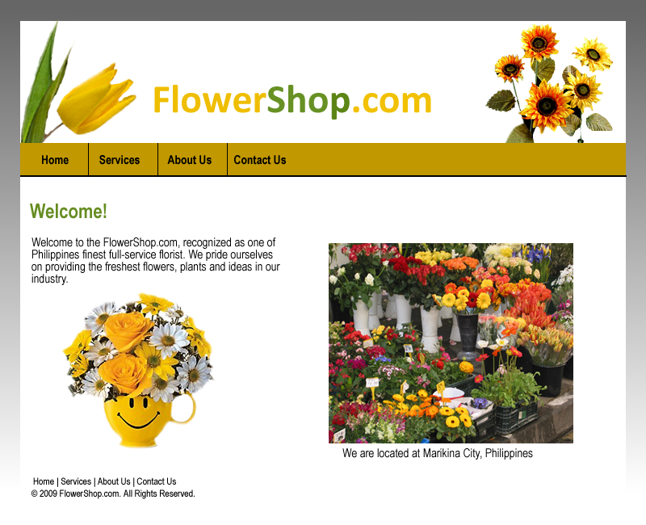

**Assessment Tool:**

This assessment will be graded using the Rubric for Laboratory Performance in Web Systems and Technologies.

**Answer:**

**Source Code:**

Index.html

<!DOCTYPE html>

<html lang="en" dir="ltr">

<head>

<meta charset="utf-8">

<title>BLOOMS FOR YOU</title>

<meta name="viewport" content="width=device-width, initial-scale=1.0">

<link rel="stylesheet" href="css/design.css">

</head>

<body>

<!---NAVBAR ---->

<header>

<div class="container">

<img src="Pictures/flower01.png" alt="png" width="5%" style="float: left; margin-top: 8px;">

<div class="TextDesign">Blooms for You</div>

<nav>

<ul>

<li>

<div class="nav"><a href="#">Home</a></div>

</li>

<li>

<div class="nav"><a href="#">Season Best</a></div>

</li>

<li>

<div class="nav"><a href="#">Wedding</a></div>

</li>

<li>

<div class="nav"><a href="#">Plants</a></div>

</li>

<li>

<div class="nav"><a href="#">Cart</a></div>

</li>

<li>

<div class="dropdown">

<button class="dropbtn">Category

</button>

<div class="dropdown-content">

<a href="#">By Occasions</a>

<a href="#">By Types</a>

<a href="#">By Prices</a>

<a href="#">By Flowers</a>

</div>

</li>

</ul>

</nav>

</div><br><br><br>

</header>

<div class="ContainerforBanner">

<img src="Pictures/Banner.jpg" alt="jpg" width="50%" align="left" style="padding-right:8%">

<p><hr><b> “Flowers are the music of the ground. From earth’s lips spoken without sound.”</b><hr></p><br><br>

</div>

<div class="MainContainer">

<h3 class="text1">Featured Products</h3>

<!---Flowers--->

<div class="cards" style="align: left;">

<a href="#">

<img src="Pictures/WildAboutU.jpg" alt="jpg" width="100%" align="center" >

</a>

<a href="#" class="buy"><p class="Name">Wild About U</p> <p class="Price">₱550</p></a>

<a href="#" class="buy"><p class="Name">Add To Cart</p> <p class="Price">🛒</p></a>

</div>

<div class="cards">

<a href="#">

<img src="Pictures/Exuberance.jpg" alt="jpg" width="100%" align="center" >

</a>

<a href="#" class="buy"><p class="Name">Exuberance</p> <p class="Price">₱335</p></a>

<a href="#" class="buy"><p class="Name">Add To Cart</p> <p class="Price">🛒</p></a>

</div>

<div class="cards">

<a href="#">

<img src="Pictures/Sunglow.jpg" alt="jpg" width="100%" align="center" >

</a>

<a href="#" class="buy"><p class="Name">Sunglow</p> <p class="Price">₱780</p></a>

<a href="#" class="buy"><p class="Name">Add To Cart</p> <p class="Price">🛒</p></a>

</div>

<div class="cards">

<a href="#">

<img src="Pictures/Pegasus.jpg" alt="jpg" width="100%" align="center" >

</a>

<a href="#" class="buy"><p class="Name">Pegasus</p> <p class="Price">₱250</p></a>

<a href="#" class="buy"><p class="Name">Add To Cart</p> <p class="Price">🛒</p></a>

</div>

<div class="cards">

<a href="#">

<img src="Pictures/red rose.jpg" alt="jpg" width="100%" align="center" >

</a>

<a href="#" class="buy"><p class="Name">Very Merry</p> <p class="Price">₱670</p></a>

<a href="#" class="buy"><p class="Name">Add To Cart</p> <p class="Price">🛒</p></a>

</div>

<div class="cards">

<a href="#">

<img src="Pictures/Heartfelt.jpg" alt="jpg" width="100%" align="center" >

</a>

<a href="#" class="buy"><p class="Name">Heartfelt</p> <p class="Price">₱499</p></a>

<a href="#" class="buy"><p class="Name">Add To Cart</p> <p class="Price">🛒</p></a>

</div>

</div>

<!---Footer--->

<footer>

<div class="About">

<h2 style="color: white; font-size: 25px">About The Company</h2>

<p style="color: white; text-align: left; margin-top:2em;">

BLOOMS FOR YOU is a website where you can buy different kinds of flowers. we can assist you of what kinds of flower are you looking for. this kinds of flowers is cheap but good quality. We have a wide variety of flowers that will suit your needs and budget.We are dedicated to provide the best service possible. Our goal is to make sure that our customers are happy and satisfied with their purchase.

</p>

</div>

<div class="quickLinks">

<h2>Quick Links</h2><br>

<ul style="list-style-type: none;">

<li><a href="Aboutus.html" class="Links">About Us</a></li>

<li><a href="Contact.html" class="Links">Contact</a></li>

<li><a href="info.html" class="Links">About Creator</a></li>

<li><a href="PrivatePolicy.html" class="Links">Private Policy</a></li>

</ul>

</div>

<div class="Contacts">

<h2 style="color: white;">Email Us:</h2>

<p style="color: white; text-align: left; font-size: 0.9em;">

<p style="color: white; text-align: left;">if you have any concern please email us</p>

<input type="email" class="email" placeholder="Your Email: "><br>

<textarea name="name" rows="2" placeholder="Your Message: "></textarea><br>

<input type="submit" name="submit" class="send">

</p>

</div>

</footer>

</body>

</html>

Design.css

*{

font-family: 'Poppins', sans-serif;

margin: 0;

padding: 0;

}

body{

background-color: #e9e9e9;

}

header{

background-color: #7d2ae8;

height: 5em;

}

.container {

width: 90%;

margin: 0 auto;

}

.TextDesign{

color: white;

font-size: 20px;

text-transform: uppercase;

margin-top: 15px;

margin-bottom: auto;

margin-left: 0.2em;

float: left;

padding: 12px 0px;

font-weight: 500;

}

nav {

float: right;

}

nav ul {

margin top: 0;

padding: 0;

list-style: none;

}

nav li {

display: inline-block;

margin-left: 35px;

padding-top: 19px;

position: relative;

}

nav a {

display: inline-block;

color: #fff;

text-decoration: none;

text-transform: uppercase;

font-size: 18px;

border-radius: 15px;

}

.nav a:hover {

color: yellow ;

}

.nav a::before {

content: '';

display: block;

height: 5px;

background-color: yellow;

position: absolute;

top: 0;

width: 0%;

transition: all ease-in-out 250ms;

}

.nav :hover::before {

width: 100%;

}

.dropdown a::before{

float: right;

overflow: hidden;

}

.dropdown .dropbtn {

font-size: 20px;

border: none;

outline: none;

color: white;

background-color: red;

padding: 10px;

}

.dropdown-content {

display: none;

position: absolute;

background-color: #f9f9f9;

min-width: 200px;

}

.dropdown-content a {

float: none;

color: black;

padding: 12px 16px;

text-decoration: none;

display: block;

text-align: left;

}

.dropdown-content a:hover {

background-color: #ddd;

}

.dropdown:hover .dropdown-content {

display: block;

}

.ContainerforBanner{

margin-top: 5em;

width: 85%;

margin-left: auto;

margin-right: auto;

}

.ContainerforBanner p{

display: block;

text-align: center;

padding-top: 5%;

font-size: 25px;

}

.ContainerforBanner b{

display: block;

text-align: center;

padding-top: 2em;

padding-bottom: 2em;

font-size: 25px;

}

.MainContainer{

margin-top: 5em;

width: 85%;

height: 100%;

margin-left: auto;

margin-right: auto;

}

.cards{

width: 23%;

display: left;

display: inline-block;

margin-left: 5em;

margin-top: 5em;

text-align: center;

}

.buy{

margin-top: 10px;

color: #000;

text-decoration:none;

float: left;

width: 100%;

}

.buy:hover{

background-color: yellow;

}

.Name{

float: left;

text-align: left;

}

.Price{

float: right;

text-align: right;

}

.dropdown1 a::before{

float: left;

overflow: hidden;

}

.dropdown1 .dropbtn1 {

margin-top: 10px;

font-size: 15px;

border: none;

outline: none;

color: black;

float: left;

}

.dropdown-content1 {

display: none;

position: absolute;

min-width: 200px;

width: 40%;

background-color: #f9f9f9;

}

.dropdown-content1 p {

float: left;

color: black;

padding: 12px 16px;

text-decoration: none;

display: block;

text-align: left;

}

.dropdown-content1 a:hover {

background-color: #ddd;

}

.dropdown1:hover .dropdown-content1 {

display: block;

}

/* This is for Footer*/

footer{

display: inline-block;

width: 100%;

height: 100%;

padding-bottom: 2em;

background-color: #000;

color: white;

bottom: -1em;

margin-top: 10em;

}

footer .About{

margin-top: 2em;

width: 30%;

float: left;

font-size: 1em;

margin-left: 5em;

line-height: 1.5em;

}

.quickLinks{

margin-top: 2em;

width: 25%;

float: left;

margin-left: 25px;

line-height: 2em;

list-style: inside;

text-align: center;

}

.Links{

color: #fff;

text-decoration: none;

}

.Links:hover{

text-decoration: underline;

}

.Contacts{

margin-top: 2em;

width: 30%;

float: left;

margin-left: 25px;

line-height: 2em;

}

.email{

width: 80%;

padding: 12px 20px;

}

textarea{

width: 80.5%;

padding: 12px 20px;

margin-top: 5px;

}

.send{

padding: 4px 10px;

}

<screenshot of source code>

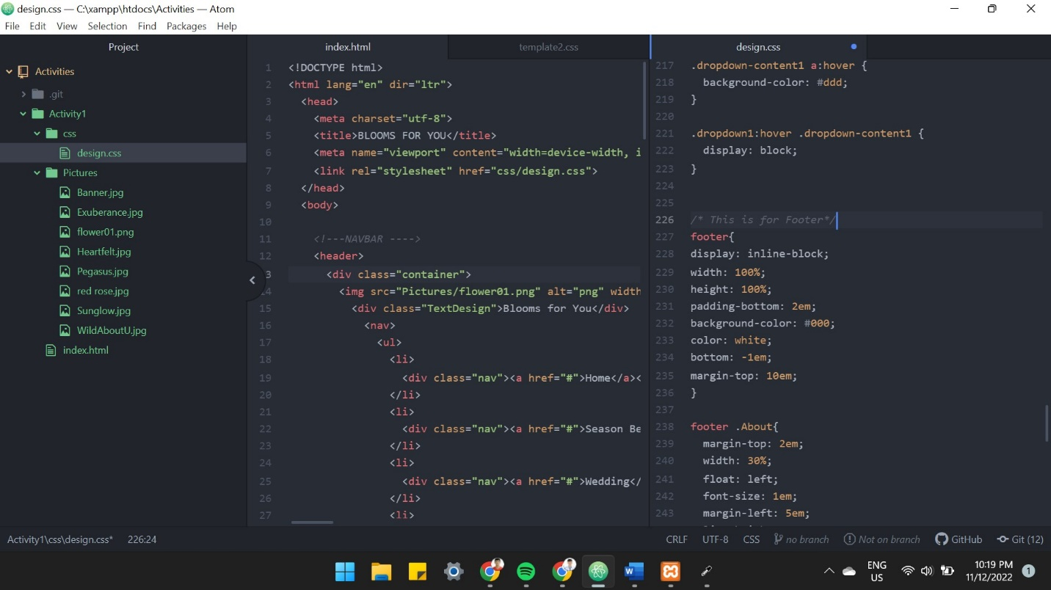

My homepage is index.html and I created 2 separate folder, 1 is for the css and 1 for pictures.

I make this folder to make my files well organize

**Sample Output:** (running in the web browser)

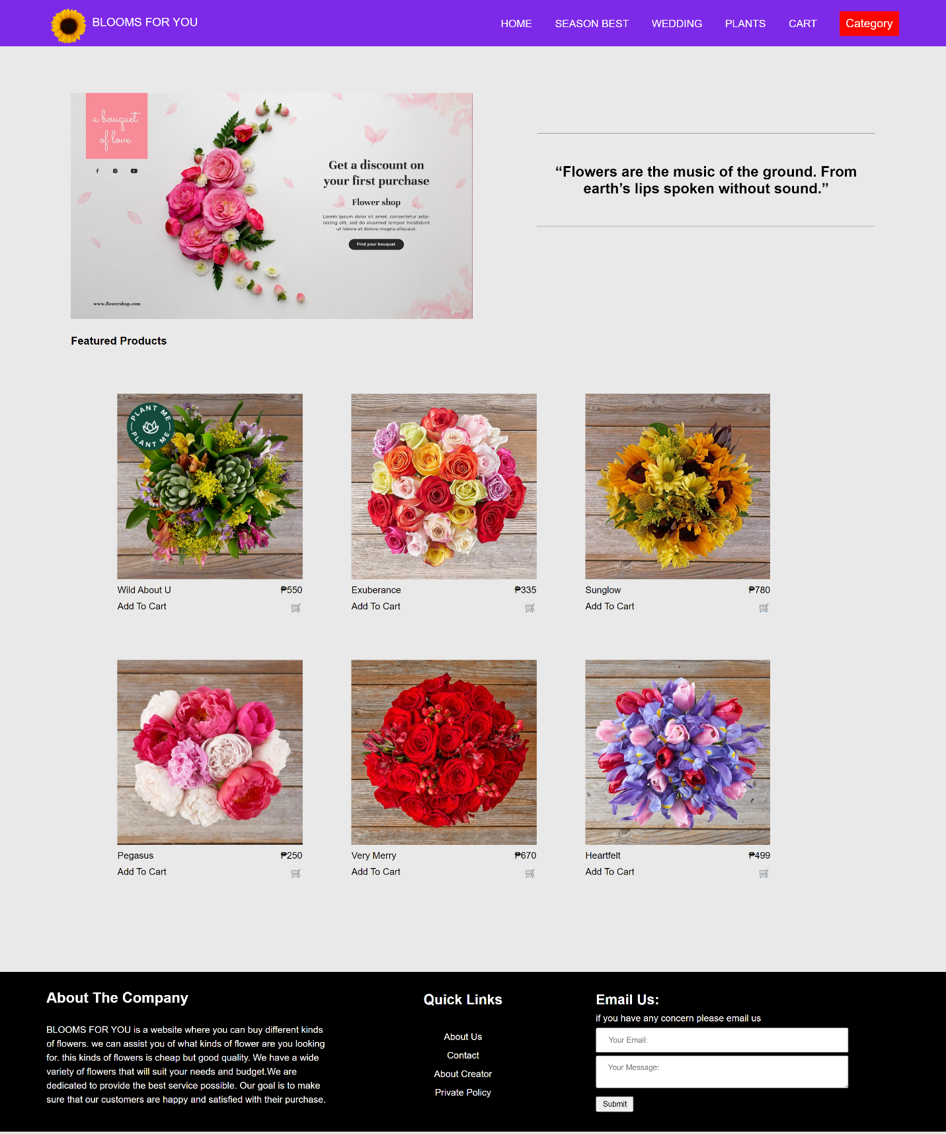

* I create a website that so users friendly and easy to use
* I select a colors that can easily to read if you put text on it

Honor Pledge

"I affirm that I have not given or received any unauthorized help on this assignment and that this work is my own".