# Mixed-models in R

**Part 1 - Important concepts**

1. Many names (multilevel, fixed-and-random effects, …). The mixture of fixed and random effects is what makes the mixed model a mixed model.
2. Like linear models, describe a relationship between a response variable and some of the covariates that have been measured or observed along with the response.
3. Differently from linear models, they can handle both between and??within subjects data, data with repeated measures
4. VERY POWERFUL compared to traditional approaches (e.g. rmANOVA), including:
5. Data analyzed at multiple levels (trial, participant, …). Mixed models account for items and subject variation in a single model.

* No loss of information! More of the involved processes can be modelled.
* Unbalanced designs
* Missing data

**Assumptions**

1. LMM assumptions:

* Non-independency assumption: repeated-measures designs
* Residuals are assumed to be normally distributed, and the regression line is fitted to the data such that the mean of the residuals is zero. Must be checked!

1. GLMM assumptions

* Handle non-normal distribution of the DV. Ex. Binomial DV
* Non-independency assumption: repeated-measures data

**Random vs. Fixed Effects**

1. Random effects:

Factors whose levels were sampled randomly from a larger population about which we wish to generalize. In other words, the levels occurring in the current sample are only a subset of the levels occurring in the population

* Ex: Humans or animals, stimuli items presented to human participants, etc.

1. Fixed effects:

Fixed effects are the factors of interest that we manipulate in a study. They’ve been the kinds of variables, the independent variable

* Ex: Participants’ gender, weight, age, drug vs. placebo; congruent vs. incongruent; low versus high loss amount, etc.

**Random intercept models vs. Random slope models**

1. Random intercept models do not allow adjustments to the intercept

* DV ~ IV1 + IV2 + (1 | participants) + (1 | items)

1. Random slope models allow each group line to have a different. They allow the explanatory variable to have a different effect for each group. i.e., they allow the relationship between the explanatory variable and the response to be different for each group.

* DV ~ IV1 + IV2 + (1 + IV| participants) + ( 1 | items)
* DV ~ IV1 + IV2 + (1 + IV*IV| participants) + ( 1 | items)

**Contrasts setting**

1. Used to to checked which groups differ from which others. More info (Schad et al., 2020)

* Deviation coding: compares the mean of the dependent variable for a given level to the overall mean of the dependent variable. Used frequently to test the difference between two factor levels
* Dummy coding: compares each level of the categorical variable to a fixed reference level (baseline).

**likelihood-ratio tests**

1. Likelihood ratio tests for model selection.

The basic idea is that if the AIC (or BIC) is lower (e.g. when comparing random slope models and random intercept models) then the gain in fit is worth the extra model complexity.

## Datasets

**Bodysway**

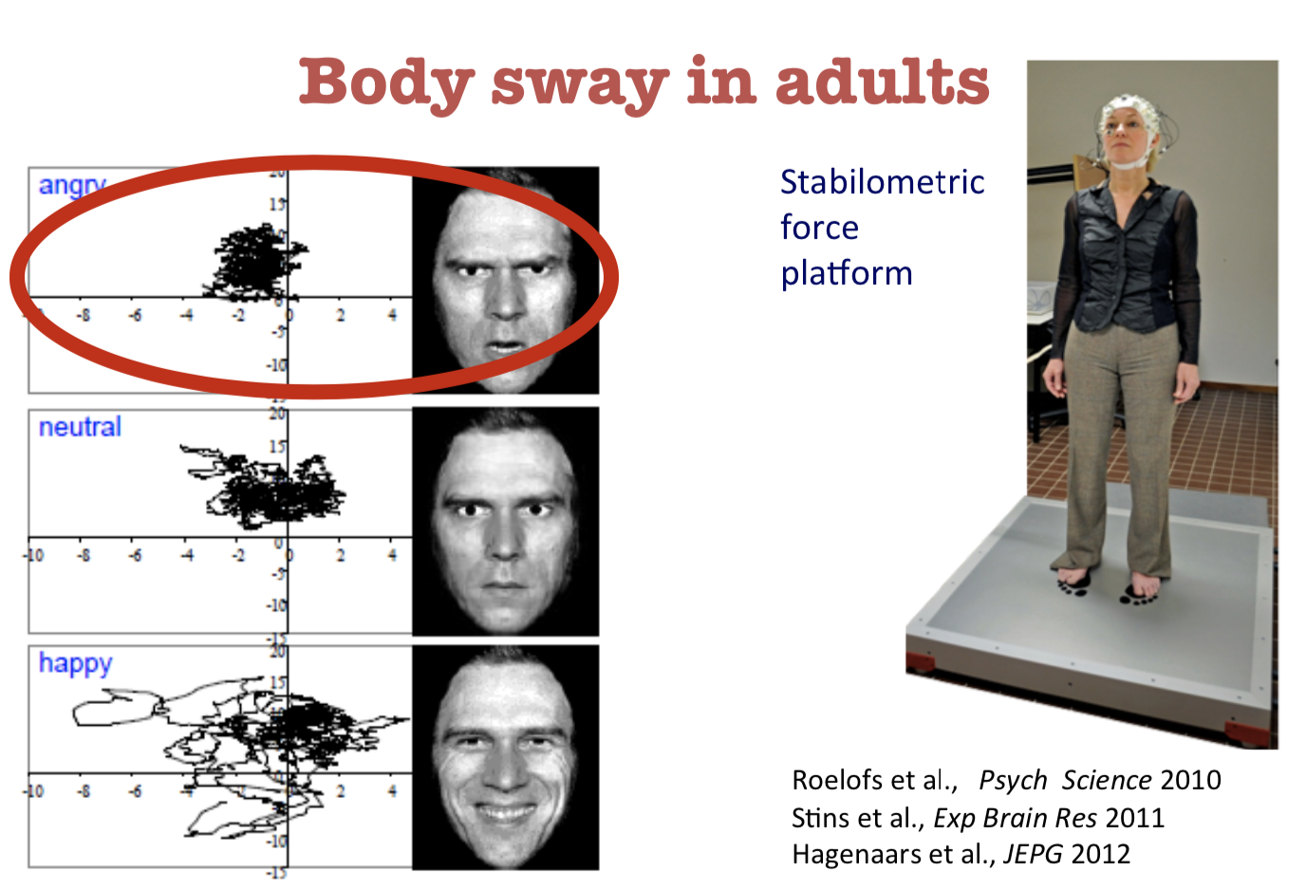

alt text

**Structure**

Body sway in response to happy (20), angry(20), and neutral (20) pictures of faces in adolescents.Each pp contributes 60 data points. Total 2400 data points.

* 40 participants.Each pp contributes 60 data points. Total 2400 data points.
* DV: Body sway (SD_AP)
* IV: Picture Category
* IV: Block number (1, 2, 3)
* IV: Picture number within block (1-20)
* IV: Picture identity (20 identities)

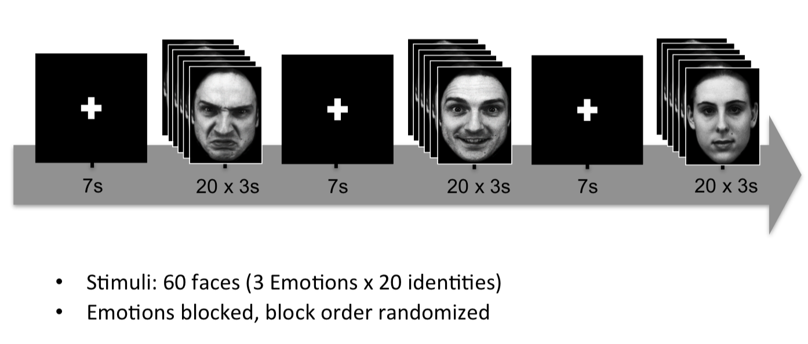

alt text

**MTrill**

Impact of Google Translate on English syntactic processing. Check whether participants re-use in their subsequent speech the syntactic structure previously seen in the Google output.

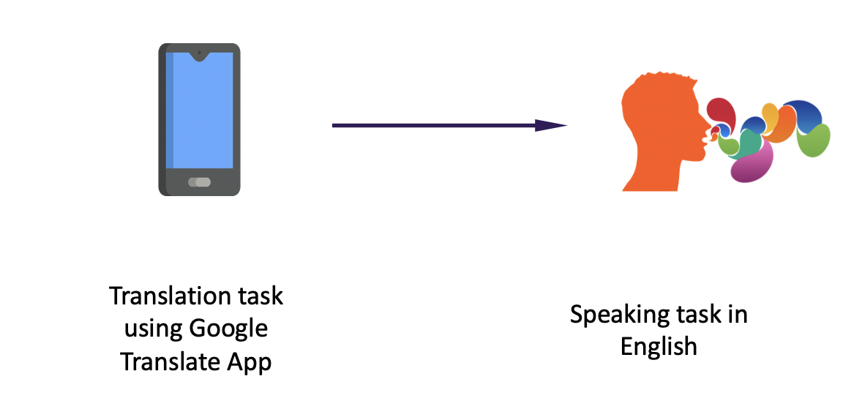

alt text

**Structure**

* Syntactic structure used: noun phrases with a relation of possession between nouns (e.g. E.g. A capa do livro ?? vermelha >> Book Cover is red (NP) or The cover of the book is red (PNP))
* Two phases: pre-test phase (baseline) and priming phase
* 19 participants. Each pp contributes to 40 data points (20 pre-test and 20 priming test). Total 760 datapoints
* Binominal DV: “1” if pp re-used the structure and “0” if pp did not re-use
* IV: Structure used (PNP/other or NP)
* IV: English test grade (continuous)
* IV: Type of test: Baseline/Priming

**Coding in R studio**

1. Preparatory steps
2. Descriptive analysis
3. Data transformation (if necessary)
4. Contrasts
5. Model fit
6. Model selection
7. Model diagnosis
8. P-values

#### R Studio

Let’s load body sway dataset

Bodyway_R_course.2 <- read.csv("~/Dropbox/MixedEffectsModel/Bodyway_R_course 2.csv", sep=";")

Some preprocessing…

bodysway=Bodyway_R_course.2  
bodysway= bodysway[-c(4)]

make DV numeric

bodysway$SD_AP <- as.numeric(bodysway$SD_AP)

For factors, it’s best NOT to use numerical indicators as this might lead to confusion whether it’s numerical or not, so change that:

# subject  
bodysway$Subject_f <- as.factor(bodysway$Subject_f)  
  
# PicCategory  
bodysway$PicCategory_f <- as.factor(bodysway$PicCategory_f)  
  
#PicIdentity, make factor variable out of it  
bodysway$PicIdent_f <- as.factor(bodysway$PicIdent_f)

Get descriptives

library(ggplot2)  
library(psych)

##   
## Attaching package: 'psych'

## The following objects are masked from 'package:ggplot2':  
##   
## %+%, alpha

with(bodysway, describeBy(SD_AP, group = list(PicCategory_f), mat = TRUE))

## item group1 vars n mean sd median trimmed mad min max  
## X11 1 A 1 800 1169.381 676.6051 1167.5 1165.331 871.7688 1 2395  
## X12 2 H 1 800 1183.980 706.3079 1158.0 1179.934 884.3709 3 2399  
## X13 3 N 1 800 1248.139 693.9896 1256.5 1257.247 891.7839 2 2400  
## range skew kurtosis se  
## X11 2394 0.02465110 -1.192260 23.92160  
## X12 2396 0.06134244 -1.227191 24.97176  
## X13 2398 -0.09182398 -1.179436 24.53624

with(bodysway, describeBy(SD_AP, group = list(gender_f), mat = TRUE))

## item group1 vars n mean sd median trimmed mad min max  
## X11 1 f 1 1200 1123.253 684.3592 1082.5 1110.009 867.3210 1 2399  
## X12 2 m 1 1200 1277.747 693.1873 1343.0 1291.756 873.9927 6 2400  
## range skew kurtosis se  
## X11 2398 0.1386973 -1.164436 19.75575  
## X12 2394 -0.1419194 -1.176015 20.01059

with(bodysway, describeBy(SD_AP, group = list(BlockNr), mat = TRUE))

## item group1 vars n mean sd median trimmed mad min max  
## X11 1 1 1 800 1162.629 707.4506 1133.5 1156.166 926.6250 3 2395  
## X12 2 2 1 800 1206.515 680.8648 1210.5 1209.039 867.3210 1 2400  
## X13 3 3 1 800 1232.356 689.3841 1248.5 1235.873 898.4556 4 2399  
## range skew kurtosis se  
## X11 2392 0.06718813 -1.243526 25.01216  
## X12 2399 -0.02155328 -1.164043 24.07221  
## X13 2395 -0.04239723 -1.194150 24.37341

#picture category  
barSD_AP <- ggplot(bodysway, aes(PicCategory_f, SD_AP))   
  
barSD_AP+ stat_summary(fun.y = mean, geom = "bar", fill = "White", colour = "Black") + stat_summary (fun.data = mean_cl_normal, geom = "errorbar", width = 0.2) + labs (x = "Picture Category", y = "Mean SD_AP") # add error bars

## Warning: `fun.y` is deprecated. Use `fun` instead.

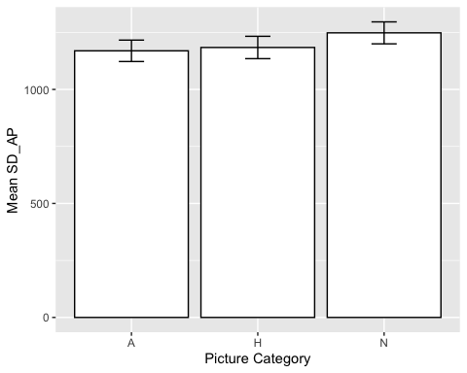

#gender  
barSD_AP <- ggplot(bodysway, aes(gender_f, SD_AP))   
  
barSD_AP+ stat_summary(fun.y = mean, geom = "bar", fill = "White", colour = "Black") + stat_summary (fun.data = mean_cl_normal, geom = "errorbar", width = 0.2) + labs (x = "Gender", y = "Mean SD_AP") # add error bars

## Warning: `fun.y` is deprecated. Use `fun` instead.

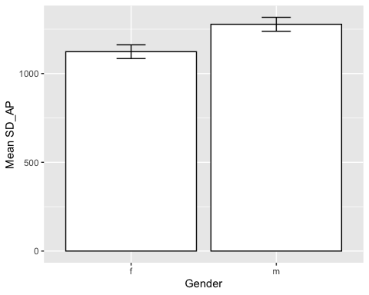

#block number  
barSD_AP <- ggplot(bodysway, aes(BlockNr, SD_AP))   
  
barSD_AP+ stat_summary(fun.y = mean, geom = "bar", fill = "White", colour = "Black") + stat_summary (fun.data = mean_cl_normal, geom = "errorbar", width = 0.2) + labs (x = "Block", y = "Mean SD_AP") # add error bars

## Warning: `fun.y` is deprecated. Use `fun` instead.

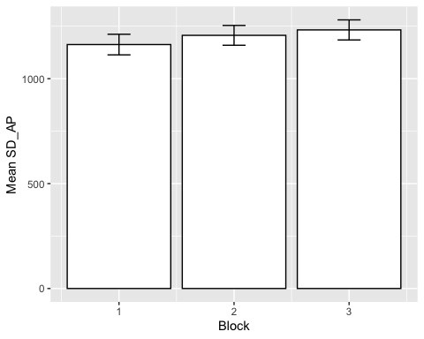

Density plots per participant and items

library(lattice)

## Warning: package 'lattice' was built under R version 3.4.4

#density plots per participant  
with(bodysway, densityplot(~SD_AP | Subject_f))

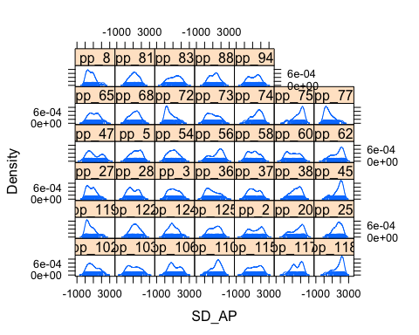

with(bodysway, densityplot(~SD_AP | PicIdent_f))

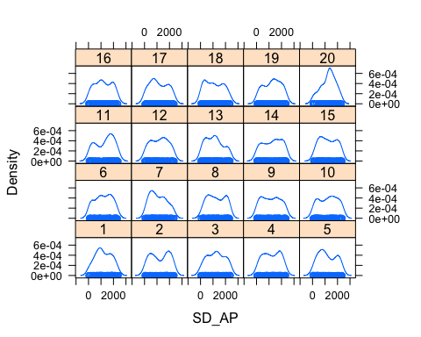

DV distribution check

library(lattice) #for histograms  
  
  
hist.SD_AP <- ggplot(bodysway, aes(SD_AP)) + theme(legend.position = "none") + geom_histogram(aes(y=..density..), colour = "black", fill = "white") + labs(x = "SD_AP", y = "Density") + stat_function (fun = dnorm, args = list(mean = mean(bodysway$SD_AP, na.rm = TRUE), sd = sd(bodysway$SD_AP, na.rm = TRUE)), colour = "black", size = 1)   
hist.SD_AP

## `stat_bin()` using `bins = 30`. Pick better value with `binwidth`.

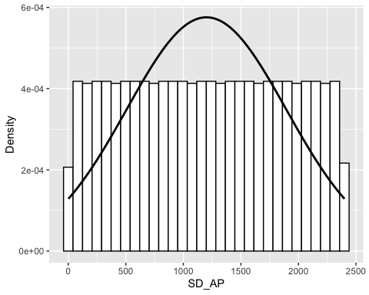

with(bodysway, densityplot(SD_AP))

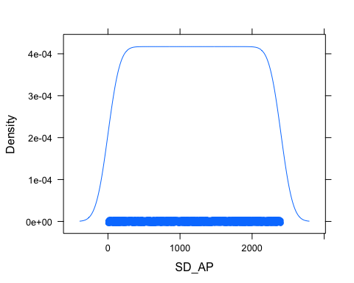

#skewness and kurtosis  
skew(bodysway$SD_AP) #0 - symmetric

## [1] 0

Data transformation - centering data DV and IV - good practice! [linked phrase](https://statisticsbyjim.com/regression/standardize-variables-regression/)

bodysway$SD_APz <- scale(bodysway$SD_AP, scale = FALSE)  
  
  
#checking distribution skewness  
skew(bodysway$SD_APz) #skewness 0

## [1] 0

#plots distribution DV centered   
  
hist.SD_APz <- ggplot(bodysway, aes(SD_APz)) + theme(legend.position = "none") + geom_histogram(aes(y=..density..), colour = "black", fill = "white") + labs(x = "SD_AP", y = "Density") + stat_function (fun = dnorm, args = list(mean = mean(bodysway$SD_APz, na.rm = TRUE), sd = sd(bodysway$SD_APz, na.rm = TRUE)), colour = "black", size = 1)   
  
hist.SD_APz

## `stat_bin()` using `bins = 30`. Pick better value with `binwidth`.

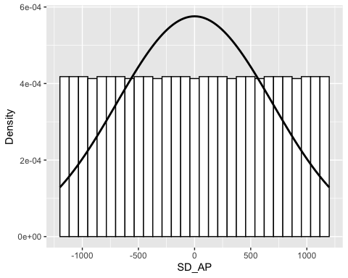

hist(bodysway$SD_APz)

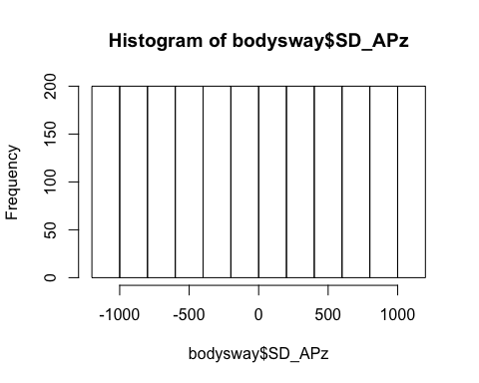

#centering continuous variables  
bodysway$BlockNr_c <- scale(bodysway$BlockNr, center = TRUE, scale = TRUE)  
bodysway$PicNr_c <- scale(bodysway$PicNr, center = TRUE, scale = TRUE)

Contrasts setting

# Angry and Happy as opposed to Neutral  
bodysway$EmotionVsNeutral <- as.factor(ifelse(bodysway$PicCategory_f == 'A' | bodysway$PicCategory_f == 'H', 'Emotion', ifelse(bodysway$PicCategory_f == 'N', 'Neutral', NA)))  
  
  
options(contrasts = c("contr.sum", "contr.poly"))  
#1) Save contrast matrix into a variable  
Dev_cont_EmotionVsNeutral_f <- contrasts(bodysway$EmotionVsNeutral)  
#2) Add a first column of 1's (for the intercept)"  
Dev_cont_EmotionVsNeutral_f <- cbind(c(1,1), Dev_cont_EmotionVsNeutral_f)  
#3)Invert (=solve) the matrix, to get the actual weights  
solve(Dev_cont_EmotionVsNeutral_f)

## Emotion Neutral  
## [1,] 0.5 0.5  
## [2,] 0.5 -0.5

Models

attach(bodysway)  
names(bodysway)

## [1] "Subject_f" "PicNr" "SD_AP" "PicCategory_f"   
## [5] "gender_f" "BlockNr" "PicIdent_f" "SD_APz"   
## [9] "BlockNr_c" "PicNr_c" "EmotionVsNeutral"

library(lme4)

## Loading required package: Matrix

#backwards procedure   
  
m1 <- lmer(SD_APz ~ gender_f + EmotionVsNeutral * PicNr_c * BlockNr_c + (1 + EmotionVsNeutral * PicNr_c * BlockNr_c | Subject_f) + (1 | PicIdent_f), data = bodysway)

## Warning in commonArgs(par, fn, control, environment()): maxfun < 10 *  
## length(par)^2 is not recommended.

#increased number of interactions  
m2 <- lmer(SD_APz ~ gender_f + EmotionVsNeutral * PicNr_c * BlockNr_c + (1 + EmotionVsNeutral * PicNr_c * BlockNr_c | Subject_f) + (1 | PicIdent_f), data = bodysway, control=lmerControl(optCtrl=list(maxfun=2000000)))  
print(summary(m2), corr = FALSE) #converged

## Linear mixed model fit by REML ['lmerMod']  
## Formula: SD_APz ~ gender_f + EmotionVsNeutral * PicNr_c * BlockNr_c +   
## (1 + EmotionVsNeutral * PicNr_c * BlockNr_c | Subject_f) +   
## (1 | PicIdent_f)  
## Data: bodysway  
## Control: lmerControl(optCtrl = list(maxfun = 2e+06))  
##   
## REML criterion at convergence: 37633.5  
##   
## Scaled residuals:   
## Min 1Q Median 3Q Max   
## -2.58107 -0.80090 0.03368 0.77169 2.59143   
##   
## Random effects:  
## Groups Name Variance Std.Dev. Corr   
## Subject_f (Intercept) 92778.2 304.60   
## EmotionVsNeutral1 3535.2 59.46 0.26   
## PicNr_c 2205.8 46.97 -0.10 -0.01  
## BlockNr_c 3602.9 60.02 -0.55 -0.53  
## EmotionVsNeutral1:PicNr_c 2920.6 54.04 0.00 -0.78  
## EmotionVsNeutral1:BlockNr_c 2852.6 53.41 0.46 0.03  
## PicNr_c:BlockNr_c 1555.6 39.44 0.38 0.45  
## EmotionVsNeutral1:PicNr_c:BlockNr_c 3217.9 56.73 0.54 -0.31  
## PicIdent_f (Intercept) 760.7 27.58   
## Residual 361438.8 601.20   
##   
##   
##   
##   
## 0.46   
## -0.57 0.20   
## 0.52 0.43 -0.11   
## -0.10 -0.89 -0.42 -0.47   
## 0.63 0.09 -0.05 0.59 0.11  
##   
##   
## Number of obs: 2400, groups: Subject_f, 40; PicIdent_f, 20  
##   
## Fixed effects:  
## Estimate Std. Error t value  
## (Intercept) 20.0318 50.4757 0.397  
## gender_f1 -72.3599 45.1661 -1.602  
## EmotionVsNeutral1 -50.5803 16.7508 -3.020  
## PicNr_c 47.6155 16.0301 2.970  
## BlockNr_c 29.1928 18.4213 1.585  
## EmotionVsNeutral1:PicNr_c -37.6265 16.4259 -2.291  
## EmotionVsNeutral1:BlockNr_c 21.7125 21.7992 0.996  
## PicNr_c:BlockNr_c 0.9816 16.8513 0.058  
## EmotionVsNeutral1:PicNr_c:BlockNr_c 4.3608 17.3634 0.251

m3 <- lmer(SD_APz ~ gender_f + EmotionVsNeutral * PicNr_c * BlockNr_c + (1 + EmotionVsNeutral | Subject_f) + (1 | PicIdent_f), data = bodysway, control=lmerControl(optCtrl=list(maxfun=2000000)))  
print(summary(m3), corr = FALSE)

## Linear mixed model fit by REML ['lmerMod']  
## Formula: SD_APz ~ gender_f + EmotionVsNeutral * PicNr_c * BlockNr_c +   
## (1 + EmotionVsNeutral | Subject_f) + (1 | PicIdent_f)  
## Data: bodysway  
## Control: lmerControl(optCtrl = list(maxfun = 2e+06))  
##   
## REML criterion at convergence: 37673.3  
##   
## Scaled residuals:   
## Min 1Q Median 3Q Max   
## -2.49284 -0.80469 0.04927 0.79148 2.40569   
##   
## Random effects:  
## Groups Name Variance Std.Dev. Corr  
## Subject_f (Intercept) 97836.1 312.79   
## EmotionVsNeutral1 3992.6 63.19 0.23  
## PicIdent_f (Intercept) 376.5 19.40   
## Residual 375806.8 613.03   
## Number of obs: 2400, groups: Subject_f, 40; PicIdent_f, 20  
##   
## Fixed effects:  
## Estimate Std. Error t value  
## (Intercept) 7.547 51.528 0.146  
## gender_f1 -84.317 51.108 -1.650  
## EmotionVsNeutral1 -38.380 16.953 -2.264  
## PicNr_c 41.581 13.515 3.077  
## BlockNr_c 28.740 16.643 1.727  
## EmotionVsNeutral1:PicNr_c -39.692 13.519 -2.936  
## EmotionVsNeutral1:BlockNr_c 36.728 19.944 1.841  
## PicNr_c:BlockNr_c 4.414 13.483 0.327  
## EmotionVsNeutral1:PicNr_c:BlockNr_c 0.545 13.478 0.040

#random intercept for PicIndent removed  
m4 <- lmer(SD_APz ~ gender_f + EmotionVsNeutral * PicNr_c * BlockNr_c + (1 + EmotionVsNeutral | Subject_f), data = bodysway, control=lmerControl(optCtrl=list(maxfun=2000000)))  
print(summary(m4), corr = FALSE) #converged

## Linear mixed model fit by REML ['lmerMod']  
## Formula: SD_APz ~ gender_f + EmotionVsNeutral * PicNr_c * BlockNr_c +   
## (1 + EmotionVsNeutral | Subject_f)  
## Data: bodysway  
## Control: lmerControl(optCtrl = list(maxfun = 2e+06))  
##   
## REML criterion at convergence: 37673.4  
##   
## Scaled residuals:   
## Min 1Q Median 3Q Max   
## -2.48252 -0.80256 0.04473 0.79258 2.41357   
##   
## Random effects:  
## Groups Name Variance Std.Dev. Corr  
## Subject_f (Intercept) 97828 312.78   
## EmotionVsNeutral1 3986 63.13 0.23  
## Residual 376177 613.33   
## Number of obs: 2400, groups: Subject_f, 40  
##   
## Fixed effects:  
## Estimate Std. Error t value  
## (Intercept) 7.5474 51.3445 0.147  
## gender_f1 -84.3173 51.1076 -1.650  
## EmotionVsNeutral1 -38.3803 16.9533 -2.264  
## PicNr_c 41.5842 13.5160 3.077  
## BlockNr_c 28.7375 16.6439 1.727  
## EmotionVsNeutral1:PicNr_c -39.5960 13.5160 -2.930  
## EmotionVsNeutral1:BlockNr_c 36.7225 19.9479 1.841  
## PicNr_c:BlockNr_c 4.5111 13.4764 0.335  
## EmotionVsNeutral1:PicNr_c:BlockNr_c 0.4743 13.4764 0.035

m5 <- lmer(SD_APz ~ gender_f + EmotionVsNeutral + PicNr_c + BlockNr_c + (1 | Subject_f), data = bodysway, control=lmerControl(optCtrl=list(maxfun=2000000)))  
print(summary(m5), corr = FALSE) #converged

## Linear mixed model fit by REML ['lmerMod']  
## Formula: SD_APz ~ gender_f + EmotionVsNeutral + PicNr_c + BlockNr_c +   
## (1 | Subject_f)  
## Data: bodysway  
## Control: lmerControl(optCtrl = list(maxfun = 2e+06))  
##   
## REML criterion at convergence: 37721.8  
##   
## Scaled residuals:   
## Min 1Q Median 3Q Max   
## -2.58348 -0.81331 0.02491 0.81136 2.41322   
##   
## Random effects:  
## Groups Name Variance Std.Dev.  
## Subject_f (Intercept) 94821 307.9   
## Residual 381650 617.8   
## Number of obs: 2400, groups: Subject_f, 40  
##   
## Fixed effects:  
## Estimate Std. Error t value  
## (Intercept) 13.75 50.50 0.272  
## gender_f1 -77.25 50.29 -1.536  
## EmotionVsNeutral1 -41.25 13.53 -3.049  
## PicNr_c 28.45 12.61 2.256  
## BlockNr_c 34.37 12.76 2.693

Model selection

#models comparison - Likelihood ratio test  
anova(m3,m2)

## refitting model(s) with ML (instead of REML)

## Warning in commonArgs(par, fn, control, environment()): maxfun < 10 *  
## length(par)^2 is not recommended.

## Data: bodysway  
## Models:  
## m3: SD_APz ~ gender_f + EmotionVsNeutral * PicNr_c * BlockNr_c +   
## m3: (1 + EmotionVsNeutral | Subject_f) + (1 | PicIdent_f)  
## m2: SD_APz ~ gender_f + EmotionVsNeutral * PicNr_c * BlockNr_c +   
## m2: (1 + EmotionVsNeutral * PicNr_c * BlockNr_c | Subject_f) +   
## m2: (1 | PicIdent_f)  
## Df AIC BIC logLik deviance Chisq Chi Df Pr(>Chisq)  
## m3 14 37771 37852 -18871 37743   
## m2 47 37798 38070 -18852 37704 38.404 33 0.2379

anova(m3,m4)

## refitting model(s) with ML (instead of REML)

## Data: bodysway  
## Models:  
## m4: SD_APz ~ gender_f + EmotionVsNeutral * PicNr_c * BlockNr_c +   
## m4: (1 + EmotionVsNeutral | Subject_f)  
## m3: SD_APz ~ gender_f + EmotionVsNeutral * PicNr_c * BlockNr_c +   
## m3: (1 + EmotionVsNeutral | Subject_f) + (1 | PicIdent_f)  
## Df AIC BIC logLik deviance Chisq Chi Df Pr(>Chisq)  
## m4 13 37769 37844 -18872 37743   
## m3 14 37771 37852 -18871 37743 0.1184 1 0.7307

anova(m3,m4)

## refitting model(s) with ML (instead of REML)

## Data: bodysway  
## Models:  
## m4: SD_APz ~ gender_f + EmotionVsNeutral * PicNr_c * BlockNr_c +   
## m4: (1 + EmotionVsNeutral | Subject_f)  
## m3: SD_APz ~ gender_f + EmotionVsNeutral * PicNr_c * BlockNr_c +   
## m3: (1 + EmotionVsNeutral | Subject_f) + (1 | PicIdent_f)  
## Df AIC BIC logLik deviance Chisq Chi Df Pr(>Chisq)  
## m4 13 37769 37844 -18872 37743   
## m3 14 37771 37852 -18871 37743 0.1184 1 0.7307

anova(m2,m4)

## refitting model(s) with ML (instead of REML)

## Warning in commonArgs(par, fn, control, environment()): maxfun < 10 *  
## length(par)^2 is not recommended.

## Data: bodysway  
## Models:  
## m4: SD_APz ~ gender_f + EmotionVsNeutral * PicNr_c * BlockNr_c +   
## m4: (1 + EmotionVsNeutral | Subject_f)  
## m2: SD_APz ~ gender_f + EmotionVsNeutral * PicNr_c * BlockNr_c +   
## m2: (1 + EmotionVsNeutral * PicNr_c * BlockNr_c | Subject_f) +   
## m2: (1 | PicIdent_f)  
## Df AIC BIC logLik deviance Chisq Chi Df Pr(>Chisq)  
## m4 13 37769 37844 -18872 37743   
## m2 47 37798 38070 -18852 37704 38.523 34 0.2723

anova(m5,m4) #interaction effects highly significant

## refitting model(s) with ML (instead of REML)

## Data: bodysway  
## Models:  
## m5: SD_APz ~ gender_f + EmotionVsNeutral + PicNr_c + BlockNr_c +   
## m5: (1 | Subject_f)  
## m4: SD_APz ~ gender_f + EmotionVsNeutral * PicNr_c * BlockNr_c +   
## m4: (1 + EmotionVsNeutral | Subject_f)  
## Df AIC BIC logLik deviance Chisq Chi Df Pr(>Chisq)   
## m5 7 37776 37816 -18881 37762   
## m4 13 37769 37844 -18872 37743 18.958 6 0.004236 **  
## ---  
## Signif. codes: 0 '***' 0.001 '**' 0.01 '*' 0.05 '.' 0.1 ' ' 1

#best model - model 4

Model diagnosis

plot(m4) # fitted vs. residuals

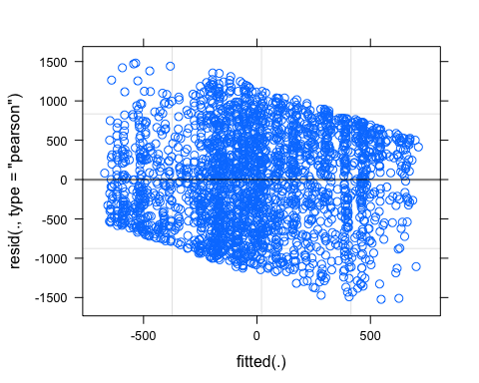

densityplot(resid(m4)) # distribution of the residuals

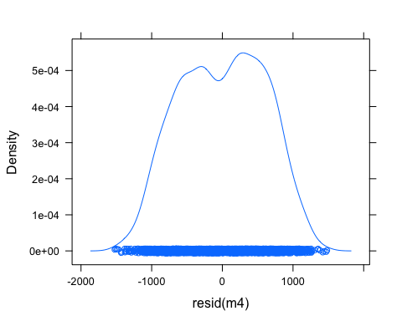

qqnorm(resid(m4))

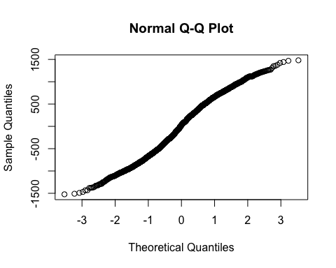 Get P-values

library(car)

##   
## Attaching package: 'car'

## The following object is masked from 'package:psych':  
##   
## logit

Anova_m4 <- Anova(m4, type = 3, test = 'F')  
Anova_m4

## Analysis of Deviance Table (Type III Wald F tests with Kenward-Roger df)  
##   
## Response: SD_APz  
## F Df Df.res Pr(>F)   
## (Intercept) 0.0216 1 38.14 0.883924   
## gender_f 2.5831 1 37.72 0.116351   
## EmotionVsNeutral 5.1145 1 38.39 0.029471 *   
## PicNr_c 9.4658 1 2315.00 0.002118 **  
## BlockNr_c 2.8469 1 46.81 0.098207 .   
## EmotionVsNeutral:PicNr_c 8.5823 1 2315.00 0.003428 **  
## EmotionVsNeutral:BlockNr_c 3.2786 1 93.29 0.073409 .   
## PicNr_c:BlockNr_c 0.1121 1 2315.00 0.737848   
## EmotionVsNeutral:PicNr_c:BlockNr_c 0.0012 1 2315.00 0.971927   
## ---  
## Signif. codes: 0 '***' 0.001 '**' 0.01 '*' 0.05 '.' 0.1 ' ' 1