# Context Diagram

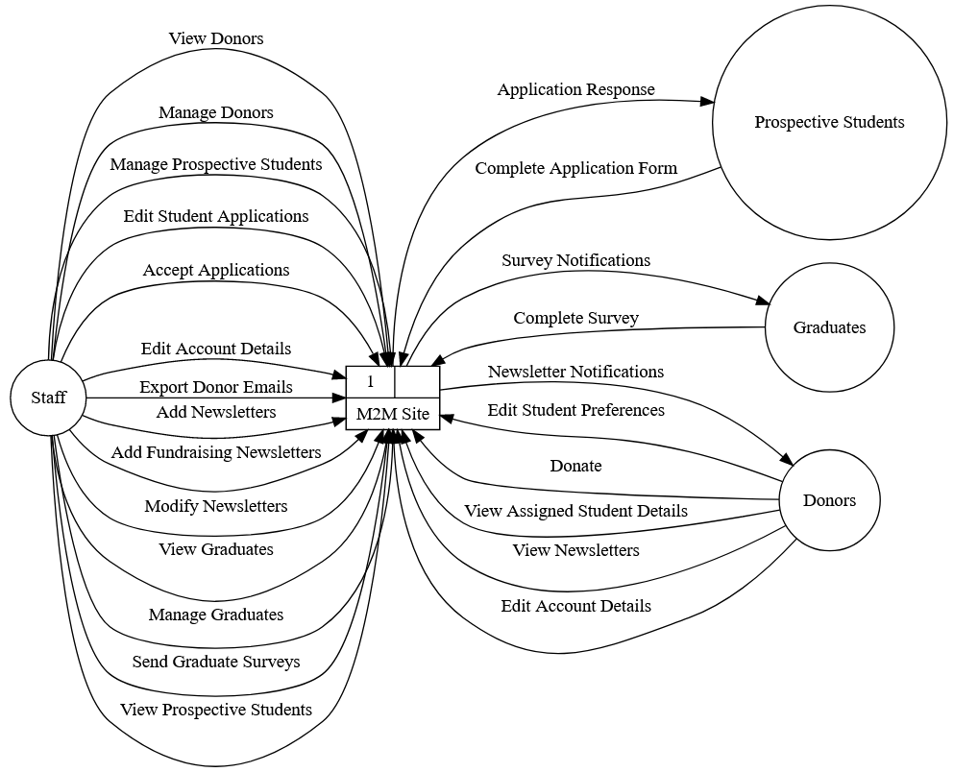

# Level 1 Partial Diagrams

To better show off the various data flows, we created multiple level 1 diagrams each focusing on how each entity interacts with the M2M site.

## Donors and Newsletters

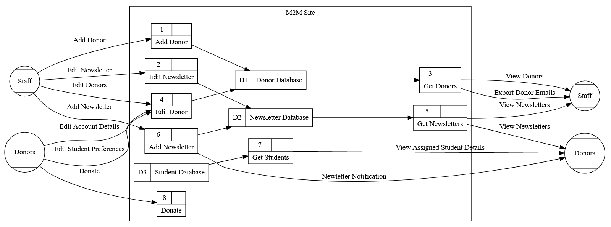

The donor and newsletter systems are quite interconnected, so are shown on a single graph.

Donors are stored in datastore D1. Staff can view all donors, and export their emails (say to use in a mail merge) through process 3. Staff are also able to edit donor details and add new donors through processes 4 and 1 respectively. Donors themselves can edit their own account details and their student preferences, also through process 4 (though locked to only their own account of course). Donors can view updates on their assigned students through process 7, which grabs information from the student database D3. All other interactions with this database are out of scope for our part of the project. Finally, donors are of course able to make a donation through process 8.

Newsletters are stored in datastore D2. By going through process 5, staff are able to view all existing newsletters, and then either modify them if necessary or add new ones through processes 2 and 6 respectively, which each flow back into D2. Process 6, adding a newsletter, also sends a notification out to donors so they can stay up to date.

## Prospective Students

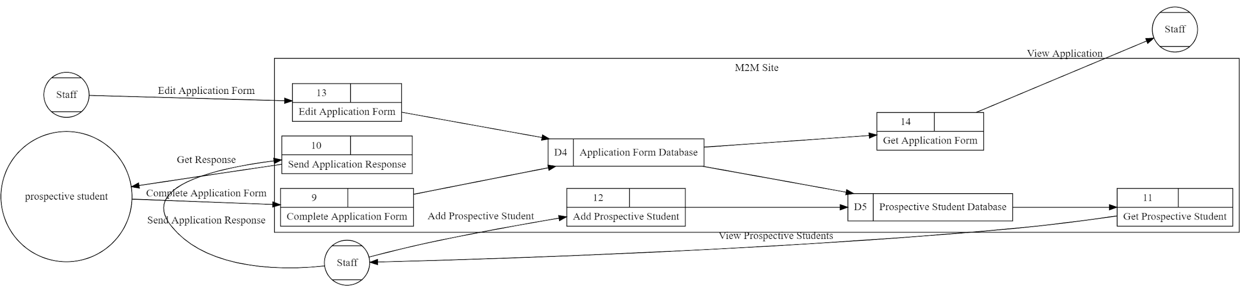

Prospective student data is stored in two parts: information on the student in D5, and information on each application in D4. This allows a single student to submit multiple applications if needed. Each prospective student fills out an application form and submits it through process 9. This data is stored in D4, which in turn creates a new data entry in D5 if necessary. Staff members can view these prospective student details and applications through processes 11 and 14 respectively, and send responses back through process 10. Staff can also add prospective students manually through process 12, and make changes to submitted applications through process 13.

## Graduates

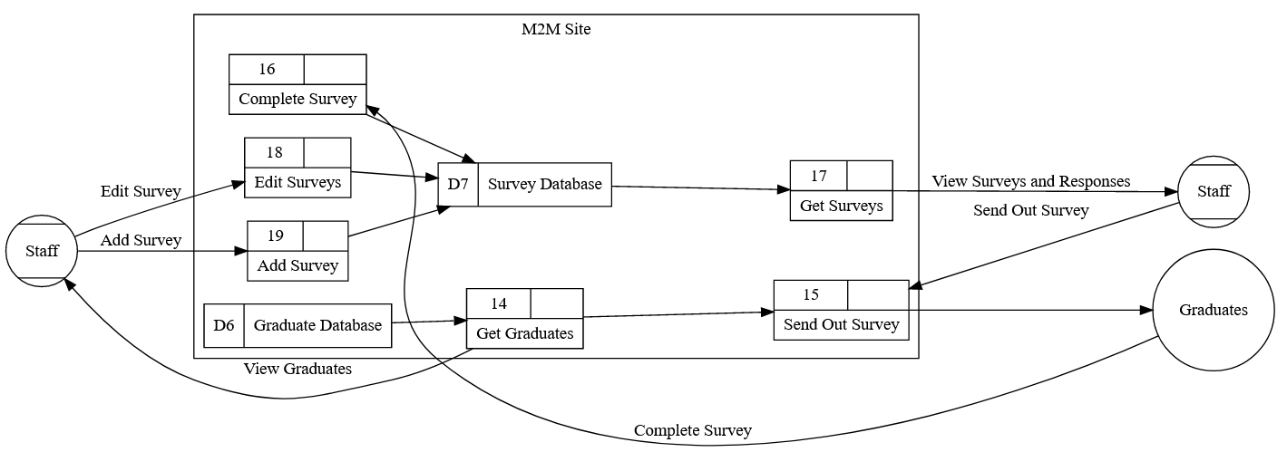

The graduates and survey systems are also quite interconnected, so are again shown on a single graph.

The datastore D7 contains the complete surveys and new surveys that need to be sent out.

Medic to Medic sends out annual surveys to their graduates. Surveys are stored in Datastore D7. Staff members can view all existing surveys and responses through process 17, as well as add new surveys through process 19 and edit them through process 18. Staff will start process 15 to send out new surveys, this gets the graduate information from datastore D6, via process 14, and sends the survey to the retrieved graduates. Graduates can then complete the form and return their data through process 16, which stores their responses back in D7 to be viewed by the staff.