**1.Customer Management**

**1.4 Display a customer report**

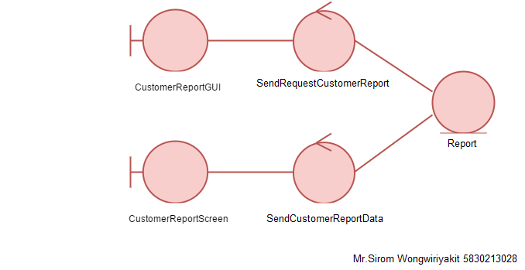- Model-View-Controller (MVC) Model

* Sequence Diagram

