**2.Sales Management**

2.4 **Fix the computer rental rate**

- Model-View-Controller (MVC) Model

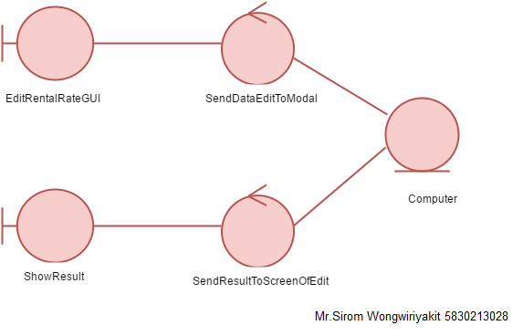

* Sequence Diagram

