**25 feb 2024**

Day 1:

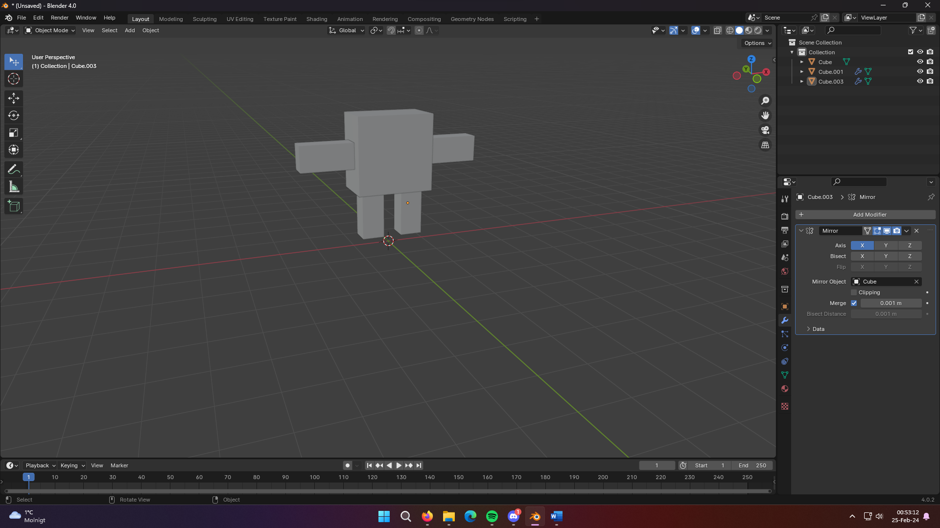

Started learning how to do simple model and rigging for animations in Blender 4.0 for the first time  
<https://www.youtube.com/watch?v=4z7G4TyKE9g>

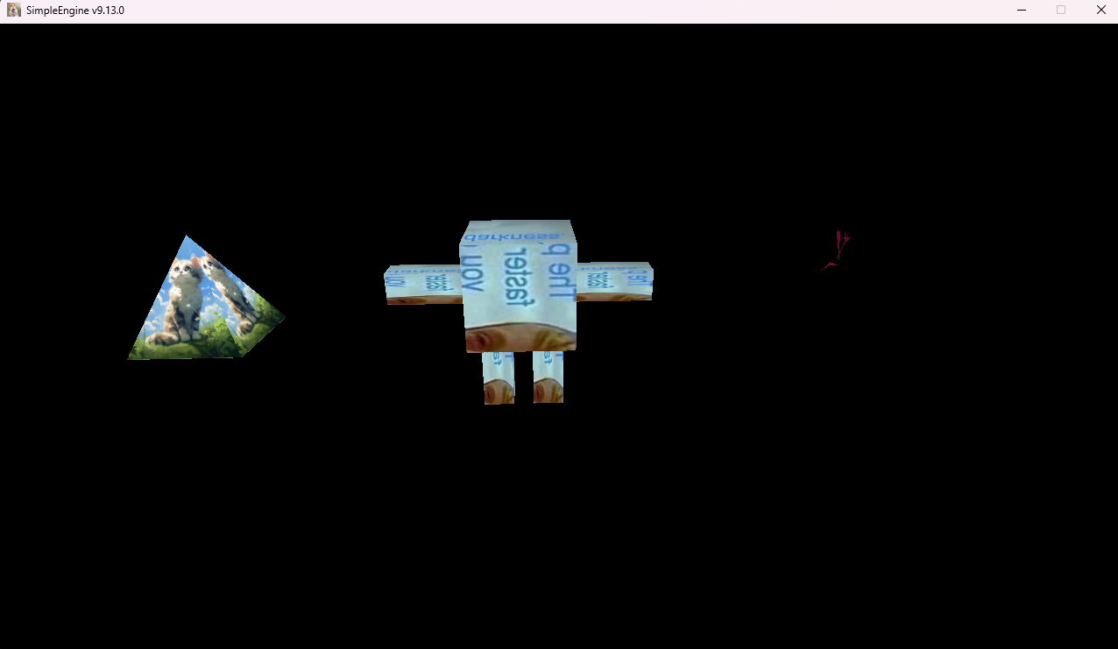

Managed to export the FBX mesh and have it loaded and render correct in the engine. Due to Blender have different coordinate system the model at first renderer in wrong rotation. I tried to somehow convert it during TGAFBXLoader but quickly gave up for now. Luckily the Blender has export option to choose Up-Axis and Forward-Axis.

