**25 feb 2024**

Day 1:

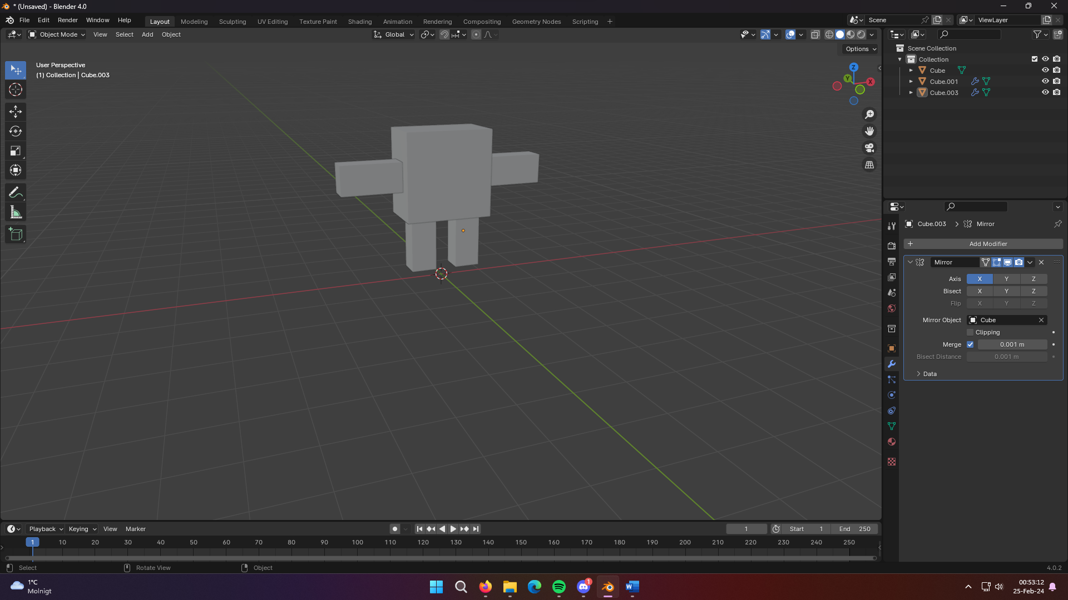

Started learning how to do simple model and rigging for animations in Blender 4.0 for the first time  
<https://www.youtube.com/watch?v=4z7G4TyKE9g>