Comparing RGB and Multispectral Convolutional Neural Networks for Land Use and Land Cover Classification
Data Science Capstone Report
Nate Smith
Western Governors University, M.S. Data Analytics, Data Science
September 2026

Research Question

Question
To what extent do convolutional neural networks trained on 10 Sentinel-2 spectral bands classify land use and land cover more accurately than those trained on RGB bands alone, according to macro F1-score?

Context
Land use and land cover (LULC) classification identifies what occupies a given section of the earth’s surface. This includes classifications such as cropland, forest, industrial, and bodies of water. Governments and non-governmental organizations use LULC for urban planning, deforestation tracking, climate monitoring, water management, and crop monitoring. The availability of accurate and up-to-date data is critical for operation in these modern fields. Because hand labeling LULC changes with each new satellite pass is time consuming and expensive, organizations have begun to adopt the use of automated classification models to keep maps current.
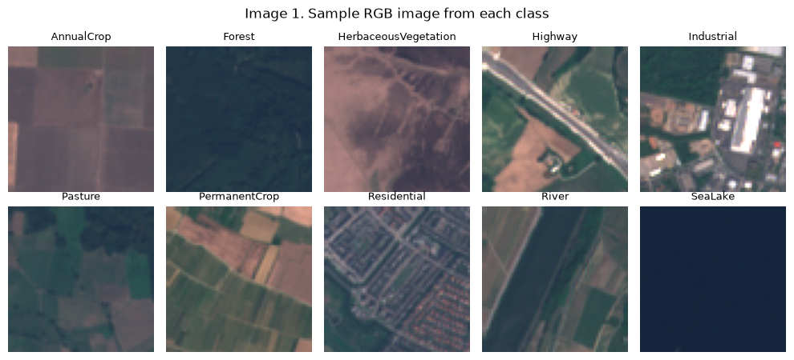
Free satellite imagery has become available to the public in recent years, most notably from the European Space Agency’s Sentinel-2 satellites. These satellites orbit the earth and cover all land surfaces between 56° S and 82.8° N with a revisit time of 5 days at the equator (European Space Agency, n.d.). Although S-2 captures 13 spectral bands, most pretrained image classification models expect only the three visible bands (red, green, and blue) because these are what ordinary photographs contain. The additional spectral bands capture light outside of the visible range: red-edge bands respond to chlorophyll and stressed plant life, near-infrared (NIR) bands respond to healthy leaf structure, and shortwave-infrared (SWIR) bands respond to moisture in soil and vegetation as well as mineral composition (European Space Agency, n.d.). Classification models that neglect these bands lose out on information that is relevant to the distinctions that an LULC classifier makes such as separating types of vegetation or human development.

Justification
Using additional spectral bands is not free. An image with all 10 spectral bands takes more than 3 times the storage of a 3 band RGB image, takes longer to train on, and doesn’t automatically work with existing RGB-based classification models. An organization deciding how to build an LULC pipeline, therefore needs evidence on whether the use of additional bands actually produces models with higher classification power. This research provides a direct, controlled answer: 2 groups of models that are identical except in the number of spectral bands they are trained on, compared on a class-balanced metric. Macro F1-score was chosen because it averages the F1-score of each class equally, giving equal representation to all classes regardless of sample size. This is important so that a model can’t score well by having high accuracy for larger classes and low accuracy for smaller ones.

Hypothesis
Null hypothesis (H₀): Convolutional neural networks trained on 10 Sentinel-2 spectral bands do not achieve a higher macro F1-score than those trained on RGB bands alone.
Alternative hypotheses (H₁): Convolutional neural networks trained on 10 Sentinel-2 spectral bands achieve a higher macro F1-score than those trained on RGB bands alone.
This hypothesis is directional because the properties of red-edge, NIR, and SWIR bands give a clear reason to expect an improvement in classification performance. The hypothesis was tested with a one-sided paired t-test with an alpha of 0.05. I also expected that both model configurations would achieve a macro F1-score of above 0.80 and that the multispectral configuration would outperform the RGB configuration on accuracy, precision, and recall.

Data Collection

Data Collected
The data used is the multispectral version of the EuroSAT dataset (Helber et al. 2018, 2019) and was downloaded as a zip archive from its public Zenodo page (Helber et al., 2018a). EuroSAT includes 27,000 Sentinel-2 images taken over 34 countries in Europe. Each image is 64 x 64 pixels and is stored as a GeoTIFF with 13 spectral bands of 16-bit reflectance values. Every image was hand-labeled by Helber et al. (2019) into one of 10 LULC classes: AnnualCrop, Forest, HerbaceousVegitation (original spelling maintained), Highway, Industrial, Pasture, PermanentCrop, Residental, River, and SeaLake. The classes contain 2,000-3,000 images each (Table 1). The dataset is publicly available, non-proprietary, and contains no human subjects or personal information.
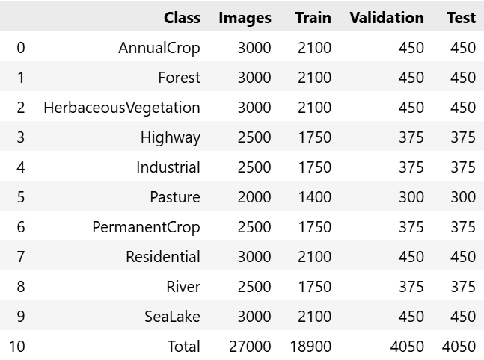
Table 1: Train, validation, and test size by class
Of the 13 available bands, I chose to include 10 in the training of the multispectral models. B01, B09, and B10 were all omitted because they are atmospheric bands that measure conditions in the air rather than on the earth’s surface (European Space Agency, n.d.). The bands used in each configuration are shown below (Table 2).
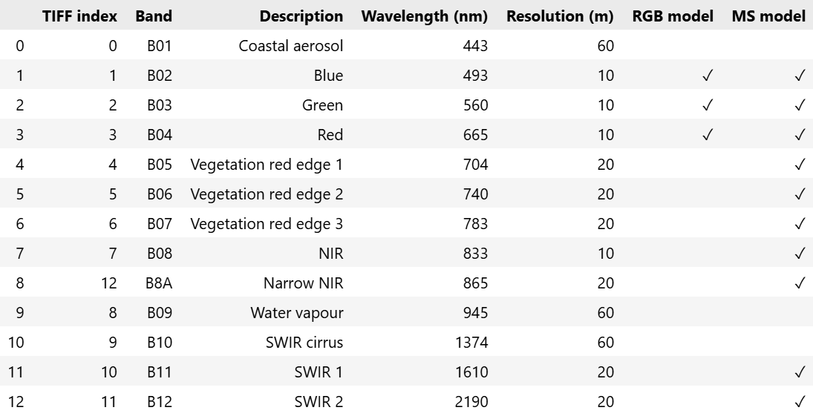
Table 2: Sentinel-2 bands and their use in each model configuration.
An advantage of using the EuroSAT dataset is that it is publicly available and is already labeled by the authors of the dataset. This makes it easy to use and reproduce. Because the images come from Sentinel-2 which will continue operating for several years, a model trained on them can be applied to future images of the same format. A disadvantage of using this dataset is that I had no control over which images were captured and which labels were assigned. Since all the images were taken over Europe, the model may not generalize as well on imagery from other parts of the world where the LULC classes may have different attributes.

Data Challenges
Loading speed. I decided to do 20 separate training runs and loading 27,000 images into Python with tifffile every time a model was trained would have been slow. I decided to run every image once through a preparation script (cache.py) validating its shape and datatype and then saving the full dataset as a uint16 NumPy array with a shape of 27,000 x 64 x 64 x 13. Each training run used this rather than loading 27,000 files.
Keeping the comparison fair. Both model configurations needed to see the exact same training, validation, and testing images. I created the 70/15/15 split once, saved the index arrays, and had every training run load the same indices so the only difference between model configurations was the set of input bands.
Compute power. Training 20 convolutional neural networks (CNNs) on 27,000 images requires a lot of time to compute and my personal laptop doesn’t have the power to do it. To solve this, I used an NVIDIA Tesla T4 GPU on Kaggle which completed the training in just under 5 hours.

Data Extraction and Preparation
Data extraction and preparation were done in 2 Python scripts. cache.py runs once and extracts the raw images into NumPy arrays, creates the data split, and computes normalization statistics. train.py selects the bands for each model, standardizes them, and feeds them into the network in batches. It runs once for each of the 20 models. The steps are described below.

Extraction: reading the GeoTIFF files
cache.py lists the 10 class folders in sorted order and assigns each one an integer label from AnnualCrop = 0 to SeaLake = 9. It then reads every .tif fille with the tifffile library, verifies each image’s shape, and writes it all into a preallocated NumPy array. The class labels, the array, and the class-name list are all saved to a cache folder.
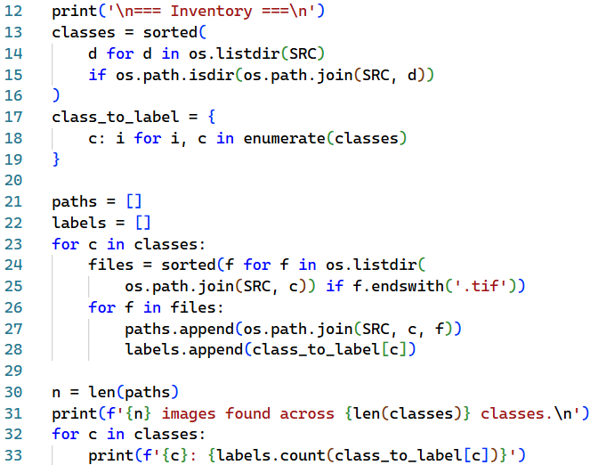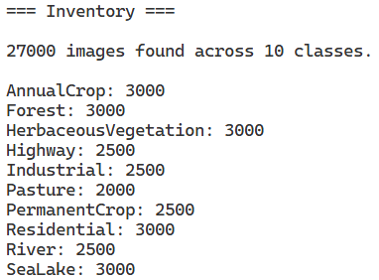
Screenshots 1, 2. cache.py: inventory of class folder.

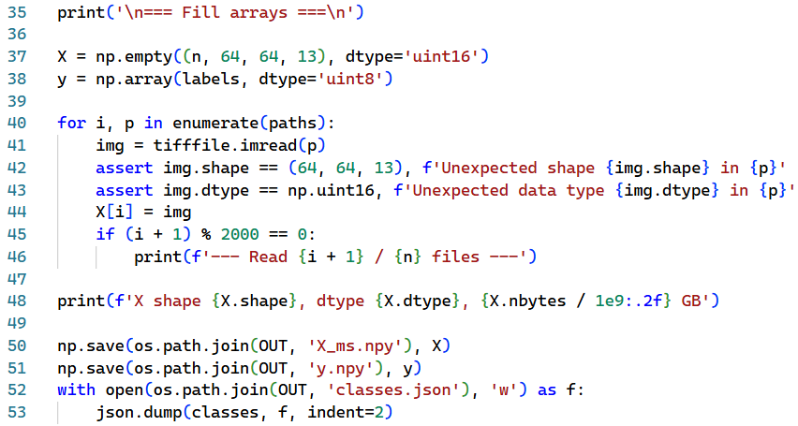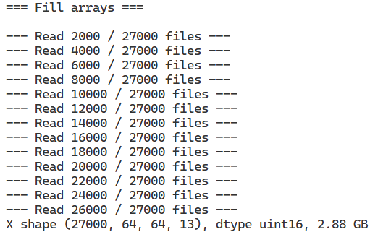
Screenshots 3, 4. cache.py: extraction of images into a NumPy array.

Stratified train / validation / test split
The 27,000 image indices were split 70/15/15 using scikit-lean’s train_test_split with stratify set to the class labels and a fixed random state of 42. The split was done in two stages: an initial 70/30, and then the 30% being split evenly between validation and test. This gave 18,900 training, 4,050 validation, and 4,050 test, each with the same class proportions as the full dataset. Assertions confirm that no image appears in more than one split. The three index arrays were saved so every model uses the identical split.
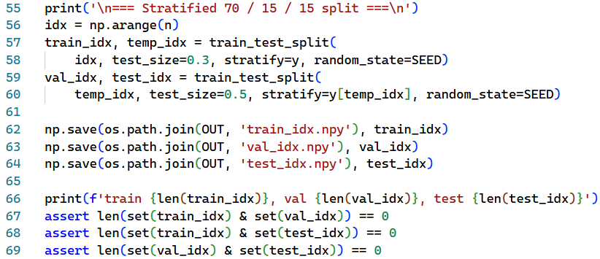
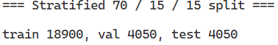
Screenshots 5, 6. cache.py: stratified 70/15/15 split with leakage checks.

Per-band normalization statistics from the training set
The raw reflectance values differ significantly in scale between bands, so each band needed to be standardized. The mean and standard deviation of each of the 13 bands were computed over the training images only in chunks of 2,000 images to limit memory use, by accumulating sums and sums of squares. Using only training images prevents information about the validation and test images from leaking into the model.
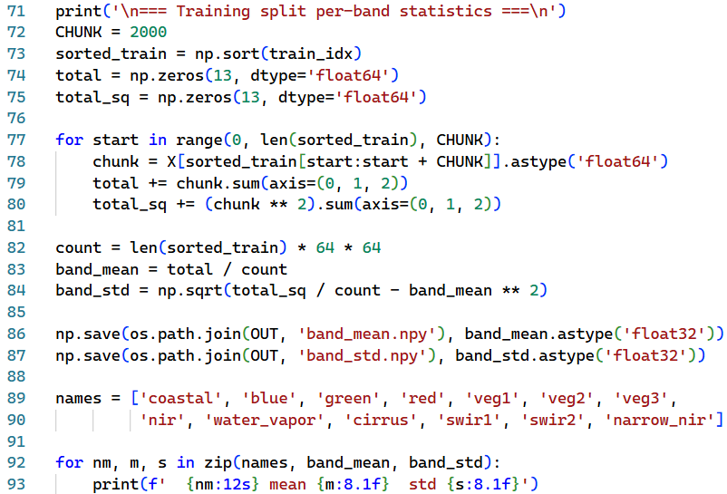
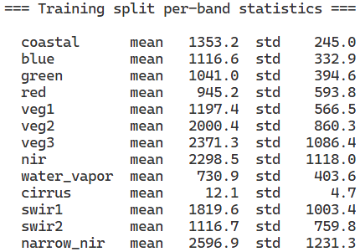
Screenshots 7, 8. cache.py: chunked per-band mean and standard deviation over the training split.

Band Selection
In train.py a command-line argument chooses the band set. The RGB configuration uses TIFF indices [3, 2, 1] (B04, B03, B02) and the multispectral configuration uses [1, 2, 3, 4, 5, 6, 7, 10, 11, 12] (B02-B08, B11, B12, B8A). The same index list is used to pick the matching entries of the saved mean and standard deviation arrays, so both model configurations use identical normalization for the bands they share.
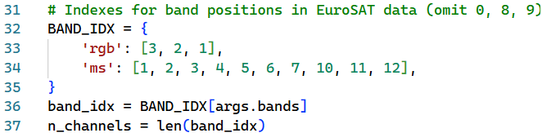
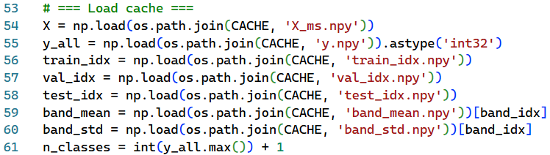
Screenshots 9, 10. train.py: band index selection and loading the cached arrays and statistics.

Standardization, augmentation, and batching
A Python generator wrapped in tf.data.Dataset.from_generator produces batches of 128 images. For each batch it selects the chosen bands, converts to float32, and standardizes each band with z = (x – mean) / std. Training batches are also augmented. Each image independently has a 50% chance of a horizontal flip, vertical flip, or transpose. Because satellite images have no natural up and down, these transformations create realistic new views of each image without changing its label. Validation and test batches are not shuffled or augmented. The random generator is seeded per run so that the shuffling and augmentation are reproducible

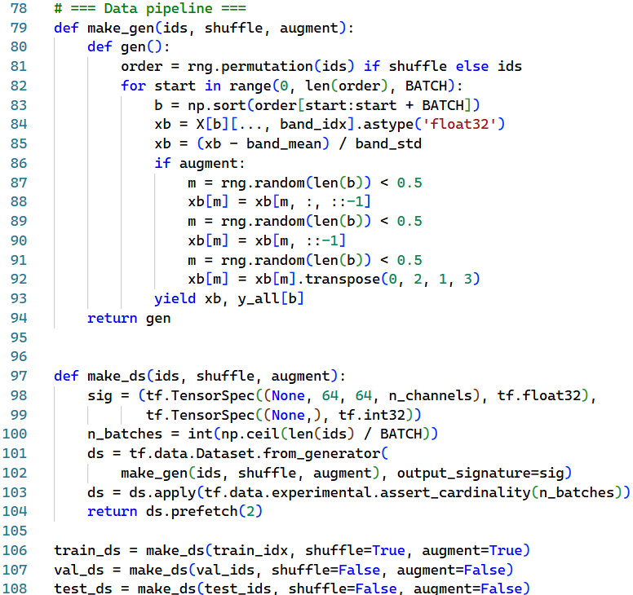
Screenshot 11. train.py: standardization, flip/transpose augmentation, and tf.data batching

Tools, Techniques, and Justification
Python was the language for the entire project because it includes libraries which cover every stage including reading the data, training neural networks, and running statistical tests within one language.
- Tifffile reads the multi-band GeoTIFFs directly into NumPy arrays. It was chosen because other libraries cannot read 13-band, 16-bit images, while tifffile handles them without extra geographic information system dependencies.
- NumPy held the full dataset as one uint16 array and was used to save and reload the cache (X_ms.npy), the split indices, and the band statistics, and to do band selection and standardization with array indexing.
- Scikit-learn produces the stratified split with train_test_split, which keeps the class proportions the same across training, validation, and test sets.
- TensorFlow and Keras streamed the prepared batches to the model and applied the same pipeline to both sets of bands.
The techniques used were caching, stratified splitting, training-only z-score standardization, band selection by index, and flip/transpose augmentation. Caching removed the repeated file reading. Stratification ensured the class balance was the same in every split, which matters when using a performance metric like macro F1-score which is class-averaged. Training-only standardization put all bands on a comparable scale without leaking test information. Augmentation reduces overfitting on a relatively small image set.
An advantage of this approach is that storing the extracted data as a single NumPy cache and selection bands by index meant that both model configurations were prepared exactly the same array, the same split, and the same normalization statistics. This is the exact controlled comparison that the research question requires. It also made each of the 20 training runs much quicker to run.
A disadvantage of this approach is that the entire 13-band dataset is loaded into memory as a 2.9 GB array. This takes up a large share of memory on a computer and would probably not be scalable to larger datasets such as entire Sentinel-2 scenes.

Analysis
The analysis had two stages. First, convolutional neural networks (CNNs) were trained under a repeated, paired design to produce the data being compared. Second, the resulting macro F1-scores were compared with statistical test, and per-class F1-scores and confusion matrices were examined to explain where the difference comes from.

Technique 1: Convolutional Neural Networks
Both model configurations use the same Keras architecture. First, there are three blocks of two 3 x 3 convolutional layers with 16, 32, and 64 filters respectively. Each convolutional layer slides learned 3 x 3 filters across the image and outputs feature maps showing how strongly each pattern (e.g. an edge or a texture) is present at each location. After batch normalization (Ioffe & Szegedy, 2015), these values go through a rectified linear unit (ReLU) activation function which helps with backpropagation and efficiency. Max pooling is applied after each block to find the strongest patterns and then global average pooling is applied. Lastly, there is a 30% dropout and a 10-class softmax output that outputs class probabilities.
These models were trained with Adam Optimizer (Kingma & Ba, 2015) and a learning rate of 0.001, sparse categorical cross-entropy loss, a maximum of 80 epochs, early stopping on validation loss with patience 10 and best weights restored, and a learning-rate halving schedule when validation loss stalled for 3 epochs. The only difference between the 10 RGB-based models and the 10 multispectral-based models is the input depth of 3 or 10 channels, which changes the first convolution layer alone. The RGB models have 73,402 parameters and the multispectral models have 74,410, a difference of 1,008 weights.
A single training run of one model of each configuration would confound the effect of the bands with random chance in weight initialization, batch order, and augmentation. I therefore trained 10 models for each configuration with random seeds (0-9), giving a total of 20 models. Each seed was used once for an RGB model and once for a multispectral model, and every model was evaluated on the same 4,050 test images. Macro F1-score was calculated with scikit-learn as the unweighted mean of the 10 per-class F1-scores, where F1 = 2 x precision x recall / (precision + recall).
I used CNNs because of their ability to learn spatial patterns such as road lines, field boundaries, and building texture directly from pixel values which is critical for LULC classification. They also accept any number of input channels, so the same network architecture can be used for 3 bands or 10 bands of data. Training from scratch rather than using a model with pre-trained weights was necessary because pre-trained networks expect three channels and would have given the RGB model an unfair head start.
An advantage of using a CNN with fixed architecture, training settings, and data is that any difference in performance can be attributed to the input bands, and repeating the experiment across 10 seeds turns a single comparison into a sample that can be tested statistically.
A disadvantage of CNN training is that it is computationally expensive. The 20 runs took about 5 hours of training time in total which limited the number of seeds and meant only one architecture could be tested.

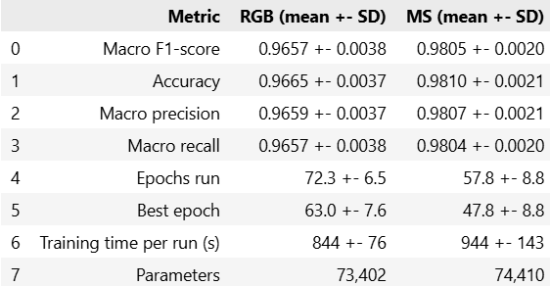
Table 3. Test set performance and training statistics across 10 seeds per model.
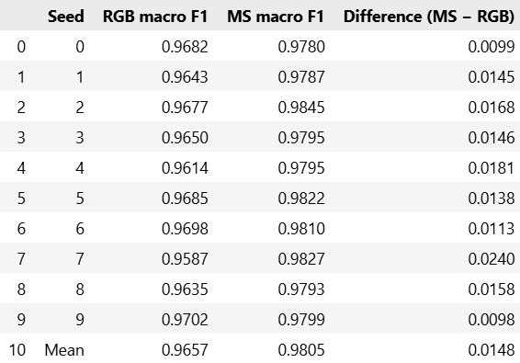
Table 4. Test macro F1-score for each paired run.
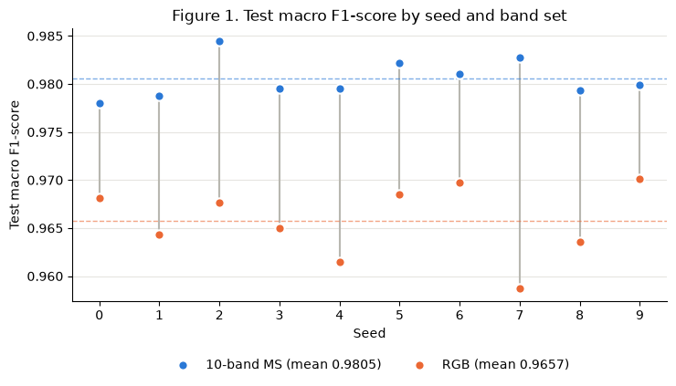
Figure 1 shows that the multispectral model scored higher than the RGB model for every one of the 10 seeds, and that the two groups do not overlap. The worst multispectral run (0.9780) is better than the best RGB run (0.9702). Figure 2 shows the training histories. The multispectral models reached a lower validation loss and higher validation accuracy and did so in fewer epochs.
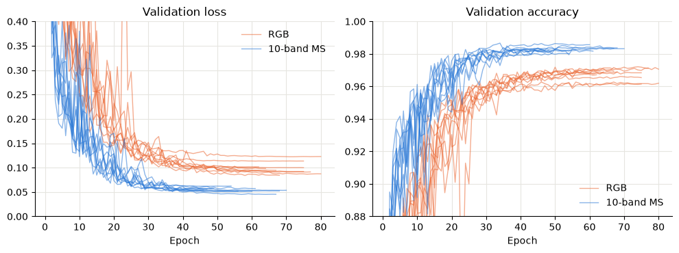Figure 2. Validation loss and training accuracy by run for MS and RGB

Technique 2: One-sided paired t-test
Because each seed produced one RGB and one multispectral model, the data are 10 matched pairs. The paired t-test tests whether the mean of the within-seed differences d = F1_{MS} – F1_{RGB} is greater than zero. Its assumption that the differences are approximately normal was checked with a Shapiro-Wilk (Shapiro & Wilk, 1965) test (W = 0.9245, p = 0.396), which gives no evidence against normality
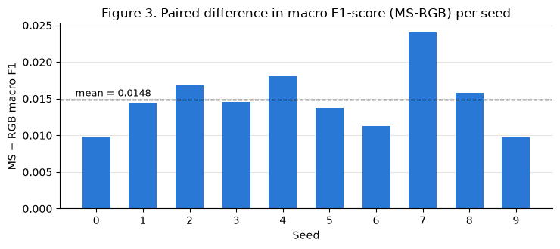
Calculations:
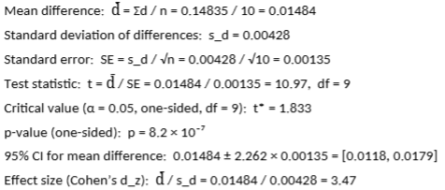
Since t = 10.97 far exceeds the critical value of 1.833 and p < 0.05, the null hypothesis is rejected. Cohen’s d_{z} of 3.47 is a very large effect meaning that the average improvement is about three and a half times the seed-to-seed variation in that improvement.
One-sided paired t-test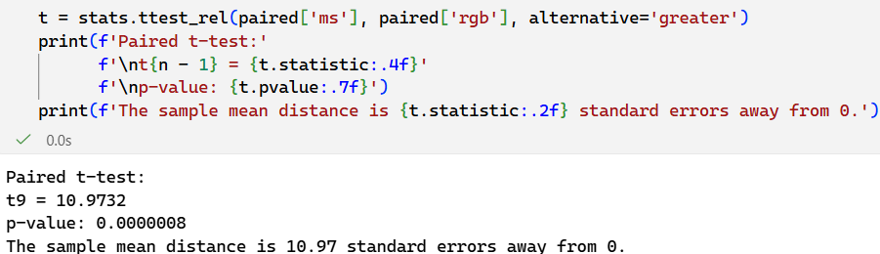
Shapiro-Wilk test for normal distribution of F1 differences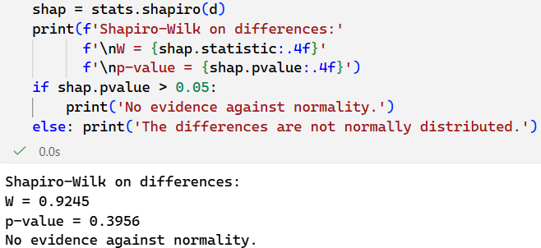
Cohen’s d_{z} test of standard difference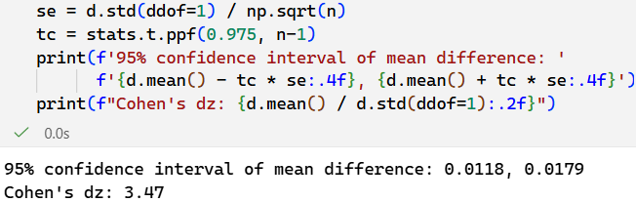
The paired t-test is the standard test for comparing two conditions measured on the same units, and it directly tests the one-sided hypothesis. It also produces a confidence interval, which answers the “to what extent” part of the research question.
An advantage of using the paired t-test is that it uses the actual size of every difference, which gives it heigh statistical power with a small sample, and it produces an interpretable effect estimate with a confidence interval in macro F1 units.
A disadvantage is that it relies on the differences being approximately normally distributed, which is hard to verify with only 10 pairs, since the Shapiro-Wilk test has little power at that sample size. In addition, the pairing here turned out to be weak. The RGB and MS scores for the same seed were essentially uncorrelated with r = 0.007, because a shared seed does not produce identical initial weights for networks with different input shapes. The paired test therefore gains little over an unpaired test in this study. A Welch two-sample t-test run as a check gave the same conclusion with t = 10.94 and p = 1.8 x 10⁻⁸.

Technique 3: Wilcox signed-rank test
To confirm that the results did not depend on the normality assumption, the Wilcoxon signed-rank test (Wilcoxon, 1945) was run on the same 10 pairs. It ranks the absolute differences and sums the ranks of the positive ones. All ten differences were positive, so the statistic is the sum of all ranks: W = 1 + 2 + … + 10 = 55. The exact one-sided p-value is ½¹⁰ = 0.00098, which is less than 0.05, so the null hypothesis is again rejected
Wilcoxon one-sided signed-rank test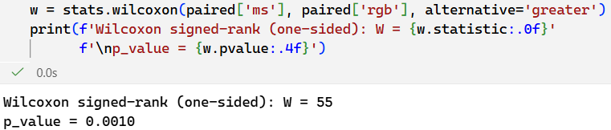
Justification: The Wilcoxon signed-rank test is the non-parametric counterpart of the paired t-test, so it is the appropriate check when the sample is too small to confirm normality.
Advantage: It makes no assumption about the distribution of the differences and is resistant to outliers, such as the unusually large difference at seed 7.
Disadvantage: It uses only the ranks of the differences, not their sizes, so it does not estimate how much better the multispectral model is. With n = 10 its smallest possible p-value is 0.00098, so it cannot show how strong the evidence is beyond showing that all 10 pairs favored the multispectral configuration.

Technique 4: Per-class F1-scores and confusion matrices
To explain where the improvement came from, the F1-score of each class was computed for every run and averaged over seeds (Screenshot 12), and confusion matrices were summed over the 10 runs of each model (Figure 4). For each class a two-sided paired t-test compared the 10 RGB and 10 MS F1-scores, and the p-values were adjusted for 10 comparisons with the Holm method (Holm, 1979) (Screenshot 13).
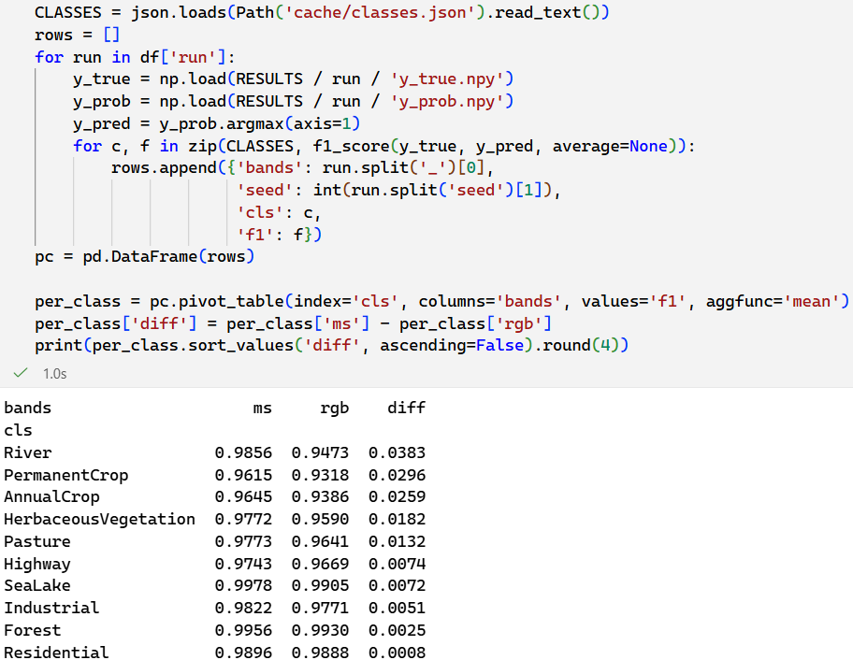
Screenshot 12. Code and output for per-class F1-score averages over seeds
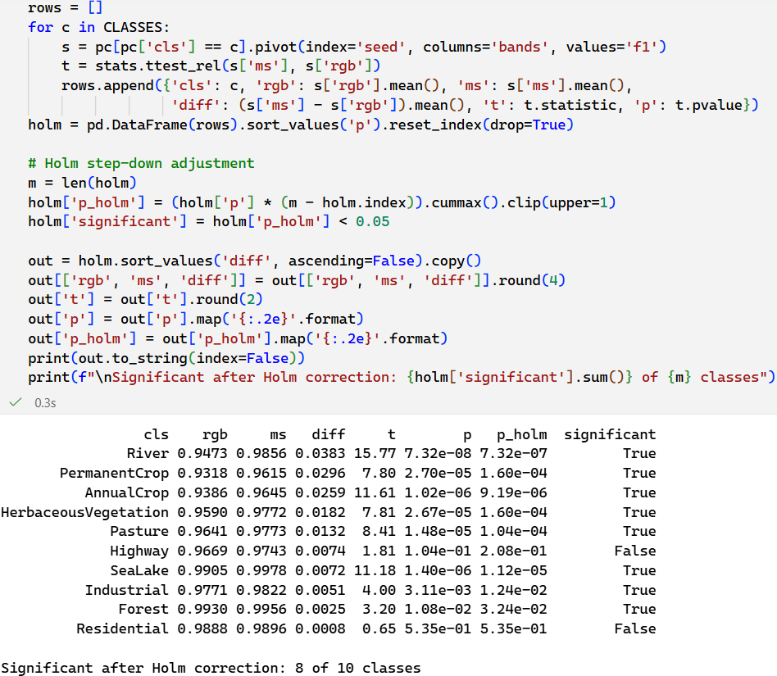Screenshot 13. Code and results for Holm test
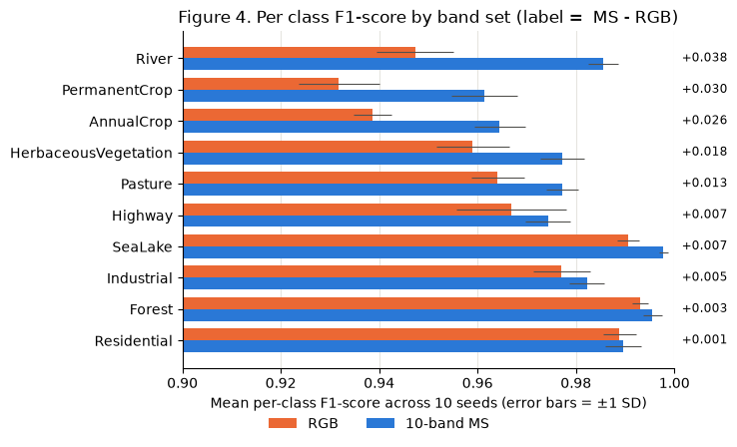

The multispectral model improved every class, and the improvement was statistically significant for 8 of the 10 classes (Screenshot 13). The largest gains were for River (+0.038) and the three agricultural classes, PermanentCrop (+0.030), AnnualCrop (+0.026), and HerbaceousVegitation (+0.018). The gains for the built-up classes Residential and Highway were small and not statistically significant. The confusion matrices (Figure 4) show the same pattern. Pooled over 10 runs, the RGB models made 1,355 errors (135.5 per run) and the multispectral models made 769 (76.9 per run), a 43% reduction. The RGB models’ most common mistakes were among crop and vegetation types. For example, PermanentCrop was predicted as HerbaceousVegetation 125 times, compared with only 49 times for the MS models and River was predicted as AnnualCrop 90 times, compared with only 10 times for the MS models.
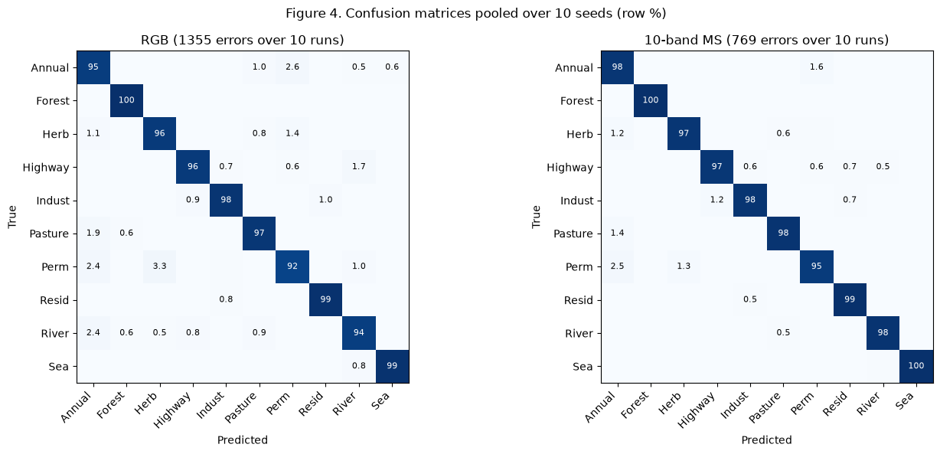
Justification: A single macro F1-score shows that the multispectral model is better but doesn’t show where it improves. Per-class scores and confusion matrices show which land-cover types benefit from the extra bands, which is needed to recommend when the extra bands are worth their cost.
Advantage: This breakdown connects the result to the physics of the bands and shows which specific classes, and class confusions, account for the overall improvement.
Disadvantage: Ten separate tests increase the chance of false positives, which the Holm correction controls but at the cost of some explanatory power. Per-class results are also based on only 300-450 test images per class, so small differences in the high-scoring classes (Forest, Residential) are within the range of random variation.

Data Summary and Implications

Results in the context of the research question
The research question was, “To what extent do convolutional neural networks trained on 10 Sentinel-2 spectral bands classify land use and land cover more accurately than those trained on RGB bands alone, according to macro F1-score?” Across 10 paired runs, the multispectral configuration reached a mean macro F1-score of 0.9805 compared with 0.9657 for the RGB configuration, a mean improvement of 0.0148 with a 95% confidence interval of 0.0118 to 0.0179). The one-sided paired t-test (t(9) = 10.97, p < 0.001) and the Wilcoxon signed-rank test (W = 55, p = 0.001) both reject the null hypothesis, so the alternative hypothesis is supported: the 10-band CNN configuration achieves a higher macro-F1 score than the 3 RGB band configuration.
Although 1.5 percentage points sounds small because both models are already relatively high-performing, it removes about 43% of the RGB models’ errors. The multispectral model was also more consistent between seeds with a standard deviation of 0.0020 vs 0.0038 and converged in fewer epochs. Both models exceed the expected 0.80 threshold, and the multispectral model performed better on accuracy, precision, and recall as well, as predicted at the beginning of the research. The gain is concentrated in vegetation, crop, and water classes, where red-edge, near infrared, and short-wave infrared bands measure plant health and moisture content that visible light cannot and is negligible for built-up classes which are already explained very well by their shapes in RGB bands.

Limitations
All models were evaluated on a single random 70/15/15 split of one dataset, with one small CNN trained from scratch. The 10 seeds capture variation due to training randomness, but not variation due to which images ended up in the test set, and EuroSAT’s patches are clean, cloud-free, European-only examples. Because the split was random rather than geographic, nearby patches from the same area can appear in both training and test sets, which likely raises the absolute scores of both model configurations. The size of the improvement may therefore be different for other regions or cloudy scenes. In addition, two RGB runs (seeds 4 and 9) reached the 80-epoch hyperparameter limit before early stopping was triggered. However, the best of all RGB runs (seed 9 with an F1-score of 0.9702) still performed more poorly than the worst multispectral run (0.9780), so this does not change the conclusion of the analysis.

Recommended Course of Action
Governments and NGOs building Sentinel-2 land usage and land cover classifiers should use the 10 non-atmospheric bands (B02-B08, B8A, B11, B12) rather than RGB alone, especially where the map is used for agriculture, crop-type monitoring, vegetation, or water and river mapping, where the gains were largest. The cost is modest: the model grew by only 1,008 parameters so latency in model deployment shouldn’t suffer significantly, and the training took about 12% longer per run (each epoch took about 40% longer but this was offset by faster convergence and early-stopping). Sentinel-2 multispectral data is openly available through the Copernicus program (Helber et al., 2018a), so the main added cost is roughly 3.3 times the storage per image. For applications that only map built up areas such as residential, industrial, or highway, RGB models perform nearly as well and may be sufficient.

Direction for Future Study
Band importance: Train additional models on subsets of the bands, such as RGB + NIR, RGB + SWIR, and RGB + red-edges to find which bands are most responsible for the improvement. If most of the gain came from one or two bands, a smaller input count achieves nearly the same accuracy with less storage and computation. Explainability methods such as per-band permutation importance could support this analysis.
Geographic generalization and larger architectures: Repeat the comparison with a spatially blocked or country-held-out split and with larger networks such as ResNet adapted to 10-channel input. This would show whether the multispectral advantage holds for regions and model sizes beyond this study, and whether it grows or shrinks when the RGB model can use more capacity or ImageNet pretraining.

References
Helber, P. (n.d.). EuroSAT: Land use and land cover classification with Sentinel-2 [GitHub repository]. https://github.com/phelber/EuroSAT
Helber, P., Bischke, B., Dengel, A., & Borth, D. (2018a). EuroSAT: A novel dataset and deep learning benchmark for land use and land cover classification (Version 1) [Data set]. Zenodo. https://doi.org/10.5281/zenodo.7711097
Helber, P., Bischke, B., Dengel, A., & Borth, D. (2018b). Introducing EuroSAT: A novel dataset and deep learning benchmark for land use and land cover classification. IGARSS 2018 – 2018 IEEE International Geoscience and Remote Sensing Symposium, 204–207. https://doi.org/10.1109/IGARSS.2018.8519248
Helber, P., Bischke, B., Dengel, A., & Borth, D. (2019). EuroSAT: A novel dataset and deep learning benchmark for land use and land cover classification. IEEE Journal of Selected Topics in Applied Earth Observations and Remote Sensing, 12(7), 2217–2226. https://doi.org/10.1109/JSTARS.2019.2918242

