**Project Milestone 1: Color Sensor**

**By: Nathan Price**

Fall 2022 MRE 320 Sensors and Actuators

**Summary of Findings**

Color sensors are sensors that are meant to find the color of objects and surfaces. Color sensors work by having the LED’s on the sensor itself produce a white light onto a nearby surface. From there following the principle that white light is made up by equal parts of the primary colors, red, blue, and yellow, and that any given object’s color is perceived as such due to the rest of the colors in light being absorbed by the object, only reflecting the color we see on the object. Once the white light is shined on the object the color of the object will be reflected back onto the sensor, where it can break down how much of the primary colors its receiving which could allow it to determine what color it is being presented with.

**Hardware**

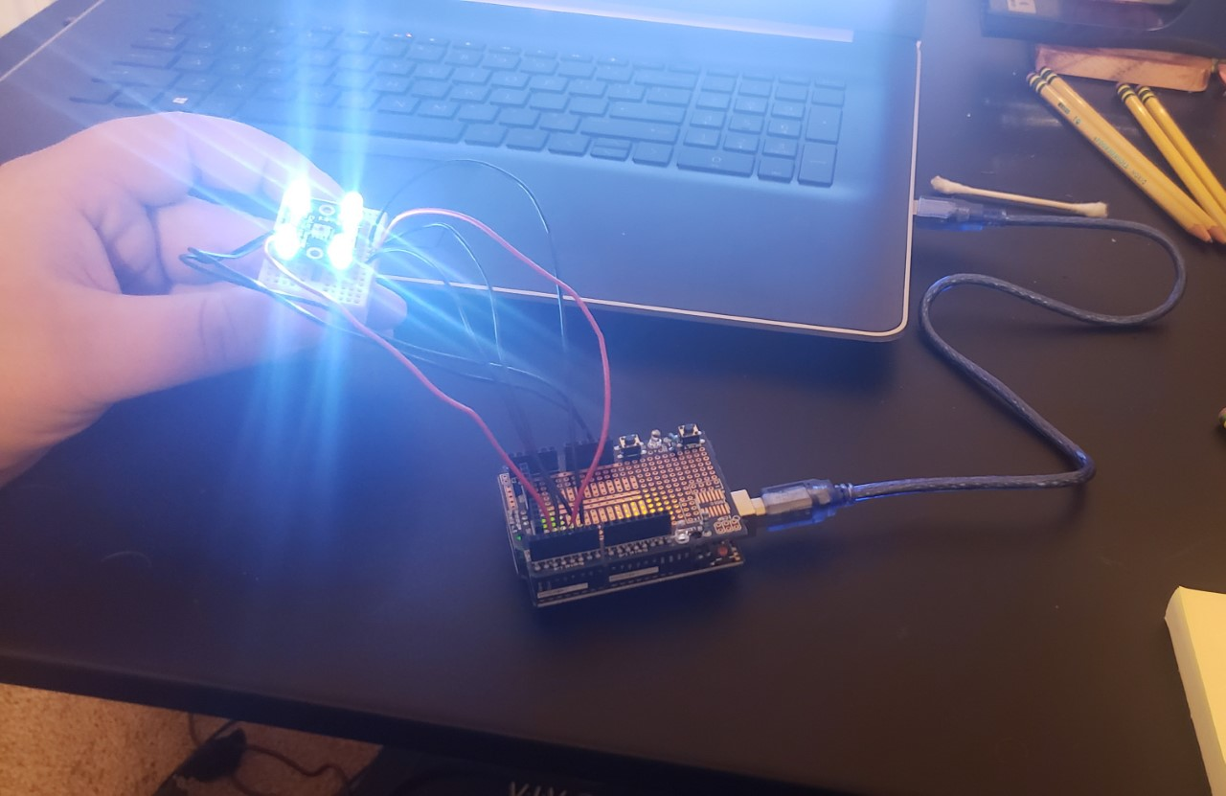

**Arduino Code**

#include <TimerOne.h>

#define S0     6

#define S1    5

#define S2     4

#define S3     3

#define OUT    2

int   g_count = 0;

int   g_array[3];

int   g_flag = 0;

float g_SF[3];

void TSC_Init()

{

   pinMode(S0, OUTPUT);

   pinMode(S1, OUTPUT);

   pinMode(S2, OUTPUT);

   pinMode(S3, OUTPUT);

   pinMode(OUT, INPUT);

   digitalWrite(S0, LOW);

  digitalWrite(S1, HIGH);

}

void TSC_FilterColor(int Level01, int Level02)

{

   if(Level01 != 0)

     Level01 = HIGH;

   if(Level02 != 0)

     Level02 = HIGH;

   digitalWrite(S2, Level01);

   digitalWrite(S3, Level02);

}

void TSC_Count()

{

   g_count ++ ;

}

void TSC_Callback()

{

   switch(g_flag)

   {

     case 0:

          Serial.println("->WB Start");

          TSC_WB(LOW, LOW);

          break;

     case 1:

          Serial.print("->Frequency R=");

          Serial.println(g_count);

          g_array[0] = g_count;

          TSC_WB(HIGH, HIGH);

          break;

     case 2:

          Serial.print("->Frequency G=");

          Serial.println(g_count);

          g_array[1] = g_count;

          TSC_WB(LOW, HIGH);

          break;

     case 3:

          Serial.print("->Frequency B=");

          Serial.println(g_count);

          Serial.println("->WB End");

          g_array[2] = g_count;

          TSC_WB(HIGH, LOW);

          break;

    default:

          g_count = 0;

          break;

   }

}

void TSC_WB(int Level0, int Level1)

{

   g_count = 0;

   g_flag ++;

   TSC_FilterColor(Level0, Level1);

   Timer1.setPeriod(1000000);

}

void setup()

{

   TSC_Init();

   Serial.begin(9600);

   Timer1.initialize();

   Timer1.attachInterrupt(TSC_Callback);

   attachInterrupt(0, TSC_Count, RISING);

   delay(4000);

   for(int i=0; i<3; i++)

     Serial.println(g_array[i]);

   g_SF[0] = 255.0/ g_array[0];

   g_SF[1] = 255.0/ g_array[1];

   g_SF[2] = 255.0/ g_array[2];

   Serial.println(g_SF[0]);

   Serial.println(g_SF[1]);

   Serial.println(g_SF[2]);

}

void loop()

{

    g_flag = 0;

    for(int i=0; i<3; i++)

     Serial.println(int(g_array[i] * g_SF[i]));

    delay(4000);

}

**Example of Sensor Readings**

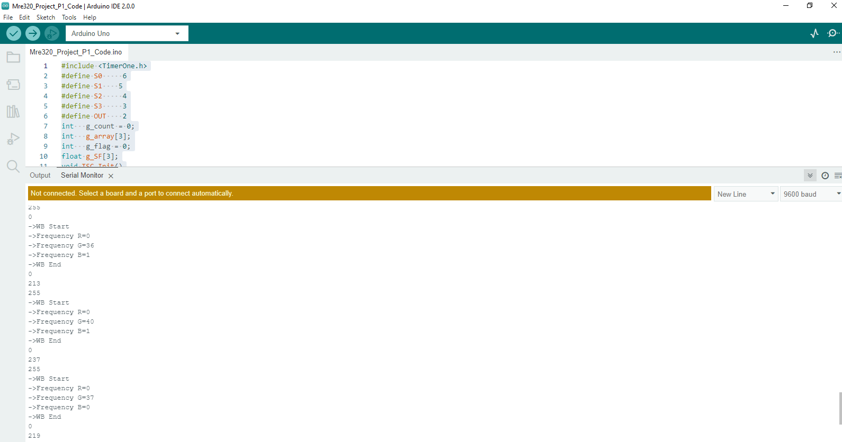

**Important Static Characteristics and Testing Plans**

**Repeatability**

For the color sensor it makes sense to me that repeatability would be rather important, so I plan to set up a point where I can have the sensor look at a certain color item, perhaps a colored sticky note on the wall, or some other piece of colored paper, then switch it to a different colored item and then perhaps a third. Then back to the initial item and repeat the cycle a number of times and use the output results to determine how accurate the results for each item are and therefore understand how repeatable the sensor is.

**Accuracy**

Accuracy is also rather important given this sensor, so to measure that I plan on printing out a number of colored sheets of paper of a known composition of the primary colors and use the sensor on all of them to determine how far off any given reading might be for the color sensor.

**Drift**

To calculate drift I plan on setting the sensor down in a manner where it shall look upon the same spot containing a colored item, most likely one used in a previous test, and should just sit there. Once it is in position I plan on letting it sit there for several data collection cycles to see how far if at all the output data changes over time.

**Range**

To calculate range I will use the principle of color theory that the color sensor works with and take a blank white sheet of paper and a black sheet of paper and the outputs of these should give an outline to the range of this sensor.

**Precision**

With the previously gathered data I should be able to find the average standard deviation between the repeated data points, which in turn with the accuracy of the sensor, should be a reliable way to gauge the precision of the sensor.