**Predicting Mild Steel Tempering Process**

**Executive summary**

This project aims to enhance the understanding of mild steel tempering through predictive modeling, ultimately aiding in the optimization of heat treatment processes in engineering applications. This will reduce the need for manual consultation of large tempering tables, and will allow for improved engineering workflow.

**Context**

Tempering of steel is an important process in engineering. It ensures that the steel is homogeneous and has no internal stresses that may cause it to behave unexpectedly. One examples of when tempering is important is after welding. The heat involved in welding can significantly change the properties of the surrounding metal, making the joint weaker. Tempering the steel undoes this previous heat treatment and can return the heat affected zone back to full strength. More broadly, tempering is one of several heat treatments that can transform a general use metal to be better suited for specific applications, and undo internal stresses accumulated through manufacturing processes like bending and rolling.

**Objectives**

* **Data Processing:** Cleaning data and ensuring it’s all in the correct data types
* **Data Augmentation:** Scrape additional properties from AzoM.com to augment the Raiipa Dataset. Associate this suite of physical properties to reach metal.
* **ML Data Processing:** Scale the data so it is appropriate for using in ML processes. Use PCA modeling to ensure the data is not biased by the multicollinearity, that will certainly be present after the addition of physical properties to each metal.

**Model and bin tempering results:** Use classification modeling to determine if there are meaningful alloy composition and heat treatment categories. Bin by resulting hardness.

**Model and predict tempering hardness:** Use modeling to predict the tempering process that would result in a specific hardness of a given steel.

**Real World Testing:** Use this model to predict the tempering process for a given alloy that has a specific hardness. Example: Predict what kind of heat treatment would be required to return ASTM X80 mild pipeline steel to the non-welded hardness.

**If time allows:**

**Deployment:** Build a web app that takes in an AISI 10xx steel grade and a desired hardness, then searches for the properties of that steel, and models what tempering process would be required to meet the desired hardness.

**Methodology**

1. Clean the data
2. Determine what steels can have additional information gathered on them
3. Scrape AZoM.com for the searchable steel
4. Run categorization models to determine if there is elemental-temperature-temping_result classifications
   1. With and without PCA
   2. Unsupervised Baseline: BIRCH, with elbow and silhouette
   3. Supervised: Random Forest – Chosen to be able to indicate feature importance
   4. Compare and contrast supervised vs unsupervised result
   5. Test sequential NN if time allows
5. Use regression modeling to predict hardness of steels that underwent a tempering process
6. With and without PCA
   1. Linear Regression model as baseline
   2. Sequential NN model for improvement
7. Compare models for the two applications

**Data Sources**

* [Raiipa Tempering data for carbon and low alloy steels](https://www.kaggle.com/datasets/rgerschtzsauer/tempering-data-for-carbon-and-low-alloy-steels) - 36 steels for 1467 rows. 31 of these steels (1201 rows) are easily searchable for additional properties
* [AzoM.com/](https://www.azom.com/) - Comprehensive and easily searchable pages for AISI mild steels. AISI 10xx series are present in the Raiipa dataset
* [Tempering microstructure and mechanical 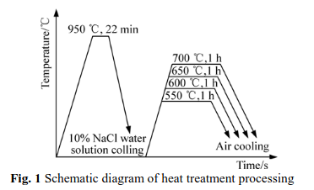properties of pipeline steel X80](https://www.sciencedirect.com/science/article/abs/pii/S1003632610601112) - “X80 steel temped at 650C obtains good match of strength and toughness”
  + HV in table 2 is Vicker’s h[sardness, which can be converted to the HRC hardness present in the Raiipa data

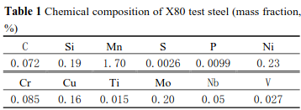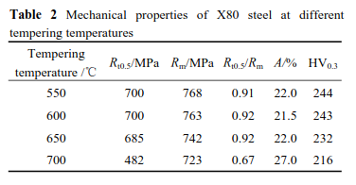

**Tools used**

Polars

Vega-Altair

Tensorflow/Keras

**By – Nathan Sheibley**

### Project start date: 09/18/2024

### Project due date: 10/17/2024