

INDUSTRY PROJECT | INTEGRATED RETAIL SALES PERFORMANCE TRACKING AND ANALYSIS
S. Y. B. Sc. Computer Science
Project-1
INDUSTRY PROJECT

By
Blessed Mazambani (31242242)

2025-2026 (Term II)

Pursued in
Department of Computer Science
Faculty of Science & Technology
Vishwakarma University, Pune
INTODUCTION
In the highly competitive retail industry, businesses face the constant challenge of monitoring sales performance across multiple channels and locations while keeping up with evolving market trends. Accurate and timely insights into sales data are critical for driving business decisions, optimizing operations, and meeting customer expectations. However, many organizations struggle with fragmented data systems, inconsistent reporting formats, and the inability to gain actionable insights from their data.

1. Project Objectives and Goals
The primary objective of this project is to design and implement a Retail Sales Performance Monitoring System that provides meaningful insights into sales data and supports data-driven decision-making.
- Key Goals:
- Analyze historical sales data to identify trends and patterns
- Evaluate product performance based on revenue and profitability
- Perform regional analysis to compare sales across different countries
- Forecast future sales using machine learning models
- Develop an interactive dashboard for real-time visualization using Power BI

2. Approach and Logic Flow
Python code:
import pandas as pd
import numpy as np
import matplotlib.pyplot as plt
from sklearn.linear_model import LinearRegression

# Load dataset
df = pd.read_excel("C:\\Users\\HP\\Downloads\\Kevin Cookie Company Financials.xlsx", sheet_name="Cookie Sales")

# Convert date column
df['Date'] = pd.to_datetime(df['Date'])

# Check missing values
print("Missing Values:\n", df.isnull().sum())

# =========================
# 🔹 FEATURE ENGINEERING
# =========================

# Monthly sales aggregation (IMPORTANT for ML)
monthly_sales = df.groupby(['Year', 'Month Number'])['Revenue'].sum().reset_index()

# Create proper date column for monthly data
monthly_sales['Date'] = pd.to_datetime(monthly_sales['Year'].astype(str) + '-' + monthly_sales['Month Number'].astype(str) + '-01')

# Country-wise sales
country_sales = df.groupby('Country').agg({
'Revenue': 'sum',
'Profit': 'sum'
}).reset_index()

# Product performance
product_sales = df.groupby('Product').agg({
'Revenue': 'sum',
'Profit': 'sum',
'Units Sold': 'sum'
}).reset_index()

# Profit Margin
df['Profit Margin'] = df['Profit'] / df['Revenue']

# =========================
# 🔹 VISUALIZATION
# =========================

plt.figure()
plt.plot(monthly_sales['Date'], monthly_sales['Revenue'])
plt.title("Monthly Sales Trend")
plt.xlabel("Date")
plt.ylabel("Revenue")
plt.xticks(rotation=45)
plt.show()

# =========================
# 🔹 PREDICTIVE ANALYTICS
# =========================

# Convert date to numeric
monthly_sales['Date_ordinal'] = monthly_sales['Date'].map(pd.Timestamp.toordinal)

X = monthly_sales[['Date_ordinal']]
y = monthly_sales['Revenue']

model = LinearRegression()
model.fit(X, y)

# Predict next 6 months
future_dates = pd.date_range(
start=monthly_sales['Date'].max() + pd.offsets.MonthEnd(1),
periods=6,
freq='ME'
)
future_ordinal = future_dates.map(pd.Timestamp.toordinal).values.reshape(-1,1)

predictions = model.predict(future_ordinal)

# Create prediction DataFrame
forecast_df = pd.DataFrame({
'Date': future_dates,
'Predicted Revenue': predictions
})

# =========================
# 🔹 EXPORT DATA FOR DASHBOARD
# =========================

monthly_sales.to_csv("monthly_sales.csv", index=False)
country_sales.to_csv("country_sales.csv", index=False)
product_sales.to_csv("product_sales.csv", index=False)
forecast_df.to_csv("forecast_sales.csv", index=False)

print(" Data exported successfully!")

Step 1: Data Collection and Preprocessing
The dataset was loaded from an Excel file using Python (pandas). Data cleaning steps included converting date columns into proper datetime format and checking for missing values. Feature engineering was performed to create monthly aggregated sales, country-wise revenue and profit, and product-wise performance metrics.

Step 2: Data Analysis
Data was grouped and aggregated to extract insights such as total revenue by country, profit by product, and monthly sales trends. Additional metrics such as Profit Margin were calculated.

Step 3: Predictive Analytics
Machine learning models were implemented to forecast future sales trends. Linear Regression was used as a baseline model, while Random Forest was used as an advanced model to capture non-linear relationships in the data.

Step 4: Dashboard Creation
An interactive dashboard was developed using Power BI, including pages for Sales Overview, Regional Analysis, Product Performance, and Sales Forecasting.

First Insight (Sales Overview Dashboard)
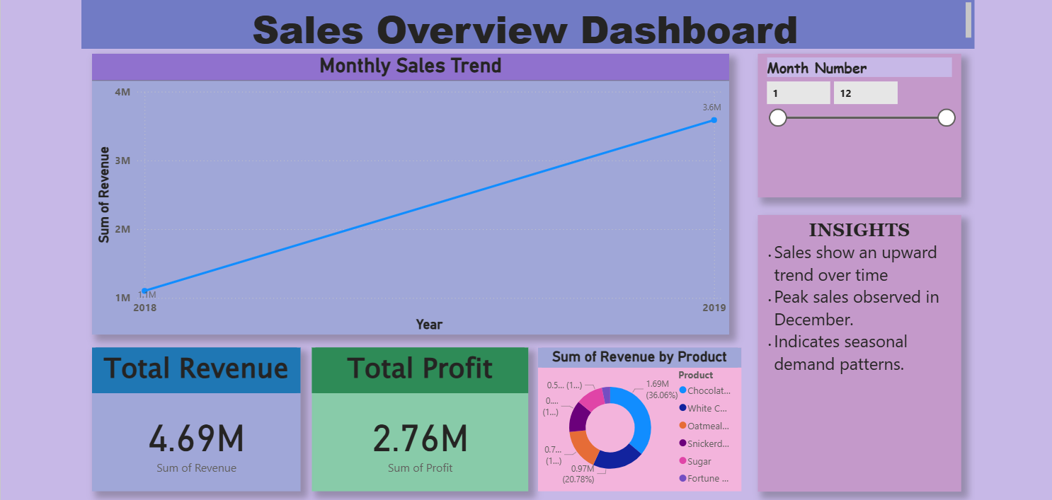

Second Insight (Regional Sales Analysis)
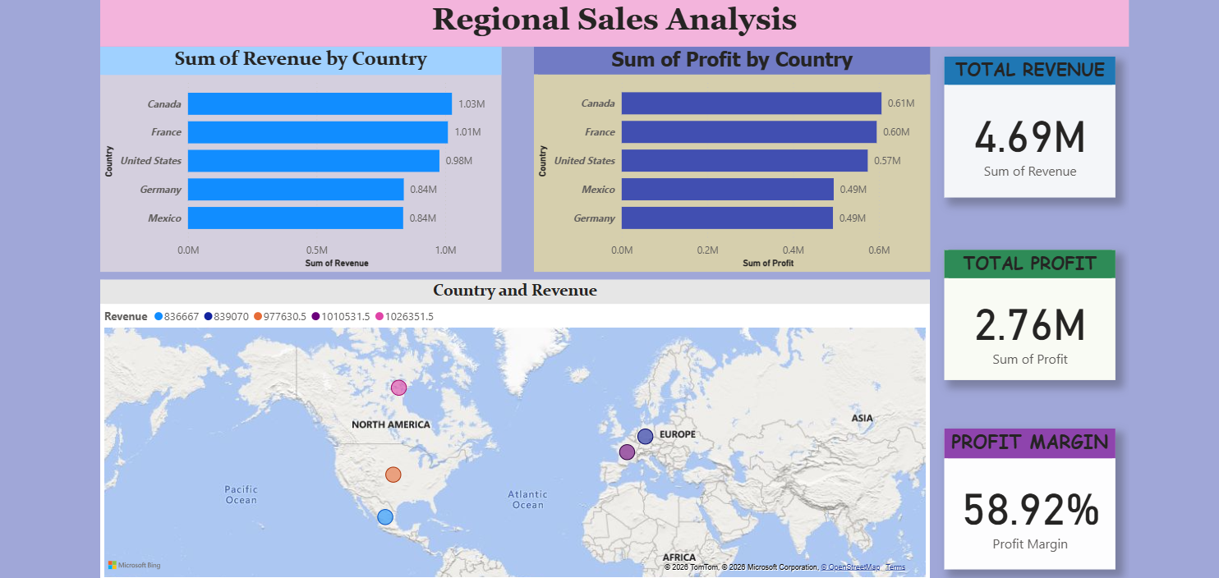

Third Insight (Product Performance Analysis)
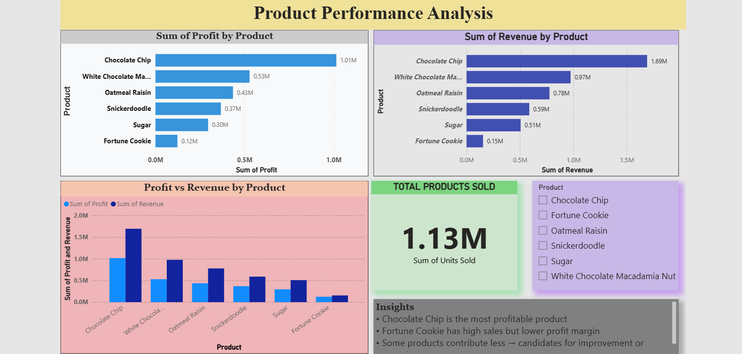

Final Insight (Sales Forecasting and Trend Analysis)
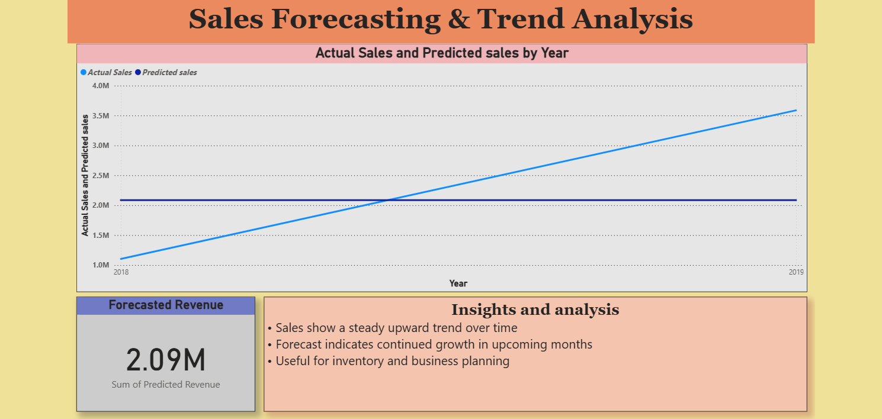

Step 5: Deployment
The dashboard was deployed using Power BI Service, allowing users to interact with and explore the data.

3. Key Findings and Insights
- Sales show a consistent trend over time
- Certain countries contribute significantly more revenue
- Some products generate higher profit margins
- Forecasting indicates continued sales trends

4. Suggested Enhancements / Future Scope
- Integrate real-time data sources
- Use advanced time series models such as ARIMA
- Implement customer segmentation using clustering techniques
- Add customer-level analysis such as Customer Lifetime Value (CLV)
- Deploy the system on cloud platforms

Conclusion
This project demonstrates how data analytics and machine learning can be used to analyze retail sales performance and generate actionable insights. The integration of predictive models and interactive dashboards provides a powerful tool for business decision-making.

