ErieGarbage Online

Project Analysis and Development Plan

Version 1.1

SWENG 497

|  |  |
| --- | --- |
| **Name** | **Student ID** |
| **Jake Wheeler** | **jlw5970** |
| **Nate Christiansen** | **ncc5136** |
| **Alex Lee** | **asl5253** |
|  |  |
|  |  |

Revision History

|  |  |  |  |
| --- | --- | --- | --- |
| **Date** | **Version** | **Description** | **Author** |
| 10/7/2016 | 1.0 | Meeting with customer (teacher) for more information.  Initial document edits to all sections.  Initial use case diagram | Jake |
| 10/7/2016 | 1.0 | Meeting with customer (teacher) for more information. | Nate |
| 10/7/2016 | 1.0 | Meeting with customer (teacher) for more information. | Alex |
| 10/8/2016 | 1.0 | Add to document, add many user use cases, and update use case diagram | Nate |
| 10/9/2016 | 1.0 | First draft of user sequence diagrams. | Jake |
| 10/11/2016 | 1.0 | Add more use cases. | Jake |
| 10/12/2016 | 1.0 | Add more use cases. | Jake |
| 10/12/2016 | 1.0 | Added some admin sequence diagrams. | Nate |
| 10/13/2016 | 1.0 | Added more admin sequence diagrams | Nate |
| 10/14/2016 | 1.0 | Finished admin sequence diagrams | Nate |
| 10/14/2016 | 1.0 | More use cases | Jake |
| 10/15/2016 | 1.0 | Use case diagram, added V’s to sequence diagrams | Jake |
| 10/18/2016 | 1.0 | Prepare to submit version 1.0 | Jake |
| 10/22/2016 | 1.1 | Update admin and login sequence diagrams | Jake |
| 10/22/2016 | 1.1 | Update some use cases to include security and better steps | Nate |
| 10/23/2016 | 1.1 | Update customer sequence diagrams | Jake |
| 10/23/2016 | 1.1 | Add use case diagrams into the document, edit text portion of the document | Jake |
| 10/23/2016 | 1.1 | Update more use cases | Nate |
| 10/23/2016 | 1.1 | Update last of use cases | Nate |
| 10/23/16 | 1.1 | Company logo | Alex |
| 10/24/2016 | 1.1 | Fix message admin sequence diagram and add it to document | Jake |
| 10/24/2016 | 1.1 | Add sequence diagrams in order. Add descriptions to use cases | Nate |

Table of Contents

1. Introduction

1.1 Purpose

1.2 Scope

1.3 Definitions, Acronyms, and Abbreviations

1.4 References

1.5 Overview

2. Problem description

2.1 Project Purpose, Scope, and Objectives

2.1.1 User interfaces

2.2 Product Functions

2.3 User Description

2.3.1 User Environment

2.3.2 User Profiles

2.4 Assumptions and Dependencies

2.5 Constraints

2.6 Specific Requirements

2.6.1 Applicable Standards

2.6.2 System Requirements

2.6.3 Performance Requirements

2.6.4 Environmental Requirements

2.7 Analysis model

3. Team Members Log Sheets

3.1 Jake Wheeler

3.2 Nate Christiansen

3.3 Alex Lee

Project Analysis and Development Plan

# Introduction

ErieGarbage is a garbage pickup and disposal proprietorship located in Erie, PA. ErieGarbage is currently serving around 3,000 customers in total. They provide garbage collections services to both residential customers and small businesses in Erie County. ErieGarbage requires an online system to help support its growing number of customers in the Erie area.

## Purpose

The purpose of this document is to define the requirements and the specifications of the ErieGarbage Online system in terms of its behavior and operation in accordance to the customer’s requirements. It ensures that all parties involved in the development process of ErieGarbage Online are aware of the issues surrounding the system and the proposed solution. The client has stated that they are strongly focused on the confidentiality of their customers and the integrity of their online system. They request an emphasis on security and expect it to be built into the program.

## Scope

The scope of this project includes admin and customer functionality within the application. The focus of this application will be on giving the customers a good experience, meaning they are able to create an account and perform actions using that account. It will also focus on giving admins a similar experience; the ability to modify some customer data, make adjustments to customer billing, and other functionalities. Some admin and customer functionality may be shared, and the system should account for this.

## Definitions, Acronyms, and Abbreviations

SRS – Software Requirements Specifications

EGO – ErieGarbage Online

GUI – Graphical User Interface

Customer – Person using the system that cannot use admin functionality

Admin – Person using the system with access to all admin functionality, and some customer functionality

## References

Secure Software Design – Author(s): Theodor Richardson & Charles Thies – 2013

Software Quality Assurance – Authors(s): Daniel Galin - 2004

## Overview

Section 2

This section describes the problem, product functionality, a user description, assumptions and dependencies, constraints, specific requirements, and analysis model.

Section 3

This section lists the team members and each of their purposes in regards to the project.

# Problem description

## Project Purpose, Scope, and Objectives

The purpose of this project is to create a web-based application to allow ErieGarbage to easily monitor and assist their customers, record customer and admin actions in a database, and allow customers an easy way to view and modify information that relates to them.

### User interfaces

The user interface of EGO will consist of multiple parts:

* Main login page
* Customer view
* Admin view

## Product Functions

ErieGarbage has specified a number of required features in EGO. Some of these functionalities are used only by customers, only by admins, or can be used by either a customer or an admin. This section will also specify system functionalities that are handled solely by the software system.

The following functionalities are used by admins only:

* Sending emails to customers
* Checking customer accounts that have payments due
* Viewing and responding to customer messages which have the following types:
  + Responding to customer complaints
  + Responding to customer bill disputes
  + Granting service suspension requests
* Creating new administrator accounts

The following functionalities are used by customers only:

* Make payments for the service
* Messaging an admin with one of the following types of messages:
  + Filing a complaint
  + Requesting service suspension
  + Disputing a specified bill
* Cancelling their own account

The following functionalities are used by both customers and admins:

* Viewing garbage collection pick up time
  + Customer: view their own pick up time
  + Admin: view a specific customer’s pick up time
* Viewing account information
  + Customer: view their own account information
  + Admin: view a specific user’s account information
* Updating account information
  + Customer: update their own account information
  + Admin: update a specific customer’s account information
* Logging in to the ErieGarbage Online system
* Updating billing information
  + Customer: update their own billing information
  + Admin: update a specific customer’s billing information

The following functionalities are used by only the system and are required by ErieGarbage:

* Sending automated receipts to customers

## User Description

### User Environment

The client has stated that this software will be web-based, meaning that users will be able to access the system from their browser of choice. The system will be scalable to allow for thousands of users to use the service concurrently.

### User Profiles

The user will need a basic knowledge of using their preferred operation system (Windows, Mac, Linux). Since this is a web-based application, there are no operating system dependencies.

## Assumptions and Dependencies

It is assumed that this software will be in constant use by thousands of customers and many admins. It is also assumed that customers will have a basic understanding of web applications to understand how to use the product. Dependencies include the hardware specifications of the server hosting the database and application

## Constraints

System constraints include:

* The system is web-based and can be accessed from a browser
* User friendly interface
* Admin should be proficient with the system in two hours of training or less
* Customers should be able to use the system without training
* Hints and help should be provided to the user

## Specific Requirements

### Applicable Standards

The client has specified that security is of great importance regarding this project. The client has stated that security should be built into the system through the development process.

### System Requirements

The client system should be a laptop or desktop computer with a web browser installed.

### Performance Requirements

None specified.

### Environmental Requirements

Invalid operations will generate an error message to let the user know that something has gone wrong with the system. These error messages will be displayed to the user so that input can be taken again. Major modifications of EGO will be done by the development team at SecQuality Development.

## Analysis model

[UML diagrams: use-case diagrams, class diagrams and sequence diagrams.]

**Use Case Diagrams:**

The following use case diagram details all of the customer only features provided by ErieGarbage Online. It describes the actors that will be involved in each use case, and the steps taken to prevent attacks on the system.

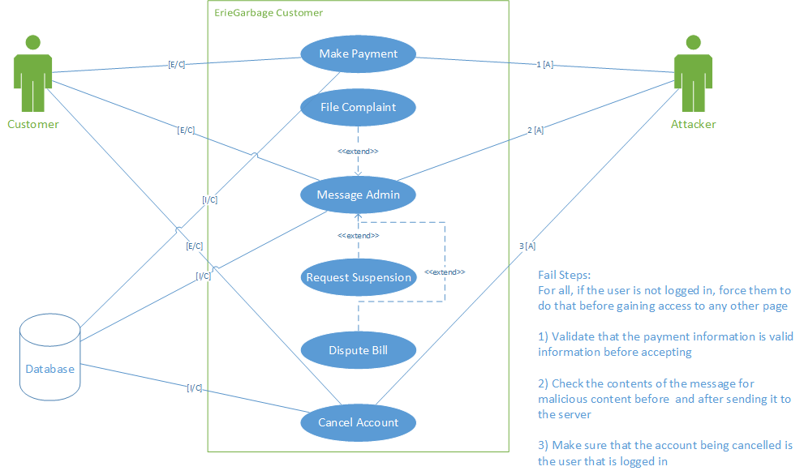

**Customer only use case diagram**

The next use case diagram details the admin only features that ErieGarbage Online provides. The admins perform administration tasks and manage interactions with users. The different functions are all centered around managing users. The steps taken to prevent malicious actions are also shown.

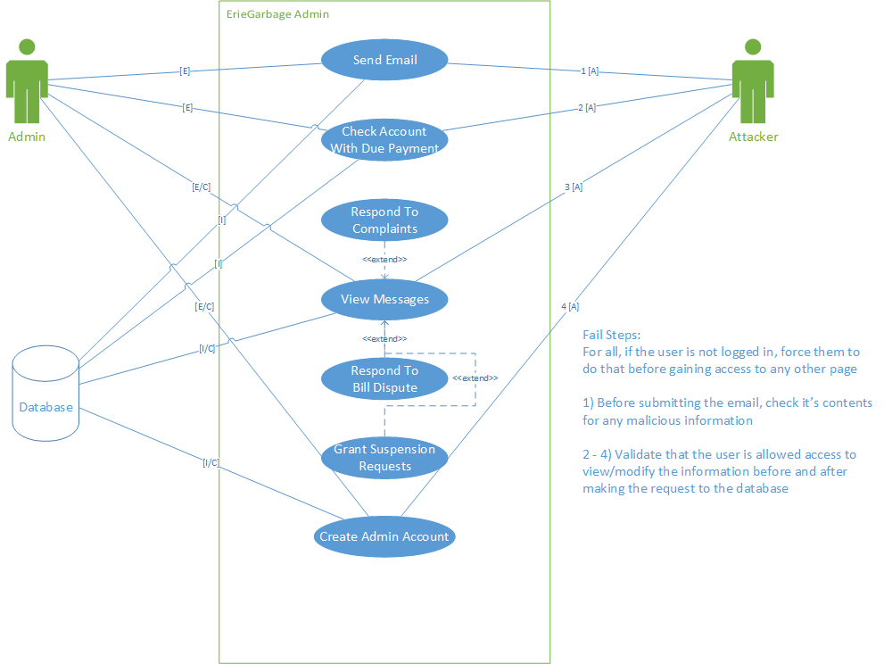

**Admin only use case diagram**

The next use case diagram details the features that are shared by both customers and administrators, and are general case features that everyone may need to perform.

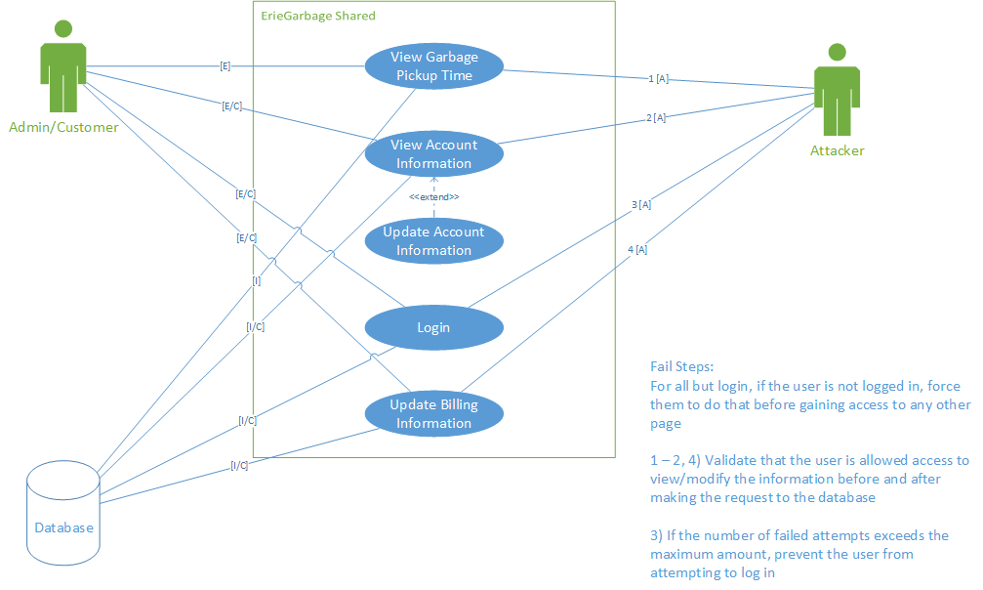

**Shared functionality use case diagram**

Use case #1 allows the user to view their account information when logged in to EGO. It can be used by either customer or admin.

|  |  |
| --- | --- |
| Use Case #1 | View Account Information |
| Goal in Context | To allow the user to view account information |
| Scope | ErieGarbage Online |
| Level | Primary |
| Primary Actor | Customer, Admin |
| Preconditions | User has an account |
| Success Guarantee | User’s account information will be displayed |
| Fail Case | User information is not displayed |
| Consequence of Failure | User’s will not be able to view or update information |
| Associated Risks | User may feel that the service is unreliable and may discontinue their usage |
| Nonfunctional Requirements | Information should be displayed within one second after attempt. If the user is not logged in or is accessing an account that isn’t theirs, return to the login page. |
| Trigger | User attempts to view account information |
| 1 | User attempts to view account information |
| 2 | The system validates that the user is logged in |
| 3 | The system displays the account to the user |
|  | Extensions |
| 2a | The user is not logged in |
|  | 2a-1 The system will return to the login page |
| 2b | The user is attempting to access an account that isn’t theirs |
|  | 2b-1 The system will return to the login page |

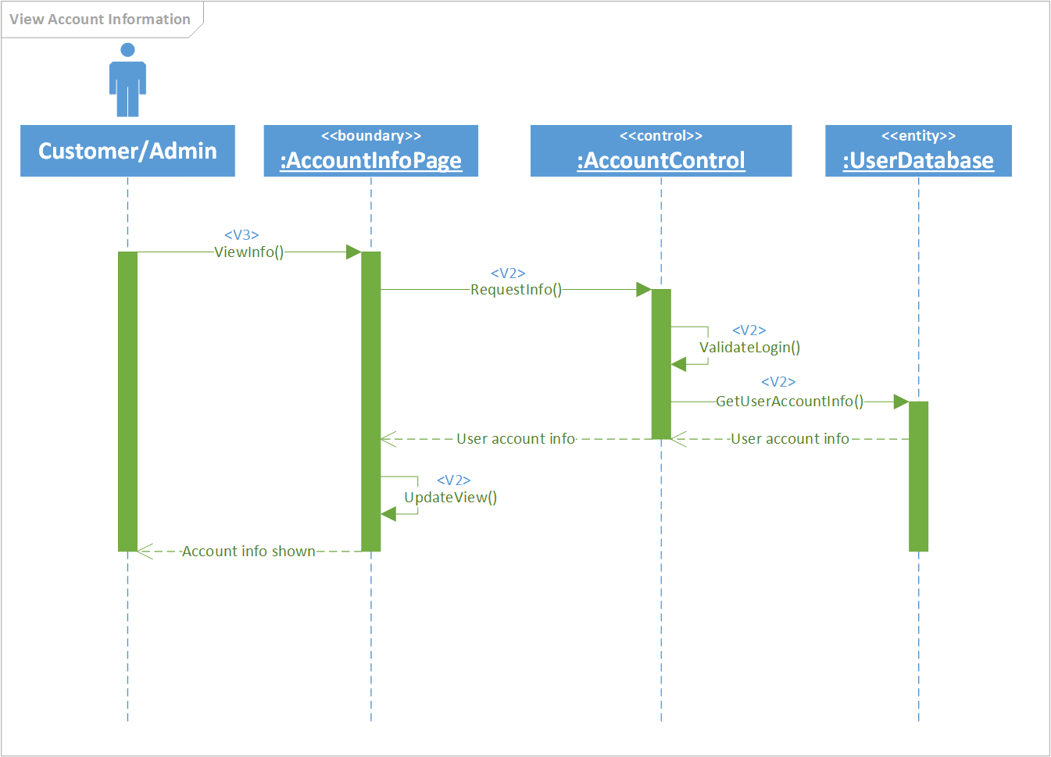

Use Case #2 allows a user to update their account information after viewing their account. It can be used by either admin or customer.

|  |  |
| --- | --- |
| Use Case #2 | Update Account Information |
| Goal in Context | To allow the user to update account information |
| Scope | ErieGarbage Online |
| Level | Primary |
| Primary Actor | Customer, Admin |
| Preconditions | User has an account, is logged in, and is viewing their profile |
| Success Guarantee | User’s account information will be updated |
| Fail Case | User’s information is not updated |
| Consequence of Failure | User’s information will be incorrect |
| Associated Risks | User information will be outdated and may cause unnecessary charges or work |
| Nonfunctional Requirements | Information should be updated immediately after saving, if the user enters invalid data, the system should alert the user and have them re-enter valid information |
| Trigger | User attempts to update account information |
| 1 | User attempts to update account information |
| 2 | The system validates that the user is logged in, then displays user’s changeable information |
| 3 | The user enters new information, then saves changes |
| 4 | The system validates the new information and saves in the database |
|  | Extensions |
| 2a | The user is not logged in |
|  | 2a-1 The system returns to the login page |
| 3a | The user cancels changes |
|  | 3a-1 The system discards the changed information |
| 4a | The system detects invalid information |
|  | 4a-1 The system returns to step 3 and asks the user to fix invalid information |

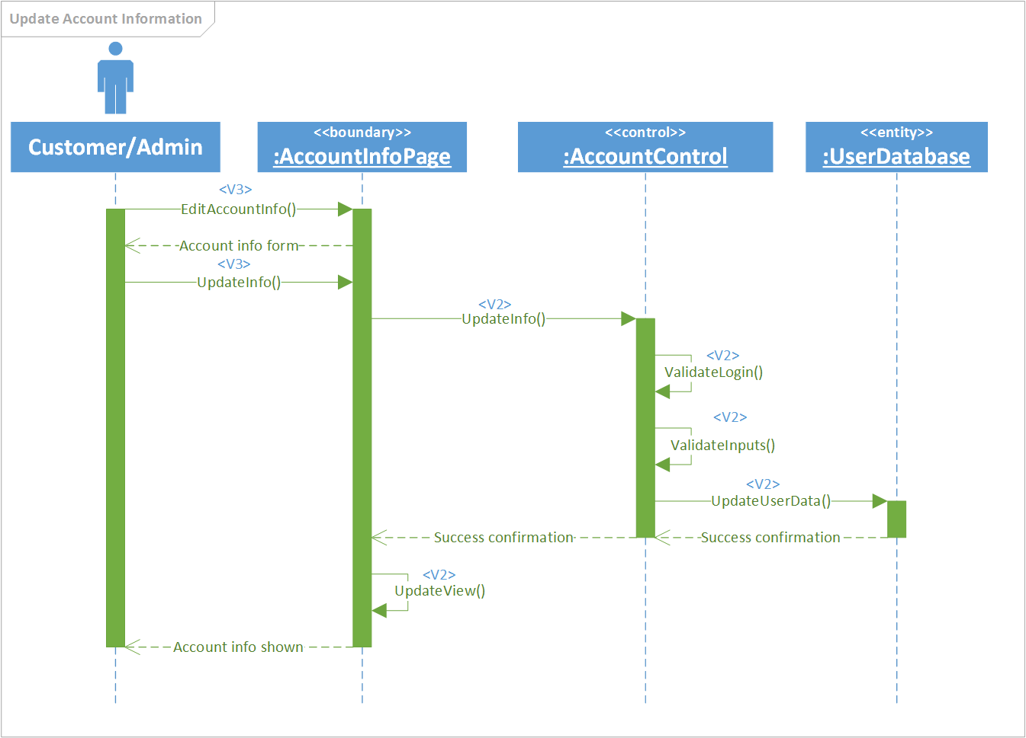

Use Case #3 allows a user to make a payment which adds the amount to their current balance. This can be used by customers.

|  |  |
| --- | --- |
| Use Case #3 | Make Payment |
| Goal in Context | To allow the customer to add money to their running balance |
| Scope | ErieGarbage Online |
| Level | Primary |
| Primary Actor | Customer |
| Preconditions | User has an account and is logged in. |
| Success Guarantee | User’s account balance will increase by the amount they pay |
| Fail Case | User’s payment doesn’t go through |
| Consequence of Failure | User may be charged without taking effect, or may be suspended unduly |
| Associated Risks | User may start a chargeback, or may feel that their billing information is not secure and cancel their account |
| Nonfunctional Requirements | The user’s balance should update immediately after payment clears. The system should validate payment information before making a charge, and have the user enter new information if it is invalid. If the user is not logged in the system will return to the login page |
| Trigger | User attempts to add money to account balance |
| 1 | User attempts to add money to account balance |
| 2 | The system validates that the user is logged in and displays the payment form |
| 3 | The user enters amount they wish to pay |
| 4 | The system validates their billing information and payment amount, and charges the user’s billing account |
| 5 | The system updates balance after receiving confirmation |
|  | Extensions |
| 2a | The user is not logged in |
|  | 2a-1 The system returns to the login screen |
| 3a | The user enters invalid payment amount |
|  | 3a-1 The system asks the user to enter a valid payment amount |
| 4a | The user’s billing information is invalid or out of date |
|  | 4a-1 The system runs asks the user to update their billing information and discards the payment |

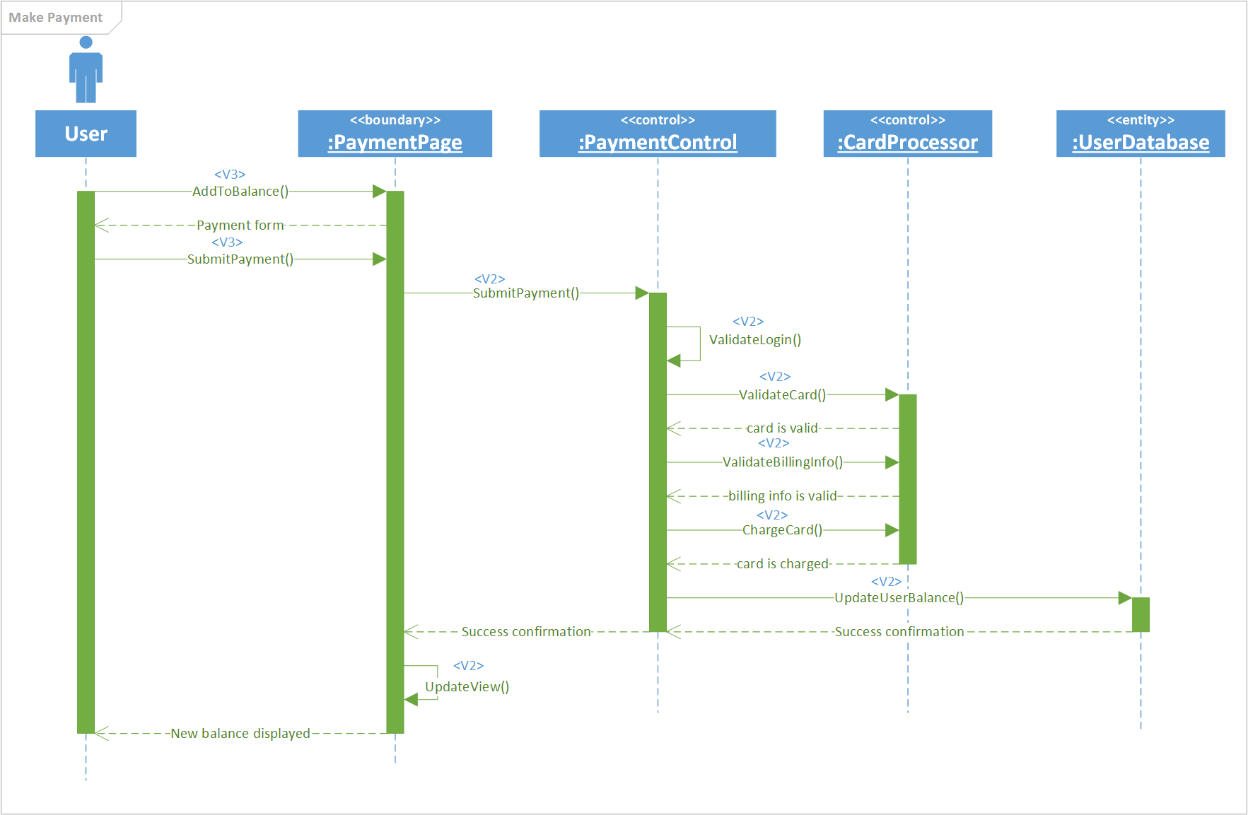

Use Case #4 allows a user to view the pickup times provided by EGO. This functionality is used by both customers and admins.

|  |  |
| --- | --- |
| Use Case #4 | View Pickup Times |
| Goal in Context | To allow the user to view pickup times |
| Scope | ErieGarbage Online |
| Level | Primary |
| Primary Actor | Customer, Admin |
| Preconditions | User has an account and is logged in. |
| Success Guarantee | ErieGarbage pickup times are displayed |
| Fail Case | Nothing is displayed |
| Consequence of Failure | User will not be able to view times for pickup |
| Associated Risks | User may not be prepared for pickup, causing a failure in the service, and the user may feel uncertain about the quality of the service. |
| Nonfunctional Requirements | Information should be displayed within one second of attempt, if the user is not logged in the system will return to the login page |
| Trigger | User attempts to view pickup times |
| 1 | User attempts to view pickup times |
| 2 | The system validates that the user is logged in displays the pickup times for the service |
|  | Extensions |
| 2a | The user is not logged in |
|  | 2a-1 The system will return to the login screen |

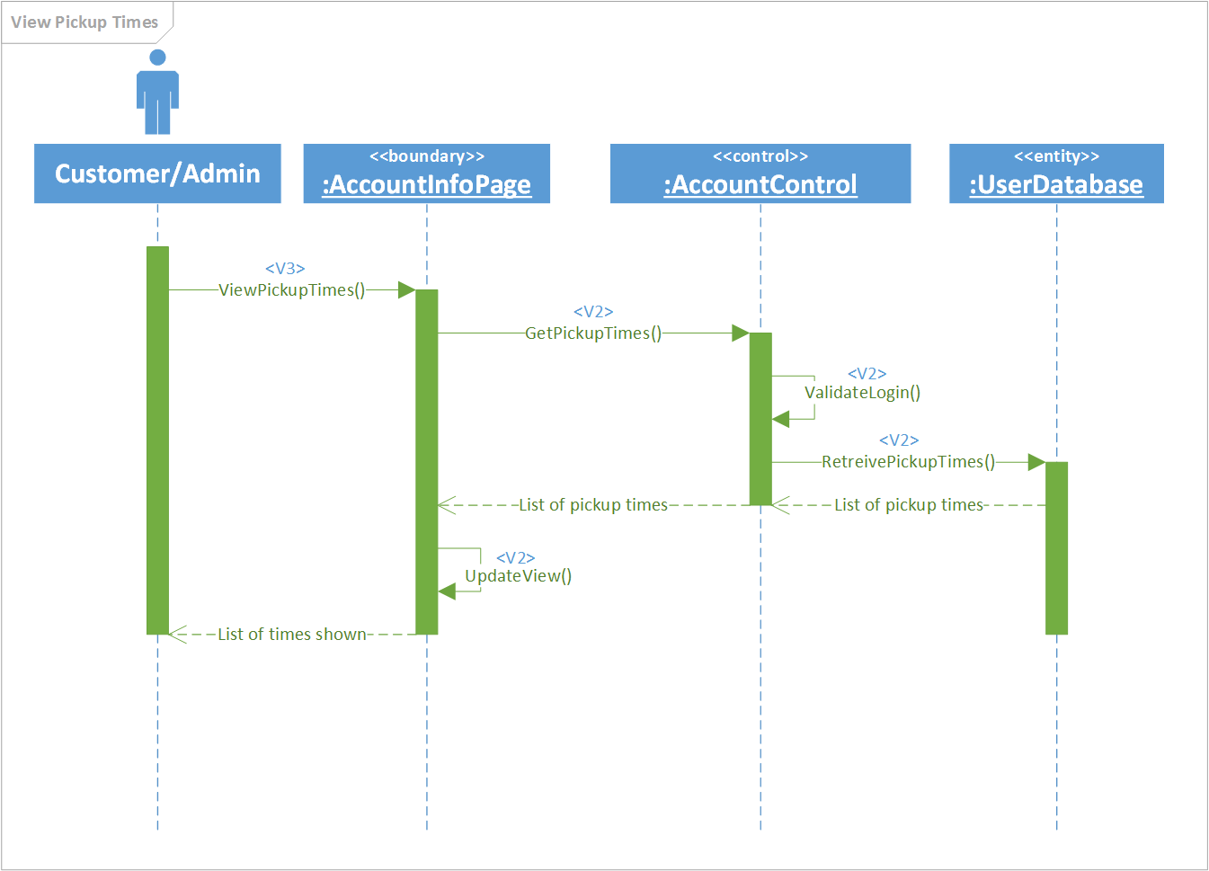

Use Case #5 allows a user to create a message which will be sent to the administration team about an issue that the user has. It is used by customers.

|  |  |
| --- | --- |
| Use Case #5 | Create Message |
| Goal in Context | To allow customers to contact the admin with an issue |
| Scope | ErieGarbage Online |
| Level | Primary |
| Primary Actor | Customer |
| Preconditions | User has an account and is logged in |
| Success Guarantee | Admin will be message with the customer’s request |
| Fail Case | Admin is not messaged |
| Consequence of Failure | Admin will not know what the user was attempting to message about |
| Associated Risks | User will feel that the system is unreliable or that the administrators don’t respond to users, and may cancel their account |
| Nonfunctional Requirements | Messages should be sent as soon as user requests it, and should have a guaranteed delivery. If the user is not logged in, the system should return to the login screen. The user must select a reason to message the admin. |
| Trigger | User attempts to message admin |
| 1 | User attempts to message admin |
| 2 | The system validates that the user is logged in and asks what their issue is |
| 3 | User chooses to dispute bill, request suspension, or file complaint |
| 4 | The system runs the dispute bill, request suspension, or file complaint use case |
|  | Extensions |
| 2a | The user is not logged in |
|  | 2a-1 The system returns to the login screen |
| 3a | The user cancels the message |
|  | 3a-1 The system discards the message and returns the home page |

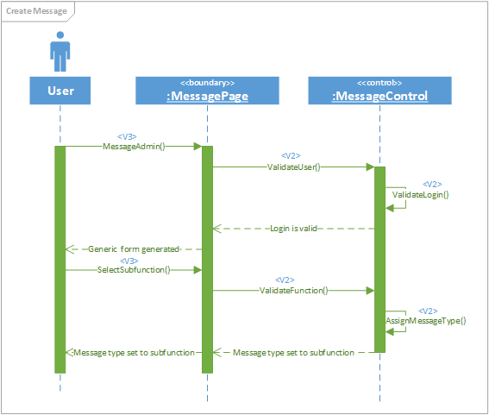

Use Case #6 is a type of message that can be sent. It is a requests suspension that will disable a customer's account for a specified period of time. It is used in conjunction with create message by customers.

|  |  |
| --- | --- |
| Use Case #6 | Request Suspension |
| Goal in Context | To allow customer to request a suspension on their account |
| Scope | ErieGarbage Online |
| Level | Subfunction |
| Primary Actor | Customer |
| Preconditions | User has an account, is logged in, and has chosen notification type suspension |
| Success Guarantee | Admin will be messaged about suspension request |
| Fail Case | Admin is not messaged |
| Consequence of Failure | Admin will not know that user wishes to suspend account |
| Associated Risks | User will be charged during desired suspension period, and will likely dispute or cancel service |
| Nonfunctional Requirements | Messaged should be sent as soon as user requests it, and should have a guaranteed delivery. The suspension period should be a valid time frame. |
| Trigger | User chooses to request suspension |
| 1 | User attempts to request suspension |
| 2 | User specifies length of time for suspension |
| 3 | The system validates that the length of time is valid and messages the admin that the user has requested a suspension |
|  | Extensions |
| 3a | The user’s time frame is invalid |
|  | 3a-1 The system displays an invalid time frame message |

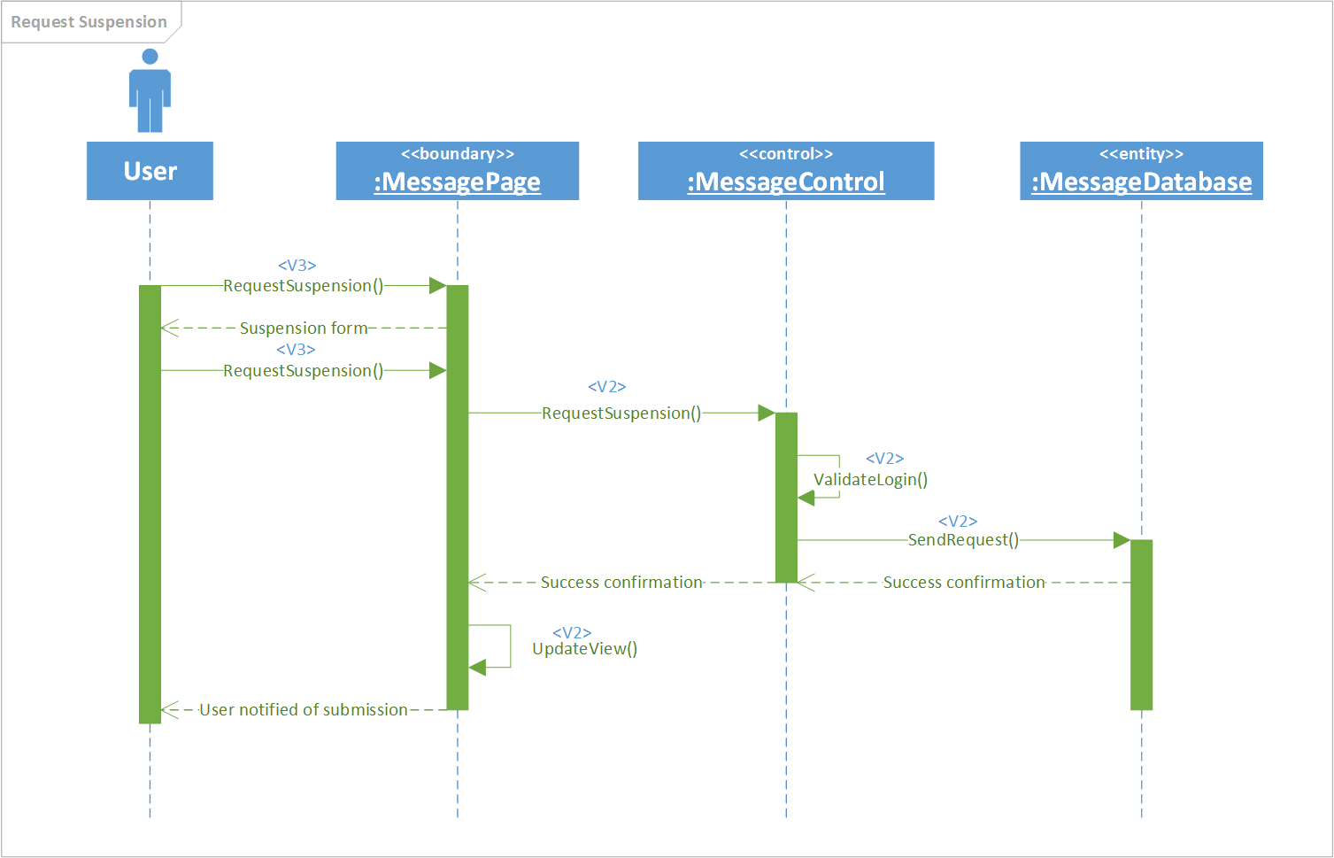

Use Case #7 allows a customer to file a complaint that they may have with the system, service, or admins. It is used alongside create message by customers.

|  |  |
| --- | --- |
| Use Case #7 | File Complaint |
| Goal in Context | To allow the user to file a complaint |
| Scope | ErieGarbage Online |
| Level | Subfunction |
| Primary Actor | Customer |
| Preconditions | User has an account, is logged in, and chooses to file a complaint |
| Success Guarantee | Admin will be messaged about the user’s complaint |
| Fail Case | User’s complaint is not filed |
| Consequence of Failure | User’s complaint will not reach the administration |
| Associated Risks | User will feel that their feedback is not important, and a valid concern may be not be taken care of |
| Nonfunctional Requirements | Complaint should be filed immediately after attempt. The complaint form should have all information complete and valid |
| Trigger | User chooses to file a complaint |
| 1 | User chooses to file a complaint |
| 2 | The system returns the complaint form to the user |
| 3 | The user fills out specified information to file the complaint |
| 4 | The system validates that the complaint form is complete and valid, then messages the admins about the complaint |
|  | Extensions |
| 4a | The form is incomplete or contains invalid information |
|  | 4a-1 The systems informs the user about the changes they need to make to the form |

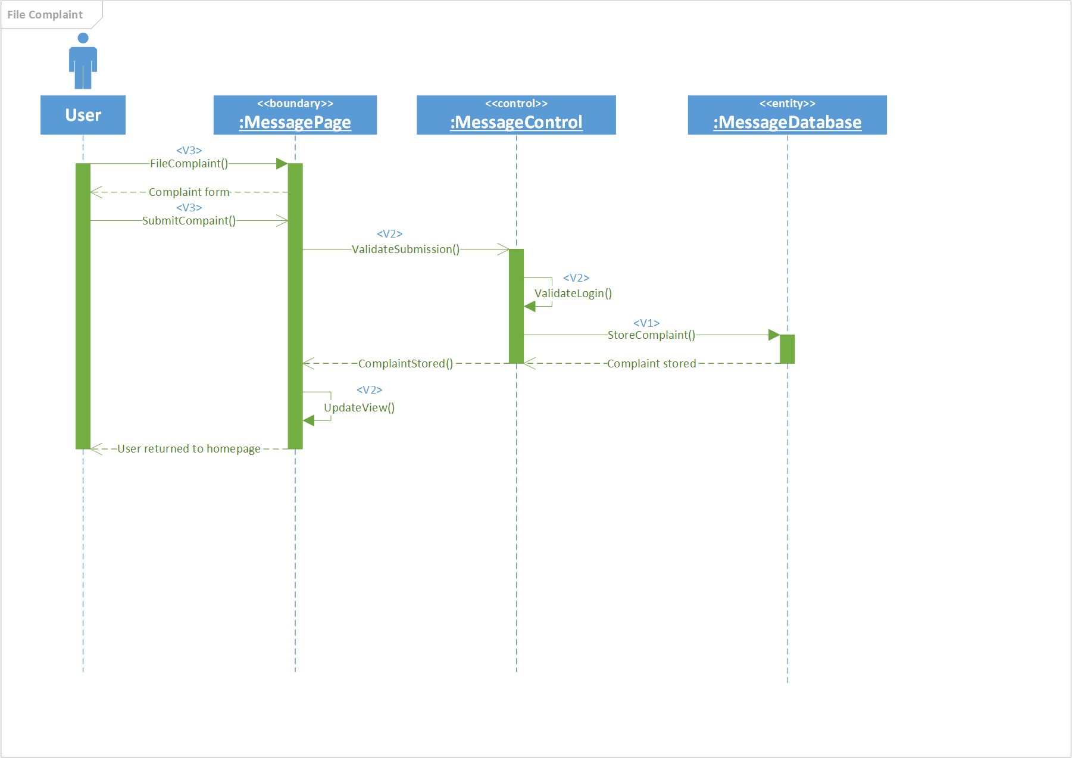

Use Case #8 allows a user to dispute a bill that has been charged to their account. It is used with send message by customers.

|  |  |
| --- | --- |
| Use Case #8 | Dispute Bill |
| Goal in Context | To allow the user to dispute bill |
| Scope | ErieGarbage Online |
| Level | Primary |
| Primary Actor | Customer |
| Preconditions | Customer has an account, is logged in, has a charge to their account, and chooses to dispute a bill |
| Success Guarantee | Admin will be messaged about the user’s dispute |
| Fail Case | User’s dispute is not filed |
| Consequence of Failure | User’s dispute will not reach the administration |
| Associated Risks | User will feel that their messages are ignored, and may be wrongly charged |
| Nonfunctional Requirements | Dispute should be filed immediately after attempt. There should always be a bill that is selected for each dispute. The form should be complete before sending. |
| Trigger | User chooses to dispute a bill |
| 1 | User chooses to dispute a bill |
| 2 | The system displays the bills for the user |
| 3 | The user selects a bill to dispute and fills out information |
| 4 | The system validates that the form is complete and valid, then messages the admins about the dispute |
|  | Extensions |
| 4a | The dispute contains invalid information or is incomplete |
|  | 4a-1 The system informs the user that the form must be fixed and resubmitted |

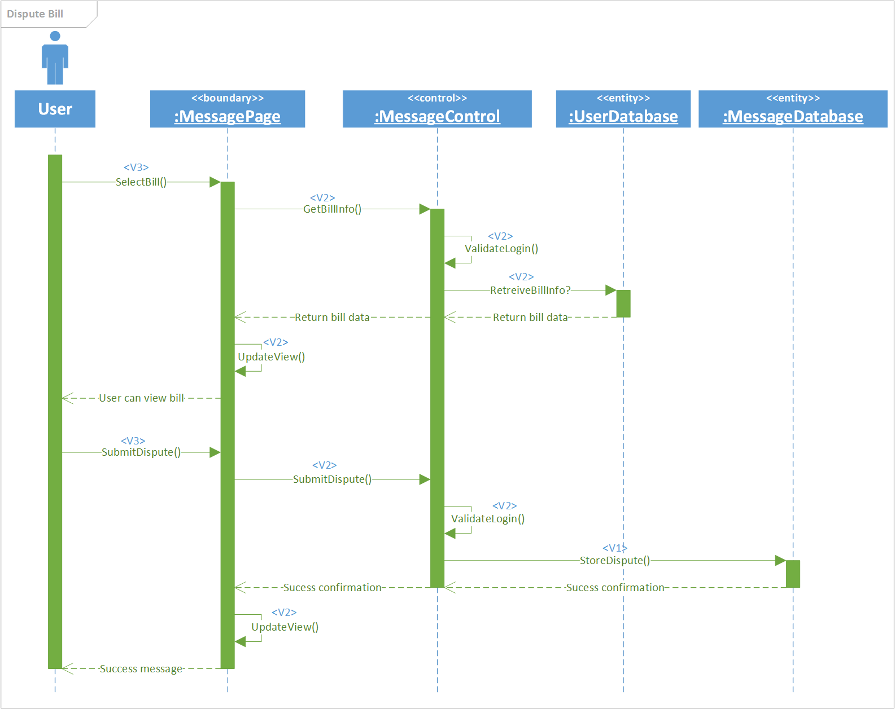

Use Case #9 allows a customer to discontinue their service by cancelling their account. It is used by customers.

|  |  |
| --- | --- |
| Use Case #9 | Cancel Account |
| Goal in Context | To allow the customer to cancel their account |
| Scope | ErieGarbage Online |
| Level | Primary |
| Primary Actor | Customer |
| Preconditions | User has an account and is logged in |
| Success Guarantee | User’s account will be cancelled |
| Fail Case | User’s account is not cancelled |
| Consequence of Failure | User’s account will remain in effect |
| Associated Risks | User may have inaccurate activity or charges made, and could potentially involve the law |
| Nonfunctional Requirements | Account should be deleted immediately after the user requests it. Customers should not be able to cancel an account that is not theirs. Customers must be logged in to cancel, and must provide extra information to verify that they are who they say they are. |
| Trigger | User attempts to cancel account |
| 1 | User attempts to cancel account |
| 2 | The system validates that the user is logged in. |
| 3 | The user specifies required cancellation information |
| 4 | The system validates the information and deletes their account |
|  | Extensions |
| 2a | The user is not logged in |
|  | 2a-1 The system returns to the login screen |
| 3a | The user cancels request |
|  | 3a-1 The systems discards the account cancellation request |
| 4a | The user provides invalid information to cancel account |
|  | 4a-1 The system informs the user that they provided invalid information |

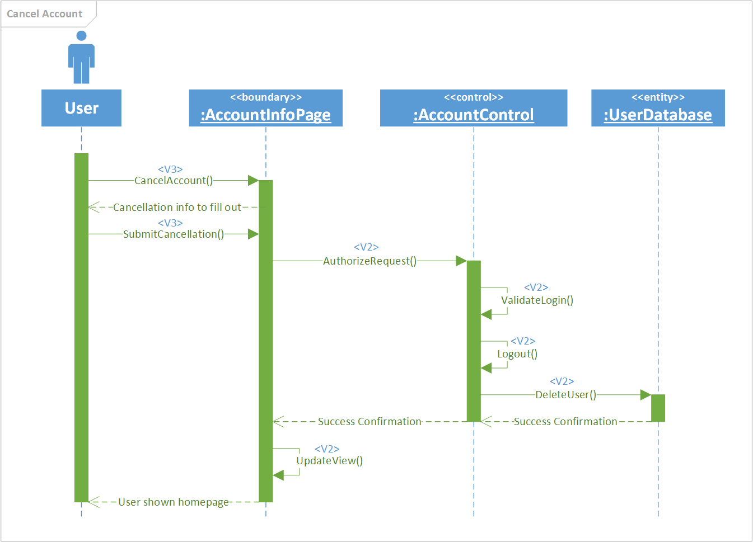

Use Case #10 allows an admin to email a customer for a variety of reasons.

|  |  |
| --- | --- |
| Use Case #10 | Send Email |
| Goal in Context | Allow the admin to email a customer |
| Scope | ErieGarbage Online |
| Level | Primary |
| Primary Actor | Admin |
| Preconditions | Admin is logged into their account |
| Success Guarantee | An email will be sent to the user of the admin’s choice |
| Fail Case | The user never receives a message from the admin |
| Consequence of Failure | Admin may assume incorrect information about the user if there is no response |
| Associated Risks | User will be unhappy if the admin makes an assumption due to the lack of  response and alters the user’s account due the assumption |
| Nonfunctional Requirements | Admin should be notified immediately if there are issues sending the message |
| Trigger | Admin attempts to email a user |
| 1 | The admin attempts to email a user |
| 2 | The admin enters the  header, subject, and body information of the email |
| 3 | The admin submits the email |
| 4 | The system sends the email to the user |
|  | Extensions |
| 3a | The admin cancels the email |
|  | 3a-1 The system discards the email |

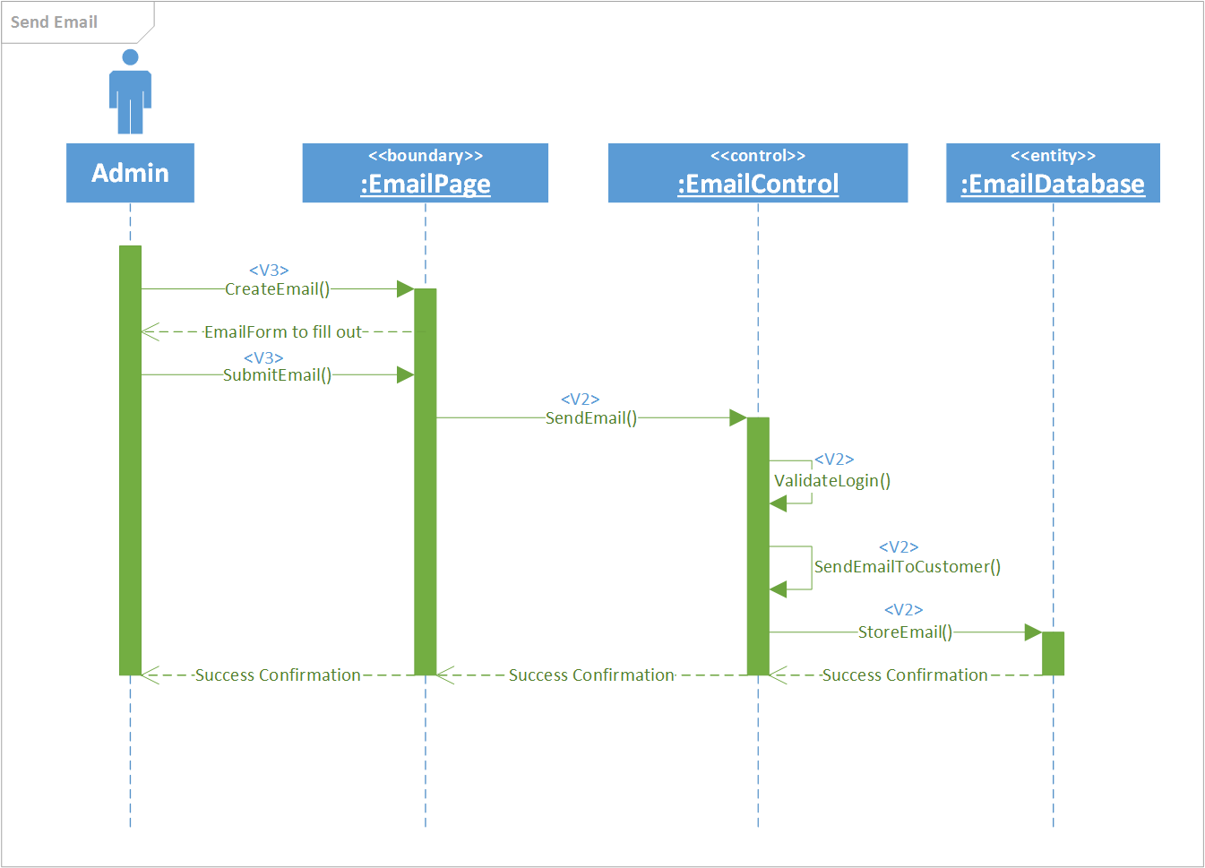

Use Case #11 allows an admin to create other admin accounts to perform administrative functions. The initial admin account will be created with the system database.

|  |  |
| --- | --- |
| Use Case #11 | Create Admin Account |
| Goal in Context | Allow an admin to create another admin account |
| Scope | ErieGarbage Online |
| Level | Primary |
| Primary Actor | Admin |
| Preconditions | Admin is logged into their account |
| Success Guarantee | The admin creates an account for another admin to use |
| Fail Case | No account is created or the created account is a customer account |
| Consequence of Failure | Admin will not be able to login or will only have customer privileges |
| Associated Risks | Admin will be confused and may waste time trying to resolve this issue |
| Nonfunctional Requirements | The new admin account should be useable immediately |
| Trigger | Admin attempts to create another admin account |
| 1 | The admin attempts to create another admin account |
| 2 | The admin enters the email, password, and phone number of the new admin account |
| 3 | The admin submits the account information |
| 4 | The system validates that the account is unique and valid |
| 5 | The system creates an account using the provided information |
|  | Extensions |
| 3a | The admin cancels the creation process |
|  | 3a-1 The system discards the information |
| 4a | The account is not valid |
|  | 4a-1 The admin modifies the invalid information |

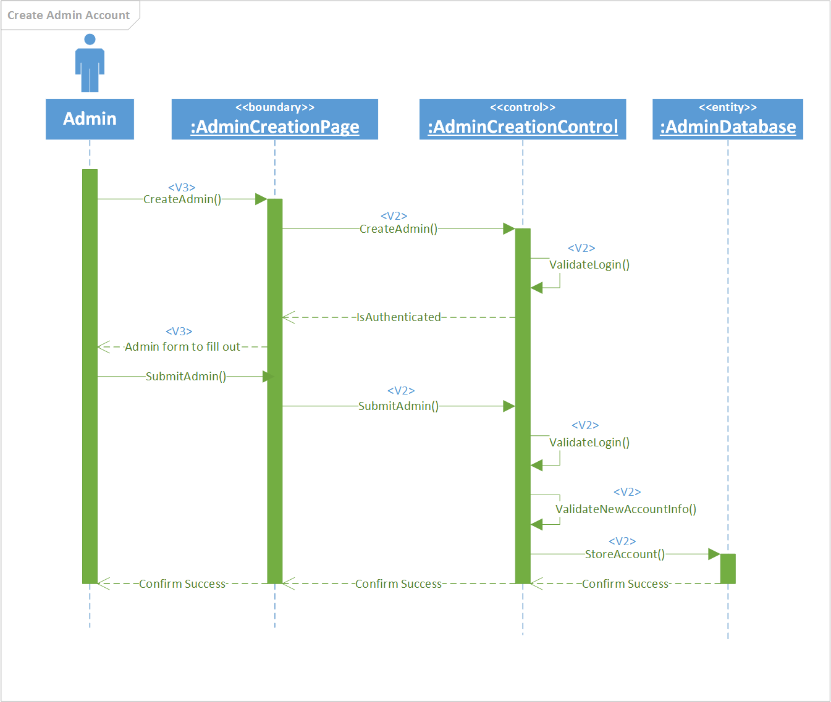

Use Case #12 allows an admin to update a customer’s billing information.

|  |  |
| --- | --- |
| Use Case #12 | Update Billing Information |
| Goal in Context | Allow an admin to update a user’s billing information |
| Scope | ErieGarbage Online |
| Level | Primary |
| Primary Actor | Admin |
| Preconditions | Admin is logged into their account |
| Success Guarantee | The admin alters the user’s billing information |
| Fail Case | User’s billing information remains the same |
| Consequence of Failure | User may not be able to pay if their billing information is incorrect |
| Associated Risks | User and admin will become frustrated; they may try to work around the system to allow the customer to pay on time |
| Nonfunctional Requirements | The user’s billing information should be updated immediately once submitted by the admin |
| Trigger | Admin attempts to update the user’s billing information |
| 1 | The admin enters the email of the user that needs their billing information updated |
| 2 | The system locates and displays the user’s information |
| 3 | The admin can update the user’s email address, home address, and phone number |
| 4 | The admin submits the billing information updates |
| 5 | The system updates the user’s records |
|  | Extensions |
| 4a | The admin cancels the update |
|  | 4a-1 The system discards the updated information |

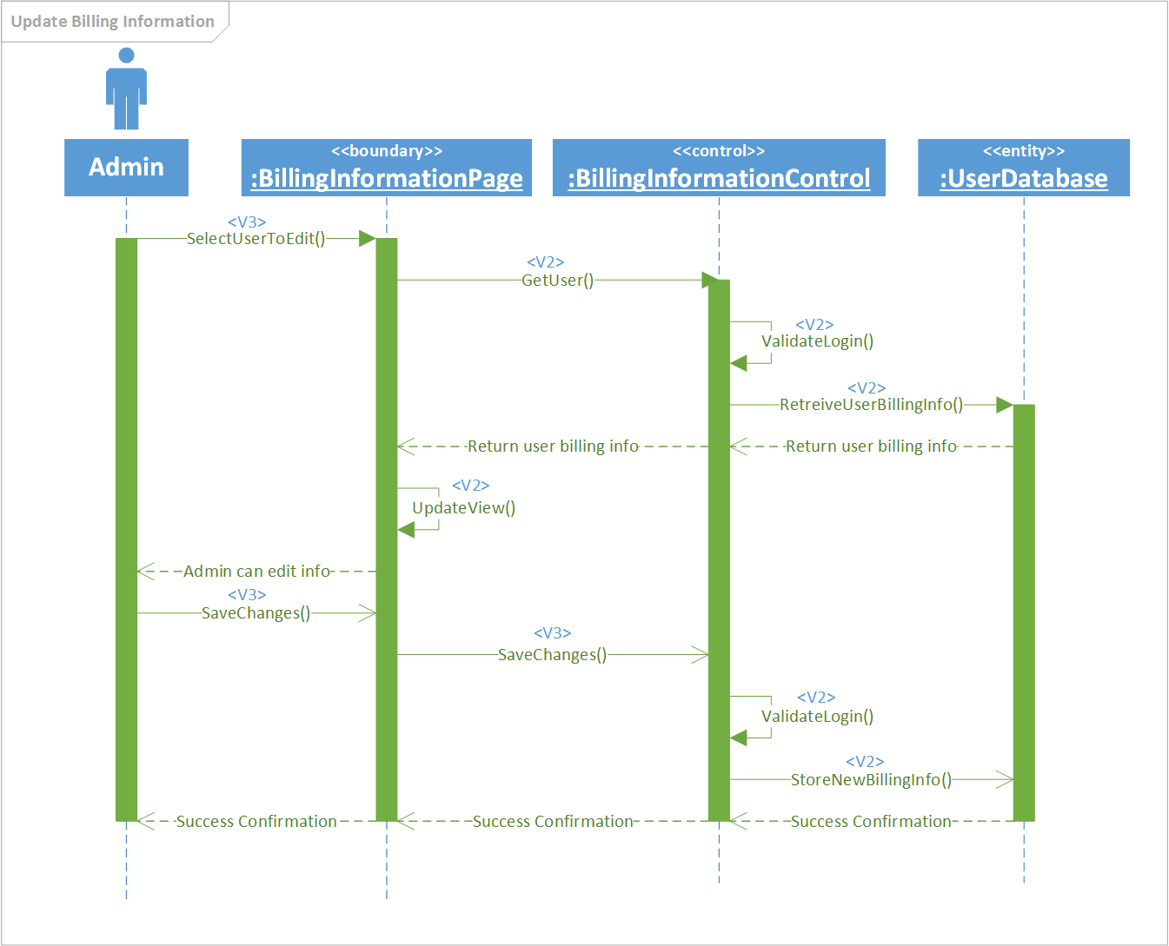

Use Case #13 allows an admin to view messages that have been sent by customers.

|  |  |
| --- | --- |
| Use Case #13 | View Messages |
| Goal in Context | Allow an admin to view messages sent by users |
| Scope | ErieGarbage Online |
| Level | Primary |
| Primary Actor | Admin |
| Preconditions | Admin is logged into their account |
| Success Guarantee | The admin is able to view a list of messages from users |
| Fail Case | The admin is not able to view the list |
| Consequence of Failure | Admin will not be able to respond to users |
| Associated Risks | Users will become frustrated they they are not being assisted by admins; admins will become frustrated that they cannot perform their job duties |
| Nonfunctional Requirements | The list should be color coded depending on the type of messages in the inbox. The admin should be logged in before seeing the messages. |
| Trigger | Admin attempts to view list of messages |
| 1 | The admin attempts to view their messages |
| 2 | The system validates that the admin is logged in and retrieves messages sent to admins and displays them in a list |
|  | Extensions |
| 2a | The admin is not logged in |
|  | 2a-1 The system returns to the login screen |
| 2b | There are currently no messages |
|  | 2b-1 The system displays that there are currently no messages instead of a list |

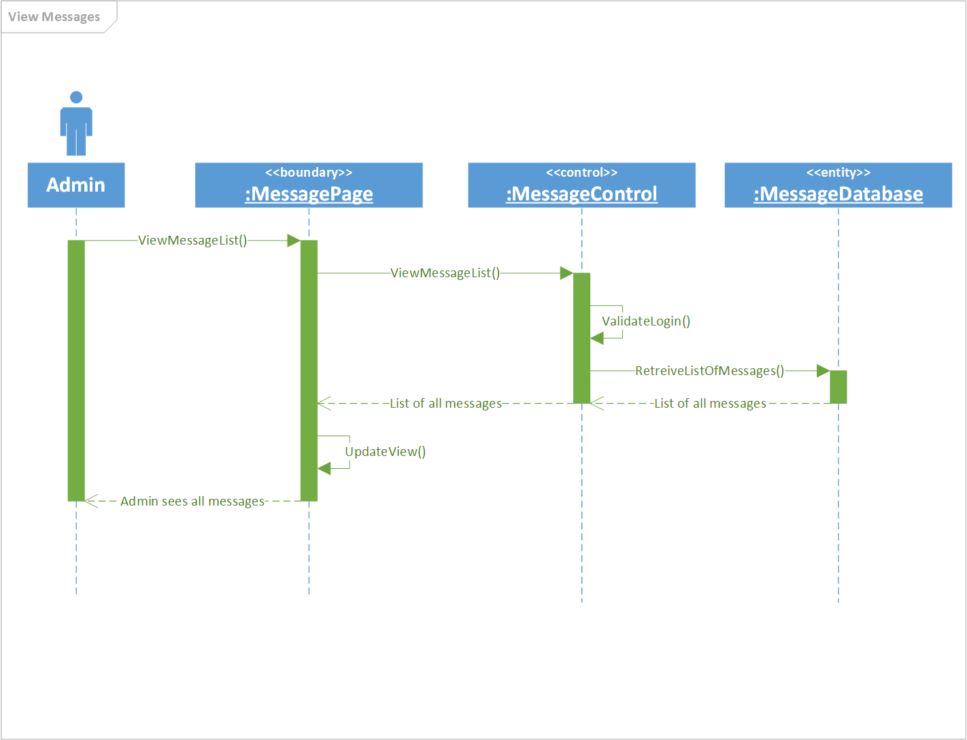

Use Case #14 allows an admin to respond to complaint messages from customers.

|  |  |
| --- | --- |
| Use Case #14 | Respond To Complaints |
| Goal in Context | Allow an admin to respond to a customer’s complaint |
| Scope | ErieGarbage Online |
| Level | Primary |
| Primary Actor | Admin |
| Preconditions | Admin is logged into their account and has viewed messages |
| Success Guarantee | The admin is able to respond to a user’s complaint |
| Fail Case | The admin’s response is not sent to the user |
| Consequence of Failure | Admin will not be able assist a user with their request |
| Associated Risks | Users may not want to use a system with seemingly careless admins; admins will become frustrated that they are trying to help but cannot |
| Nonfunctional Requirements | The admin should be notified immediately if their response cannot be sent. The admin must be logged in to respond. |
| Trigger | The admin selects a complaint message |
| 1 | The admin selects a complaint message |
| 2 | The system displays the contents of the message |
| 3 | The admin fills out the response form to respond to the complaint |
| 4 | The system validates that the response is valid and sends to the customer |
|  | Extensions |
| 3a | The admin cancels the response |
|  | 3a-1 The system discards the response data |
|  | 3a-2 The system reverts to the message list |
| 4a | The form contains invalid or incomplete information |
|  | 4a-1 The system informs the admin that the form contains invalid or incomplete fields |

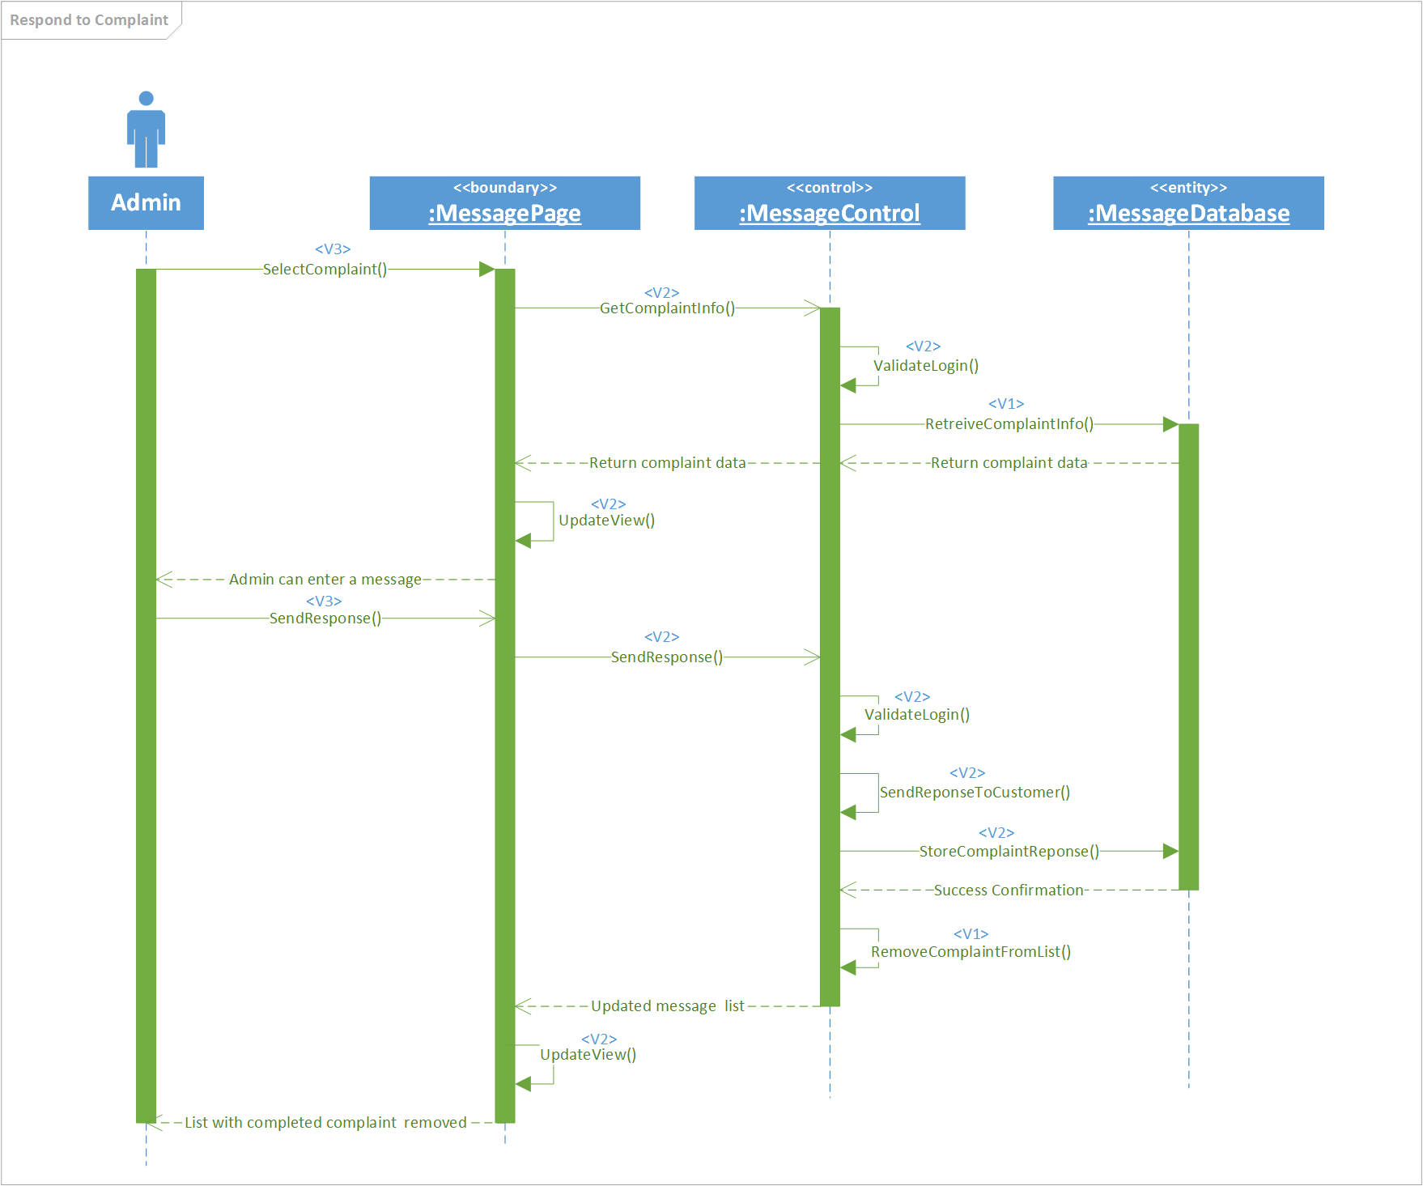

Use Case #15 allows an admin to respond to bill dispute messages from customers.

|  |  |
| --- | --- |
| Use Case #15 | Respond To Bill Dispute |
| Goal in Context | Allow an admin to respond to a customer’s bill dispute request |
| Scope | ErieGarbage Online |
| Level | Primary |
| Primary Actor | Admin |
| Preconditions | Admin is logged into their account and has viewed messages |
| Success Guarantee | The admin is able to respond to a user’s bill dispute request |
| Fail Case | The admin’s response is not sent to the customer |
| Consequence of Failure | Admin will not be able assist a customer with their request |
| Associated Risks | Customers may not want to use a system with seemingly careless admins; admins will become frustrated that they are trying to help but cannot |
| Nonfunctional Requirements | If the user is not logged in, the system should return to the login screen. The dispute form should be completely filled out before being able to send. |
| Trigger | The admin selects a bill dispute message |
| 1 | The admin selects a bill dispute message |
| 2 | The system displays the bill and information from the customer |
| 3 | The admin responds to the bill dispute |
| 4 | The system validates the information and sends to the customer |
|  | Extensions |
| 3a | The admin cancels the response |
|  | 3a-1 The system discards the response data |
|  | 3a-2 The system reverts to the message list |
| 4a | The form contains invalid or incomplete information |
|  | 4a-1 The system informs the admin that the form contains invalid or incomplete fields |

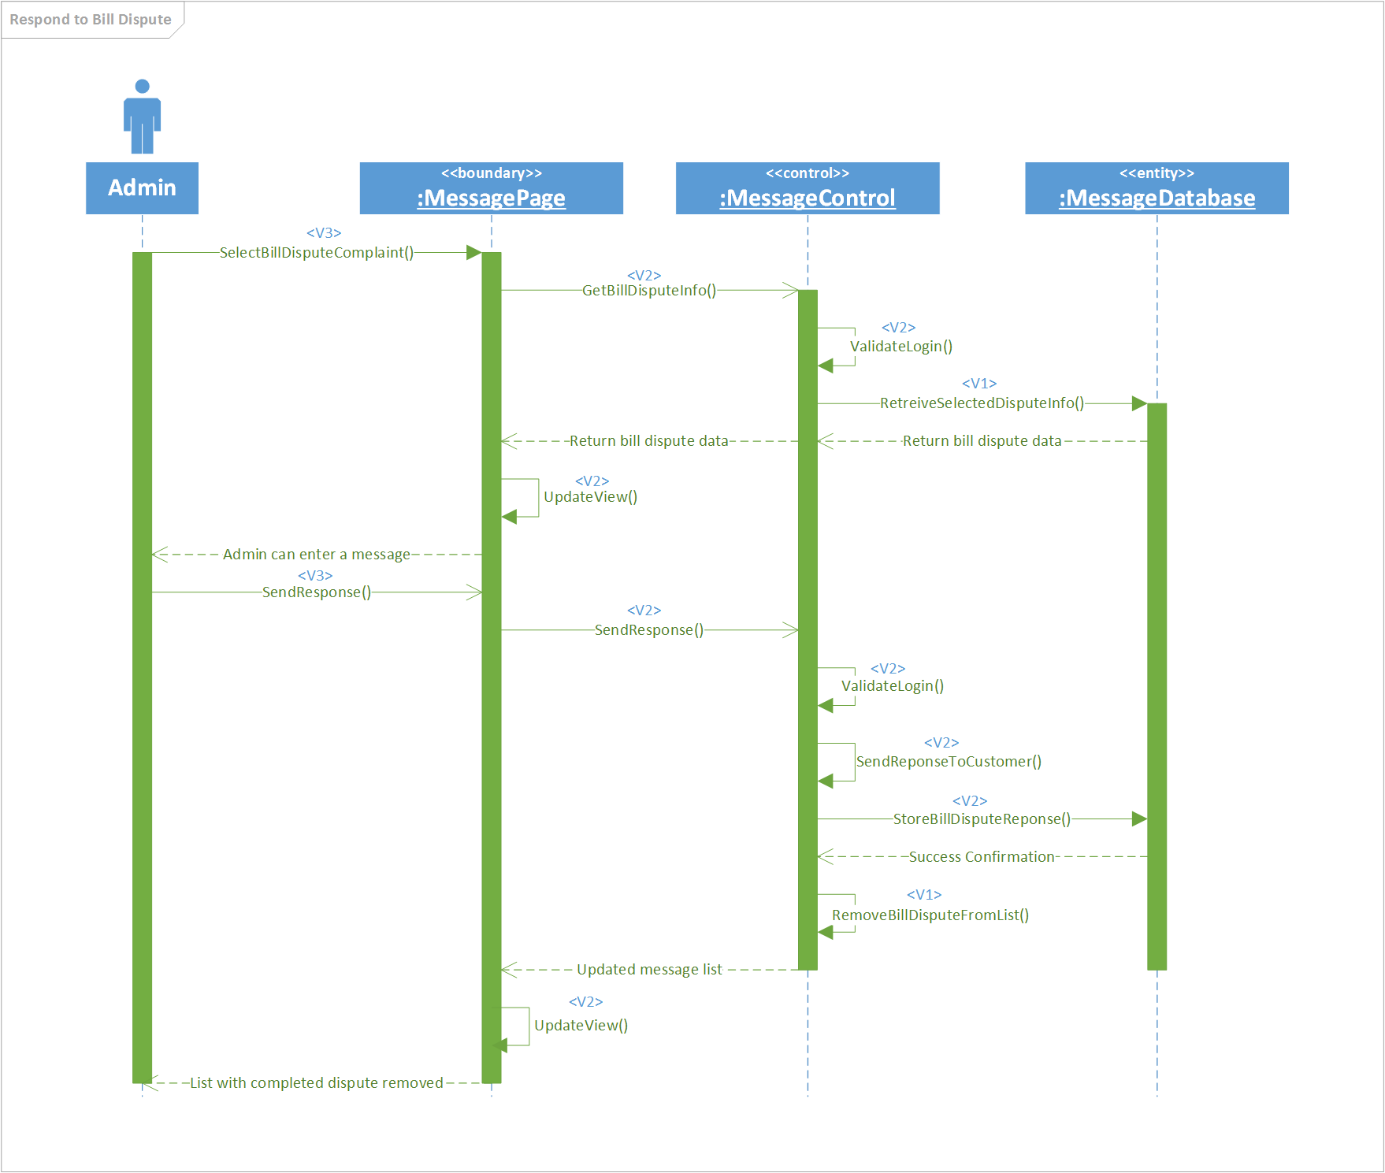

Use Case #16 allows an admin to respond to suspension requests from customers and suspend their account.

|  |  |
| --- | --- |
| Use Case #16 | Respond To Suspension Request |
| Goal in Context | Allow an admin to respond to a customer’s request to have their account suspended |
| Scope | ErieGarbage Online |
| Level | Primary |
| Primary Actor | Admin |
| Preconditions | Admin is logged into their account and has viewed messages |
| Success Guarantee | The admin is able to respond to a user’s suspension request |
| Fail Case | The admin’s response is not sent to the customer. The customer’s account is not suspended if granted. |
| Consequence of Failure | Admin will not be able assist a customer with their request |
| Associated Risks | Customers may not want to use a system with seemingly careless admins; admins will become frustrated that they are trying to help but cannot |
| Nonfunctional Requirements | If the admin is not logged in, the system should return to the login screen. The suspension form should contain valid information and be completed before submitting |
| Trigger | The admin selects a suspension request message |
| 1 | The admin selects a suspension request message |
| 2 | The system validates that the admin is logged in and displays the request |
| 3 | The admin fills out and submits the suspension form |
| 4 | The system validates the form, suspends the account, and sends the response to the customer |
|  | Extensions |
| 2a | The admin is not logged in |
|  | 2a-1 The system returns to the login screen |
| 3a | The admin cancels the response |
|  | 3a-1 The system discards the response data |
|  | 3a-2 The system reverts to the message list |
| 4a | The form contains invalid or incomplete information |
|  | 4a-1 The system informs the admin that the form contains invalid or incomplete fields |
| 4b | The admin denied the suspension request |
|  | 4b-1 The customer’s account is not suspended |

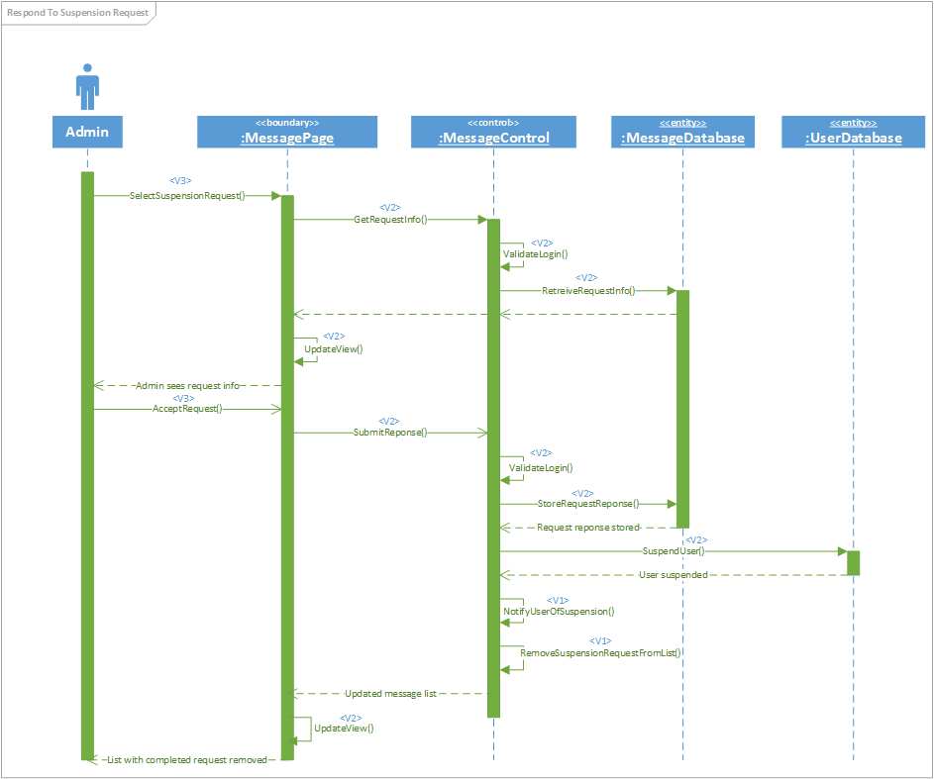

Use Case #17 allows a user to login to the EGO system. It is used by both customers and admins.

|  |  |
| --- | --- |
| Use Case #17 | Login |
| Goal in Context | Allow a user to login to the system |
| Scope | ErieGarbage Online |
| Level | Primary |
| Primary Actor | Customer, Admin |
| Preconditions | User can access the system through an internet connection |
| Success Guarantee | User is logged into the system |
| Fail Case | User enters correct credentials and is not logged in |
| Consequence of Failure | User is not able to interact with admins and access their profile |
| Associated Risks | It may be affecting many users; the site may lose customers |
| Nonfunctional Requirements | The user should be able to login within 5 seconds. The system should not allow users to log in unless the information is correct. The system should lock after 3 failed attempts. |
| Trigger | User attempts to login to ErieGarbage Online |
| 1 | The user enters their account username and password |
| 2 | The system validates that the information is correct and logs the user in to ErieGarbage Online |
|  | Extensions |
| 2a | Username and password do not match |
|  | 2a-1 The system prompts the user that the username or password is incorrect |
| 2b | The failed attempts exceed 3 tries |
|  | 2b-1 The system locks the user from continued attempts |

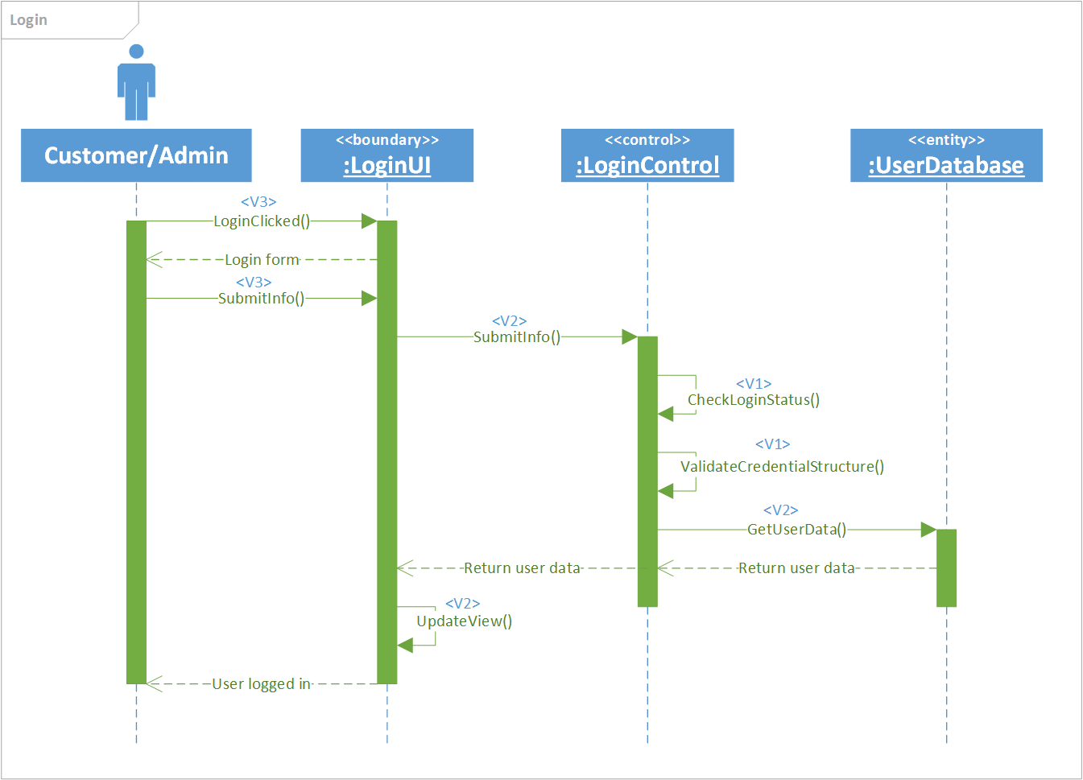

Use Case #18 allows an admin to view all customers who have a negative balance on their account.

|  |  |
| --- | --- |
| Use Case #18 | Check Account with Due Payment |
| Goal in Context | Allow an admin to obtain a list of users that have due payments |
| Scope | ErieGarbage Online |
| Level | Primary |
| Primary Actor | Admin |
| Preconditions | Admin is logged into their account |
| Success Guarantee | Admin has a viewable list of users that have due payments |
| Fail Case | A list with no results is returned even though there are users that have missed payments |
| Consequence of Failure | Admin is not able to handle interact with only the user accounts that have missed payments |
| Associated Risks | Admin may need to find a work around to interact with these specific users |
| Nonfunctional Requirements | The list returned should be in alphabetical order by user’s last name. The admin must be logged in to view the details. The information provided should not compromise a customer’s private details. |
| Trigger | Admin attempts to check accounts with due payments |
| 1 | The admin attempts to check accounts with due payments |
| 2 | The system validates that the user is logged in, returns a list of users with due payments and displays it to the admin |
|  | Extensions |
| 2a | The system validates that the admin is not logged in |
|  | 2a-1 The system returns to the login screen |
| 2b | There are no accounts with due payments |
|  | 2b-1 The system displays a message indicating that there are no accounts with dues |

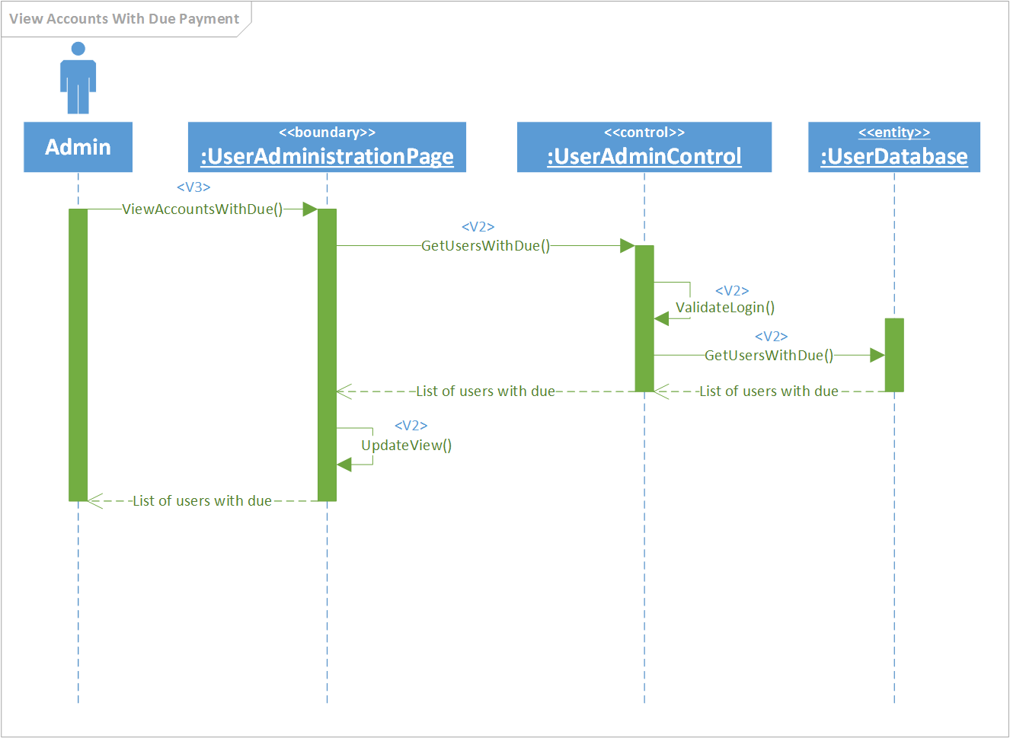

# Team Members Log Sheets

## Jake Wheeler

|  |  |  |
| --- | --- | --- |
| **date** | **task** | **duration** |
| 10/7/2016 | Meeting with customer (teacher) for more information.  Initial document edits to all sections.  Initial use case diagram. | 2.5 hrs. |
| 10/9/2016 | First draft of user sequence diagrams. | 2.5 hrs. |
| 10/11/2016 | Add more use cases. | 1.5 hr. |
| 10/12/2016 | Add more use cases. | 1 hr. |
| 10/14/2016 | More use cases | 2 hrs. |
| 10/15/2016 | Use case diagram  Added Vs to sequence diagrams | 1.5 hrs. |
| 10/18/2016 | Prepare to submit version 1.0 | 1.5 hrs. |
| 10/22/2016 | Update admin and login sequence diagrams | 2 hrs. |
| 10/23/2016 | Update customer sequence diagrams | 1.5 hrs. |
| 10/23/2016 | Add use case diagrams into the document, edit text portion of the document | 1.5 hrs. |
| 10/24/2016 | Fix message admin sequence diagram and add it to document | 1 hrs. |
|  | **Total :** | 18.5 hrs. |

## Nate Christiansen

|  |  |  |
| --- | --- | --- |
| **date** | **task** | **duration** |
| 10/7/2016 | Meeting with customer (teacher) for more information. | .25 hr. |
| 10/8/2016 | Add to document, add many user use cases, and update use case diagram | 1.5 hrs. |
| 10/12/2016 | Added some admin sequence diagrams. | 1 hr. |
| 10/13/2016 | Added more admin sequence diagrams | 2 hrs. |
| 10/14/2016 | Finished admin sequence diagrams | 2 hrs. |
| 10/22/2016 | Update some use cases to include security and better steps | 3 hrs. |
| 10/23/2016 | Update more use cases | 2.5 hrs |
| 10/23/2016 | Update last of use cases | 1.5 hrs |
| 10/24/2016 | Add sequence diagrams in order. Add descriptions to use cases | 1.5 hrs |
|  | **Total :** | 15.25 hrs. |

## Alex Lee

|  |  |  |
| --- | --- | --- |
| **date** | **task** | **duration** |
| 10/7/2016 | Meeting with customer (teacher) for more information. | 0.25 hr. |
| 10/8/16 | Add to document, use cases and update | 1 hr. |
| 10/11/16 | Reviewing use cases and updates | 1.5 hrs |
| 10/16/16 | Unsuccessful practice of Visio for sequence diagrams | 2.5 hrs (not counting) |
| 10/18/16 | Read project | 3 hrs (not counting) |
| 10/23/16 | Company logo | 1.5 hrs |
|  |  |  |
|  | **Total :** | 4.25 hrs |