Nate Dauterman
ECE 49595
April 23rd, 2022

Car.csv Decision Tree
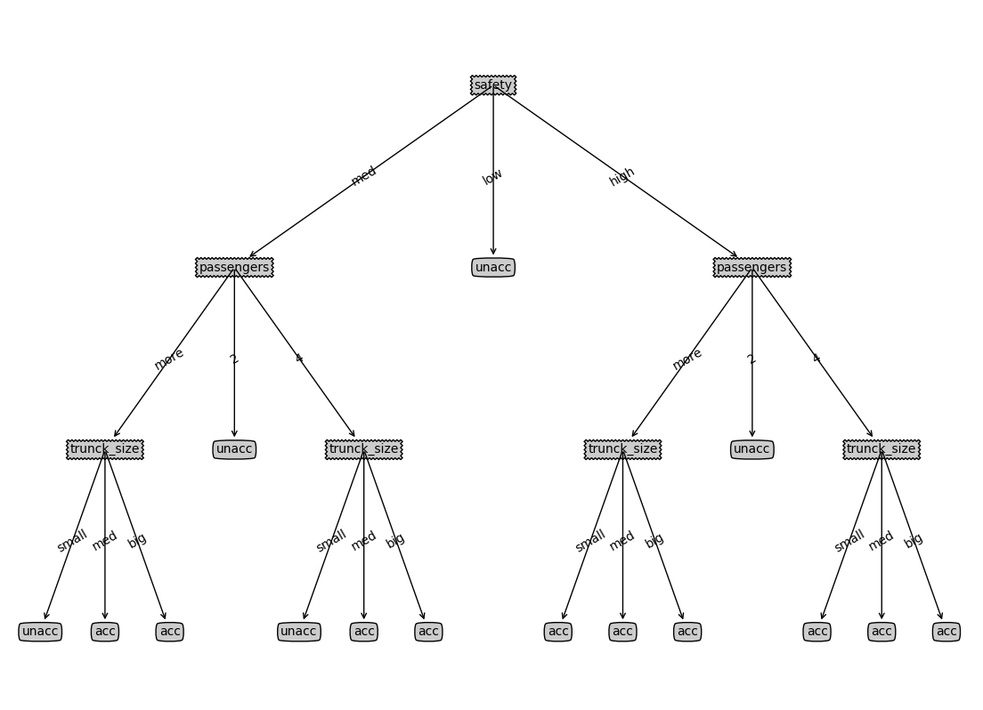
Code for stopCriteria function

def stopCriteria(dataSet):
'''
Criteria to stop splitting:
1) if all the classe labels are the same, then return the class label;
2) if there are no more features to split, then return the majority label of the subset.

Parameters
-----------------
dataSet: 2-D list
[n_sampels, m_features + 1]
the last column is class label

Returns
------------------
assignedLabel: string
if satisfying stop criteria, assignedLabel is the assigned class label;
else, assignedLabel is None
'''
assignedLabel = None

lastColumn = [row[len(row) - 1] for row in dataSet]

if lastColumn.count(lastColumn[0]) == len(lastColumn):
assignedLabel = lastColumn[0]
elif len(dataSet[0]) == 1:
assignedLabel = max(lastColumn, key = lastColumn.count)

#print(assignedLabel)
return assignedLabel

Code for chooseBestFeature function
def chooseBestFeature(dataSet):
'''
choose best feature to split based on Gini index

Parameters
-----------------
dataSet: 2-D list
[n_sampels, m_features + 1]
the last column is class label

Returns
------------------
bestFeatId: int
index of the best feature
'''

uniqueItems = []
for i in range(len(dataSet[0])):
uniqueItems.append(set([row[i] for row in dataSet]))
#print(uniqueItems)

masterGini = 1
for label in uniqueItems[len(uniqueItems) - 1]:
labelCol = ([row[len(row) - 1] for row in dataSet])
masterGini -= (labelCol.count(label) / len(labelCol)) ** 2
#print(masterGini)

gains = []
for colInd, col in enumerate(uniqueItems[:-1]):
copyMasterGini = masterGini
for item in col:
rowLabels = [dataSet[i][len(uniqueItems) - 1] for i, x in enumerate(dataSet) if x[colInd] == item]

gini = 1
for label in uniqueItems[len(uniqueItems) - 1]:
gini -= (rowLabels.count(label) / len(rowLabels)) ** 2
#print(gini)

copyMasterGini -= ([row[colInd] for row in dataSet].count(item) / len([row[colInd] for row in dataSet])) * gini

gains.append(copyMasterGini)

#print(gains)
maxGains = max(gains)
bestFeatId = gains.index(maxGains)

return bestFeatId

