Nate Dauterman
ECE 49595
April 6th, 2022

Yeast Gene Centroids

[[-2.41271429e-01 -1.28750000e-01 6.22500000e-02 1.73350000e-01
2.17914286e-01 1.65169286e+00 1.90532143e+00]

[-9.53509804e-01 -1.47164706e+00 7.75294118e-02 -1.79490196e-01
-1.00482353e+00 1.15121569e+00 9.68803922e-01]

[ 1.65103659e-01 9.16524390e-02 -1.03884146e-01 -5.52585366e-01
-6.30085366e-01 -1.72318293e+00 -1.75481098e+00]

[ 2.32857143e-02 2.50809524e-01 -2.76952381e-01 -3.64000000e-01
-7.35428571e-01 -8.94619048e-01 7.00142857e-01]

[-1.55555556e-03 1.56506173e-01 3.56253086e-01 7.01580247e-01
1.00971605e+00 1.84231481e+00 1.64341975e+00]

[-3.93289474e-02 1.53947368e-01 4.36078947e-01 1.10581579e+00
1.44871053e+00 3.01634211e+00 2.82938158e+00]]

Yest Gene PCA Plot
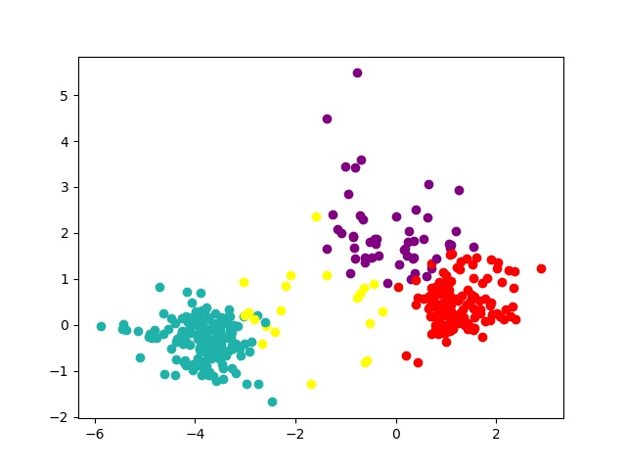

Utilities Merges

0-th merging: 12, 21, 23
1-th merging: 10, 13, 24
2-th merging: 4, 24, 25
3-th merging: 7, 23, 26
4-th merging: 25, 20, 27
5-th merging: 14, 19, 28
6-th merging: 1, 18, 29
7-th merging: 15, 26, 30
8-th merging: 29, 28, 31
9-th merging: 2, 27, 32
10-th merging: 8, 16, 33
11-th merging: 32, 30, 34
12-th merging: 34, 22, 35
13-th merging: 9, 31, 36
14-th merging: 35, 36, 37
15-th merging: 6, 37, 38
16-th merging: 3, 38, 39
17-th merging: 39, 33, 40
18-th merging: 17, 40, 41
19-th merging: 11, 41, 42
20-th merging: 5, 42, 43

K-Means Code

def assignCluster(dataSet, k, centroids):
'''For each data point, assign it to the closest centroid
Inputs:
dataSet: each row represents an observation and
each column represents an attribute
k: number of clusters
centroids: initial centroids or centroids of last iteration
Output:
clusterAssment: list
assigned cluster id for each data point
'''
clusterAssment = []

dataSetCopy = copy.deepcopy(dataSet)

for data in dataSetCopy:
minDist = -1
minIndex = -1
for cenInd, center in enumerate(centroids):
totalDist = 0
#print(data, center)
for dat, cen in zip(np.asarray(data).flatten(), np.asarray(center).flatten()):
#print(dat, cen)
totalDist += (dat - cen) ** 2
totalDist = sqrt(totalDist)
if minDist == -1 or totalDist < minDist:
minDist = totalDist
minIndex = cenInd
clusterAssment.append(minIndex)

return clusterAssment

def getCentroid(dataSet, k, clusterAssment):
'''recalculate centroids
Input:
dataSet: each row represents an observation and
each column represents an attribute
k: number of clusters
clusterAssment: list
assigned cluster id for each data point
Output:
centroids: cluster centroids
'''

dataSetCopy = copy.deepcopy(dataSet)

centroids = []
#print(centroids)

lastIndex = max(clusterAssment)
for cenInd in range(lastIndex + 1):
#print(cenInd)
indexes = np.where(np.array(clusterAssment) == cenInd)[0]
#print(indexes)
totalPoints = 0
for ind in indexes:
if isinstance(totalPoints, int):
totalPoints = copy.deepcopy(dataSet[ind])
else:
totalPoints += dataSet[ind]
#print(totalPoints)
totalPoints /= len(indexes)
#print(totalPoints.tolist()[0])
centroids.append(totalPoints.tolist()[0])
centroids = np.matrix(centroids)

return centroids

Hierarchical Cluster Code

def merge_cluster(distance_matrix, cluster_candidate, T):
''' Merge two closest clusters according to min distances
1. Find the smallest entry in the distance matrix—suppose the entry
is i-th row and j-th column
2. Merge the clusters that correspond to the i-th row and j-th column
of the distance matrix as a new cluster with index T

Parameters:
------------
distance_matrix : 2-D array
distance matrix
cluster_candidate : dictionary
key is the cluster id, value is point ids in the cluster
T: int
current cluster index

Returns:
------------
cluster_candidate: dictionary
upadted cluster dictionary after merging two clusters
key is the cluster id, value is point ids in the cluster
merge_list : list of tuples
records the two old clusters' id and points that have just been merged.
[(cluster_one_id, point_ids_in_cluster_one),
(cluster_two_id, point_ids_in_cluster_two)]
'''
merge_list = []

minValue = np.amin(distance_matrix)
#print(minValue)
index = np.where(distance_matrix.flatten() == minValue)
coords = np.unravel_index(index, (len(distance_matrix), len(distance_matrix[0])))

for key, value in cluster_candidate.items():
if coords[0].flatten()[0] in value:
id1 = key
if coords[0].flatten()[1] in value:
id2 = key

merge_list = [(id1, copy.deepcopy(cluster_candidate[id1])), (id2, copy.deepcopy(cluster_candidate[id2]))]

points1 = copy.deepcopy(cluster_candidate[id1])
points2 = copy.deepcopy(cluster_candidate[id2])
points1.extend(points2)
cluster_candidate[T] = points1

cluster_candidate.pop(id1)
cluster_candidate.pop(id2)

return cluster_candidate, merge_list

def update_distance(distance_matrix, cluster_candidate, merge_list):
''' Update the distantce matrix

Parameters:
------------
distance_matrix : 2-D array
distance matrix
cluster_candidate : dictionary
key is the updated cluster id, value is a list of point ids in the cluster
merge_list : list of tuples
records the two old clusters' id and points that have just been merged.
[(cluster_one_id, point_ids_in_cluster_one),
(cluster_two_id, point_ids_in_cluster_two)]

Returns:
------------
distance_matrix: 2-D array
updated distance matrix
'''

coordList = [[a, b] for a in merge_list[0][1] for b in merge_list[1][1] if a != b]
for coord in coordList:
distance_matrix[coord[0]][coord[1]] = 100000
distance_matrix[coord[1]][coord[0]] = 100000

return distance_matrix

