Republic of the Philippines
University of Cabuyao
(Pamantasan ng Cabuyao)
College of Computing Studies

ITP104 – Information Management 2
Semestral Project Documentation

Sales and Expense Monitoring System
for Small Businesses
A Case Study of Dela Cruz Mini Mart, City of Cabuyao, Laguna

Submitted by:
[Group Name / Member Names]

Submitted to:
[Instructor's Name]
August 2026

Table of Contents
1. Project Title and Abstract 3
2. Introduction and Background 3
3. Problem Statement 4
4. Project Objectives 4
5. Target Users and System Modules 5
6. System Requirements 6
7. System Design 8
8. Database Design 10
9. System Interface and Implementation 12
10. Core System Features 18
11. System Testing 19
12. Conclusion 21
13. Appendices 21

1. Project Title and Abstract

Official Title
Sales and Expense Monitoring System for Small Businesses

Abstract
Many small businesses in the Philippines, such as sari-sari stores, small eateries, and mini marts, still record their daily sales and operating expenses using handwritten notebooks or informal notes. This makes it difficult for the owner to know, at any given moment, how the business is actually performing. This project presents a web-based Sales and Expense Monitoring System built for small business owners, using Dela Cruz Mini Mart in Cabuyao, Laguna as the representative case study. The system allows an authenticated business owner (Administrator) and staff/cashier (Staff) to record sales transactions with itemized line items, record and categorize operating expenses, and instantly view daily and monthly summaries through a dashboard and a set of printable reports: a Daily Sales Summary, a Monthly Financial Performance report, a Category-wise Expense Breakdown, and a Profit Estimation Statement. The system enforces role-based access control so that only the owner can manage user accounts and expense categories, while staff can record day-to-day transactions. It is built with PHP, MySQL, HTML5, CSS3 (Bootstrap 5), and JavaScript, following a normalized (3NF) relational database design, prepared statements to prevent SQL injection, bcrypt password hashing, and full ACID transaction handling (commit/rollback) for every sale that is recorded, so that partial or invalid transactions are never saved.

2. Introduction and Background
Dela Cruz Mini Mart is a small, family-run retail store operating in Barangay Banay-banay, City of Cabuyao, Laguna. Like most micro and small businesses in the area, the store currently tracks its daily sales and expenses through a combination of a handwritten logbook and loose receipts kept in a folder. At the end of each day, the owner manually adds up the entries to estimate how much the business earned, and at the end of the month, the same manual process is repeated using a full month's worth of paper records to estimate overall profit.
This manual process creates several practical difficulties. Sales entries are sometimes skipped during busy hours, expense receipts are occasionally misplaced before they can be logged, and the notebook provides no easy way to see how much was spent on a specific category (such as rent or supplies) without flipping through many pages. Because totals are computed by hand, arithmetic mistakes are common, and the owner has no quick way to check whether the business is profitable on any given day until the manual tally is finished. The people most affected by these problems are the business owner, who needs accurate figures to make purchasing and pricing decisions, and the staff/cashier, who is responsible for recording transactions correctly during the day.
A computerized system directly addresses these difficulties: it enforces required fields and valid amounts at the moment a transaction is entered, computes totals automatically instead of by hand, keeps expenses organized by category from the start, and can produce a daily or monthly summary in seconds instead of requiring a manual review of paper records. This project's Sales and Expense Monitoring System was designed specifically to replace that manual process for a business of this size and type.

3. Problem Statement

General Problem
Dela Cruz Mini Mart currently records its sales and operating expenses manually using a notebook and loose receipts, making it difficult to maintain accurate, organized records and to determine the business's actual daily, and monthly financial performance.

Specific Problems
- Difficulty in accurately recording sales transactions with multiple items, since totals are computed by hand and are prone to arithmetic errors.
- Difficulty in recording and organizing operating expenses by category (e.g., rent, utilities, supplies), since the notebook lists them chronologically rather than by type.
- Difficulty in determining daily and monthly sales and expense totals without manually reviewing every paper entry for the period.
- Difficulty in estimating whether the business is profitable at a given point in time, since profit is only calculated after manually totaling both sales and expenses.
- Difficulty in producing a presentable, shareable summary or report of the business's performance, since the only record that exists is the handwritten notebook itself.

4. Project Objectives

General Objective
To develop a web-based Sales and Expense Monitoring System that allows a small business owner and staff to accurately record sales and operating expenses, and to view organized, accurate summaries of daily and monthly business performance.

Specific Objectives
The system aims to:
- Provide secure, role-based user authentication so that only authorized personnel (Administrator or Staff) can access the system, with each role restricted to the functions appropriate to their responsibilities.
- Allow staff to record sales transactions with one or more line items, with the total automatically computed and saved through a complete, all-or-nothing database transaction.
- Allow the recording and categorization of operating expenses under owner-managed expense categories.
- Allow users to search and filter sales and expense records by date range, category, and payment method.
- Generate a real-time dashboard and four printable reports (Daily Sales Summary, Monthly Financial Performance, Category-wise Expense Breakdown, and Profit Estimation Statement) based on actual recorded data.
- Apply basic security practices throughout the system, including password hashing, prepared SQL statements, session-based access control, and input validation on both the client and server.

5. Target Users and System Modules

Target Users
User | Responsibility
Administrator (Business Owner) | Full access to the system: manages user accounts, manages expense categories, records and edits/deletes sales and expenses, and views all dashboards and reports.
Staff (Cashier) | Day-to-day access: records sales and expenses and views/edit records they are permitted to, without access to user account management or expense category management.

System Modules
User & Access Management → Sales Management → Expense Management → Expense Category Management → Dashboard → Reports
Module | Purpose
User & Access Management | Login/logout, session-based role restriction, and (Administrator only) creating, editing, deactivating, and deleting staff/admin accounts.
Sales Management | Recording a sale with one or more line items through a full database transaction, viewing/printing a sale receipt, searching/filtering sales history, and deleting a sale (Administrator only).
Expense Management | Recording, editing, searching/filtering, and deleting operating expenses, each linked to an expense category.
Expense Category Management | (Administrator only) Adding, editing, and deleting the categories used to classify expenses.
Dashboard | Real-time summary of today's sales, expenses, and net profit, this month's totals, and a recent activity feed.
Reports | Four printable reports: Daily Sales Summary, Monthly Financial Performance, Category-wise Expense Breakdown, and Profit Estimation Statement.

6. System Requirements

Functional Requirements
ID | Requirement
FR-01 | The system shall allow a user to log in using a username and password, and shall reject invalid credentials with a generic error message.
FR-02 | The system shall restrict access to pages and functions based on the logged-in user's role (Administrator or Staff).
FR-03 | The system shall allow an Administrator to create, edit, deactivate, and delete user accounts.
FR-04 | The system shall allow an Administrator to add, edit, and delete expense categories, preventing duplicate category names.
FR-05 | The system shall allow an authorized user to record a sale consisting of one or more line items, with the sale total computed automatically from those items.
FR-06 | The system shall save a sale and all of its line items as a single, complete transaction, so that if any part of the transaction fails, none of it is saved.
FR-07 | The system shall allow an authorized user to record an operating expense with a date, category, description, and amount.
FR-08 | The system shall allow users to search and filter sales records by date range and payment method.
FR-09 | The system shall allow users to search and filter expense records by date range, category, and description keyword.
FR-10 | The system shall validate every data-entry form on both the client side and the server side before saving a record.
FR-11 | The system shall reject invalid input, including negative amounts, zero or negative quantities, missing required fields, and future-dated expenses, with a clear message identifying the problem.
FR-12 | The system shall display a dashboard showing today's total sales, total expenses, net profit, a profit status classification, and recent account activity.
FR-13 | The system shall generate a Daily Sales Summary report for any selected date.
FR-14 | The system shall generate a Monthly Financial Performance report showing day-by-day sales and expense totals for a selected month.
FR-15 | The system shall generate a Category-wise Expense Breakdown report with subtotals per category and a grand total for a selected month.
FR-16 | The system shall generate a Profit Estimation Statement for a selected date range, including profit margin and status.
FR-17 | The system shall allow every report to be printed using the browser's print function, formatted for print rather than for screen navigation.
FR-18 | The system shall log key account activity (logins, logouts, and record changes) for the Administrator to review.

Non-Functional Requirements
- Usability: The interface uses a consistent layout (top bar, role-aware sidebar, and content area) built with Bootstrap 5, with clear labels and inline validation messages, so that a first-time staff user can record a sale or expense without additional training.
- Security: Passwords are hashed with bcrypt (never stored in plain text); every database query uses parameterized/prepared statements to prevent SQL injection; every form submission is protected by a CSRF token; and every restricted page re-checks the logged-in user's role on the server before rendering.
- Performance: Common list views (sales, expenses) are indexed on their date and lookup columns and capped to the most recent 200 records per view, keeping page loads fast for a small business's realistic transaction volume.
- Reliability: Sale recording is wrapped in a database transaction (BEGIN/COMMIT/ROLLBACK); if any step fails, the entire sale is discarded rather than left partially saved, and the user sees a clear message instead of a raw database error.
- Compatibility: The system runs on a standard XAMPP stack (Apache, MySQL/MariaDB, PHP 8) and its interface is responsive down to small-screen/mobile widths, since it was verified using Bootstrap's responsive grid.

7. System Design

System / Process Flowchart
The diagram below shows the complete flow for the system's core transaction — recording a sale — from login through confirmation, matching the actual implementation in modules/sales/add.php.
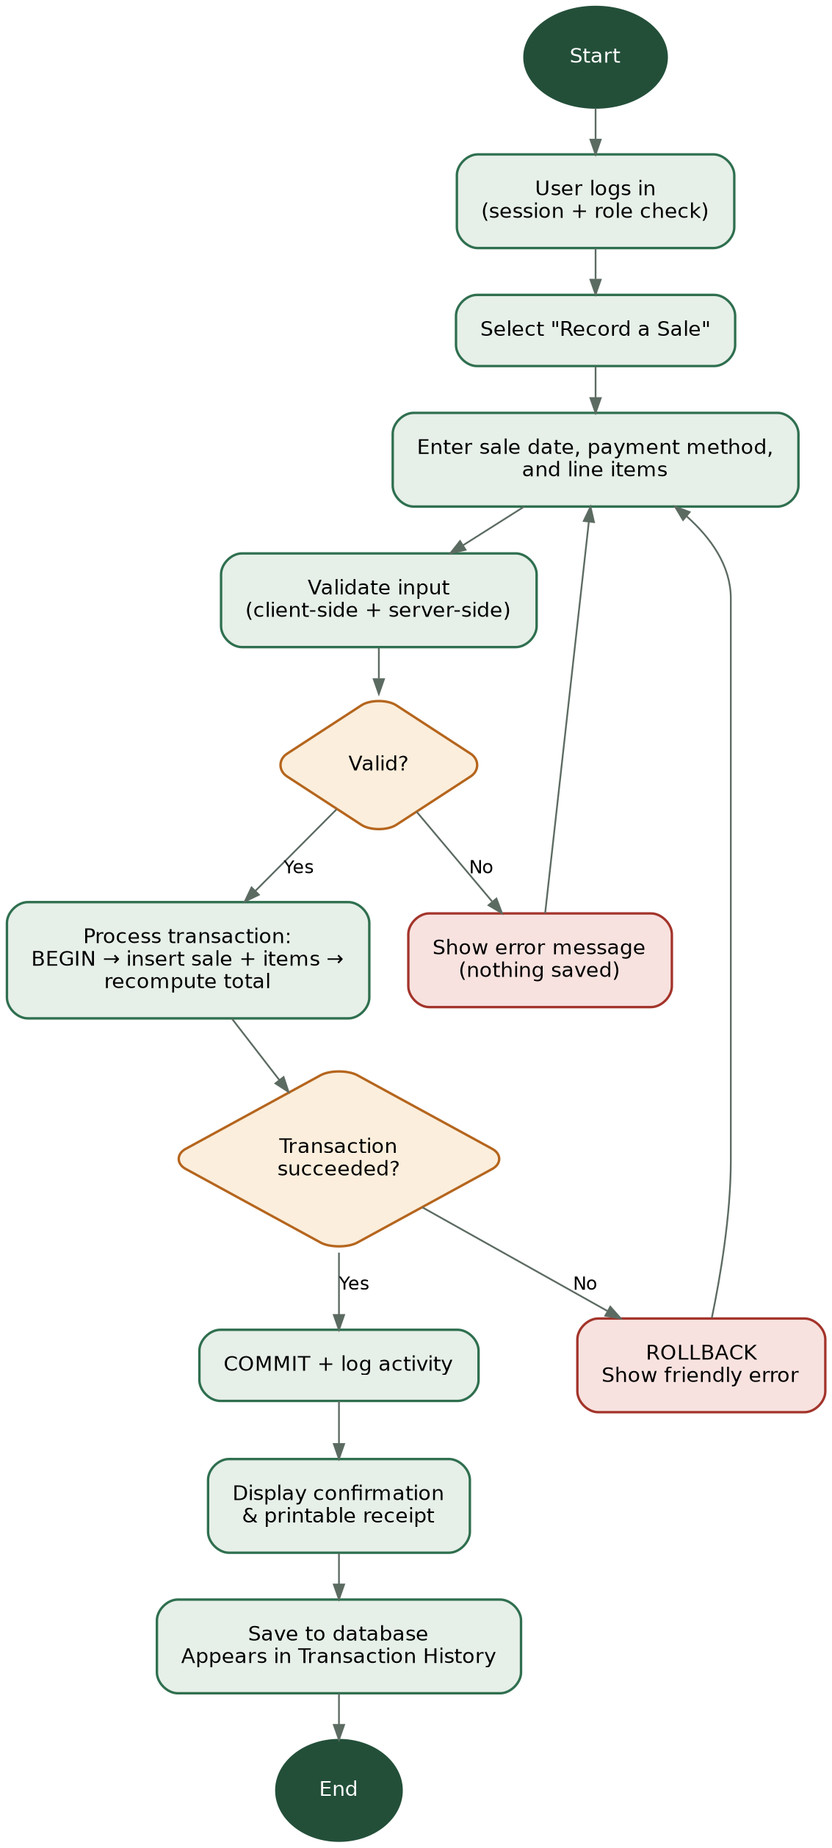
Figure 1. Sale recording process flowchart.

Entity Relationship Diagram
The ERD below reflects the actual database structure implemented in schema.sql, including every primary key, foreign key, and relationship.
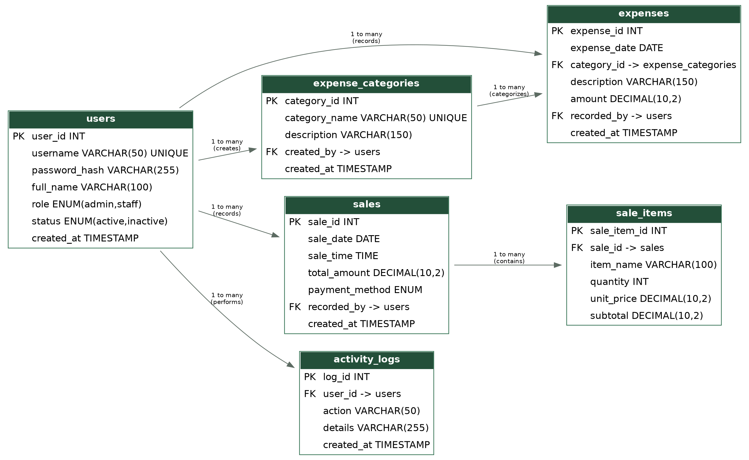
Figure 2. Entity Relationship Diagram.

8. Database Design
The database is normalized to Third Normal Form (3NF): every non-key column depends only on its table's primary key, there are no repeating groups, and no data is unnecessarily duplicated. The one intentional exception is sales.total_amount, which caches the sum of its sale_items — this value is written only by the sp_finalize_sale stored procedure immediately after a sale's items are inserted, so it can never drift out of sync with the line items it summarizes.

Data Dictionary
Table | Field | Data Type | Key | Description
users | user_id | INT, AUTO_INCREMENT | PK | Unique identifier for each user account.
users | username | VARCHAR(50), UNIQUE |  | Login name used to sign in.
users | password_hash | VARCHAR(255) |  | Bcrypt hash of the account password. Never stores plain text.
users | full_name | VARCHAR(100) |  | Display name shown throughout the system.
users | role | ENUM('admin','staff') |  | Determines which pages and functions the account can access.
users | status | ENUM('active','inactive') |  | Inactive accounts cannot log in.
users | created_at | TIMESTAMP |  | Date/time the account was created.
expense_categories | category_id | INT, AUTO_INCREMENT | PK | Unique identifier for each expense category.
expense_categories | category_name | VARCHAR(50), UNIQUE |  | Category label (e.g., Rent, Utilities).
expense_categories | description | VARCHAR(150) |  | Optional note describing the category.
expense_categories | created_by | INT | FK → users | The Administrator who created the category.
expense_categories | created_at | TIMESTAMP |  | Date/time the category was created.
sales | sale_id | INT, AUTO_INCREMENT | PK | Unique identifier for each sale transaction.
sales | sale_date | DATE |  | Calendar date of the sale.
sales | sale_time | TIME |  | Time of day the sale was recorded.
sales | total_amount | DECIMAL(10,2) |  | Sum of all line-item subtotals; recomputed by sp_finalize_sale.
sales | payment_method | ENUM(cash,gcash,card,bank_transfer) |  | How the customer paid.
sales | recorded_by | INT | FK → users | The user who recorded the sale.
sales | created_at | TIMESTAMP |  | Date/time the record was created.
sale_items | sale_item_id | INT, AUTO_INCREMENT | PK | Unique identifier for each line item.
sale_items | sale_id | INT | FK → sales | The sale this item belongs to.
sale_items | item_name | VARCHAR(100) |  | Name of the item or service sold.
sale_items | quantity | INT |  | Quantity sold; must be greater than zero.
sale_items | unit_price | DECIMAL(10,2) |  | Price per unit; must be zero or positive.
sale_items | subtotal | DECIMAL(10,2) |  | quantity × unit_price.
expenses | expense_id | INT, AUTO_INCREMENT | PK | Unique identifier for each expense record.
expenses | expense_date | DATE |  | Date the expense was incurred.
expenses | category_id | INT | FK → expense_categories | The category this expense belongs to.
expenses | description | VARCHAR(150) |  | What the expense was for.
expenses | amount | DECIMAL(10,2) |  | Amount spent; must be greater than zero.
expenses | recorded_by | INT | FK → users | The user who recorded the expense.
expenses | created_at | TIMESTAMP |  | Date/time the record was created.
activity_logs | log_id | INT, AUTO_INCREMENT | PK | Unique identifier for each activity entry.
activity_logs | user_id | INT | FK → users | The user who performed the action.
activity_logs | action | VARCHAR(50) |  | Short action code (e.g., LOGIN, SALE_RECORDED).
activity_logs | details | VARCHAR(255) |  | Human-readable description shown on the dashboard.
activity_logs | created_at | TIMESTAMP |  | Date/time the action occurred.
The complete, executable version of this structure — including all constraints, indexes, seed data, and stored procedures — is in the accompanying schema.sql file.

9. System Interface and Implementation
The screenshots below were captured from the actual working system running on localhost/XAMPP, not mockups or templates. Each is followed by a short explanation of what it shows.
Interface | Purpose
Login | Authenticates users (login.php).
Dashboard | Displays today's sales/expenses/profit, this month's totals, and recent activity (dashboard.php).
Data Entry | Adds a new sale (with line items) or a new expense (modules/sales/add.php, modules/expenses/add.php).
Record Management | Lists and manages existing sales, expenses, categories, and users (each module's list.php).
Transaction | The sale recording transaction and its printable receipt confirmation (modules/sales/add.php, view.php).
Search/Filter | Date range, category, and payment-method filters on the Sales and Expenses list pages.
Reports | The four printable reports under modules/reports/ (see Appendix C).

Login
A screenshot of the login page itself is still pending and should be added here before final submission (see the note at the end of this section).

Dashboard
The dashboard for the Administrator account, showing today's sales, expenses, and net profit (correctly computed and flagged as a "Loss" for this test day), this month's running total, quick actions, and the recent activity feed pulled from activity_logs.
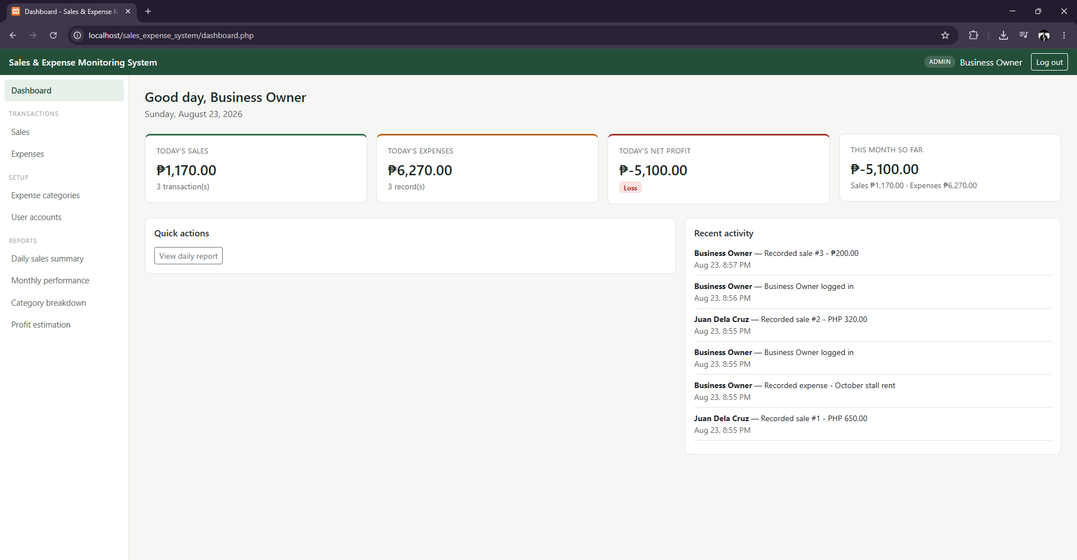

Data Entry — Record a Sale
The "Record a Sale" form with a line item being entered (8 units of "Pens" at ₱30.00 each). The subtotal and grand total update live in the browser as quantity and price are typed, before the form is even submitted.
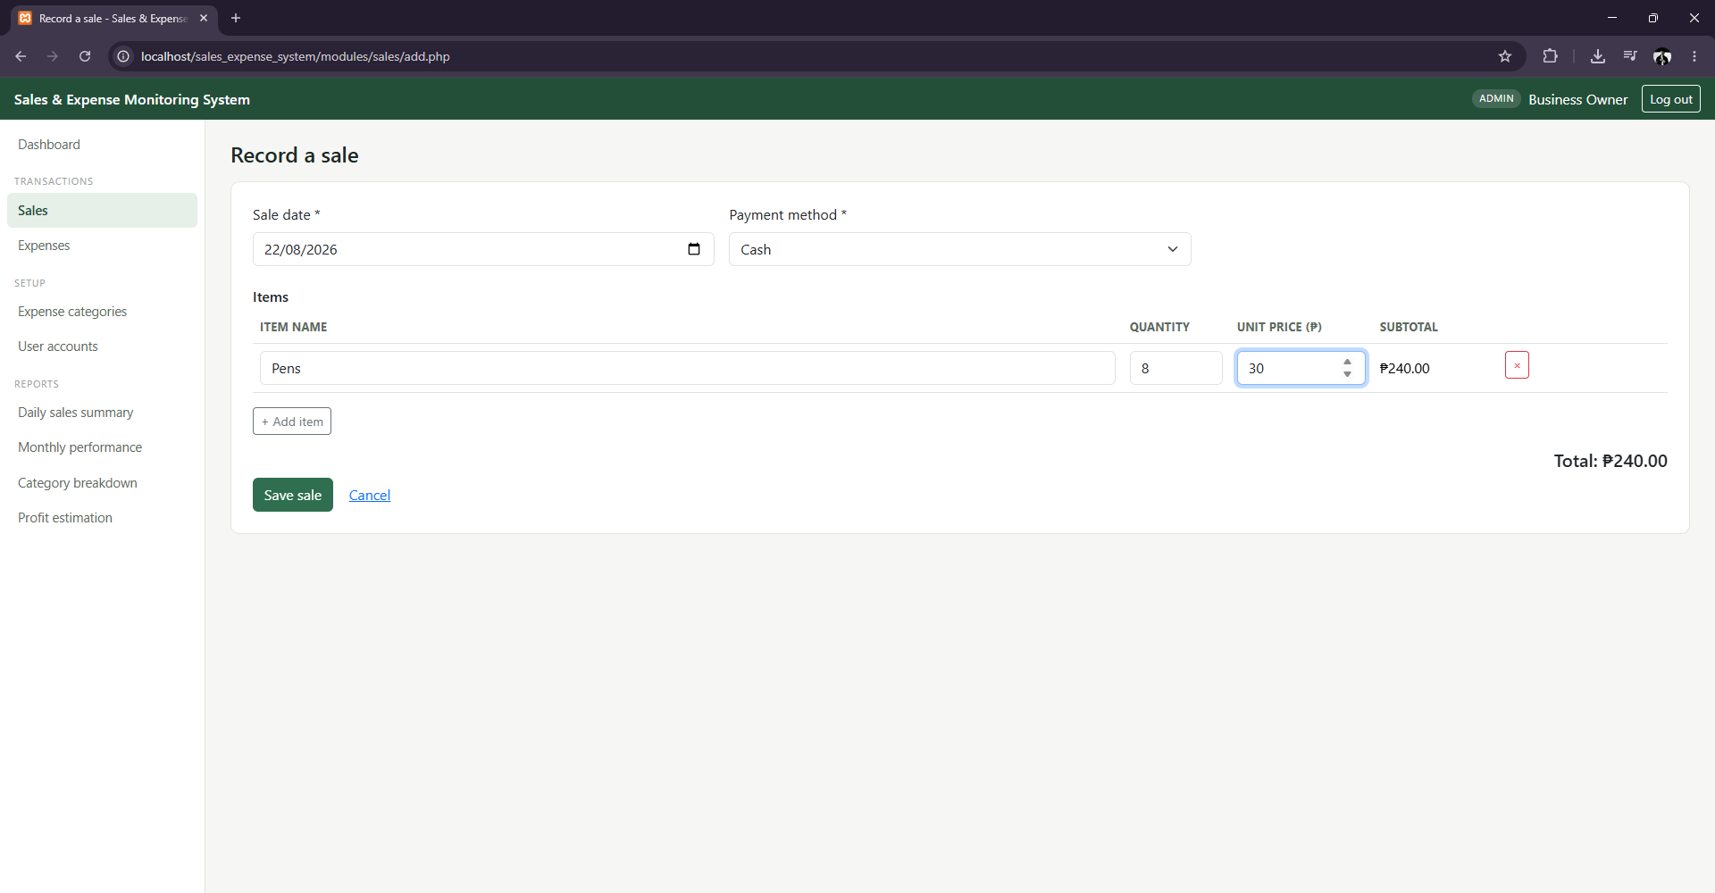

Transaction — Confirmation & Receipt
After submission, the sale is committed as sale #4 and the system redirects to a printable confirmation showing the exact items and total that were saved — the "Confirmation" step of the required transaction flow.
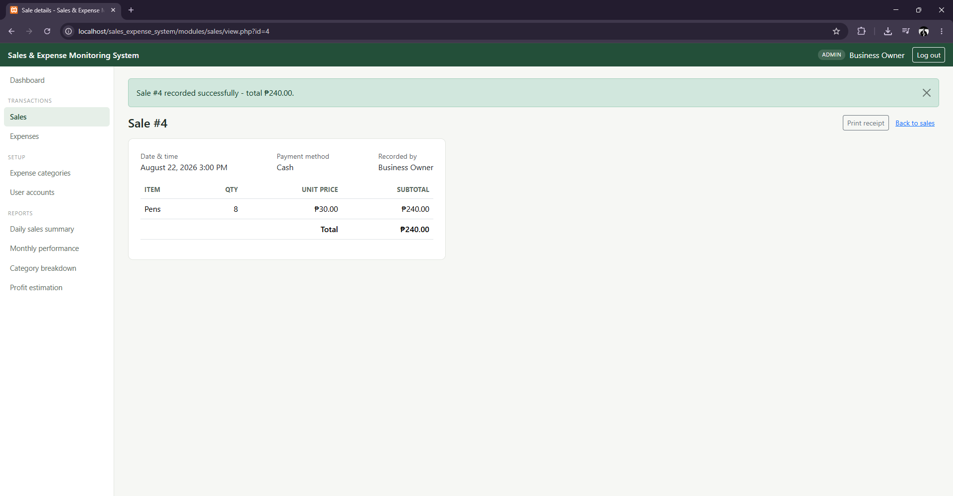

Data Entry — Record an Expense
The expense entry form, with a category selected from the owner-managed category list, a description, and an amount.
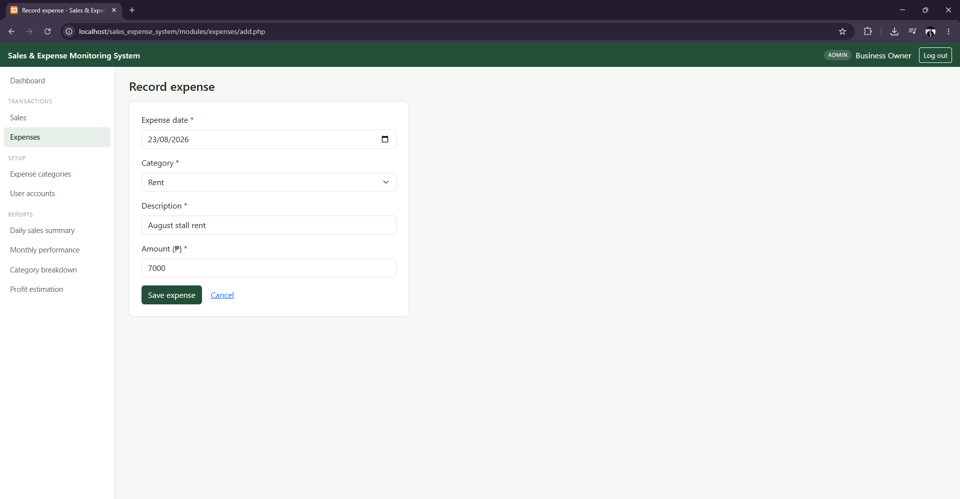

Record Management — Sales List
Transaction history for Sales, showing every recorded sale with its item count, payment method, total, and who recorded it, plus the date-range and payment-method filter controls.
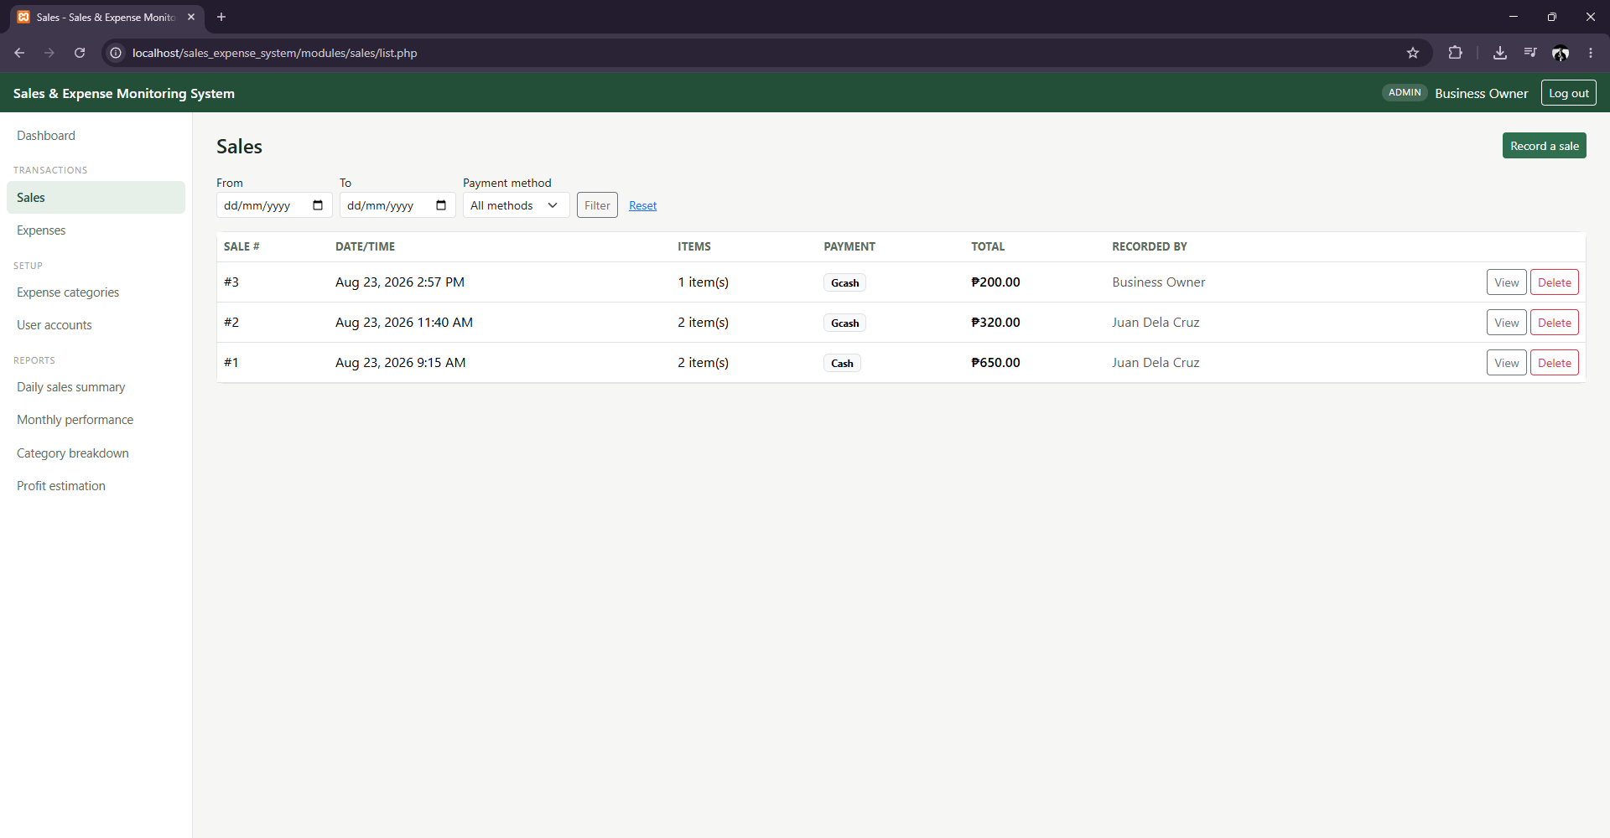

Search / Filter — Sales by Payment Method
The same Sales list filtered to Gcash-only transactions via the Payment method dropdown — the URL itself reflects the filter (payment_method=gcash), confirming the filter is a real server-side query rather than a client-side hide/show.
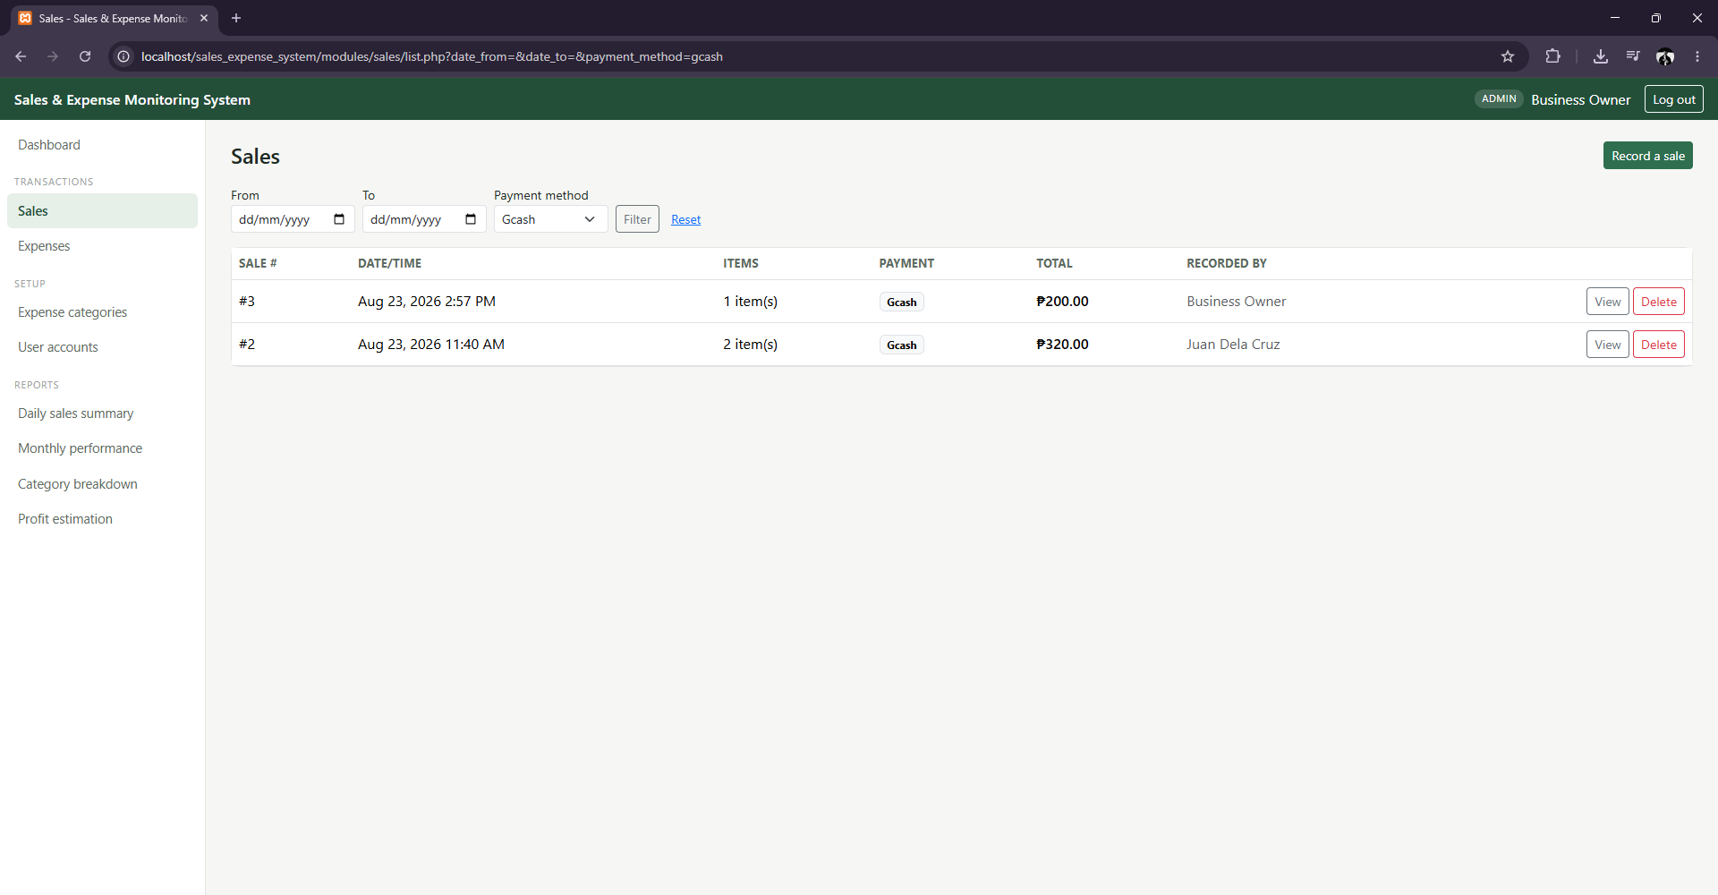

Record Management — Expenses List
The Expenses list, showing each recorded expense with its category badge, description, amount, and who recorded it.
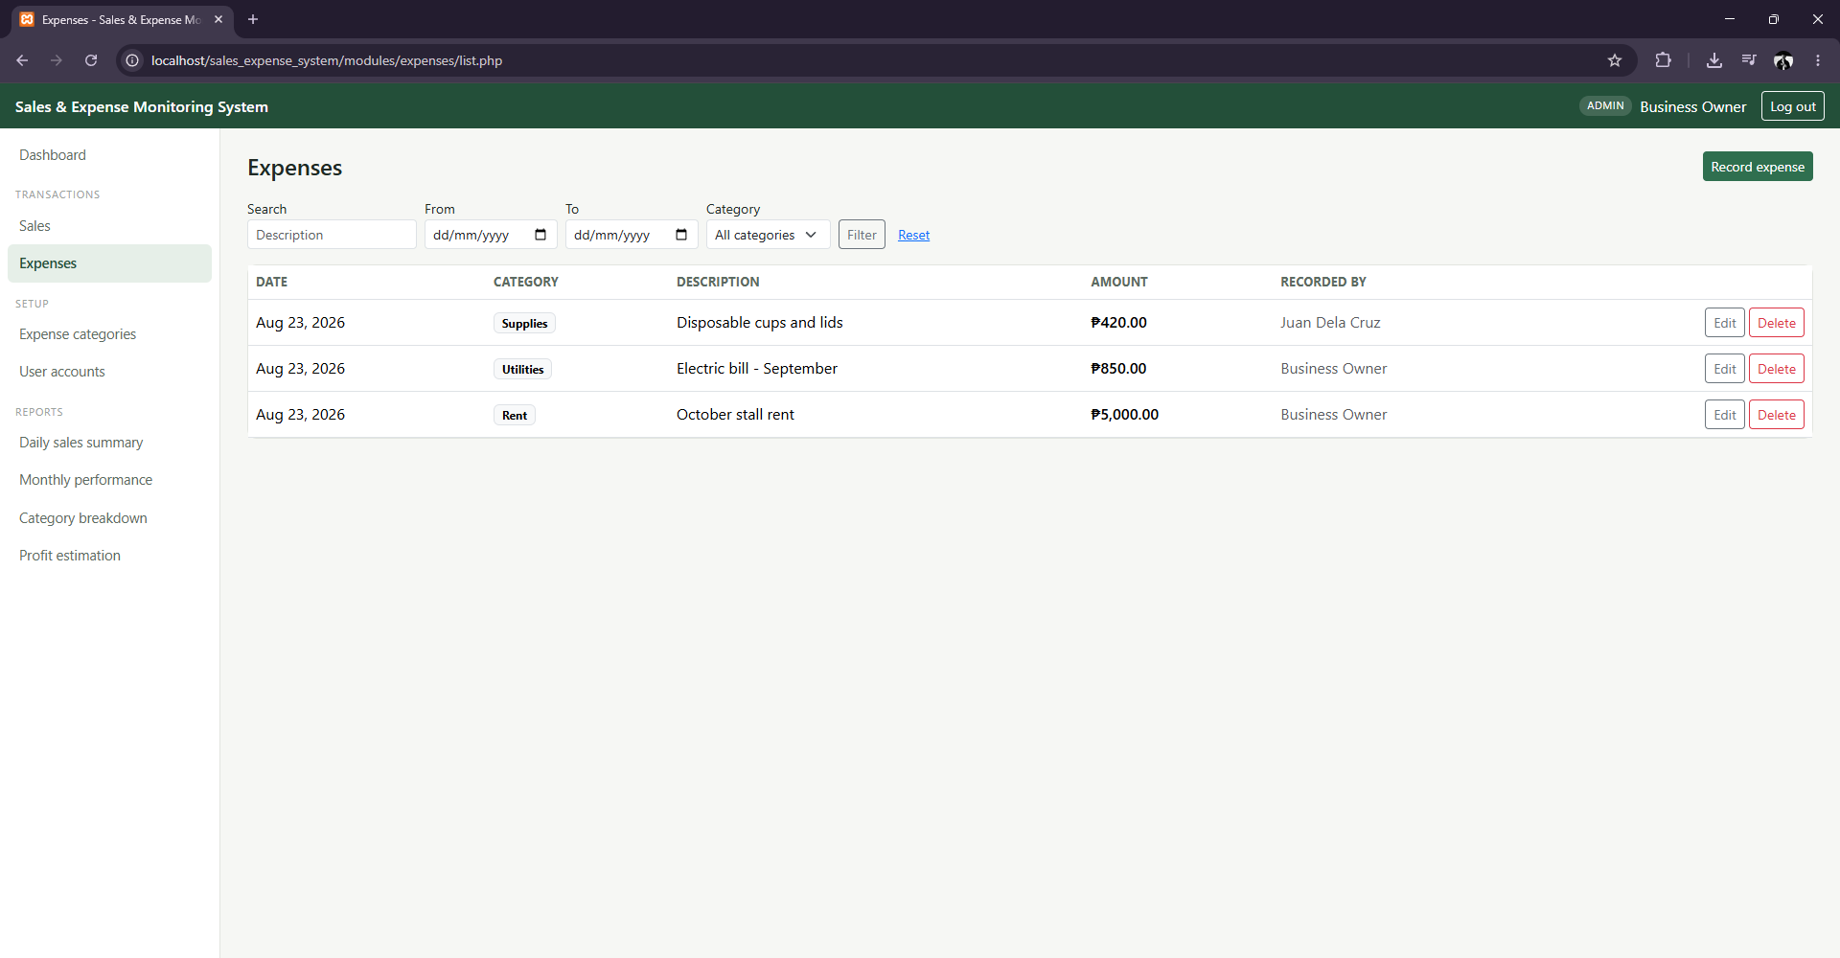

Search / Filter — Expenses by Category
The Expenses list filtered to the Utilities category only, demonstrating the category filter alongside the existing description-search and date-range controls.
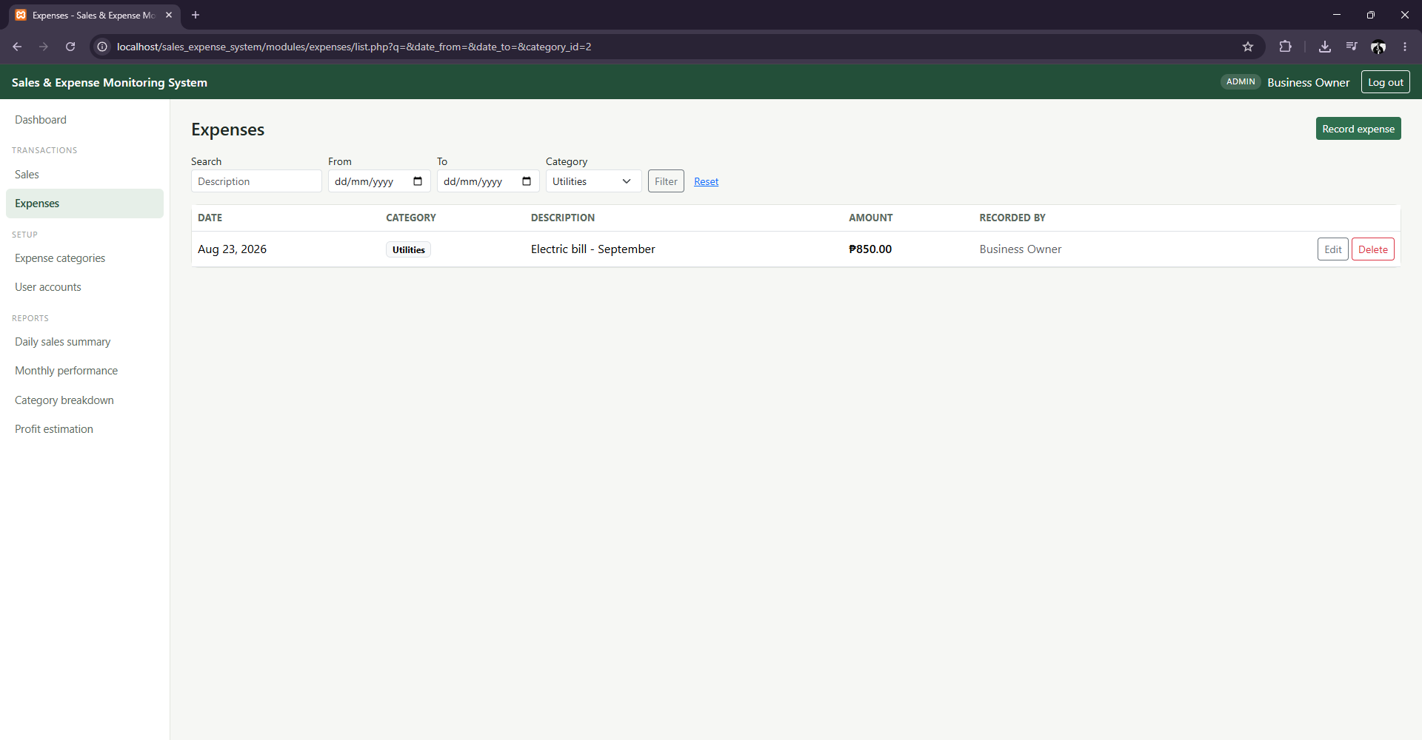

Record Management — Expense Categories
The Administrator-only Expense Categories page, showing each category, its description, who created it, and how many expenses currently use it — this usage count is what the delete safeguard (Test Case TC-09) checks before allowing a category to be removed.
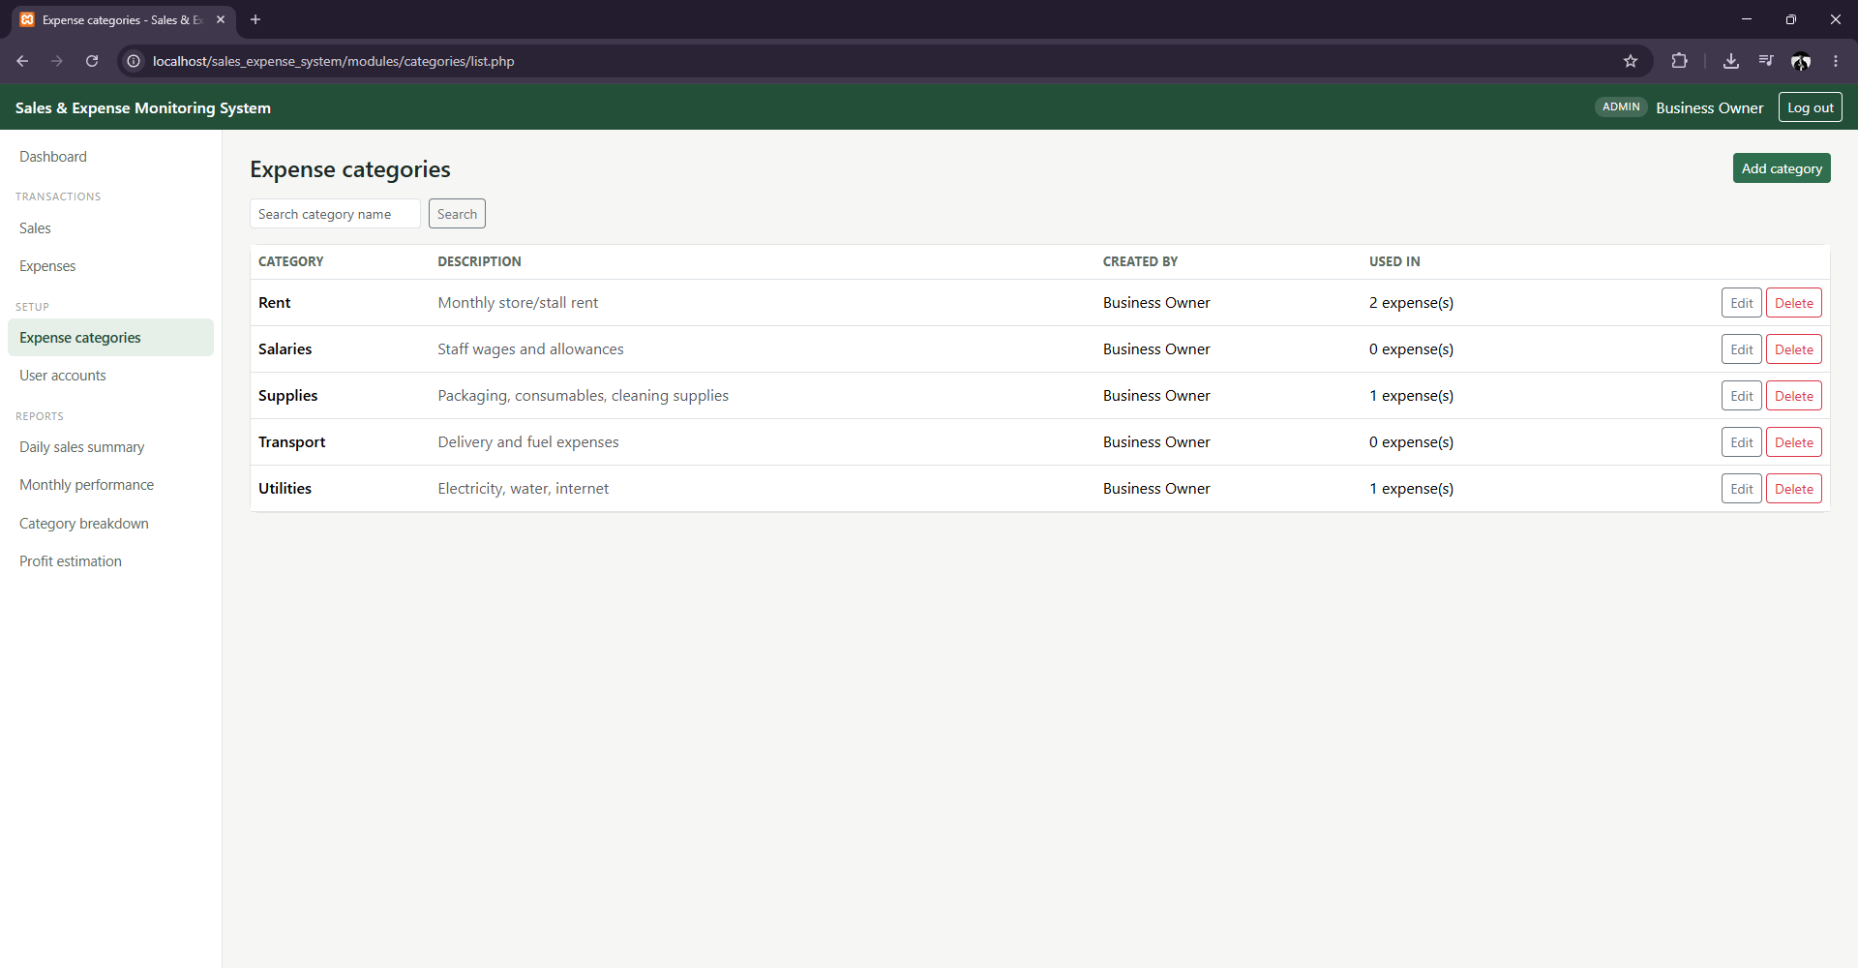

Record Management — User Accounts
The Administrator-only User Accounts page after creating a new staff account, showing all three current users, their roles, and their active/inactive status.
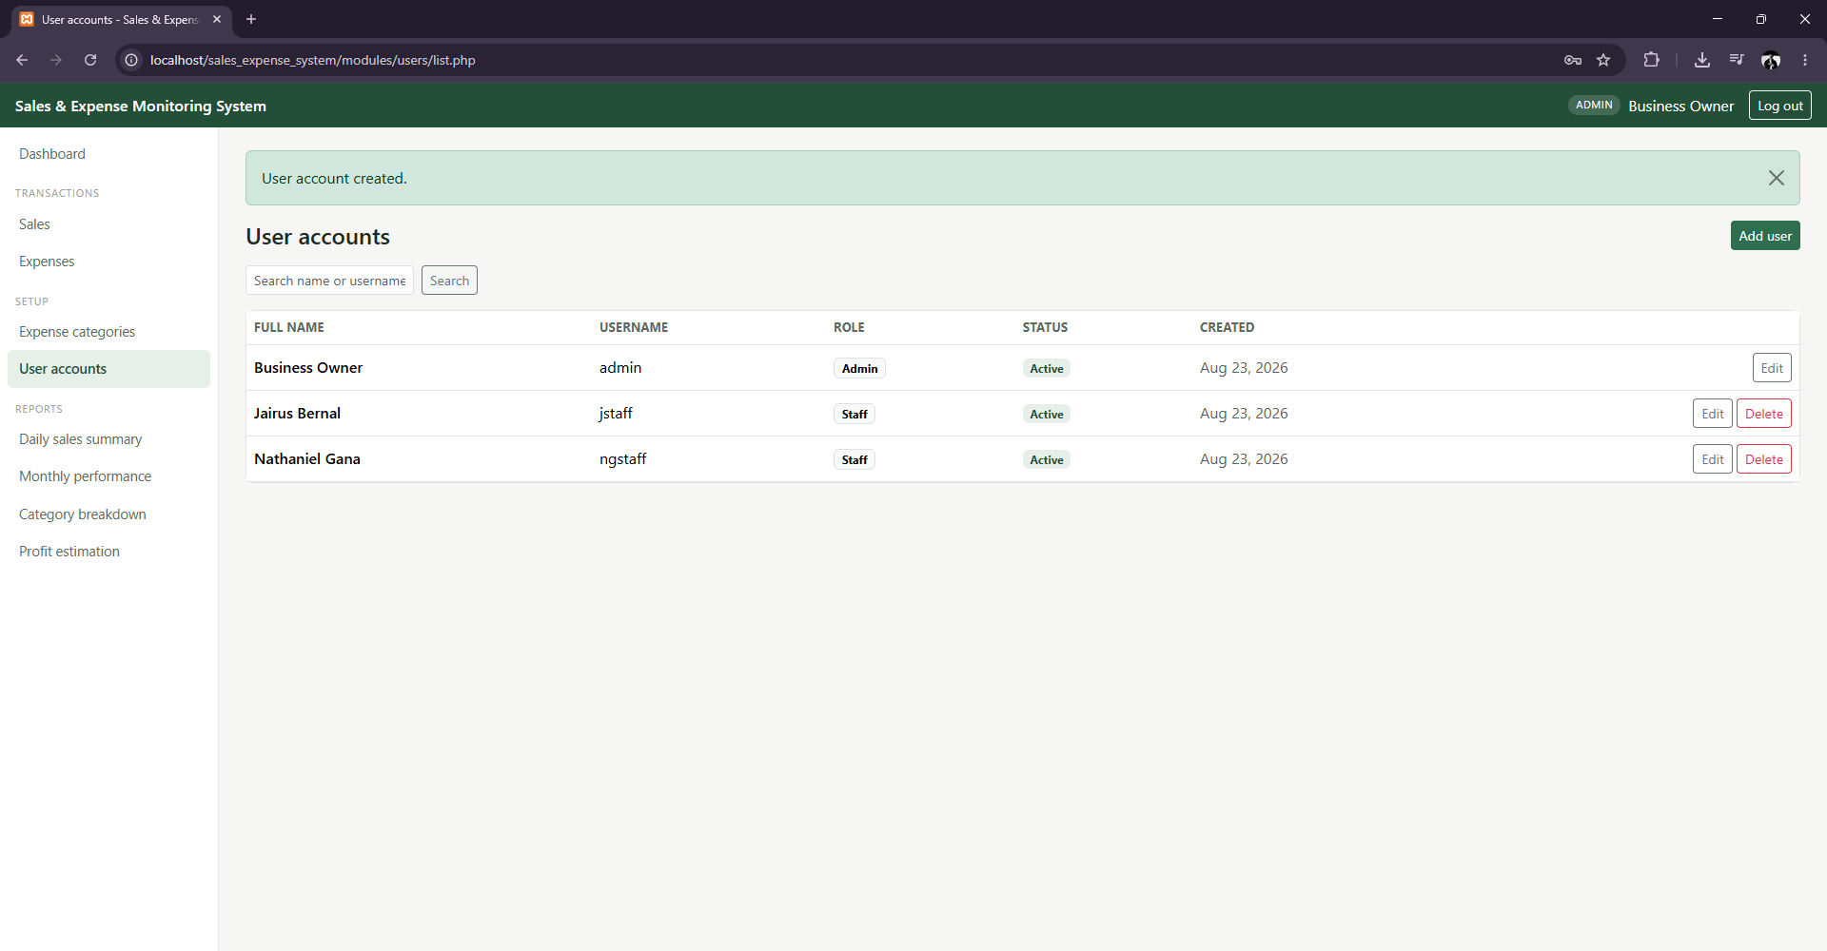
Still needed before final submission: a screenshot of the Login page. All other required interfaces (Login excepted) are documented above with real, current screenshots from the working system.

10. Core System Features

User Authentication
Session-based login/logout with two roles (Administrator, Staff), each with different access permissions enforced on every restricted page via a server-side role check.

CRUD Operations
Each major module — Sales, Expenses, Expense Categories, and Users — has its own dedicated Create, Read, Update, and Delete pages tailored to that module's fields and rules, rather than one generic form reused for everything.

Transaction Processing
Recording a sale is the system's core transaction: the sale header and every line item are inserted, and the total is recomputed, inside one database transaction. If any step fails, the entire sale is rolled back and nothing is saved.

Search and Filtering
The Sales list can be filtered by date range and payment method; the Expenses list can be filtered by date range, category, and a description keyword search. Both are backed by parameterized SQL queries.

Input Validation
Every data-entry form checks required fields, valid dates (including rejecting future-dated expenses), positive quantities and amounts, and duplicate expense category names — enforced on both the browser and the server.

Error Handling
Database exceptions are caught and converted into plain-language messages (e.g., "Unable to save the record. Please check the information and try again.") instead of ever showing raw SQL errors to the user.

Dashboard
The dashboard shows only figures computed from real data: today's total sales, today's total expenses, today's net profit with a status classification (Healthy / Low margin / Loss / No sales yet), this month's running total, and the eight most recent account activities.

Reports
Four printable reports are generated directly from the database: Daily Sales Summary, Monthly Financial Performance, Category-wise Expense Breakdown, and Profit Estimation Statement.

11. System Testing
The test cases below were executed directly against the working system during development — real HTTP requests against a live PHP application connected to a live MySQL database, not simulated. Before final submission, each of these should also be re-run manually through the browser and captured as a screenshot for Appendix A, since the documentation guidelines require test evidence to come from the actual interface.
Test ID | Function | Test Input | Expected Result | Actual Result | Status
TC-01 | Login | Correct username & password (admin / Admin@123) | Login successful, redirected to dashboard | Login successful | PASS
TC-02 | Login | Incorrect password | Generic error message shown, no session created | "Invalid username or password." shown | PASS
TC-03 | Record Sale | Valid sale: 1 item, qty 3, price 99.50 | Sale saved, total = 298.50 | Sale #4 saved, total_amount = 298.50 | PASS
TC-04 | Record Sale | Invalid item: quantity = 0 | Validation message shown, no sale record created | "quantity must be a whole number greater than zero" shown; sales count unchanged | PASS
TC-05 | Transaction | Valid multi-step sale transaction (header + items + total) | Database updated atomically; all rows consistent | sales row + sale_items rows created with matching total | PASS
TC-06 | Record Expense | Valid expense: category, description, amount = 250.75 | Expense saved | Expense #4 saved with amount 250.75 | PASS
TC-07 | Security (CSRF) | Form submitted with a forged/invalid CSRF token | Request rejected, no record saved | Redirected to login; no new expense row created | PASS
TC-08 | Add Category | Duplicate category name ("Rent", already exists) | Rejected with a duplicate-name message | "A category with that name already exists." shown | PASS
TC-09 | Delete Category | Delete a category still used by existing expenses | Deletion blocked with a friendly explanation | "This category cannot be deleted because it is used by existing expenses..." shown | PASS
TC-10 | Access Control (RBAC) | Staff account requests the admin-only User Accounts page | Access denied (403) | HTTP 403, "Access denied" page shown | PASS
TC-11 | View Transaction | Open a saved sale's receipt view | Receipt displays correct items and total | Sale #4 receipt rendered with correct items/total | PASS
TC-12 | System Stability | Load all 9 major pages (dashboard, list, and report pages) while logged in | All pages return HTTP 200 with no PHP errors/warnings | All 9 pages returned HTTP 200, 0 errors in output | PASS
TC-13 | Database Constraint | Direct SQL insert of a negative quantity / negative amount | Database rejects the row via CHECK constraint | MySQL error 4025 (constraint violation) raised, row not inserted | PASS
TC-14 | Stored Procedure | CALL sp_get_daily_summary on a day with expenses exceeding sales | profit_status returned as "Loss" | Returned net_profit = -5300.00, profit_status = "Loss" | PASS
TC-15 | Stored Procedure (ROLLUP) | CALL sp_monthly_category_report for the current month | Per-category subtotals plus one grand-total row | 3 category rows + 1 GRAND TOTAL row (6270.00), matching manual sum | PASS

12. Conclusion
The Sales and Expense Monitoring System addresses the manual record-keeping problems identified for Dela Cruz Mini Mart: sales are now recorded with automatically computed totals inside a safe, all-or-nothing transaction; expenses are organized under owner-managed categories from the moment they are entered; and daily and monthly performance is available immediately through the dashboard and the four printable reports, rather than requiring a manual review of a paper notebook.
All six project objectives were met: role-based authentication was implemented and verified with real login attempts across both roles; sales are recorded through a genuine multi-step database transaction with rollback on failure; expenses are recorded and categorized; sales and expenses can be searched and filtered; all four reports generate correctly from live data; and the required security practices (password hashing, prepared statements, session-based access control, and input validation) are applied throughout, not just in isolated places.
For a business like Dela Cruz Mini Mart, the practical improvement is straightforward: what used to take a manual review of a paper notebook at the end of the day or month now takes a few seconds on the dashboard or a single printed report, with the arithmetic errors of hand-tallying removed entirely.

13. Appendices

Appendix A — Test Cases
See Section 11 for the completed test case table. Screenshots of each test executed through the browser should be added here before final submission.

Appendix B — Data Dictionary
See Section 8 for the complete data dictionary. The full, executable schema is provided separately as schema.sql.

Appendix C — Sample Reports
The four printable reports, generated from the actual data recorded during testing.
Daily Sales Summary — for August 23, 2026:
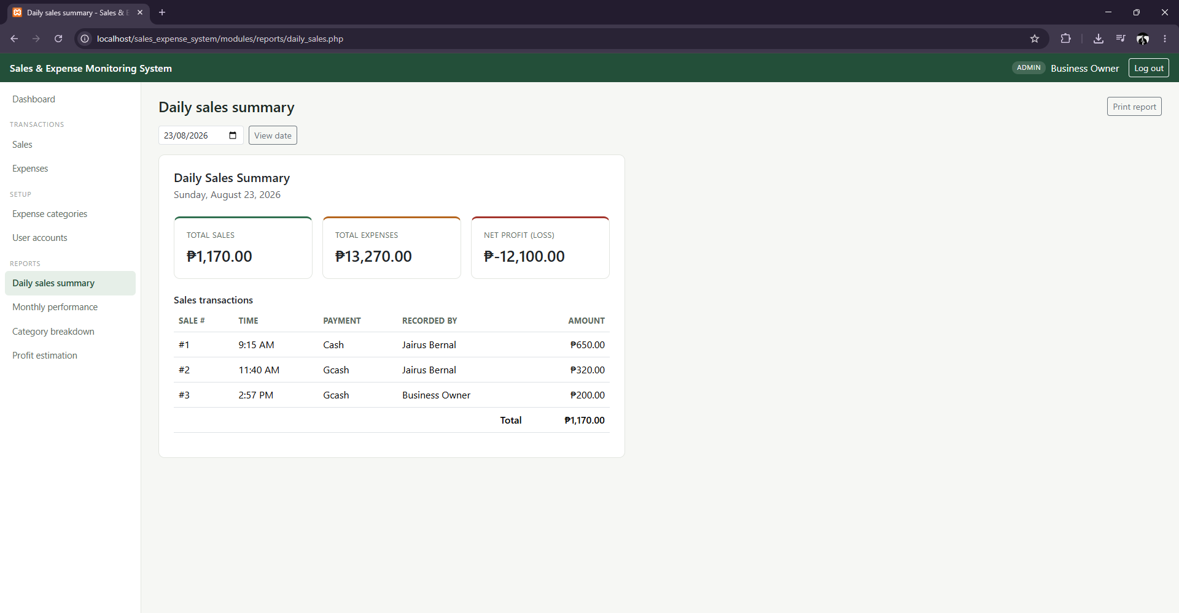
Monthly Financial Performance — for August 2026, showing the day-by-day breakdown produced by the GROUP BY ... WITH ROLLUP query:
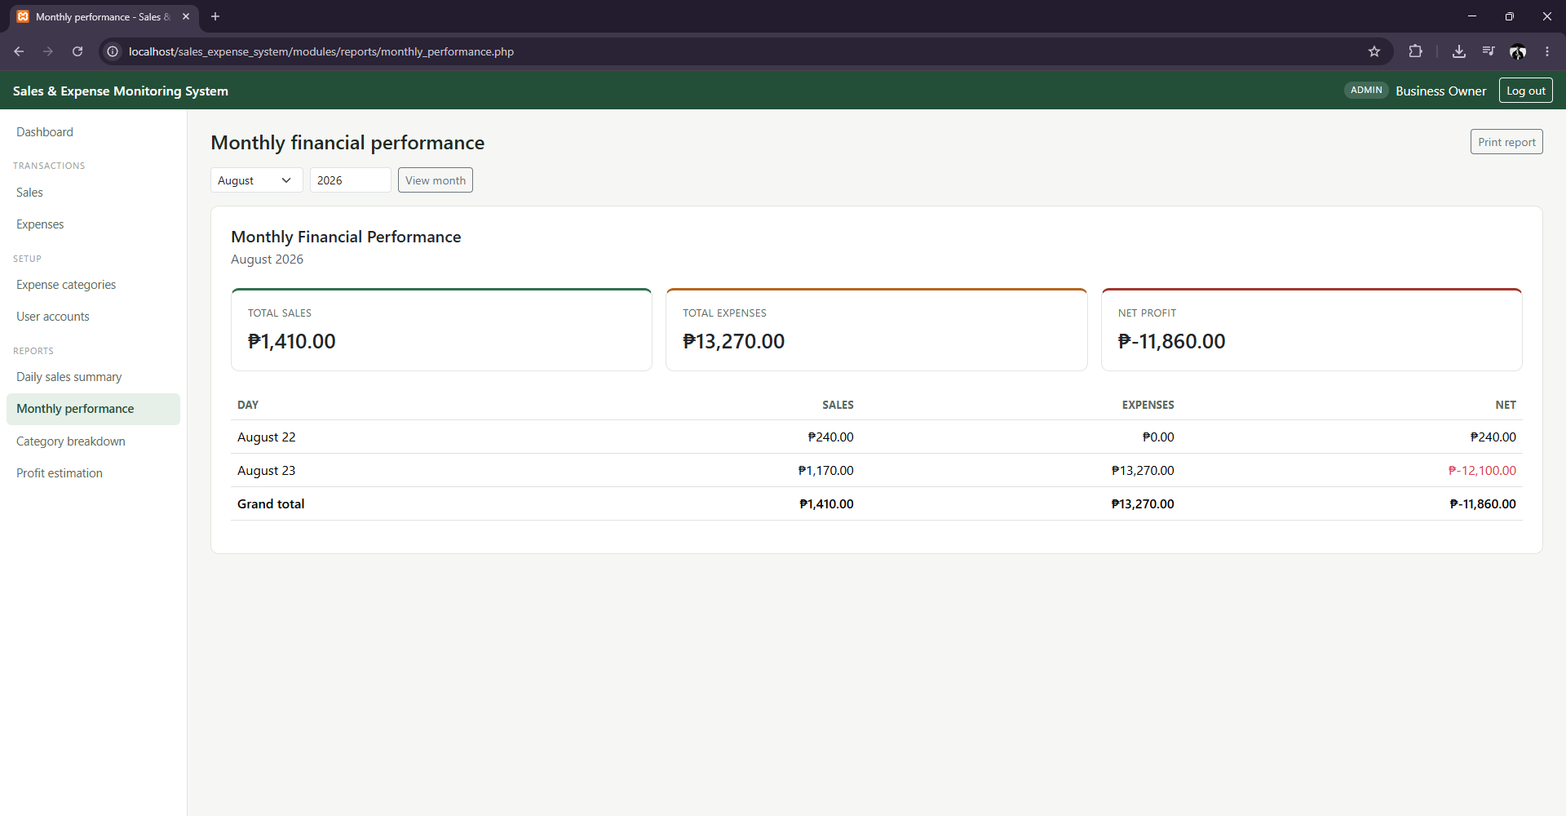
Category-wise Expense Breakdown — for August 2026, with per-category subtotals and a grand total row (sp_monthly_category_report):
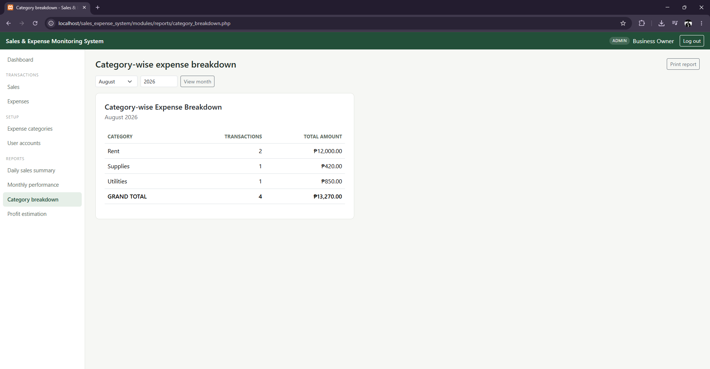
Profit Estimation Statement — for August 1–23, 2026, including profit margin, status, and where expenses went:
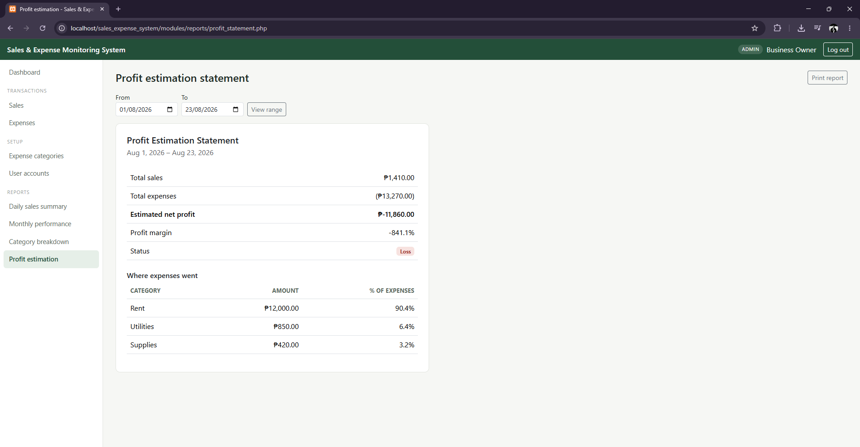

Appendix D — Additional Screenshots
Browser print dialog for a sale receipt, demonstrating the printable-reports requirement end-to-end (the @media print stylesheet hides the navigation and leaves only the receipt content):
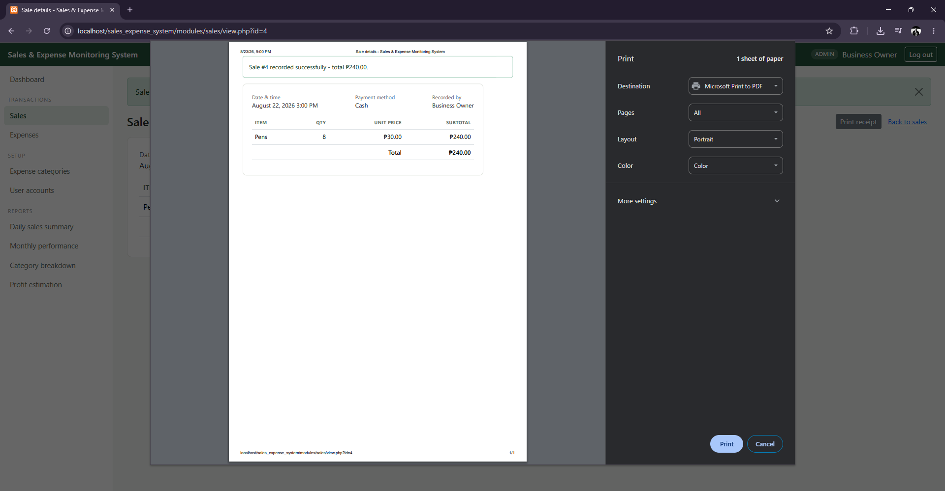
Add Expense Category form (Administrator only):
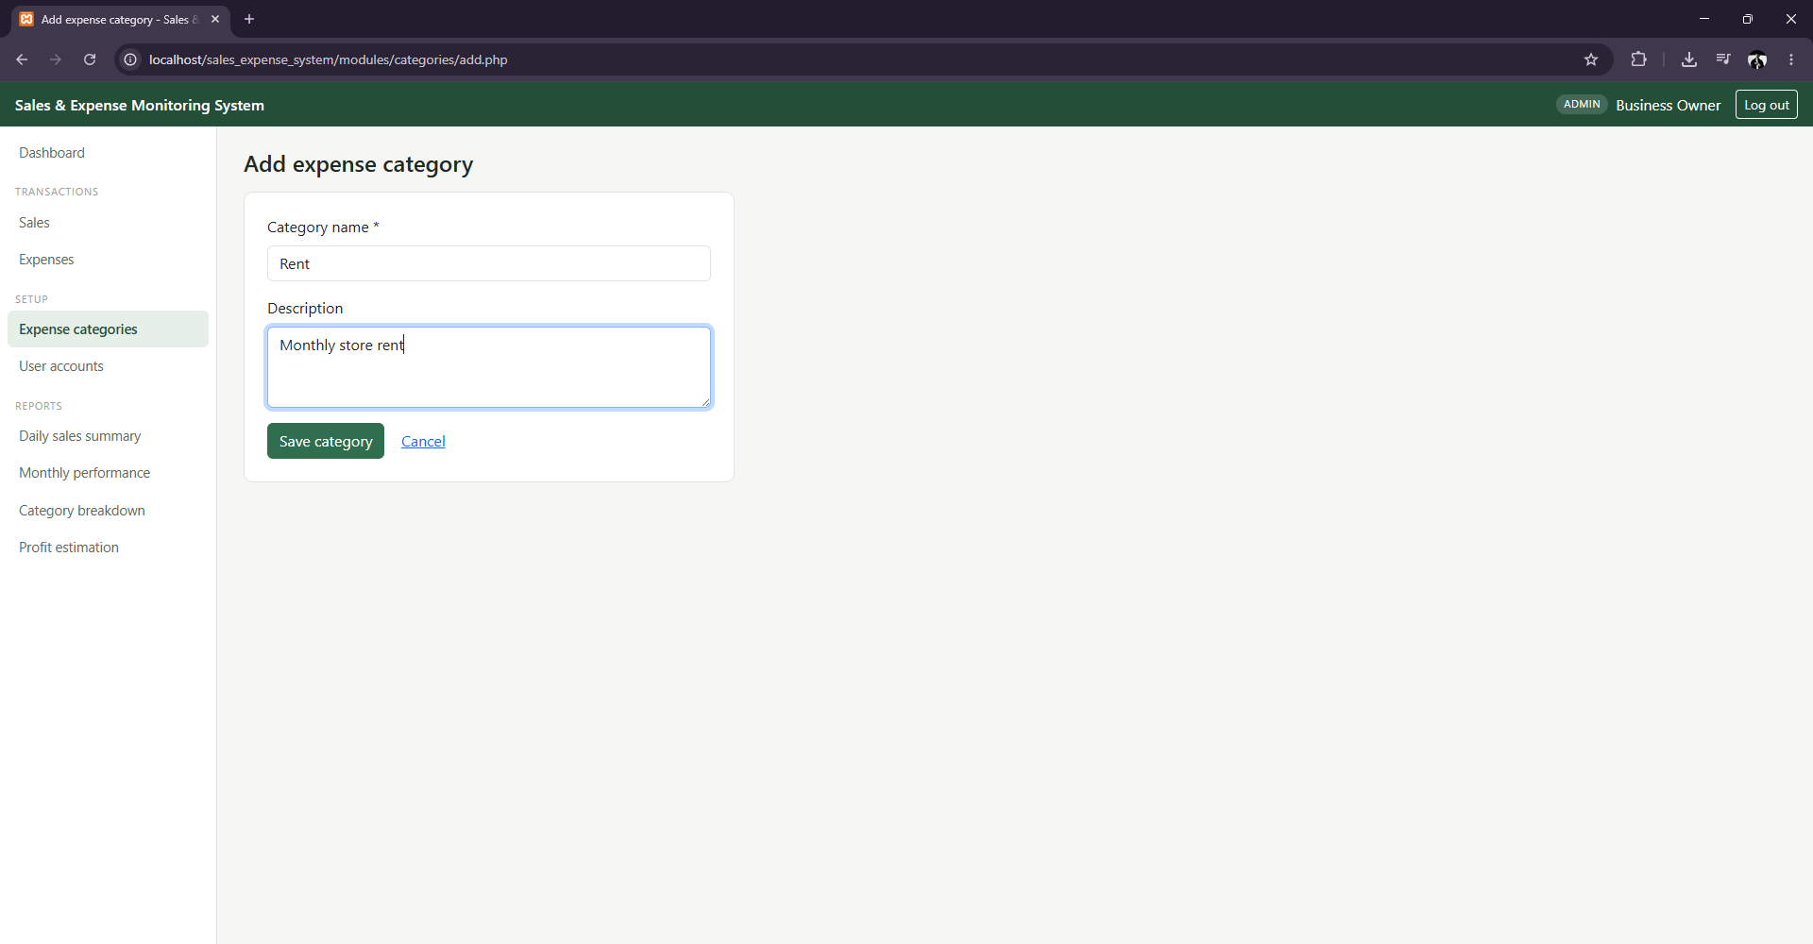
Add User form (Administrator only), showing role selection and password confirmation:
