7/20/24 Brevard, NC
Launched orange loc forte kit twice
Used motor ejection for both launches and loc parachute that came with the kit. Data tracked with Jolly Logic Altimeter 2. Used friction fit for separable sections and screws to secure the nose cone. Both launches were nominal. First ever personal launch!
Flight 1: Aerotech F50-6
529 ft
141 MPH
7.4 Gs
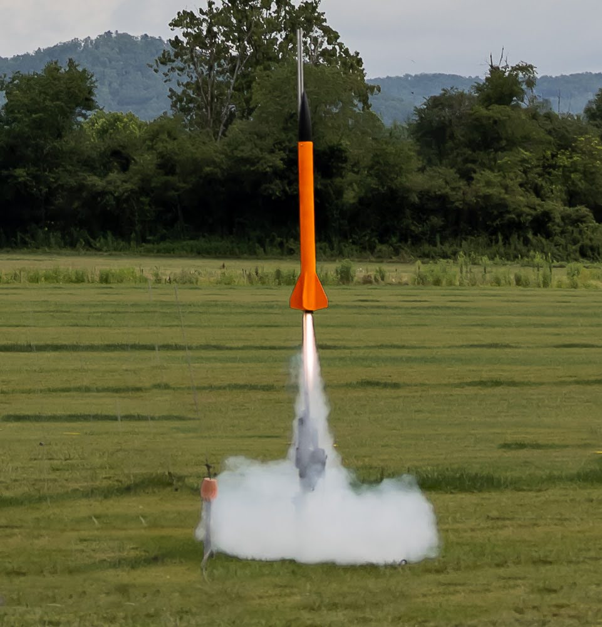
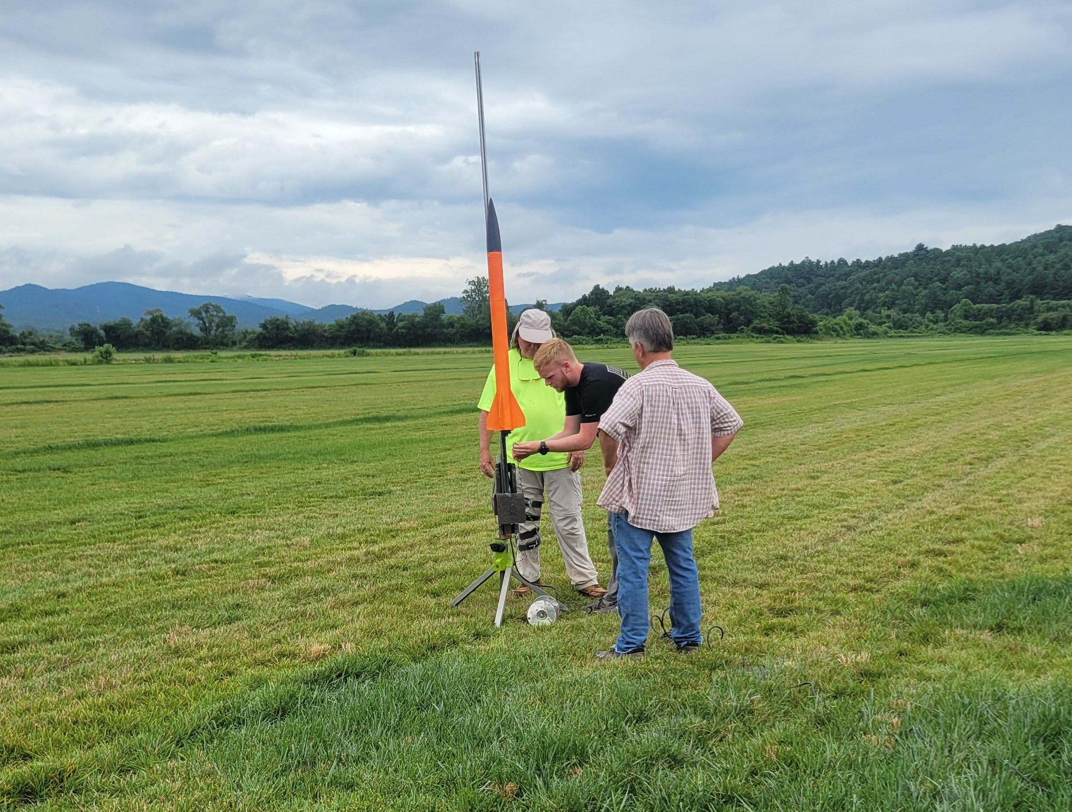

Flight 2: Aerotech G74W-6
727 ft
175 MPH
9.1 Gs

9/28/24 Bayboro, NC
First launch with NCSU HPRC
Launched orange loc forte kit for L1 cert on an H-100W-14A with motor ejection deployment. Nominal launch
2085 ft
369 MPH
13.3 Gs

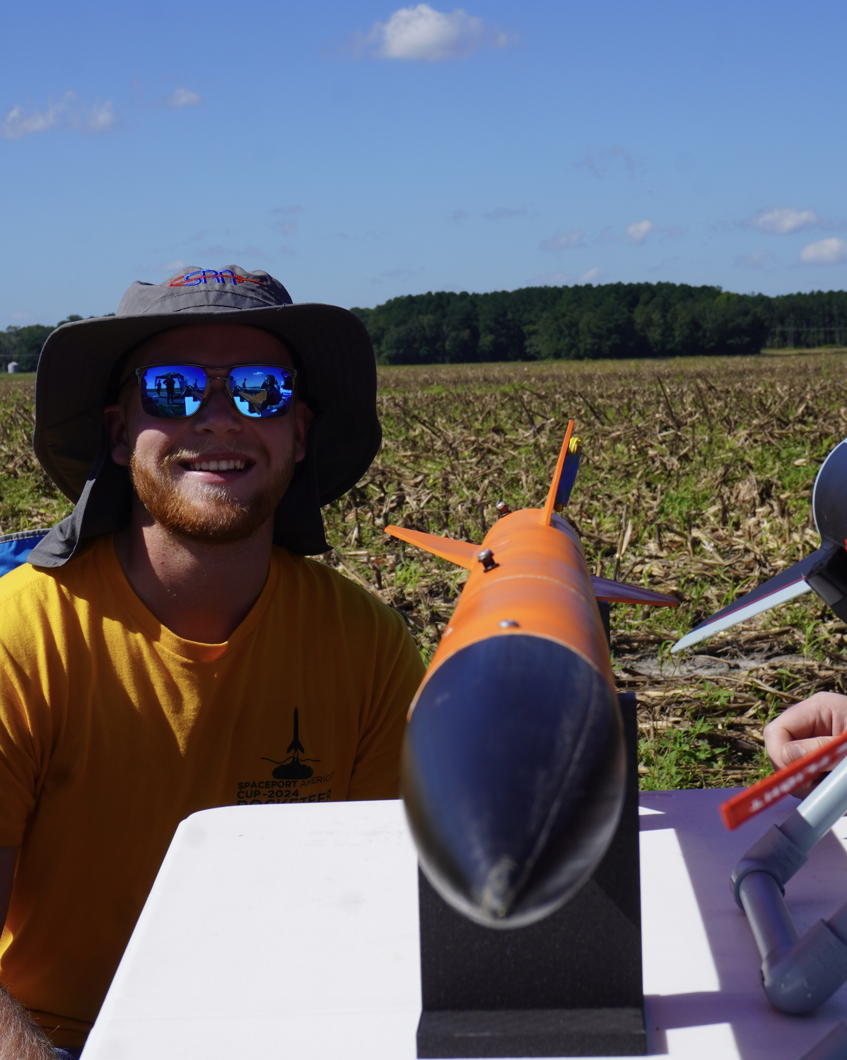
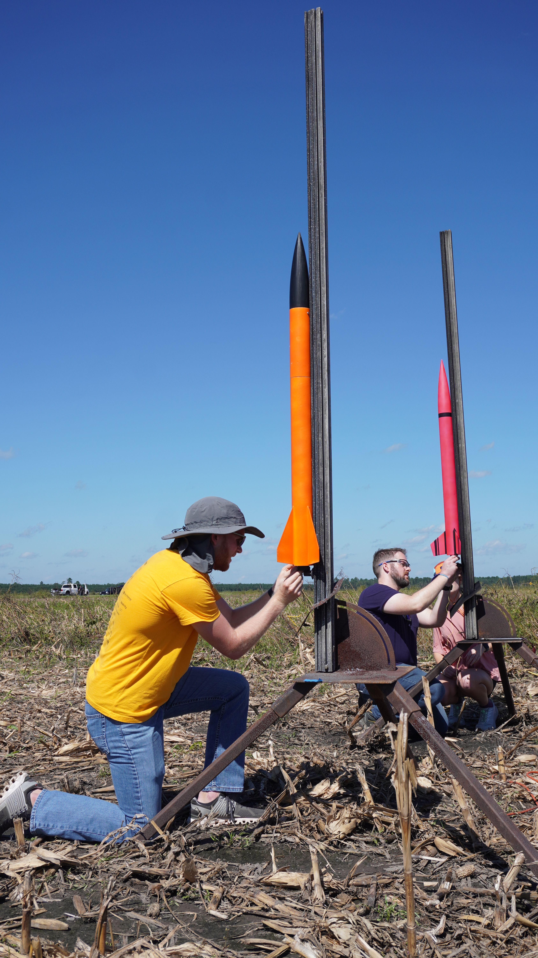

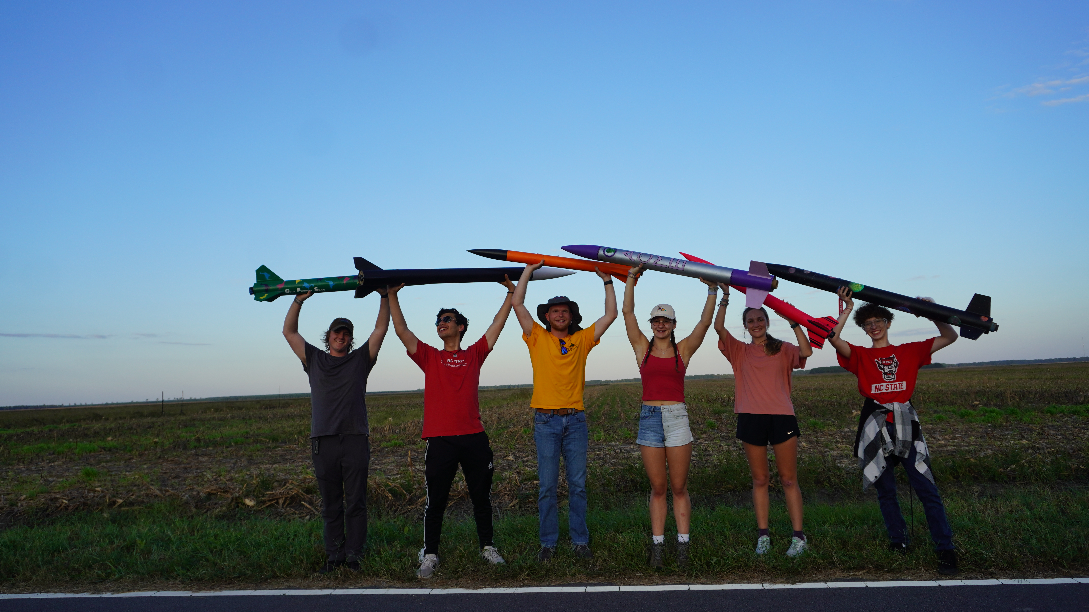

11/16/24 Bayboro, NC
L2 Cert flight
Launched “Tempest” on an Aerotech J-800. Used Altus easy mini as primary altimeter and eggtimer quasar as my secondary. 20 inch drogue parachute 52 inch main parachute.
2.85 cal. Stability and pad weight of 12.65 lbs. 4 small shear pins on both separable sections, ejection tested before the flight day. Nominal launch
4670 feet
566 fps
10.5 G

Notes: Eggtimer quasar failed to ignite main parachute due to powering off after igniting drogue. Still investigating the cause. Otherwise nominal flight. Later determined the problem was due to a pressure leak into the Avionics bay causing the quasar to detect landing.
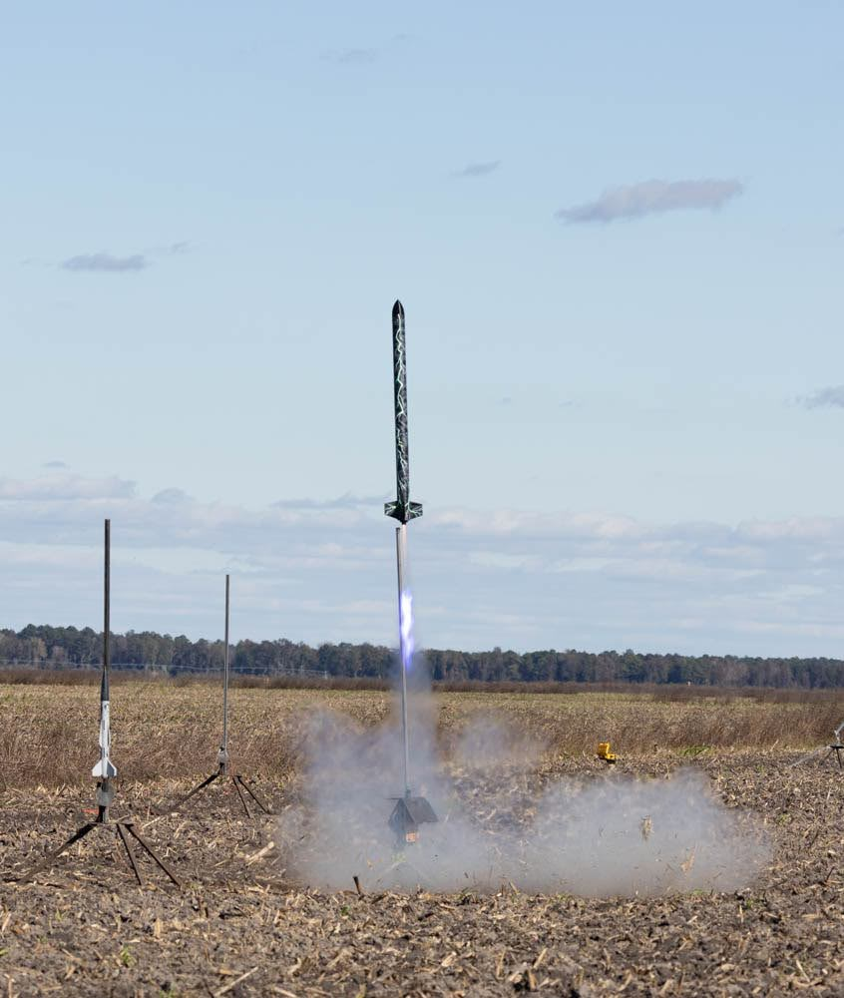
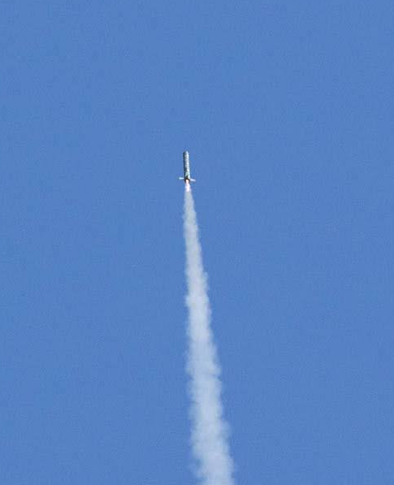

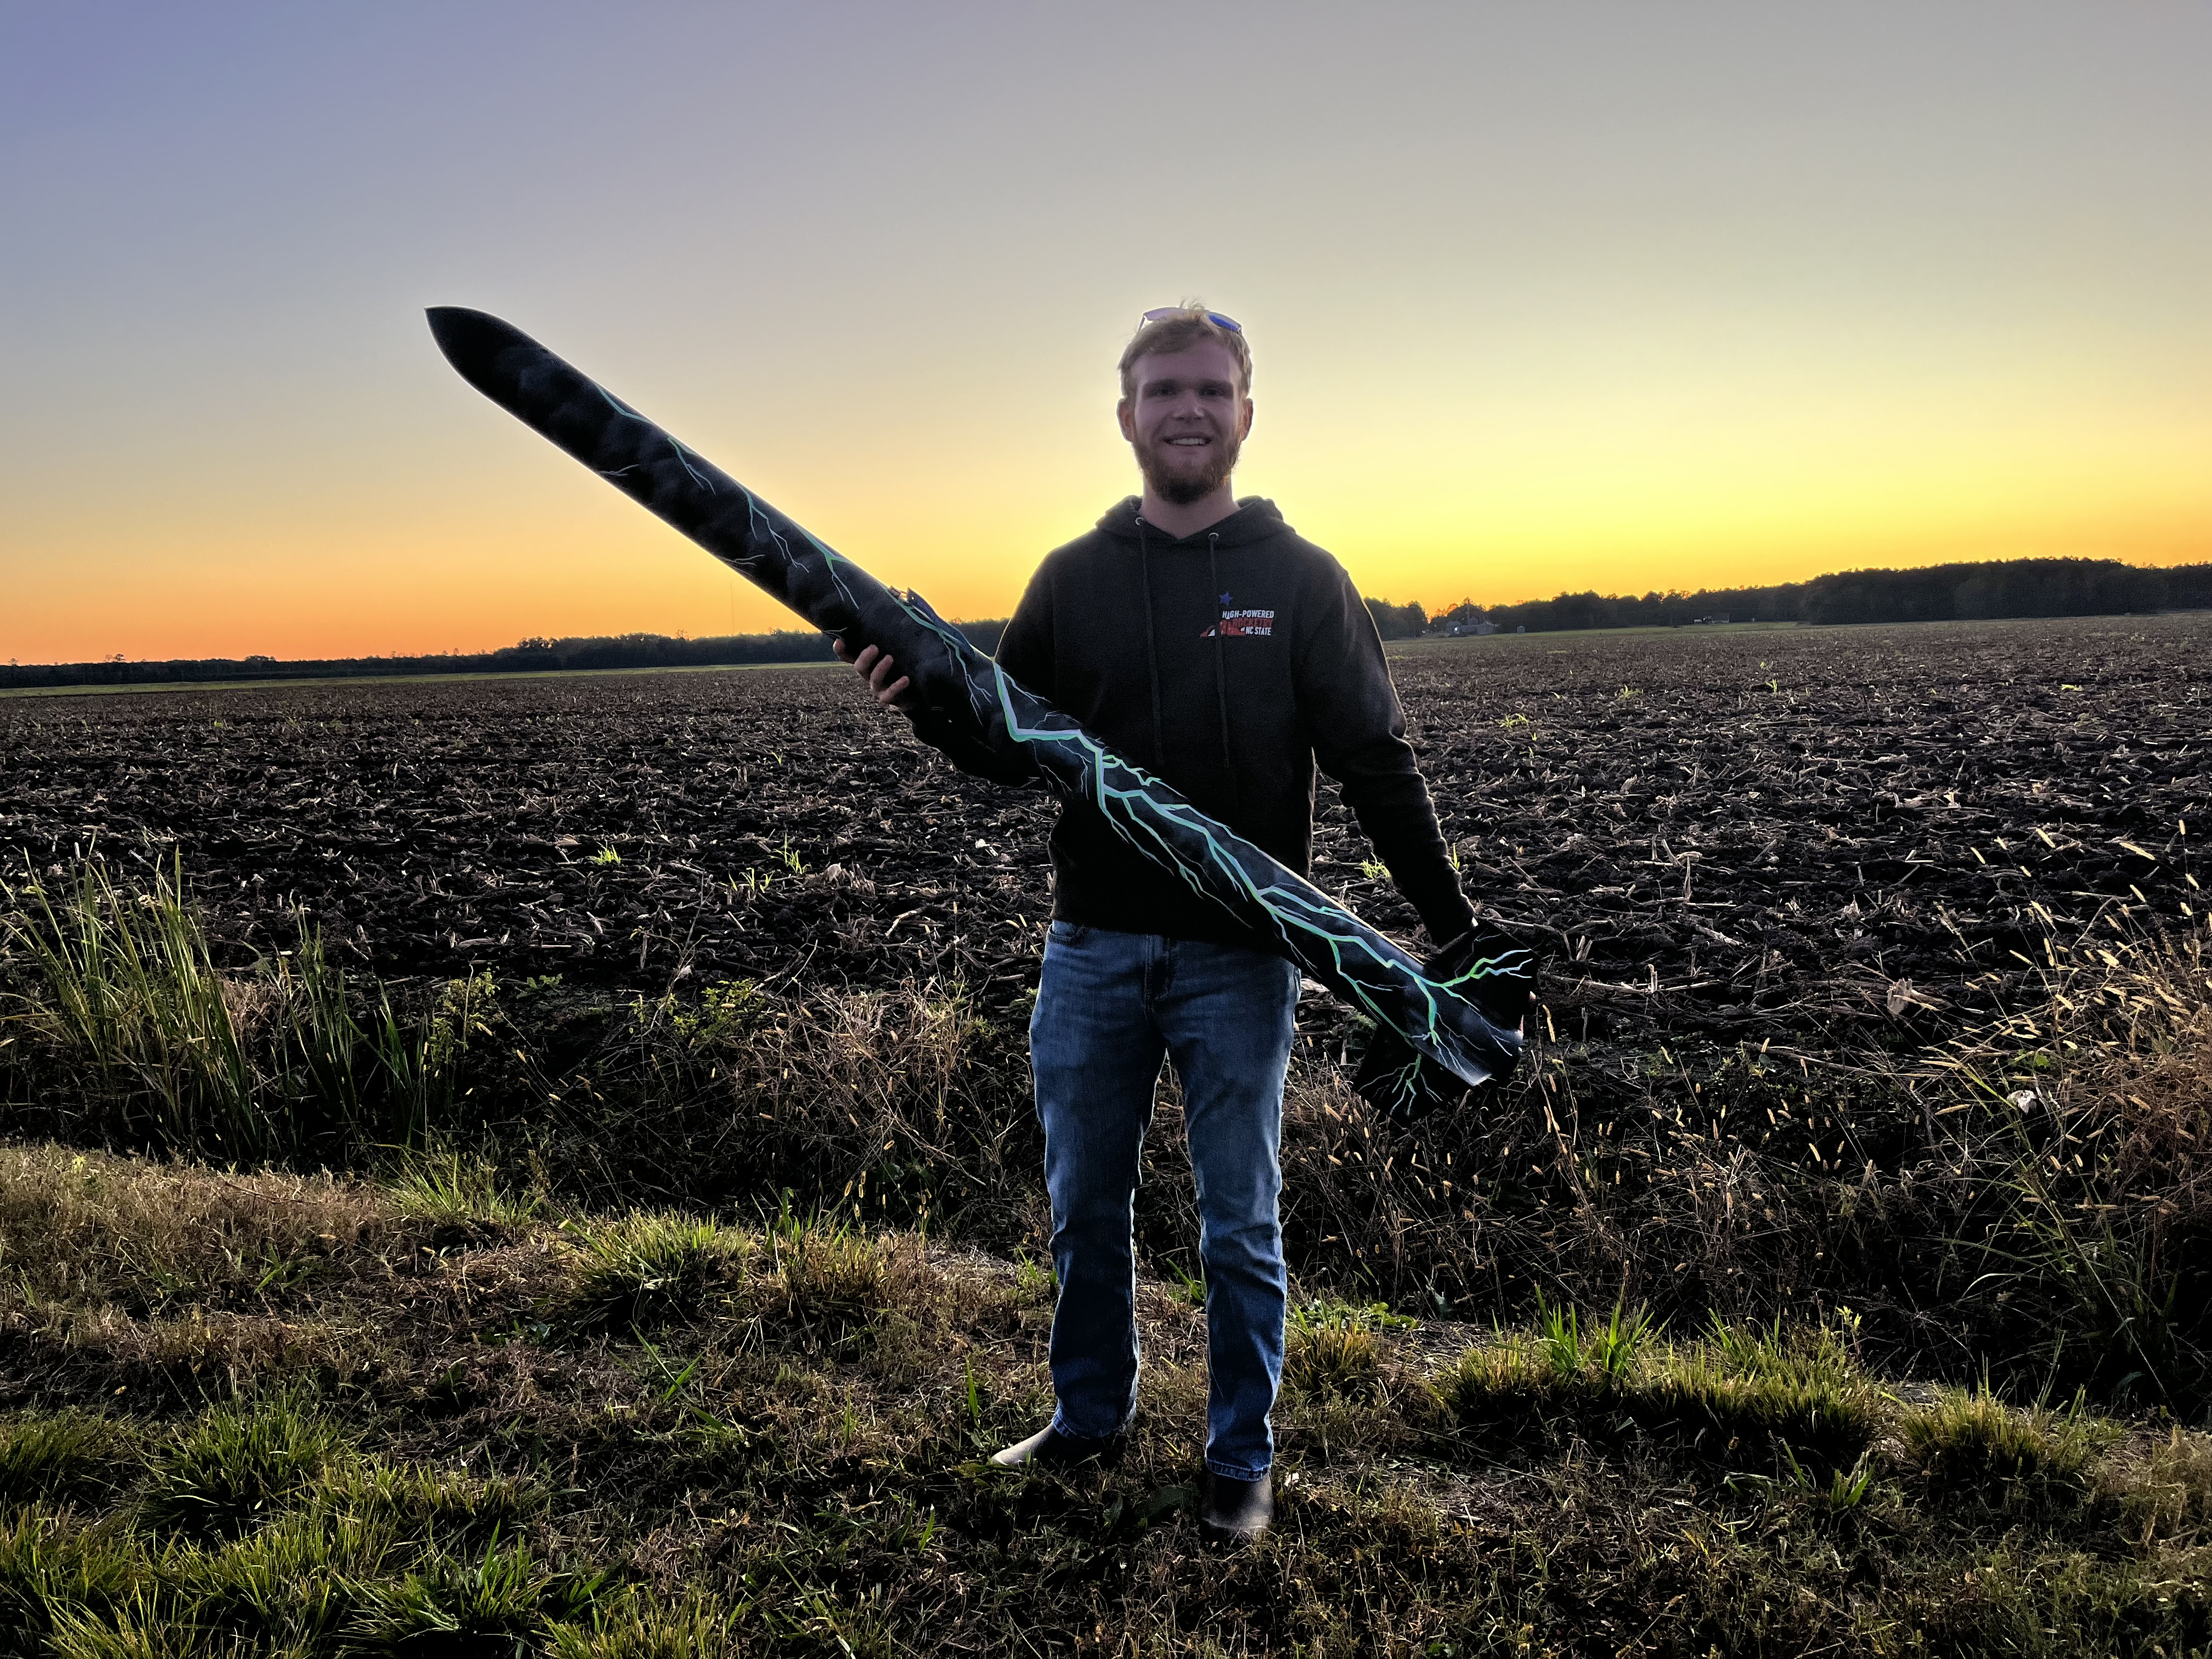

12/21/24 Midland, NC
Payload Test flight on loc forte
Launched the loc forte on a G-74 6W again but this time with my payload. The payload had a raspberry pi connected to a bmp180 and bno055. The goal of the payload was to log all of the data from the flight and act as a state machine. The state machine is more for proof of concept as I logged data throughout the entirety of the flight. The payload worked as intended. Got all launch data, finite state machine detected every state at the correct time. The actual launch was successful but not pretty, the payload brought the weight of the rocket up and it was significantly over the recommended takeoff weight for the motor. The rocket weather cocked aggressively in about 12-15 mph wind which cut down on the altitude. Otherwise the flight was fine and the parachute ejected nominally followed by a nominal landing.
Stats from homemade payload
493 feet
366 feet per second
3.1 Gs
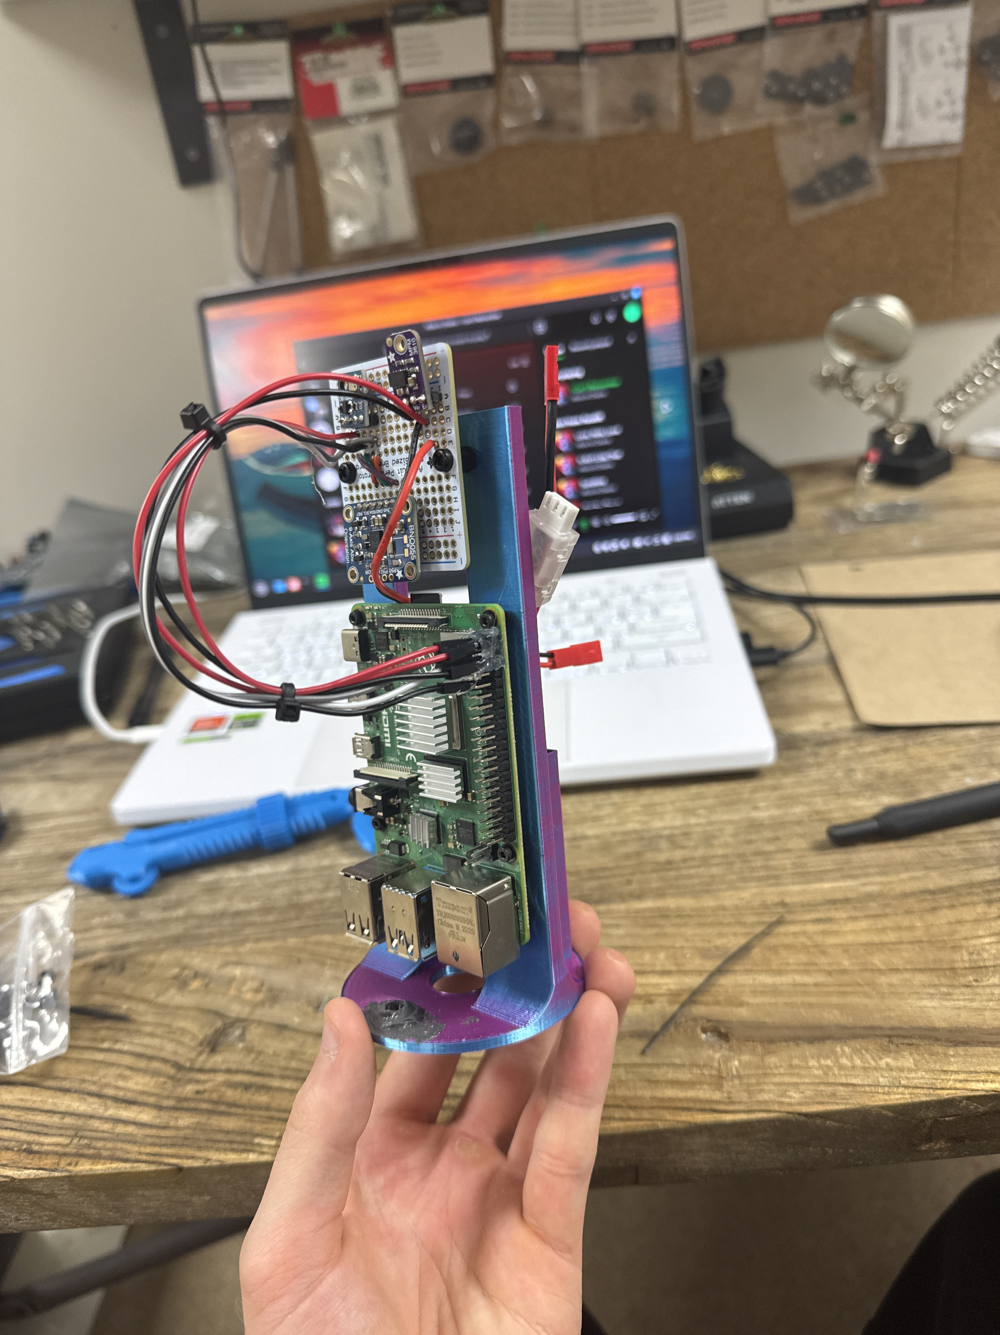

1/25/25 Bayboro, NC
Tempest with payload
Same payload as before except with a custom milled PCB to make the design more compact. Got new sheer pins which are bigger, had to reduce the number of pins to 2 for ejection testing to work. Also upped the black powder in the backup charges because more black powder is better than less.
Payload was nominal and recorded the state changes properly and ended logging upon reaching the ground.
Nominal launch, very low winds. Flew on an Aerotech K 1275 with dual deploy electronics. Went to 8290 feet which was well above expected. Landed softly in wet and snowy mud. Great day for launch and loved the red flame. Could definitely use a smaller drogue parachute because I had to walk 0.5 miles to recover. By far my favorite launch and motor yet, super aggressive and high flying.
Eggtimer quasar failed to deploy both charges this time. Looking into issue.
First flight over mach!!!!!!!!!
Stats
8270 feet
Mach 1.02
17 Gs
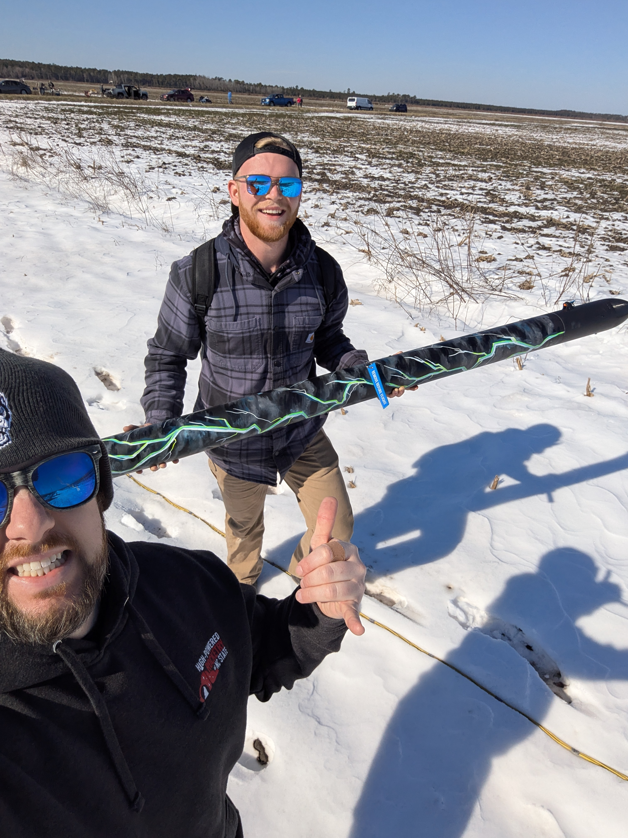
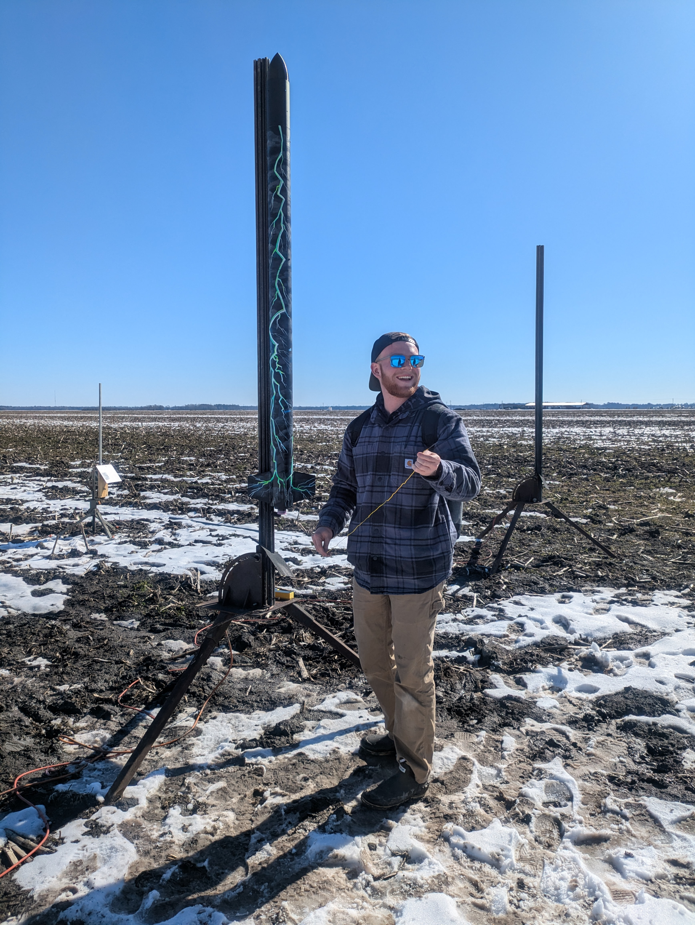

2/22/25 Bayboro, NC
Orange Creamsicle (orange Loc Forte l1 kit)
Flew this on a G-80 for fun, nominal flight. Used motor ejection and was fine. Super muddy field created soft landing but harsh recovery conditions.

6/8/25 Dalzell, SC
Orange Creamsicle
Flew on an Aerotech I-285R-14 flying with my first deployment altimeter, Zenith. Due to having electronics, a heavier motor, and ballast, this was the heaviest flight configuration I have ever flown on this rocket. For that reason, I opted for a larger 45” parachute. This ended up not working in my favor as the apogee was simulated to roughly 3500 feet. The rocket drifted extremely far away and out of sight in the windy conditions. I was unfortunately not able to ever find the rocket despite two days of searching. The lesson here is that I should have opted for the smaller parachute and faster ground hit velocity given the high wind. This will be the last flight for Orange Creamsicle, it served me well as my first personal rocket and I learned tons with it.
On the other hand, Zenith seemed to work perfectly as intended. The parachute deployed directly at apogee roughly 9 seconds after motor ignition. This seems to indicate that it was indeed the computer that deployed the parachute rather than the 14 second delay grain. This project has forced me to learn more about PCB design, C, and microprocessors. I ground tested Zenith extensively in a vacuum chamber ensuring that it would work in the rocket. The next steps for Zenith are now to put everything on one board rather than connecting multiple breakout boards with a PCB.
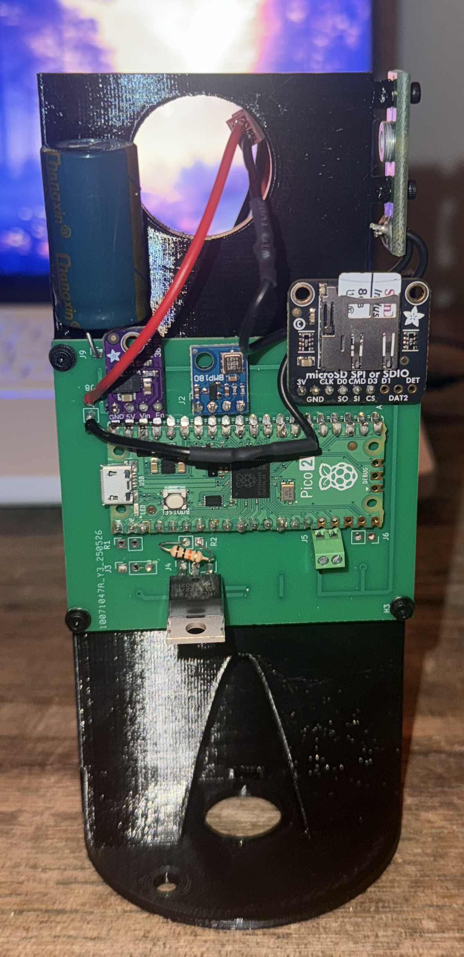
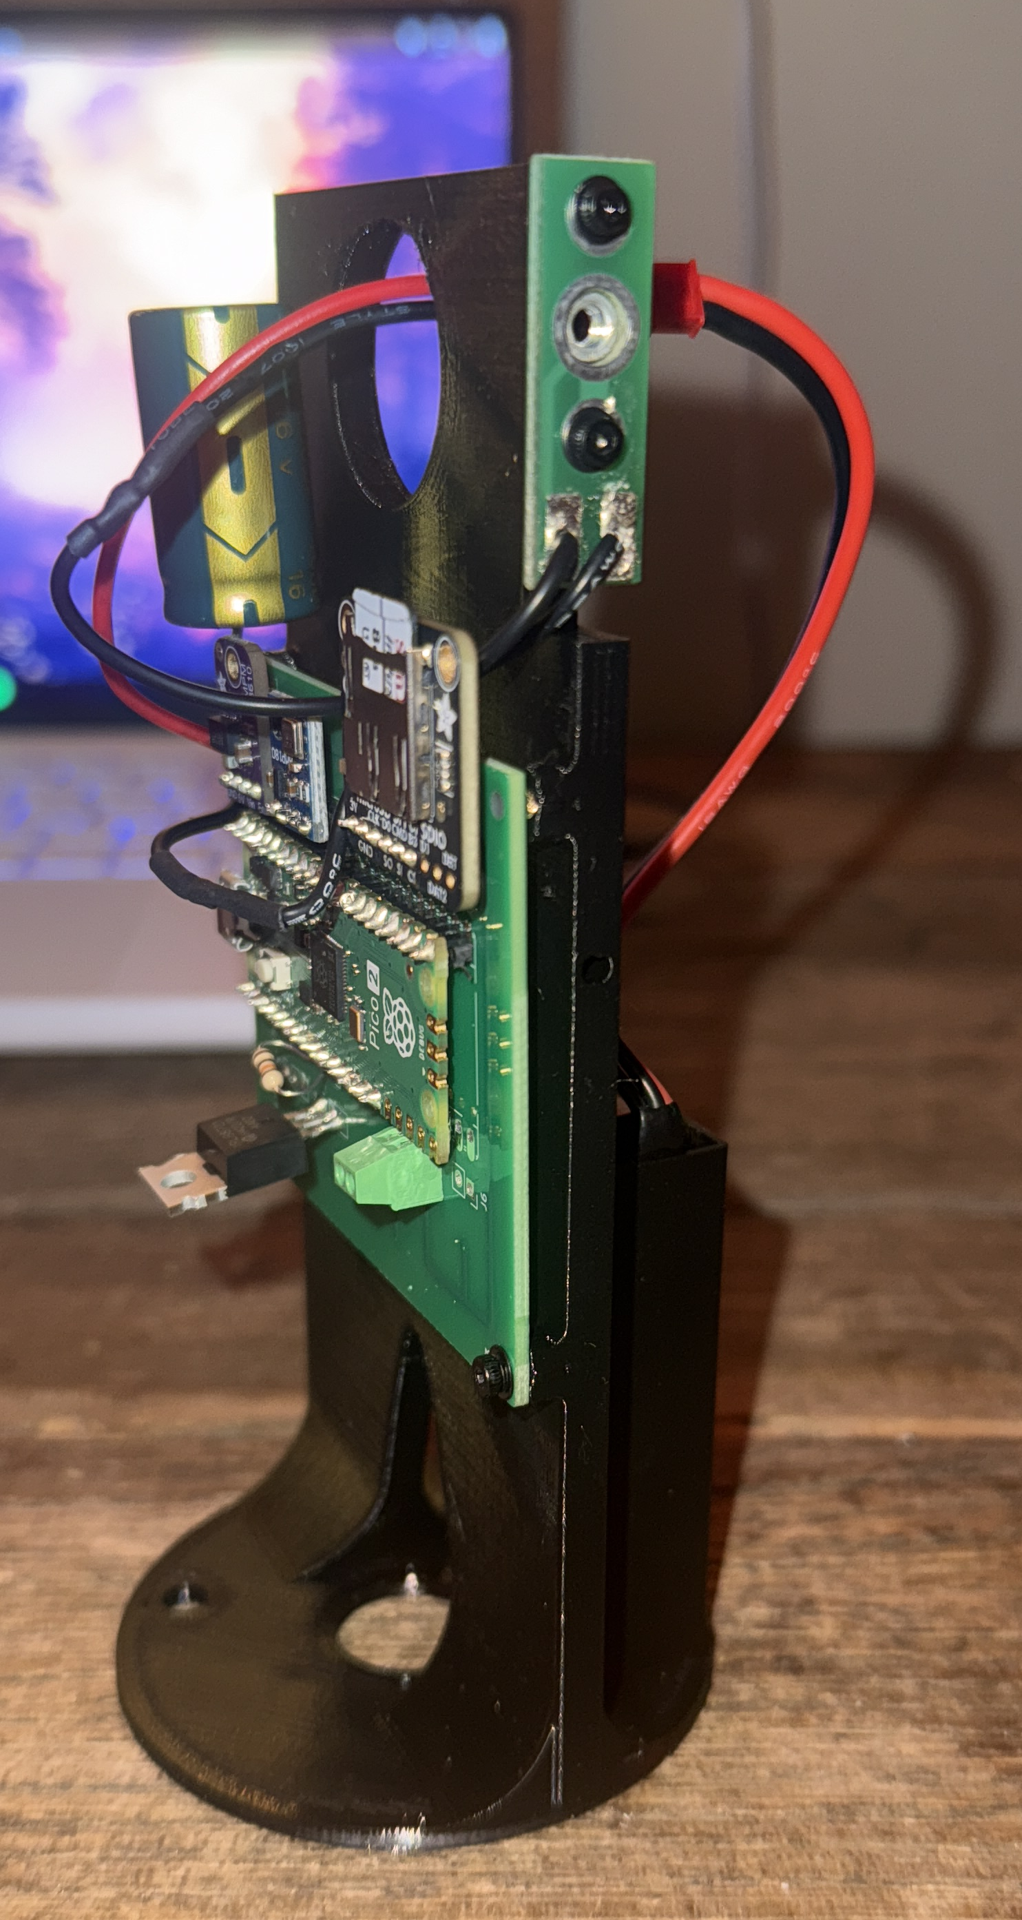
More info about Zenith (GitHub.com/NateOrlowski06/Zenith)

Good-bye Orange Creamsicle!


