How to make a transparent background

1. Download GIMP ([www.gimp.org](http://www.gimp.org))

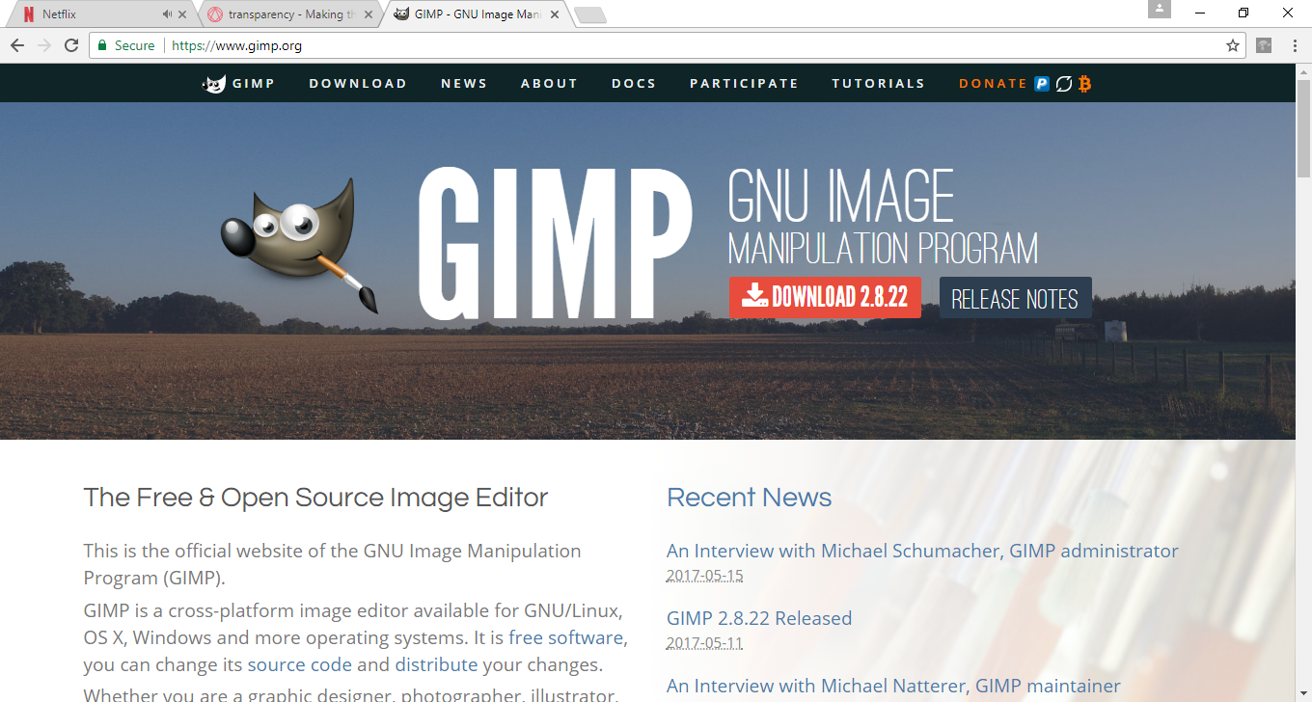

1. Open GIMP
2. Go to File > Open

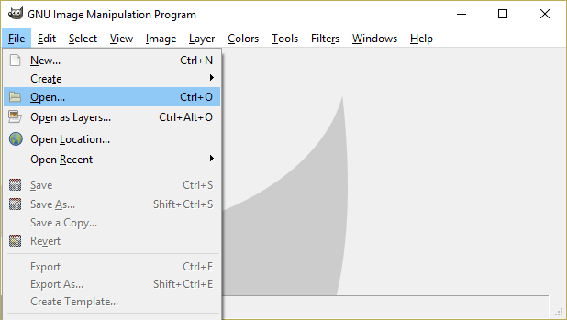

1. Find your file

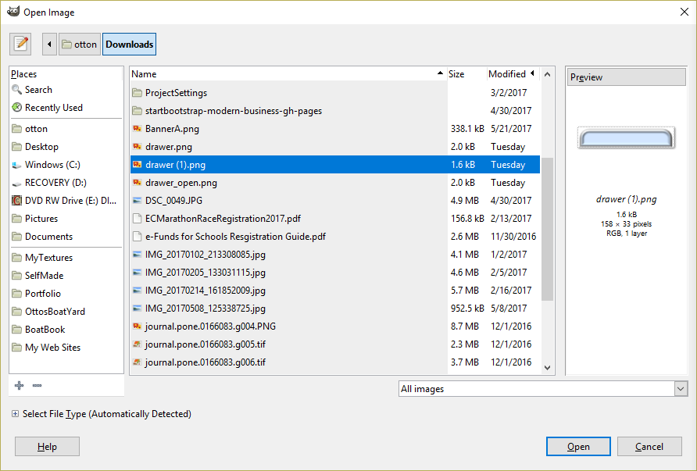

1. GIMP has floating menus. In the Toolbox menu (on the right), select Fuzzy Select

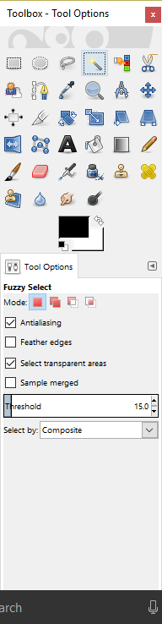

1. Click on the white space on the image. The white space appears as a dotted line.

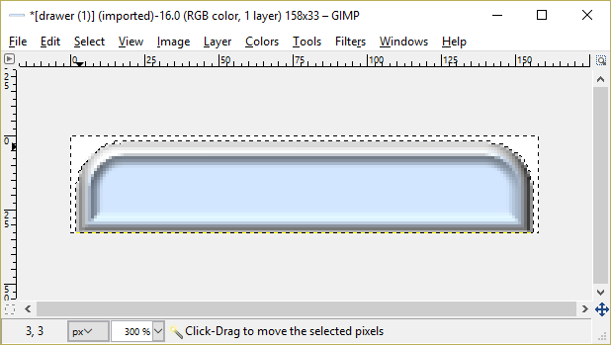

1. Go to the Layer menu (above the image). Select Transparency > Add Alpha Channel

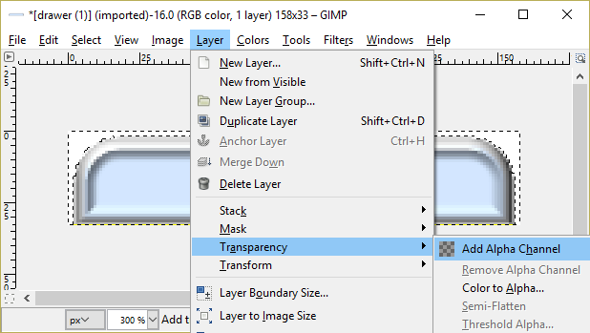

1. Press Delete.

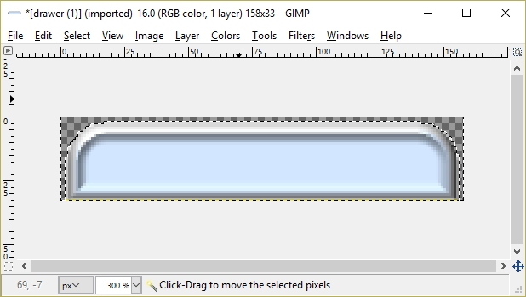

1. The little gray boxes indicate the area that is transparent. Save the image.