Nathaniel Shetler

**A.)**

Table 1-1 Running time in millisecond for case 1 (points are within a circle):

|  |  |  |  |
| --- | --- | --- | --- |
| n* | Running time | | |
| Graham Scan | Jarvis March | Quickhull |
| 10,000 | 2 | 1 | 16 |
| 20,000 | 31 | 16 | 47 |
| 40,000 | 63 | 47 | 109 |
| 80,000 | 109 | 78 | 234 |
| 160,000 | 234 | 219 | 563 |
| 320,000 | 469 | 438 | 1078 |

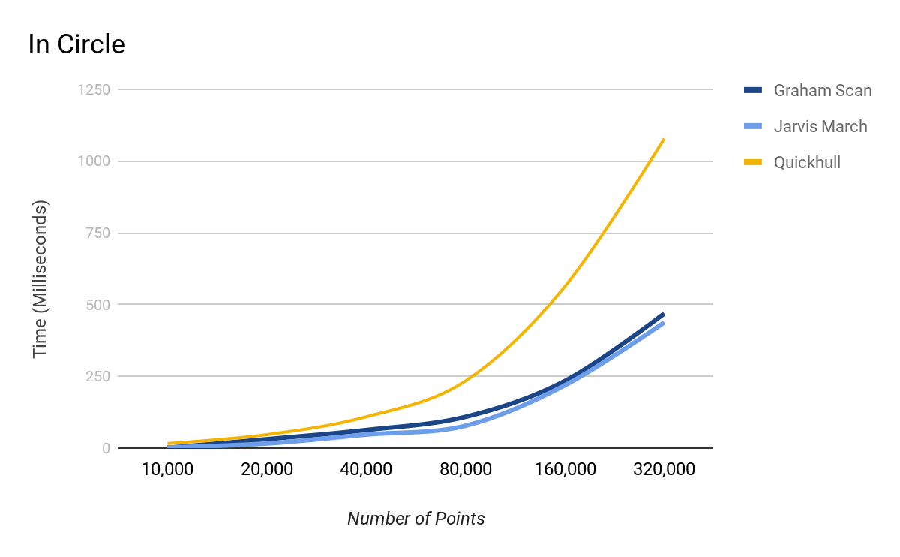

Table 1-2 Running time in millisecond for case 2 (points are on a circle):

|  |  |  |  |
| --- | --- | --- | --- |
| n* | Running time | | |
| Graham Scan | Jarvis March | Quickhull |
| 10,000 | 0 | 0 | 0 |
| 20,000 | 16 | 78 | 156 |
| 40,000 | 47 | 203 | 344 |
| 80,000 | 63 | 375 | 672 |
| 160,000 | 141 | 688 | 1234 |
| 320,000 | 311 | 1484 | 2486 |

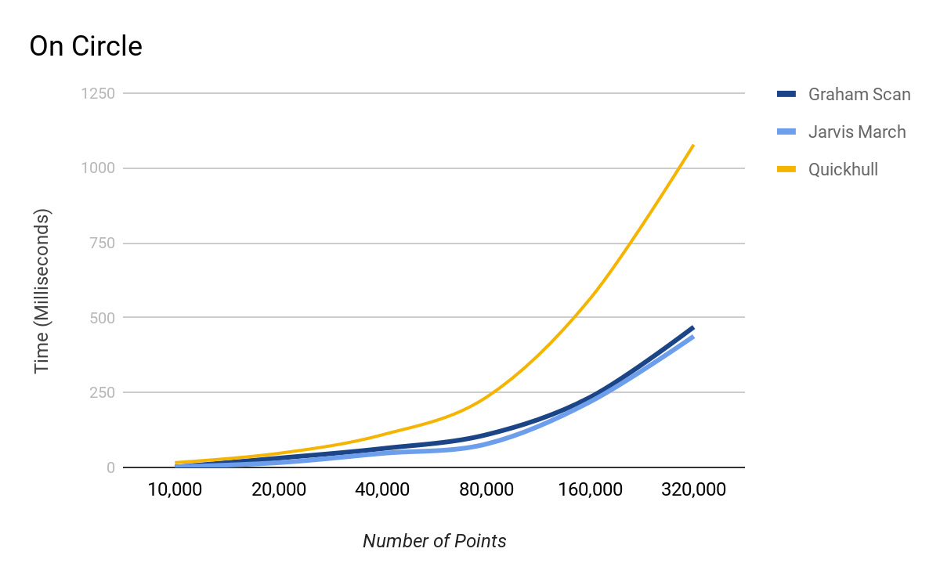

Table 1-3 Running time in millisecond for case 3 (points are within a rectangle):

|  |  |  |  |
| --- | --- | --- | --- |
| n* | Running time | | |
| Graham Scan | Jarvis March | Quickhull |
| 10,000 | 0 | 0 | 0 |
| 20,000 | 16 | 16 | 16 |
| 40,000 | 47 | 33 | 47 |
| 80,000 | 109 | 78 | 109 |
| 160,000 | 219 | 172 | 203 |
| 320,000 | 469 | 359 | 411 |

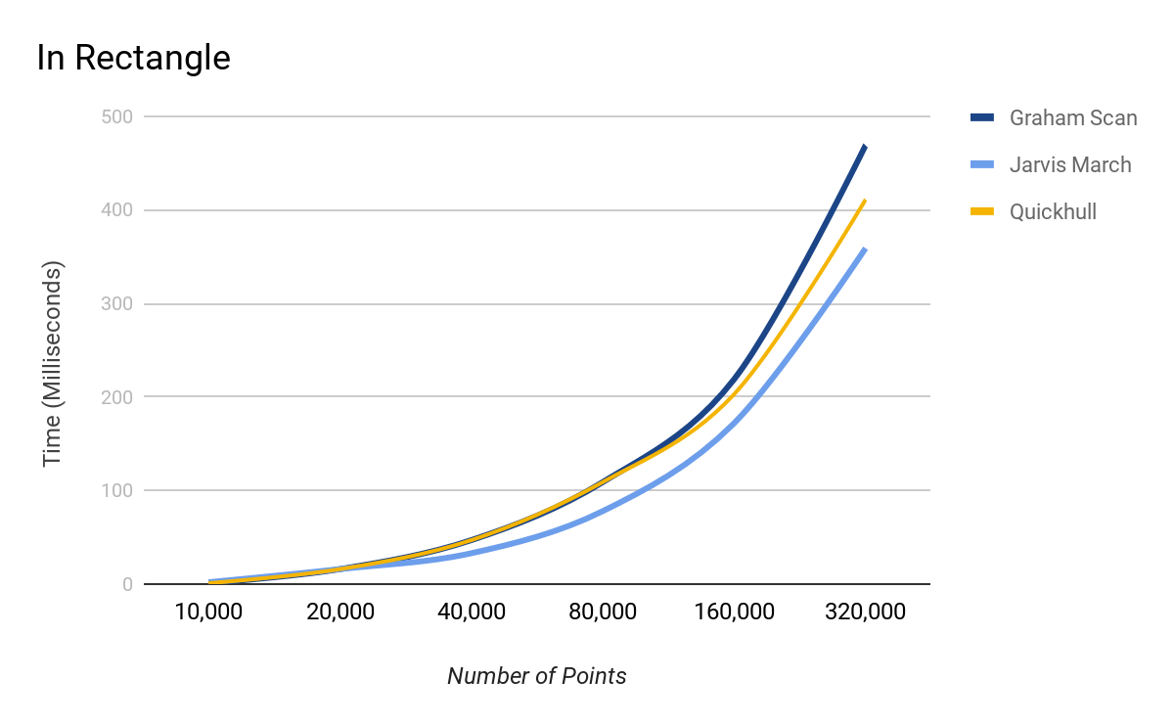

Table 1-4 Running time in millisecond for case 4 (points are within a triangle):

|  |  |  |  |
| --- | --- | --- | --- |
| n* | Running time | | |
| Graham Scan | Jarvis March | Quickhull |
| 10,000 | 1 | 1 | 1 |
| 20,000 | 16 | 16 | 16 |
| 40,000 | 47 | 31 | 31 |
| 80,000 | 125 | 63 | 78 |
| 160,000 | 219 | 125 | 149 |
| 320,000 | 453 | 175 | 275 |

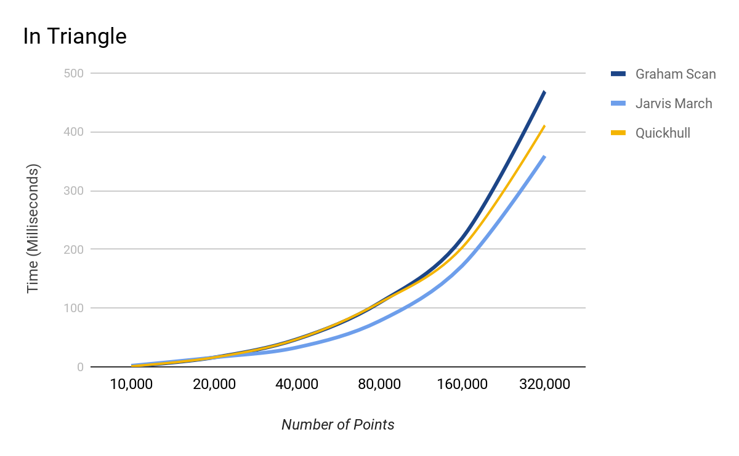

**B.)**

What’s the asymptotic time complexity of the three algorithms? Complete the following table:

|  |  |  |  |
| --- | --- | --- | --- |
|  | Running time complexity | | |
| Graham Scan | Jarvis March | Quickhull |
| Best case | O(nlogn) | O(n) | O(n) |
| Average case | O(nlogn) |  | O(nlogn) |
| Worst case | O(nlogn) | O($n^{2}$) | O($n^{2}$) |

**C.)**

Does your empirical analysis match with your theoretical analysis? Justify your answer.

Yes my empirical analysis matches with my theoretical analysis. They match because the rate at which the empirical data graphs grow match the corresponding growth rate of the time complexity of the theoretical analysis. For example, for any of the shapes tried, Graham Scan’s graph matches up relatively well with the graph of O(nlogn). This makes sense due to the average, best and worst cases being O(nlogn) for Graham Scan. The same goes for Jarvis March and Quickhull. In the data tried, most of the empirical graphs are similar to the O(nlogn) graph, but some of the Jarvis March and Quichull resemble some of the other possible cases such as the worst case, $O(n^{2})$.