Nathan Somevi - Technical Rider
Hybrid guitar / tenor sax / keyboard / drums
Version: draft for advance | Contact: [insert booking/tech email]

Overview
This rider covers a four-piece setup built around hybrid guitar, tenor saxophone, keyboard and drum kit. The hybrid guitar uses a split rig: guitar-side signal to a guitar amp and bass-side signal to a bass amp. The tenor sax setup uses a normal dry mic plus a separate wet/reverb channel where possible.
Assumption: the exact amp ownership and keyboard/backline provision should be confirmed during advance. This rider is written so it works whether the artist brings some gear or the venue provides backline.

Stage plot
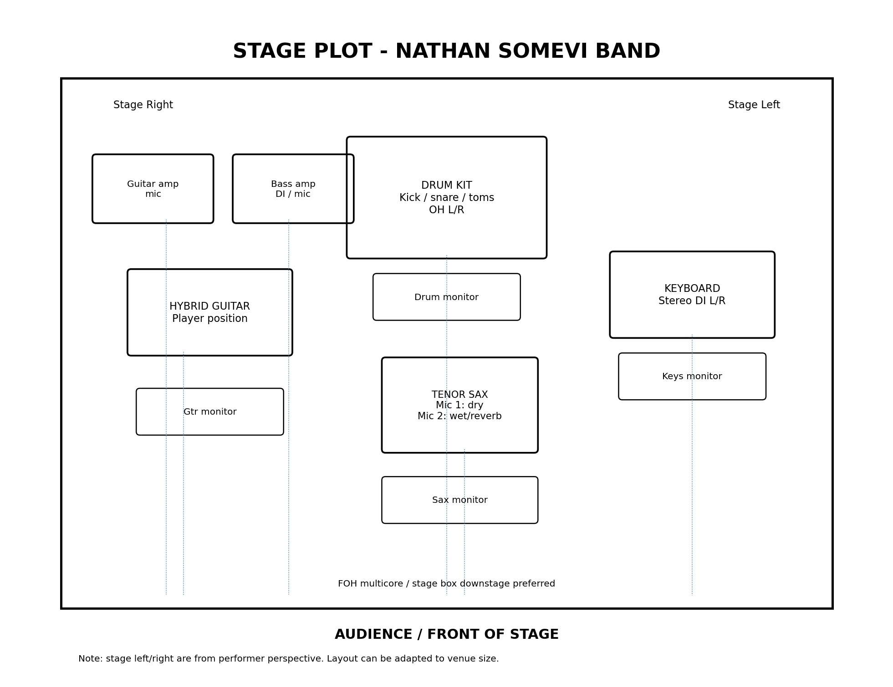

Preferred stage layout
- Hybrid guitarist: stage right, with guitar amp and bass amp behind or slightly behind/side of player.
- Tenor sax: front centre or centre-right, with two channels available at the sax position.
- Keyboard: stage left, stereo DI preferred.
- Drums: upstage centre.
- FOH stage box/multicore downstage or centre stage if possible.

Input list
Ch. | Source | Mic / DI | Stand / power | Notes
1 | Hybrid guitar - guitar amp | Dynamic guitar mic, SM57/equivalent | Short boom | Clean/warm guitar side. Avoid excessive low end.
2 | Hybrid guitar - bass amp | DI from bass amp preferred, or dynamic mic | DI or short boom | Low/bass side of hybrid guitar. Keep full but controlled.
3 | Tenor sax - dry | Clip-on or stand mic | Tall boom | Main sax channel. Natural sound, light/no reverb.
4 | Tenor sax - wet/reverb | Second mic or split of sax mic | Tall boom or channel split | Large plate/hall reverb. Keep separate from dry sax channel.
5 | Keyboard L/Mono | DI | Mains power | Use L/Mono if mono only.
6 | Keyboard R | DI | Mains power | Stereo preferred where practical.
7 | Kick drum | Kick mic | Short boom | Standard kit mic.
8 | Snare top | Dynamic mic | Short boom | Standard kit mic.
9 | Hi-hat | Condenser mic | Short boom | Optional for smaller rooms.
10 | Rack tom | Tom mic | Clip/short boom | If kit has rack tom.
11 | Floor tom | Tom mic | Clip/short boom | If kit has floor tom.
12 | Overhead L | Condenser mic | Tall boom | Stereo overhead pair.
13 | Overhead R | Condenser mic | Tall boom | Stereo overhead pair.

Sax reverb setup
Preferred: two separate sax channels at FOH - one dry/normal and one wet/reverb. The wet channel should use a large hall or plate-style reverb and be blended tastefully during soundcheck.
Fallback: if two physical sax mics are not possible, split one sax mic into two console channels and process one as dry and one as wet/reverb.

Monitor requirements
Mix | Position | Main needs
M1 | Hybrid guitar | Guitar amp, bass amp, sax, keys, some kick/snare.
M2 | Tenor sax | Sax, guitar, keys, some drums.
M3 | Keyboard | Keys, guitar, sax, kick/snare.
M4 | Drums | Hybrid guitar bass side, keys, sax, enough guitar side for pitch.
Minimum workable setup: 2 monitor mixes. Preferred: 4 independent mixes.

Backline request
- 1 clean guitar amp suitable for jazz/clean electric guitar tone.
- 1 bass amp suitable for the low/bass side of the hybrid guitar.
- Standard drum kit: kick, snare stand, hi-hat stand, rack/floor toms, cymbal stands and drum throne. Drummer usually provides cymbals, snare and breakables unless agreed otherwise.
- Keyboard stand, sustain pedal and mains power near keyboard position. Keyboard player to bring keyboard unless venue backline is agreed in advance.
- At least 2 tall boom stands, 3 short boom stands, 2 DI boxes for keyboard and one spare DI if possible.
- 4 wedge monitors preferred.

Power
- Two clean power points near guitar position for pedals/amps if required.
- Two clean power points near keyboard position.
- Power should be safely taped/secured and not run through audience walkways.

Soundcheck and notes for FOH
- Ideal soundcheck: 45 minutes after full line check. Minimum line check: 20 minutes.
- Keep the hybrid guitar guitar-side and bass-side clear and separated. The bass side should carry weight but not overpower the acoustic drums.
- Dry sax should stay present and natural. Wet sax/reverb channel should feel spacious but not wash out the melody.
- Keyboard can be stereo where the room and desk allow; mono is acceptable for small venues.
- No backing tracks or click are required unless confirmed separately.

Advance checklist
- Confirm whether venue or artist provides guitar amp and bass amp.
- Confirm whether the sax wet/reverb channel will be created with two mics or one mic split to two channels.
- Confirm drum kit/backline details and what the drummer brings.
- Confirm keyboard provision and number of DI boxes.
- Confirm monitor count and independent mixes.
- Send stage dimensions and venue curfew/load-in information.

