**Terms**

Computer Program

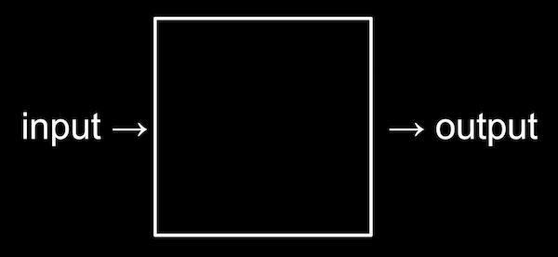

* Algorithm

# Binary

* Computers only understand electricity or not electricity
* Yes / No, True / False, 1 / 0
* We count in Decimal, there are 10 symbols
* Binary is counting with 2 symbols

# 123

# One Hundred Twenty Three

**Decimal**

| Hundreds | Tens | Ones |
| --- | --- | --- |
| 1 | 2 | 3 |

**Binary**

| Fours | Twos | Ones |
| --- | --- | --- |
| 0 | 0 | 0 |
| 0 | 1 | 1 |

# Binary Is More Than Numbers

* ASCII, common pattern to translate
* 65 means "A", 66 means "B"...
* Computer uses context to figure out what the binary means

Bit: One binary digit Byte: Eight bits

* Unicode

# Abstraction

* Lower levels are hidden
* We use easier higher levels

We don't need binary, we'll use a programming language

# Pseudocode

* Not a real programming language, just an abstraction
* Looks like english
* Boolean