|  |
| --- |
| NEW Games |
| Pixel Tapper |
| **Mobile Game Development** |
| Version #2.0  All work Copyright © 2020 by NEW Games.  All rights reserved. |
| **Nathan E. Whitehead** |
|  |

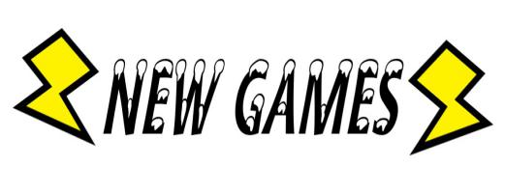

|  |
| --- |
| October 19, 2020 |

**Table of Contents**

**1: Game Overview**

**2: Gameplay Mechanics**

**3: Camera**

**4: Controls**

**5: Saving/Loading**

**6: Interface Sketches/Menu and Game Descriptions**

**7: Game World**

**8: Levels**

**9: Game Progression**

**10: Characters and NPC’s**

**11: Items**

**12: Scripts**

**13: Scoring**

**14: Sounds**

**15: Story**

**16: Art**

**17: Design Notes**

**18: Future Features**

**Version History**

Version 0.1 - Initial asset creation and game planning, September 16, 2020.

Version 0.2 - All assets complete, finalizing design document, September 22, 2020.

Version 1.0 - Polishing document for assignment 1, September 29, 2020.

Version 2.0 - Feature complete build, October 19, 2020.

1. **Game Overview**

Pixel Tapper is based off the arcade classic Tapper, or later rebranded Root Beer Tapper. The objective of the game to to serve thirsty patrons beverages before they reach the end of their bar. The player must rush between kegs to serve the patrons and collect empty mugs.

1. **Game Play Mechanics**

In Pixel Tapper the core gameplay is for the player to go between bars to fill beverages and send them to patrons. Patrons will spawn on one of 4 bars and slowly move towards the bar tender (player). If the patron reaches the end of their bar they will get angry and the player will lose a life. However, if the player can fill and send a beverage before the patron reaches the end they player will score points and the patron will go home satisfied. An added trick to the game is patrons will send back their empty mug and the player must collect it before it slides off the bar or else lose a life. The player will start with 3 lives.

1. **Camera**

The camera is stationary showing all the gameplay on a single screen. The game will be for portrait mode on mobile, the camera and game reflect this.

1. **Controls**

Controls have been slightly altered. Swiping still is the way to move the player up and down, and single tap to pour/send the beverage. The inputs will always use your last finger position compared to new finger position allowing to also single tap up and down to move and tapping the same spot to pour/send beverage. There is no cast time or cooldown to pouring anymore either.

1. **Saving and Loading**

At the moment no saving or loading will be present. Score will be recorded and possibly saved if time permits.

1. **Interface Sketch**

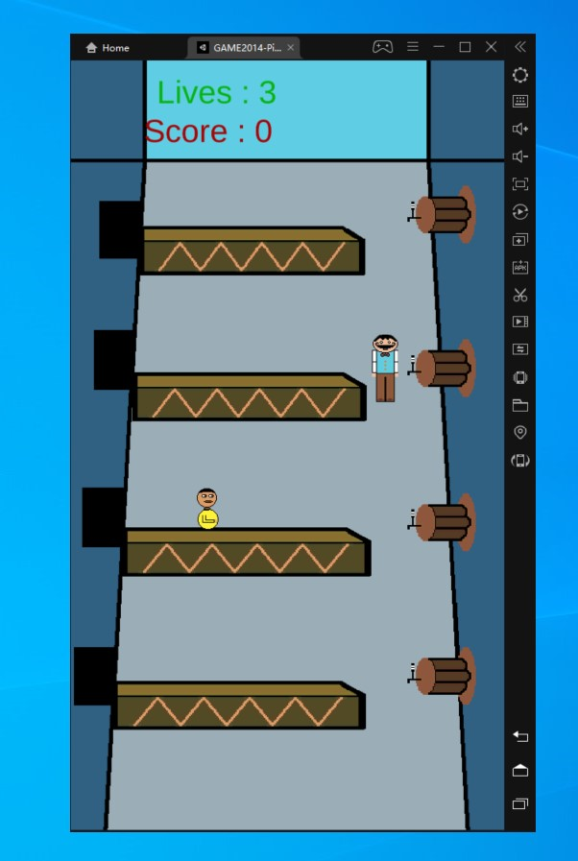

The player (avatar on the right) traverses from bar to bar to meet randomly spawned patrons with a nice refreshing beverage. Patrons appear from 1 of 4 black boxes and slowly move towards the player. If the player does not serve them by the time they reach the end the player loses a life.

1. **Menu and Screen Descriptions**

Main Menu sketch, How to play/controls sketch, Game over sketch

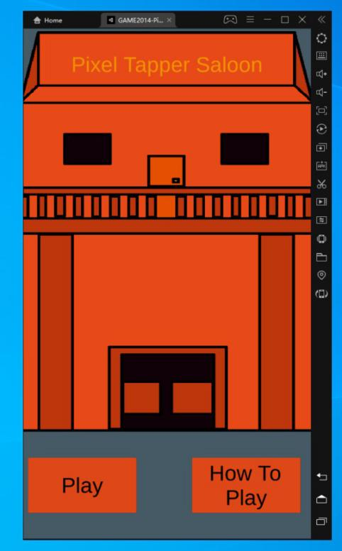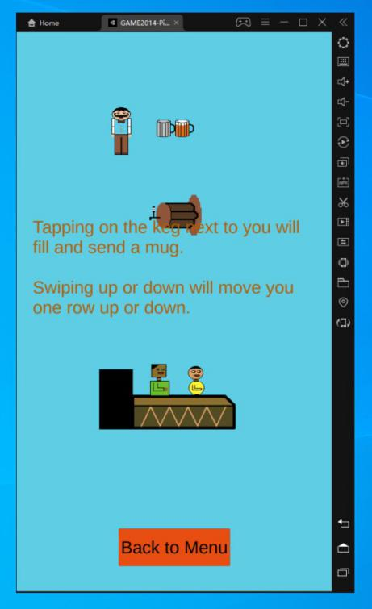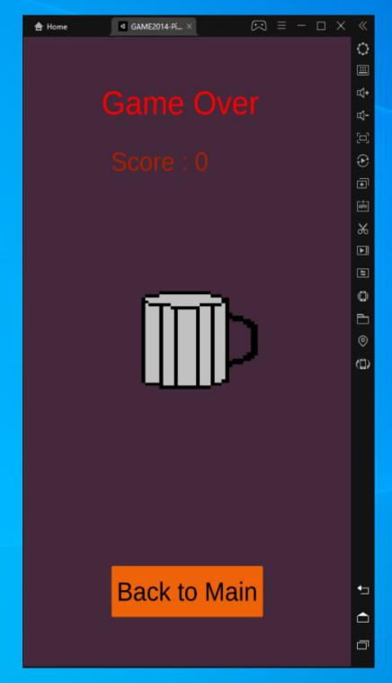

1. **Game World**

Game world is set in a bar. Simplistic pixel graphics make up the world.

1. **Levels**

There is a single playable level shown above. The randomly spawning patrons come at faster intervals based on how many have spawned previously and player score. Starting at every 5 seconds and speeding up to a blazing fast .75 seconds to add a lot of challenge. Serving and collecting empty mugs then becomes a real juggle of player positioning.

1. **Game Progression**

Progressions is done by serving patrons and collecting empty mugs.

1. **Characters**

The player is an old timey bar tender trying to make some quick money by serving patrons and collecting tips.

1. **Non-player Characters**

Currently there are 2 NPC that serve as bar patrons. They spawn randomly and move towards the player. The NPC’s AI is very minimal. They move, collect, and disappear. The original tapper game followed this structure and I decided to keep the AI this way.

1. **Items**

Empty mugs that come toward the player must be collected. They are spawned when the beverage reaches the patron.

1. **Script**

Scripts involved will be for player controls and scene changing. Patrons will be given simple AI script to spawn and move.

1. **Scoring**

The player will be awarded 10 points per beverage served, and an additional 5 per empty mug picked up.

1. **Sound Index**

The game is made up of 4 background soundtracks. Every scene has it’s own unique background music. Sound effects were added to button presses, pouring/sending beverage, and when a new patrons is spawned. All were created by me in a program called Rymtik studio on Steam.

1. **Story Index**

You are a bar tender trying to make a living. Thirsty patrons come from one of 4 open doors and you must serve them cold refreshing beverages.

1. **Art / Multimedia Index**

Sprites being used. Created by me in Asperite.

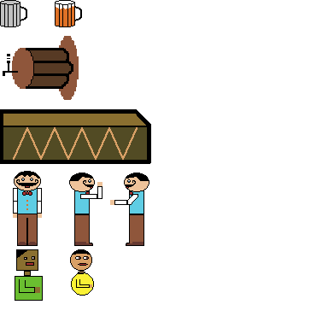

1. **Design Notes**

Simple concept with easy to learn controls to keep the player engaged in breaking the hiscore is the main design. Try to capture the frantic fun of games like Overcooked, and Diner Dash where orders pile up and only good players will be able to meet demand. However, start slow for the player to learn the basics and escalate as they progress.

1. **Future Features**

Having a hiscore list added to the end screen would be nice. To show the player how they are progressing and to beat their old score.

Varied patrons, beverages, and bar tender skins would be nice as unlocks to have the player wanted to keep playing to unlock these things.