|  |
| --- |
| NEW Games |
| Knightly Platformer |
| **Mobile Game Development** |
| Version #1.0  All work Copyright © 2020 by NEW Games.  All rights reserved. |
| **Nathan E. Whitehead** |
|  |

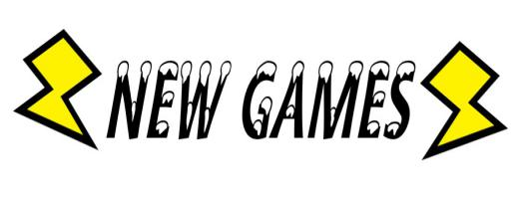

|  |
| --- |
| November 10, 2020 |

**Table of Contents**

**1: Game Overview**

**2: Gameplay Mechanics**

**3: Camera**

**4: Controls**

**5: Saving/Loading**

**6: Interface Sketches/Menu and Game Descriptions**

**7: Game World**

**8: Levels**

**9: Game Progression**

**10: Characters and NPC’s**

**11: Items**

**12: Scripts**

**13: Scoring**

**14: Sounds**

**15: Story**

**16: Art**

**17: Design Notes**

**18: Future Features**

**Version History**

Version 0.1 - Initial asset creation and game planning, November 10, 2020

1. **Game Overview**

Knightly Platformer is a mobile platformer game with a medieval setting. The player is a knight and must traverse the castle to reach the top and save a princess.

1. **Game Play Mechanics**

As a knight you have the ability to run, jump, and attack. You must dodge obstacles and fight enemies on your way to save a princess. Special platforms will include, spring boards, floating platforms, and disappearing platforms. There will also be pitfalls, enemy knights and hazards to challenge the player.

1. **Camera**

The camera is going to be following the player through the level. Potentially static during enemy/boss encounter forcing the player to deal with the problem at hand instead of fly by it.

1. **Controls**

Controls will be a joystick in the lower left hand side and two buttons on the right, for jumping and attacking.

1. **Saving and Loading**

No saving or loading will be implemented.

1. **Menu and Screen Descriptions**

Main Menu sketch, How to play/controls sketch

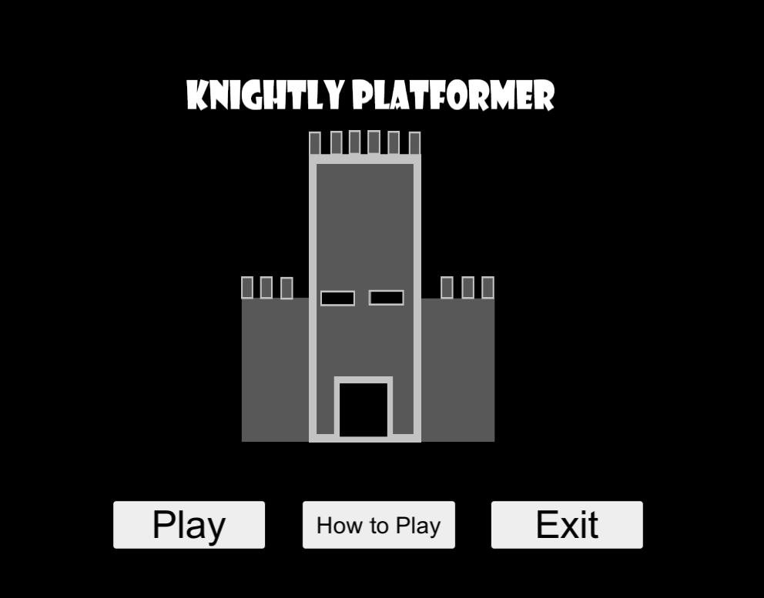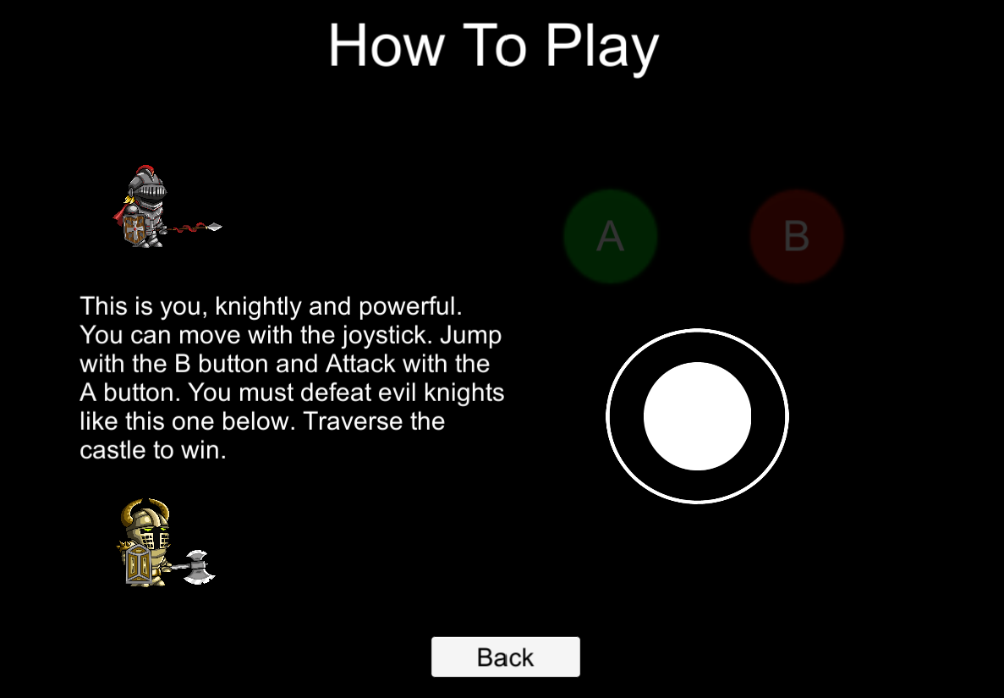

1. **Game World**

Game world is set in a medieval castle. Level design below, the player starts all the way on the left with various enemies along the path to the end. Notable platforms are the first gap, will be floating back and forth, after the first enemy a spring board platform then lastly 2 platforms that will break after 2 seconds.

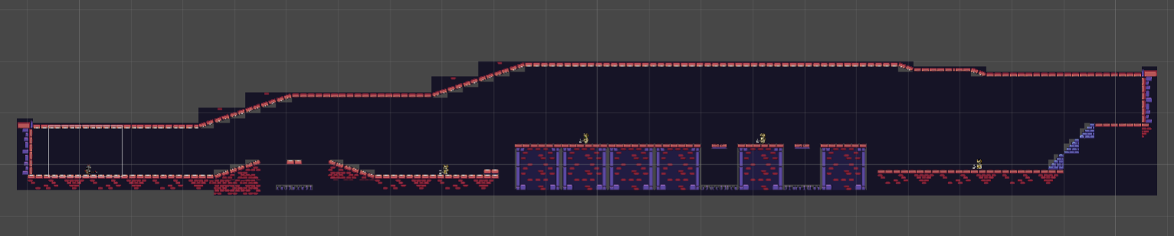

1. **Levels**

There will be a single playable level, in which the player must use platforming skills to traverse a multitude of hazards, enemies, and the world itself.

1. **Game Progression**

Progressions is done by slaying enemies and collecting gold. The basic game progression will be to get through the level and reach the goal.

1. **Characters**

The player is a knight. They can run, jump, attack.

1. **Non-player Characters**

There is one enemy character that is also a knight. They can do everything the player can and multiple of these enemy knights will be placed around the level to challenge the players ability to overcome the deadly enemy.

1. **Items**

Currently no items are available.

1. **Script**

Scripts involved will be for player controls, enemy AI, unique platforms, scene changes.

1. **Scoring**

The player will be awarded score for picking up gold. Gold can be found around the level and dropped of slaying enemy knights.

1. **Sound Index**

The game is made up of 4 background soundtracks. Each scene will have a unique background music track that loops. All music and sound effects have been made and produced by myself in a music creation software called Rytmik.

1. **Story Index**

You are a noble knight tasked with bringing back the princess from a castle. However, many hazards and evil knights guard the way to her. You must use your strength to slay the enemy knights and agility to traverse dangerous hazards.

1. **Art / Multimedia Index**

Sprites being used. Found online for free.

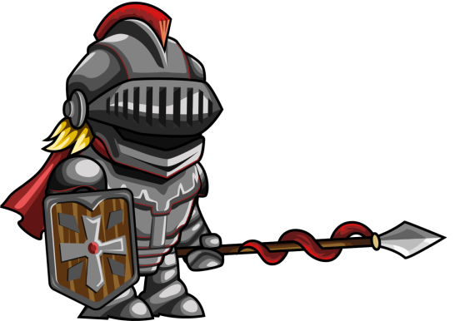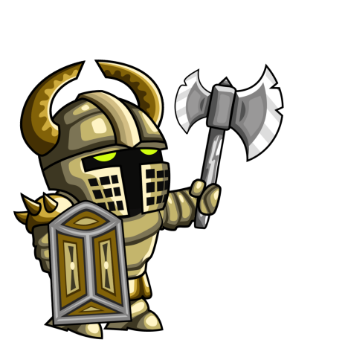

1. **Design Notes**

While designing this game I’m looking at creating a smooth platformer experience like Rayman. This allows the player to move, jump, and attack seamlessly. Some platformers focus more on puzzles, however this one will focus more on platforming skill and how to handle the danger ahead. Being a simple concept there’s a lot I can add to make this a fun mobile platformer.

1. **Future Features**

Secret area’s, and hidden rooms are always a fun touch on any game but for platformers especially. Adding more enemy types and unique platforms would be a nice addition too.