Allan Torres
04/19/2026
CS-340-11052-M01

Overview
This project implements a fully functional web-based data dashboard for Grazioso Salvare, a company specializing in training rescue dogs for various mission types. The dashboard is built using Python, Dash, Plotly, and MongoDB, and provides an interactive interface for filtering, visualizing, and mapping animal shelter data.
The dashboard allows users to:
- Filter animals by rescue type
- View updated results in a dynamic data table
- Visualize breed distribution using a pie chart
- Display the selected animal’s geographic location on a map
- Interact with the data in real time through Dash callbacks
This submission includes the complete dashboard notebook and the CRUD module originally developed in Project One.
Project Structure
- ProjectTwoDashboard.ipynb Contains the full Dash application, including layout, callbacks, and data visualization logic.
- CRUD_Python_Module.py Implements the AnimalShelterCRUD class used to connect to MongoDB and perform Create, Read, Update, and Delete operations.
- Logo.png The Grazioso Salvare logo displayed at the top of the dashboard.
Technologies Used
- Python 3
- Dash (JupyterDash, dash_table, dash_leaflet)
- Plotly Express
- Pandas
- MongoDB
- PyMongo
- Jupyter Notebook
Key Features
1. CRUD Integration
The dashboard connects to MongoDB using the AnimalShelterCRUD class. The read() method is used to retrieve documents based on user-selected filters.
2. Interactive Filtering
Users can filter animals by rescue type:
- Water Rescue
- Mountain/Wilderness Rescue
- Disaster/Individual Tracking
- Reset (show all)
Each filter applies a MongoDB query based on:
- Breed lists defined in the project specification
- Age requirements (in weeks)
3. Dynamic Data Table
The table supports:
- Sorting
- Filtering
- Row selection
- Pagination
Selecting a row updates the map and chart.
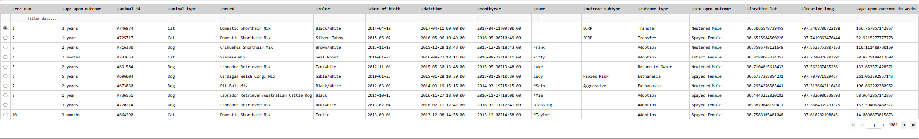
4. Breed Distribution Pie Chart
The pie chart updates automatically based on the filtered dataset and displays the distribution of breeds currently visible in the table.
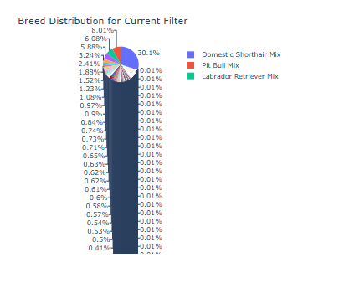
5. Geolocation Map
A map is generated using dash_leaflet, showing:
- The selected animal’s latitude and longitude
- A tooltip with the breed
- A popup with the animal’s name
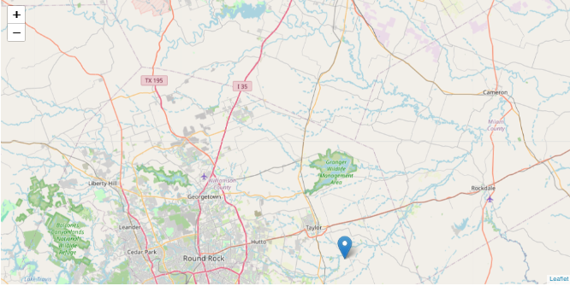

How to Run the Dashboard
- Open ProjectTwoDashboard.ipynb in Jupyter Notebook or JupyterLab.
- Ensure MongoDB is accessible with the correct username and password.
- Run all cells from top to bottom.
- The dashboard will launch automatically using JupyterDash.
- Interact with the filters, table, chart, and map.

Notes
- This project was completed using Copilot Copilot

