Ex. No. 1 | Design A Website Using HTML5
Date of Exercise | 14.7.26
GitHub Host Link | https://github.com/NateshNaren/AnimeVerse

Aim
To design and develop a simple yet structured Anime Fan Website using HTML5 by implementing semantic elements, headings, paragraphs, images, tables, lists, hyperlinks, comments, and basic CSS formatting to create an attractive and user-friendly webpage.
Description
This exercise is implemented using HTML5 and internal CSS to design a simple Anime Fan Site webpage. The following technical concepts are used:
<!DOCTYPE html> | Declares the document as an HTML5 document.

<html> | Root element that contains the entire webpage.

<head> | Contains the title and style information of the webpage.

<title> | Displays the webpage title in the browser tab.

<style> | Applies CSS styles to the webpage.

<body> | Contains all the visible content of the webpage.

<div> | Divides the webpage into different sections.

<h1> | Displays the main heading of the webpage.

<h2> | Displays section headings.

<p> | Displays paragraphs of text.

<img> | Displays an image on the webpage.

<table> | Displays information in rows and columns.

<tr> | Creates rows in the table.

<th> | Displays table headings.

<td> | Displays table data.

<ul> | Creates an unordered (bulleted) list.

<ol> | Creates an ordered (numbered) list.

<li> | Represents items in a list.

<dl> | Creates a description list.

<dt> | Defines a term in the description list.

<dd> | Gives the description of the term.

<a> | Creates hyperlinks to other pages or sections.

background-color | Sets the background color of the webpage.

color | Changes the text color.

font-family | Changes the font style of the text.

border | Adds borders to the table.

border-collapse | Combines table borders into a single border.

padding | Adds space inside table cells.

width | Sets the width of the image.

<hr> | Inserts a horizontal line to separate sections.

Procedure:
- Open Visual Studio Code or any text editor.
- Create a new folder named AnimeVerse.
- Inside the folder, create a new file named index.html.
- Save Anime images in a sub-folder
- Begin the HTML document with the <!DOCTYPE html> declaration.
- Add the required HTML5 tags such as <html>, <head>, <meta>, <title>, and <body>.
- Create different sections using <div> elements.
- Insert the main heading using <h1> and subheadings using <h2>.
- Add paragraphs describing the Anime Fan Site using <p> tags.
- Insert a Anime image using the <img> tag.
- Create an ordered list, unordered list, and description list to display services and features.
- Create a table to display Anime name, genre and rating.
- Add different hyperlinks including external, internal, bookmark, email, phone, and clickable image links.
- Insert HTML comments before each section for better code readability.
- Apply background color and text color using internal CSS.
- Save the file.
- Open the file in a web browser or Live Server to view the output.
- Verify that all required HTML elements are displayed correctly.

Program
<!DOCTYPE html>
<html lang="en">
<head>
<meta charset="UTF-8">
<meta name="viewport" content="width=device-width, initial-scale=1.0">
<title>AnimeVerse | Anime Fan Site</title>
<style>
body {
background-color: #12181b;
color: #e8e8e8;
font-family: Arial, sans-serif;
margin: 20px;
line-height: 1.6;
}
h1 {
text-align: center;
color: #ff8c42;
letter-spacing: 2px;
}
p.tagline {
text-align: center;
color: #cfcfcf;
}

.section {
border: 1px solid #2c363a;
background-color: #1c2529;
padding: 15px 20px;
margin: 20px 0;
border-radius: 6px;
}
h2 {
color: #ff8c42;
border-left: 5px solid #ff8c42;
padding-left: 10px;
}
.hero {
text-align: center;
}
.hero-img {
width: 100%;
max-height: 320px;
object-fit: cover;
object-position: center 30%;
border-radius: 6px;
}
.caption {
font-size: 13px;
color: #999;
}
.poster {
width: 220px;
float: left;
margin: 0 15px 10px 0;
border-radius: 6px;
}
.clear {
clear: both;
}
table {
width: 100%;
border-collapse: collapse;
margin-top: 10px;
}
table, th, td {
border: 1px solid #2c363a;
padding: 8px;
text-align: center;
}
th {
background-color: #ff8c42;
color: #0a0f11;
}

td {
background-color: #12181b;
}
a {
color: #ff8c42;
}
footer {
text-align: center;
color: #888;
border-top: 3px solid #ff8c42;
padding: 15px;
margin-top: 20px;
}
</style>
</head>
<body>
<h1 id="top">AnimeVerse</h1>
<p class="tagline">Your hub for anime recommendations, genres, and fan community</p>

<div class="hero">
<a href="https://en.wikipedia.org/wiki/Anime" target="_blank">
<img src="images/hero-banner.jpg" alt="Bleach Gotei 13 captains lineup" class="hero-img">
</a>
<p class="caption">Click the banner to read about anime on Wikipedia</p>
</div>
<div class="section" id="about">
<h2>About This Site</h2>
<p>
AnimeVerse is a fan-made site for anime lovers. Browse anime by genre, check out
a ranked collection, and follow the links to learn more about each show.
</p>
<p>
Whether you are new to anime or a longtime fan, AnimeVerse brings together
recommendations, background information, and links to learn more about your
favorite shows.
</p>
</div>
<div class="section" id="stats">
<h2>Quick Facts</h2>
<ul>
<li>3 Featured Anime</li>
<li>4 Genres Covered</li>
<li>9 Anime Linked to Wikipedia</li>
<li>Updated with New Picks Regularly</li>
</ul>
</div>
<div class="section" id="featured">
<h2>Featured Anime</h2>

<a href="https://en.wikipedia.org/wiki/Bleach:_Thousand-Year_Blood_War" target="_blank">
<img src="images/bleach-poster.jpg" alt="Bleach: Thousand-Year Blood War poster" class="poster">
</a>
<h3>Bleach: Thousand-Year Blood War</h3>
<p>The Gotei 13 captains face their final battle against the Quincy army in the
climactic arc of Bleach.</p>
<div class="clear"></div>

<a href="https://en.wikipedia.org/wiki/Fullmetal_Alchemist:_Brotherhood" target="_blank">
<img src="images/fma-brotherhood-poster.jpg" alt="Fullmetal Alchemist: Brotherhood poster" class="poster">
</a>
<h3>Fullmetal Alchemist: Brotherhood</h3>
<p>Two brothers use alchemy in their search for the Philosopher's Stone to restore
what they lost.</p>
<div class="clear"></div>

<a href="https://en.wikipedia.org/wiki/Jujutsu_Kaisen" target="_blank">
<img src="images/jjk-poster.jpg" alt="Jujutsu Kaisen poster" class="poster">
</a>
<h3>Jujutsu Kaisen</h3>
<p>Yuji Itadori joins a secret organization of sorcerers to eliminate a powerful
Curse, Ryomen Sukuna.</p>
<div class="clear"></div>
</div>

<!-- Genres Section (Nested Lists) -->
<div class="section" id="genres">
<h2>Browse by Genre</h2>

<h3>By Type (Unordered)</h3>
<ul>
<li>Shonen
<ul>
<li><a href="https://en.wikipedia.org/wiki/Jujutsu_Kaisen" target="_blank">Jujutsu Kaisen</a></li>
<li><a href="https://en.wikipedia.org/wiki/Naruto" target="_blank">Naruto</a></li>
<li><a href="https://en.wikipedia.org/wiki/My_Hero_Academia" target="_blank">My Hero Academia</a></li>
</ul>
</li>
<li>Isekai
<ul>
<li><a href="https://en.wikipedia.org/wiki/Re:Zero_%E2%88%92_Starting_Life_in_Another_World" target="_blank">Re:Zero</a></li>
<li><a href="https://en.wikipedia.org/wiki/Sword_Art_Online" target="_blank">Sword Art Online</a></li>
</ul>
</li>
</ul>

<h3>Ranked Picks (Ordered)</h3>
<ol>
<li>Adventure
<ol>
<li><a href="https://en.wikipedia.org/wiki/Fullmetal_Alchemist:_Brotherhood" target="_blank">Fullmetal Alchemist: Brotherhood</a></li>
<li><a href="https://en.wikipedia.org/wiki/One_Piece" target="_blank">One Piece</a></li>
</ol>
</li>
<li>Action / Supernatural
<ol>
<li><a href="https://en.wikipedia.org/wiki/Bleach_(manga)" target="_blank">Bleach</a></li>
<li><a href="https://en.wikipedia.org/wiki/Demon_Slayer:_Kimetsu_no_Yaiba" target="_blank">Demon Slayer</a></li>
</ol>
</li>
</ol>
</div>

<!-- Collection Table Section -->
<div class="section" id="collection">
<h2>My Collection</h2>
<table>
<tr>
<th>Anime</th>
<th>Genre</th>
<th>Rating</th>
</tr>
<tr>
<td>Bleach: Thousand-Year Blood War</td>
<td>Action / Supernatural</td>
<td>9.2</td>
</tr>
<tr>
<td>Fullmetal Alchemist: Brotherhood</td>
<td>Adventure</td>
<td>9.1</td>
</tr>
<tr>
<td>Jujutsu Kaisen</td>
<td>Shonen</td>
<td>8.8</td>
</tr>
</table>
</div>

<div class="section" id="contact">
<h2>Contact Us</h2>
<p><b>Email:</b> <a href="mailto:animeverse@example.com">animeverse@example.com</a></p>
<p><b>Phone:</b> <a href="tel:+918072111716">+91 80721 11716</a></p>
<p><a href="#about">Jump to About Us</a></p>
<p><a href="#top">Back to Top</a></p>
</div>

<!-- Footer -->
<footer>
<p>&copy; 2026 AnimeVerse Fan Site | Fan-made, not affiliated with any studio or publisher</p>
</footer>

</body>
</html>

Output
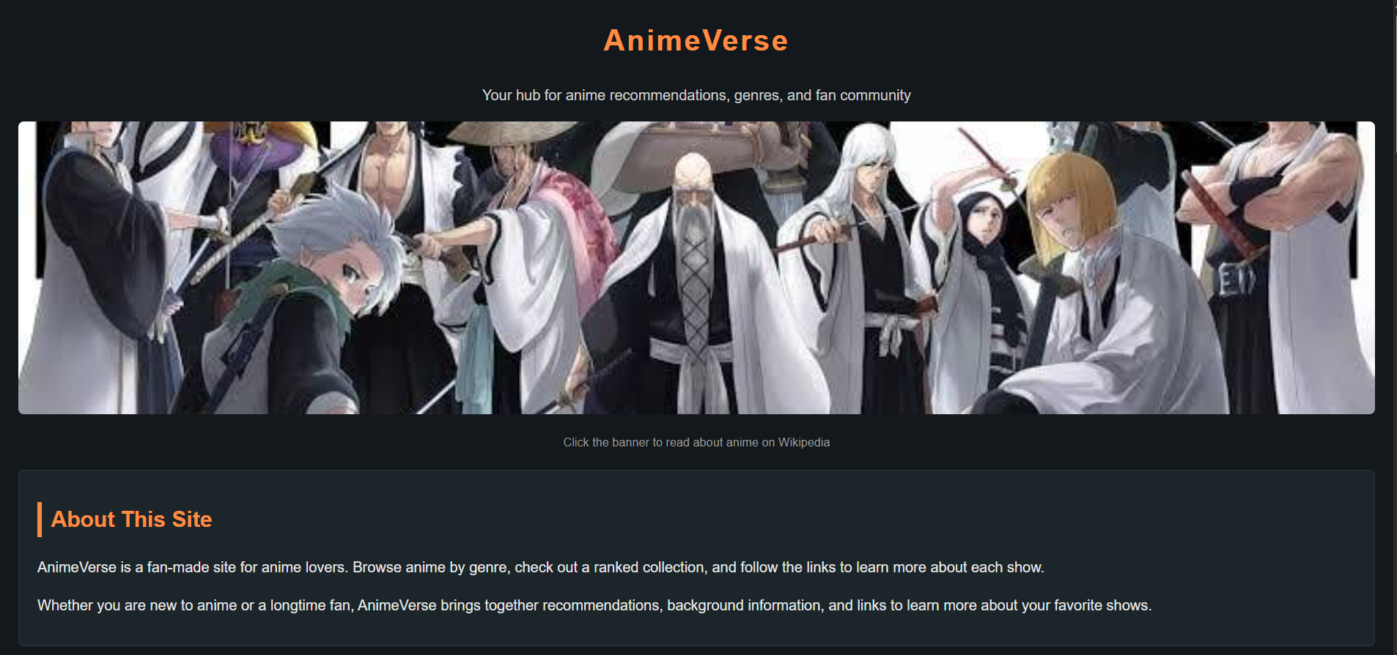
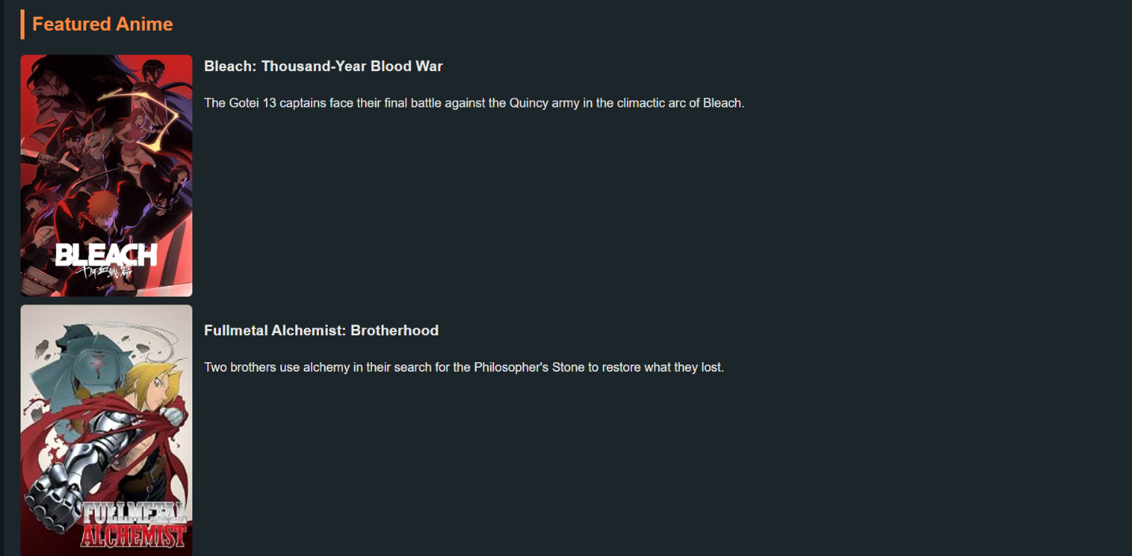

Result
The HTML5 Anime Fan Site webpage was successfully designed and executed using HTML5 tags and basic CSS. The output was verified successfully.

