Fungi-wide annotation of small RNAs shows diverse systems of RNAi

# Introduction

# Results

## Section 1

## 

### Figure 1 - sRNAs found in fungi vary by clade.

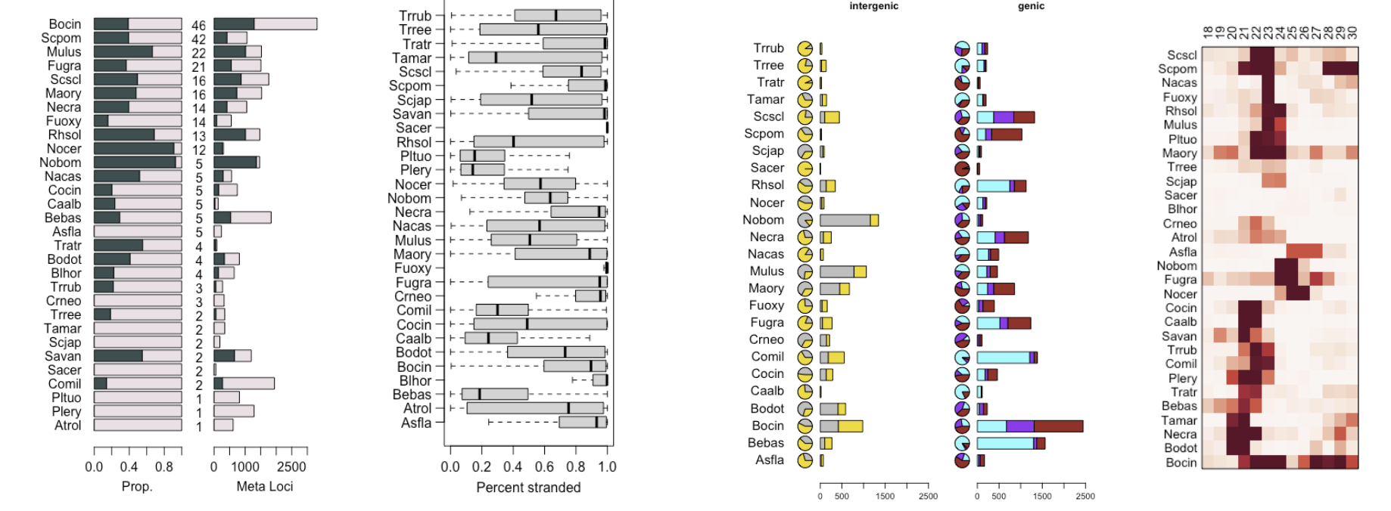

### Figure 2 -

## Derived sRNA loci point to shared RNAi on a locus level

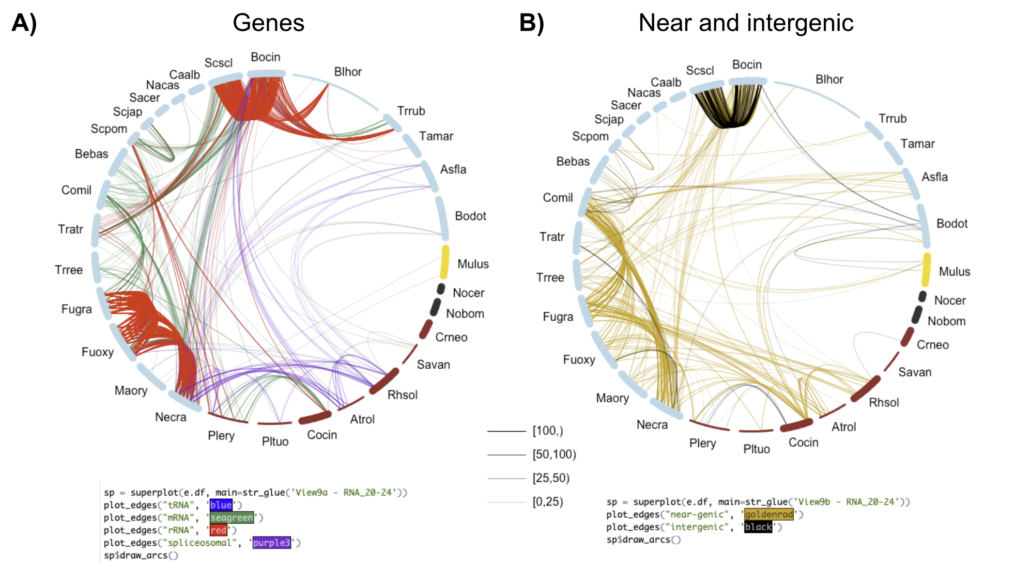

### Figure 4 - Conservation of small RNA classes between close and distant species

# Discussion

## Hairpin-derived sRNAs in fungi are very young

* Only very short distance conservation (how far back)
* Poor selection of miRNA:star duplex.
* Low precision in general.
* Is there an evolutionary advantage to double-miRNAs?