2017

Btec it unit 26

James Wagstaff

# Table of Contents

Table of Contents 1

Introduction 1

Conclusion 1

Bibliography and References 1

# P6:

# P7:

# P8:

# Data Task [TASK 4 -D2] P9/P10/M5:

## Data:

**Hypothesis:**

My data will be about how many times a person looks at their watch a day. I will gather this data for 6 different people for 3 days each, to be able to determine the different averages. My hypothesis for the average amount of times a person looks at their watch a day would be around 10 – 12 times a day.

**Data Set:**

|  |  |  |  |
| --- | --- | --- | --- |
| Person | Day 1 | Day 2 | Day 3 |
| Nathan | 13 | 7 | 9 |
| Ruben | 7 | 8 | 6 |
| Megan | 8 | 12 | 7 |
| Simon | 11 | 10 | 13 |
| Tom | 14 | 15 | 18 |
| Dan | 16 | 19 | 17 |

**Frequency Diagram:**

**Mean, Median & Mode:**

The Mean is the total divided by the number of records. 213 / 18 = 11.83.

The Median is the middle value of the data set, if it was in order, which in this case is 11.5.

The Mode is the value that is most common in the data set, which in this case is 7.

**Range:**

The range is the difference between the lowest and highest value in the data set, which in this case is the difference between 7 and 19, which is 12.

**IQ Range:**

The Interquartile Range is defined as “a measure of variability, based on dividing a data set into quartiles. Quartiles divide a rank-ordered data set into four equal parts. The values that divide each part are called the first, second, and third quartiles; and they are denoted by Q1, Q2, and Q3, respectively.”

Box Plot:

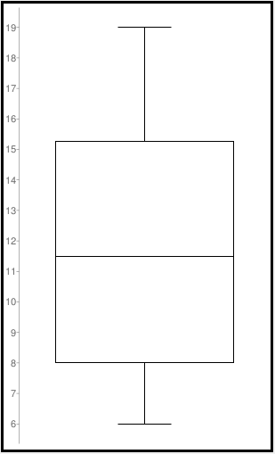

Q1 = 8

Q3 = 15.25

IQ Range = 7.25

**Variance:**

The Variance is defended as “The average of the squared differences from the Mean”. To work out the Variance, first work out the Mean, and then subtract the Mean from each piece of data. Then square them, to make them positive, and add them all together. Divide this by the amount of values in the data set. This will give you the Variance for your data set.

**Conclusion:**

Judging from the information I have gathered, it seems people look at their watches on average 11 times a day. This would make sense, as the information I gathered was in college, which means people would need to check the time often to make sure they were going to get to the right lessons on time. I suspect that because of this, the results would be different in a different work environment, such as an office or a catering job.

# TASK 5:

## Recursion:

In computing, a recursive method is a piece of self-contained code that will call upon its self repeatedly. These are often used in algorithms such as specialized sorting algorithms, that are designed to go through large amounts of data quickly. For example, a Non-Recursive algorithm would be a loop that would go through each element of data and check if it is the data that it is looking for, if it was, the code would return the value and stop the loop. This means that if the piece of data happens to be at the beginning of the data set, the code is very quick. But if the data is at the end of the data set, it can take a long time to get to the correct piece of data, as it must check each piece of data in order.

A Recursive Sorting algorithm would be a Binary Search. This would check the middle value of the data set, if it was not the value it was looking for, it would recursively call its self to check for the middle value of the 2 halves of the data set. The code would keep doing this until it found the piece of data it was looking for. This method is efficient for large data sets.

# TASK 6:

## Binary:

Binary is the simplest form of data transfer, and is used by computers to transfer information. Binary is represented by 0’s and 1’s, and different combinations can mean different things. Binary can also be interpreted differently, so the same combination of 0’s and 1’s can mean one thing, but can also be interpreted to mean another. One use of binary is to represent characters, such as numbers and letters, there are different ways of doing so, such as ASCII and Unicode. This is how Binary can be converted to ASCII.

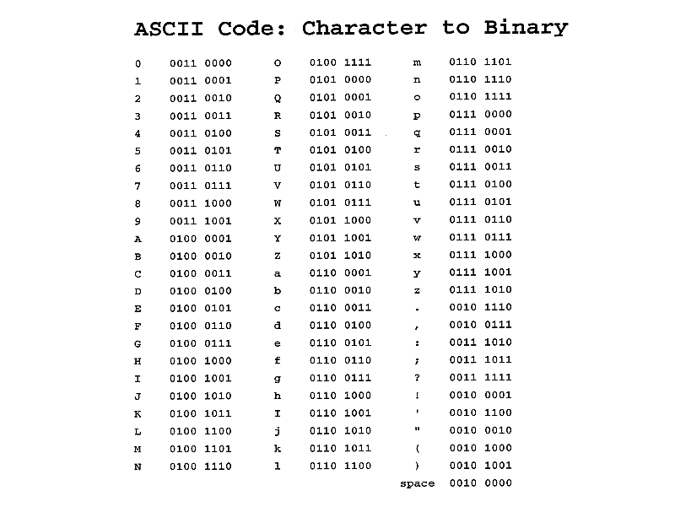

## Hexadecimal:

Hexadecimal is a shorthand way of representing binary. It is easier to read and understand for a person, so it is often used instead of binary in places where a person might need to right the information. For example, Hex is used to represent colours on computer systems, the colours are split between Red, Blue and Green, and sometimes a transparency value. For example, FFFFFF converts to pure white, while 000000 is pure black.

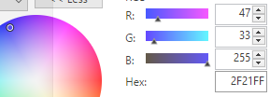

## Octal:

Octal is not often used in computer systems anymore, as computers are now based on multiples of 4 rather than 3, which means hexadecimal is used more often. However, Octal is still used on Unix system permissions as there are 3 groups, User, Group, and Others. And its file permissions are set to read, write, and execute, and as an Octal character can represent 3 Binary characters, it makes it very well suited for this task.