Q1.
A binary search tree is a data structure where items of data are held such that they can be searched for quickly and easily.
The following data items are to be entered into a binary search tree in the order given:
London, Paris, Rome, Berlin, Amsterdam, Lisbon, Madrid.

(a) Draw a diagram to show how these values will be stored.

(4)

(b) Circle the root node in your diagram.
(1)

(c) If Madrid is being searched for in this binary tree, list the data items which have to be accessed.
.......................................................................................................................
(1)
(Total 6 marks)

Q2.
The list Ports contains the following names:
[Southampton, Barcelona, Athens, Alexandria, Tunis, Lisbon]
The table below shows some functions which take a list as their single argument and return a result which is either an element of a list or a boolean value.

Head(list) – If the list is non-empty, it returns the element at the head of the list (e.g. Head (Ports) → Southampton) otherwise it reports an error
Tail(list) – If the list is non-empty it returns a new list containing all but the first element of the original list, otherwise it reports an error
Empty(list) – if the list is the empty list it returns True otherwise it returns False. The empty list is donated by [ ]

(a) What result is returned when the following function calls are made?
(i) Tail(Ports) ............................................................................................
..............................................................................................................
(1)

(ii) Head(Tail(Tail(Ports))) ..........................................................................
..............................................................................................................
(2)

(iii) Empty(Tail(Tail(Tail(Tail(Tail(Tail(Ports))))))) .......................................
..............................................................................................................
(2)

A recursively defined procedure P, which takes a list as its single parameter, is defined below.
Define Procedure P(list)
If Not Empty(list)
Then
P(Tail(list))
Print Head(list)
EndIf
EndDefine

(b) What is meant by recursively defined?
.......................................................................................................................
.......................................................................................................................
(1)

(c) Explain why a stack is needed to execute procedure P recursively.
.......................................................................................................................
.......................................................................................................................
.......................................................................................................................
(2)

(d) For the procedure call P(Ports) give the PRINTed output in the order in which it is produced.
.......................................................................................................................
.......................................................................................................................
(4)

(e) Complete the table to show the list Ports as a linked list so that the ports can be accessed in alphabetical order.
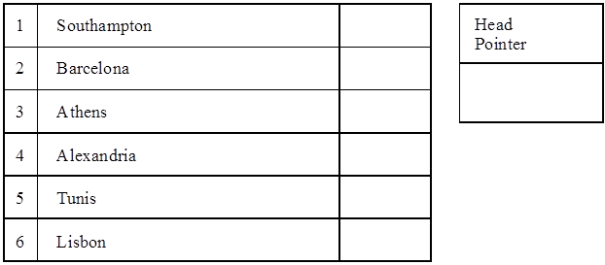
(2)
(Total 14 marks)

Q3.
(a) The series of characters J, F, H, U, S, X, T are to be entered into a binary search tree in the order given. Draw a diagram to show how these values will be stored.

(4)

(b) The following data are held in arrays Data, L and R:
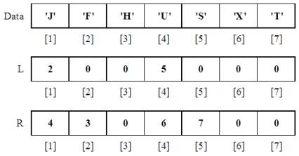

Using the arrays above, dry-run the following pseudo-code by completing the trace table opposite:
Item ← ‘T’
Ptr ← 1
WHILE Data[Ptr] < > Item DO
PRINT Data[Ptr]
IF Data[Ptr] > Item
THEN Ptr ← L[Ptr]
ELSE Ptr ← R[Ptr]
ENDIF
ENDWHILE
PRINT Data[Ptr]

Trace Table:

 | Item | Ptr | Printed Output
 | ‘T’ | 1 | ‘J’

(6)
(Total 10 marks)

Q4.
The following data is input to a program, in alphabetical order, and is stored.
Anne
Bob
Claire
Dean

(a) Draw a diagram to show how this data is stored for:
(i) a stack;

(ii) a queue.
(4)

(b) One item is retrieved from these data structures for processing, and Eden is input.
Draw the diagrams of this new situation for:
(i) the stack;

(ii) the queue.

(3)

(c) Why are queues in computer systems usually implemented as circular queues?
.......................................................................................................................
.......................................................................................................................
.......................................................................................................................
.......................................................................................................................
(2)
(Total 9 marks)

Q5.
For the expression 3+x the binary tree stores + at the root, 3 at the left hand node and x at the right hand node. If the nodes of this tree are printed as the tree is traversed, what will be printed when the traversal is
(a) pre-order; .......................................................................................................
(b) in-order; .........................................................................................................
(c) post-order? ....................................................................................................
(Total 3 marks)

Q6.
(a) (i) The birds Pheasant, Teal, Widgeon, Partridge, Woodpigeon are entered, in the order given, into a linked list so that they may be processed alphabetically. Draw this linked list.

(2)

(ii) Redraw the list after two additional items, Grouse and Snipe, are added.

(2)

(b) This linked list is said to be a dynamic structure. What is meant by the term dynamic structure?
.......................................................................................................................
.......................................................................................................................
(2)

(c) Explain how memory was allocated for the two additional data items.
.......................................................................................................................
.......................................................................................................................
(2)
(Total 8 marks)

Q7.
An algebraic expression is represented in a binary tree as follows.
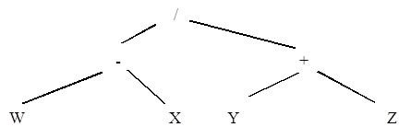

(a) On the above diagram, circle and label the root of this tree, a branch and a leaf node.
(3)

(b) In the spaces below, draw the left sub-tree and the right sub-tree of this tree.
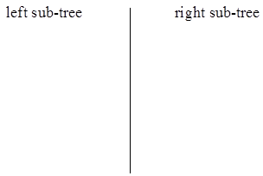
(2)

(c) What is the result if this tree is printed using in-order traversal?
.......................................................................................................................
(3)
(Total 8 marks)

Q8.
The list Days contains the following representation of the days of the week.
[Sun, Mon, Tue, Wed, Thu, Fri, Sat]
The table below shows some functions which take a list as their single argument and return a result which is either an element of a list, another list, or a Boolean value.

Head(list) - returns the element at the head of list (e.g. Head(Days)→ Sun) if list is non empty otherwise it reports an error.
Tail(list) - returns a new list containing all but the first element of the original list (e.g. Tail(Days) → [Mon, Tue, Wed, Thu, Fri, Sat]) if list is non-empty otherwise it reports an error.
Empty(list) - returns True if list is the empty list or False otherwise. The empty list is denoted by[]

(a) What result is returned when the following function calls are made?
(i) Head (Tail(Days))..................................................................................
(1)

(ii) Tail ([(Head(Days)])...............................................................................
(1)

(iii) Empty(Tail(Tail(Tail(Days)))).................................................................
(1)

(b) Explain why it is faster to access these elements if the above data is stored as a one dimensional array.
.......................................................................................................................
.......................................................................................................................
(2)
(Total 5 marks)

Q9.
A recursively-defined procedure B, which takes an integer as its single parameter, is defined below. The operators DIV and MOD perform integer arithmetic.
x DIV y calculates how many times y divides exactly into x. For example 7 DIV 3 = 2
x MOD y calculates the remainder that results. For example 7 MOD 3 = 1.
Procedure B (Number)
If (Number = 0) OR (Number = 1)
Then Print (Number)
Else
B (Number DIV 2)
Print (Number MOD 2)
EndIf
EndProcedure

(a) What is meant by recursively-defined?
.......................................................................................................................
.......................................................................................................................
(1)

(b) Why is a stack necessary to execute procedure B recursively?
.......................................................................................................................
.......................................................................................................................
(1)

(c) Dry run the procedure call B(53) showing clearly the values of the parameter and the printed output for the six calls of B.

 | Call Number | Parameter
 | 1 | 53
 | 2 | 26
 | 3 | 13
 | 4
 | 5
 | 6

Printed Output: ...............................................................................................
(6)

(d) What process does procedure B describe? ..................................................
(1)
(Total 9 marks)

Q10.
A stack is a type of abstract data type (ADT) that is often known as a LIFO data type. A stack with a single element 27 may be drawn as follows:

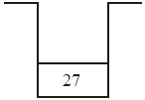

(a) What is the meaning of the term LIFO?
.......................................................................................................................
(1)

(b) A stack has two operations, Push and Pop. Push n adds item n to stack. Pop removes one item from the stack. A number of operations are performed, in sequence, on the stack drawn above. Using the stack diagrams below show the effect of this sequence of operations.
(i) Push 5

(1)
(ii) Push 9

(1)

(iii) Pop

(1)
(iv) Push 6

(1)

(c) Give one example of the use of a stack.
.......................................................................................................................
(1)
(Total 6 marks)

Q11.
A binary search tree is a data structure where items of data are stored such that they can be searched for quickly and easily.
The following data items are to be entered into a binary search tree in the order given:
Louise, Peter, Robert, Christine, Alan, Leslie, Maria
(a) Draw a diagram to show how these values will be stored in the tree.

(4)

(b) Circle the root node in your diagram.
(1)

(c) If Maria is being searched for in this binary tree, list the data items which have to be accessed.
.......................................................................................................................
(1)
(Total 6 marks)

Q12.
A recursively-defined procedure Process, which takes an integer as its single parameter, is defined below.
(a) What is meant by recursively-defined?
........................................................................................................................
........................................................................................................................
(1)

(b) Describe how a stack is used in the execution of procedure Process?
........................................................................................................................
........................................................................................................................
........................................................................................................................
........................................................................................................................
(2)

(c) Dry run the procedure call Process(1), using the data in the table below, showing clearly the order the values are printed.
Procedure Process (P)
Print (P)
If Table[P].Left <> 0
Then Process (Table[P].Left)
EndIf
Print (Table[P].Data)
If Table[P].Right <> 0
Then Process (Table[P].Right)
EndIf
EndProcedure
 |  |  | Table
 |  | Data | Left | Right
 | [1] | Jones | 3 | 2
 | [2] | Smith | 0 | 0
 | [3] | Bremner | 5 | 4
 | [4] | Fortune | 0 | 0
 | [5] | Bird | 0 | 0

Printed Output: ..............................................................................................
........................................................................................................................
(6)

(d) What does procedure Process describe?
........................................................................................................................
(1)
(Total 10 marks)

Q13.
(a) In the context of data structures what is meant by the terms:
(i) FIFO; ....................................................................................................
(ii) LIFO? ...................................................................................................
(2)

(b) Queue and stack are examples of data structures. Tick in the following table to indicate whether they are FIFO or LIFO data structures.

 |  | FIFO | LIFO
 | Queue
 | Stack

(2)

(c) Describe one example of the use of a stack.
.......................................................................................................................
.......................................................................................................................
.......................................................................................................................
(2)

(d) Describe one example of the use of a Binary Search Tree.
.......................................................................................................................
.......................................................................................................................
.......................................................................................................................
(2)
(Total 8 marks)

Q14.
A tree has the following functions defined:
RootValue(T) Returns the contents of the root node of the tree T
LeftChild(T) Returns the left child of the root node of the tree T
RightChild(T) Returns the right child of the root node of the tree T

A recursively-defined procedure P with a tree as a parameter is defined below.
Procedure P (T)
If LeftChild(T) exists
then P(LeftChild(T))
Output RootValue(T)
If RightChild(T) exists
then P(RightChild(T))
EndProc

(a) What is meant by recursively-defined?
.........................................................................................................................
.........................................................................................................................
(1)

(b) (i) Complete the table below by dry running the procedure call P(T) for the tree T given below.
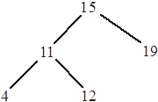

 | Procedure Call | T |  | Output
 | P₁

(6)

(ii) What does procedure P describe?
................................................................................................................
(2)
(Total 9 marks)

Q15.
A stack may be implemented by using either an array or a linked list.
(a) Give a disadvantage of:
(i) an array implementation;
................................................................................................................
(1)
(ii) a linked list implementation.
................................................................................................................
(1)

(b) Under what circumstances would it be more appropriate to use:
(i) an array;
................................................................................................................
(1)
(ii) a linked list.
................................................................................................................
(1)
(Total 4 marks)

Q16.
The data shown below is a list of surnames of 20 motor car policyholders with the number of claims they have each made in the last five years.

 |  | PolicyHolder |  | NoOfClaims
 | 1 | Wilcox | 1 | 1
 | 2 | Adams | 2 | 0
 | 3 | Pollard | 3 | 0
 | 4 | Williams | 4 | 0
 | 5 | Searle | 5 | 3
 | 6 | Kelly | 6 | 0
 | 7 | Lewis | 7 | 1
 | 8 | Franks | 8 | 5
 | 9 | Patel | 9 | 1
 | 10 | Li Che | 10 | 0
 | ... |  | ... | ...
 | ... |  | ... | ...
 | 19 | Wilkinson | 19 | 3
 | 20 | Veale | 20 | 0

(a) (i) The user inputs a policyholder. If the surname is found, the program outputs the number of claims for that policyholder.
Read(SearchName)
For P := 1 To 20 Do
If PolicyHolder[P] = SearchName
Then GoTo 200
GoTo 300
200 : Write(NoOfClaims[P])
300: End

Give two reasons why this is badly designed program code.
1 ...........................................................................................................
..............................................................................................................
2 ...........................................................................................................
..............................................................................................................
(2)

(ii) Write declaration statements (in a language with which you are familiar) for the PolicyHolder or NoOfClaims data structure above, and one other variable used in the code above.
The programming language I am using is ...........................................
1 ...........................................................................................................
2............................................................................................................
(2)

(b) A new task is to design and write code to establish if there are any policyholders who have made five or more claims. The program will output a ‘yes’ or ‘no’ message only.
Write the code for this new task in a programming language with which you are familiar.
(Hint: Use a loop structure to initiate the loop, and then end the loop when some condition is met.)
.........................................................................................................................
.........................................................................................................................
.........................................................................................................................
.........................................................................................................................
.........................................................................................................................
.........................................................................................................................
.........................................................................................................................
.........................................................................................................................
.........................................................................................................................
.........................................................................................................................
.........................................................................................................................
.........................................................................................................................
.........................................................................................................................
.........................................................................................................................
(5)
(Total 9 marks)

Q17.
A retail store employs ten sales staff. Staff try to persuade customers to take out a store card with the company when they make a purchase. The store keeps a record of the number of new store cards issued by its sales staff over the first six months of the year.
Table 1
StoreCards
 |  | [1] | [2] | [3] | [4] | [5] | [6]
 | [1] | 12 | 12 | 6 | 8 | 3 | 2
 | [2] | 12 | 17 | 7 | 4 | 5 | 6
 | [3] | 2 | 12 | 0 | 12
 | [4] | 4 | 10 | 7 | 4
 | [5] | 5 | 0 | 0 | 0 | 0 | 0
 | [6] | 6 | 1 | 4 | 6 | 7 | 8
 | [7] | 12 | 19 | 12 | 16 | 17 | 6
 | [8] | 13 | 9 | 7 | 3 | 4 | 5
 | [9] | 12 | 8 | 4 | 4 | 5 | 4
 | [10] | 14 | 11 | 12 | 4 | 5 | 6

The data is to be stored in a 2-dimensional array with identifier StoreCards as shown in the table above The first subscript of the array represents the row number (the salesperson number), and the second subscript the column number (the month).
(a) In the table the value 16 has been emboldened. Explain what this value represents.
.........................................................................................................................
(2)

(b) Write a declaration statement for the array StoreCards.
.........................................................................................................................
(2)

(c) Using the data given in the table abobe, write an assignment statement for the January sales for salesperson 8.
.........................................................................................................................
(2)

(d) Study the pseudo-code below.
Input SalesPersonNumber
PersonTotal ← 0
For Month ← 1 to 6 Do
PersonTotal ← PersonTotal +
storeCards[SalesPersonNumber, Month]
End For
Print PersonTotal
Explain what this algorithm is designed to do.
.........................................................................................................................
.........................................................................................................................
.........................................................................................................................
.........................................................................................................................
(2)

(e) A number of programs are to be written for the store card application, and the following are some of the data values which will need to be stored and/or calculated.
State what data type the programmer would use for each data item below.
(i) Average overtime hours worked by each member of staff.
................................................................................................................
(1)

(ii) Whether or not the staff are willing to work on Boxing Day.
................................................................................................................
(1)

(iii) The number of customer complaints made about each member of staff.
................................................................................................................
(1)
(Total 11 marks)

Q18.
An integer array A contains the following items.

 |  | A
 | [1] | 3
 | [2] | 5
 | [3] | 11
 | [4] | 12
 | [5] | 18
 | [6] | 21
 | [7] | 26
 | [8] | 29
 | [9] | 32

The operator DIV performs integer division. x DIV y calculates how many times y divides exactly into x. For example 7 DIV 3 = 2.

(a) Dry run the following algorithm by completing the trace table.
Number ← 12
Lower ← 1
Upper ← 9
While Lower<Upper
Current ← (Lower+Upper)DIV 2
If Number >= A [Current] Then Lower ← Current
If Number <= A [Current] Then Upper ← Current
EndWhile
Return Current

 | Number | Lower | Upper | Current

Value returned

(8)

(b) What is the purpose of this algorithm?
.......................................................................................................................
(1)
(Total 9 marks)

Q19.
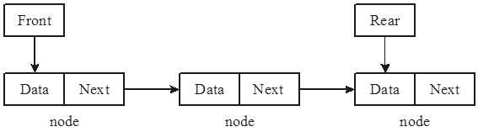

(a) Assume a queue is implemented as a linked list using pointers as in the figure.
Give the three steps required to remove a node from the front of the queue and recover the memory space occupied by the node.
1 .....................................................................................................................
2 .....................................................................................................................
3 .....................................................................................................................
(3)

(b) A set of operations are defined to manipulate the contents of the queue. As well as Remove these include FrontItem and IsQueueEmpty.
Name another operation that would be essential to use this queue.
........................................................................................................................
(1)

(c) The queue could be implemented using an array instead of a linked list.
(i) What additional operation will be required if the queue is implemented using an array?
...............................................................................................................
(1)

(ii) Give one advantage of array implementation.
...............................................................................................................
(1)
(iii) Give two disadvantages of array implementation.
1 ............................................................................................................
1 ............................................................................................................
(2)
(Total 8 marks)

Q20.
Figure 1 shows an area of 100 memory locations which are used to store string data values. This area of memory behaves as a queue. The Head and Tail values are used to control changes to the queue. Figure 1 shows the state of the queue after three values have been added.
Figure 1
 | Address | Memory contents
 | 99
 | …
 | …
 | …
 | 7
 | 6
 | 5
 | 4
 | 3
 | Tail 2 | ‘Frog’
 | 1 | ‘Dog’
 | Head 0 | ‘Cat’

(a) What is the function of the Tail pointer?
.........................................................................................................................
.........................................................................................................................
(1)

(b) Which item in the queue will be the first item to leave?
.........................................................................................................................
(1)
Figure 2
 | Address | Memory contents
 | 99
 | …
 | …
 | …
 | 7
 | 6
 | 5
 | 4
 | 3
 | 2 | ‘Frog’
 | 1 | ‘Dog’
 | 0 | ‘Cat’

(c) Three new items join the queue in the order ‘Snake’, ‘Eel’ and ‘Shark’ and two items then leave.
Draw on Figure 2 the new state of the queue, including the Head and Tail pointers.
(3)

(d) After extensive data changes the queue will become unusable. Explain why this is so.
.........................................................................................................................
.........................................................................................................................
(2)
(Total 7 marks)

Q21.
(a) State the principle of operation of a set of data values which behave as a stack.
......................................................................................................................
......................................................................................................................
(1)

(b) Memory locations 600 to 605 are to be used as a stack area to store character data, and the first value added to the stack is to be stored at address 600.
Figure 1 shows the initial empty state of the stack.
Figure 1
600
601
602
603
604
605

(i) Show on Figure 2 the state of the stack after the characters ‘A’, ‘V’, ‘E’, ‘R’ and ‘Y’ join the stack.
Figure 2
600
601
602
603
604
605

(1)

(ii) Two items are removed from the stack. Show on Figure 3 the state of the stack.
Figure 3
600
601
602
603
604
605

(1)

(iii) Two new characters ‘S’ and ‘P’ join the stack. Show on Figure 4 the final state of the stack.
Figure 4
600
601
602
603
604
605

(1)

(c) The original items in this stack are to be reversed. This can be done using a second data structure which uses locations 700 to 705 respectively. The first item added to the stack was character ‘A’.
Figure 5


 | 600 | ‘A’ | 700 |  | 600
 | 601 | ‘V’ | 701 |  | 601
 | 602 | ‘E’ | 702 |  | 602
 | 603 | ‘R’ | 703 |  | 603
 | 604 | ‘Y’ | 704 |  | 604
 | 605 |  | 705 |  | 605
 |  | Stack  (before the operation) |  | (i) ....................... |  | Stack  (after the operation)

(i) Name the second data structure. Label Figure 5.
.........................................................................................................................
(1)
(ii) Describe Step 1 in Figure 5.
.........................................................................................................................
.........................................................................................................................
(1)

(iii) Describe Step 2 in Figure 5.
.........................................................................................................................
.........................................................................................................................
(1)
(iv) Show on Figure 5 the final contents of all the memory locations.
(2)
(Total 9 marks)

Q22.
A county has a number of local libraries in various towns. Books currently belong to each library and there is no system for the exchange of books between libraries.
New programs have to be written, as the decision has been made to have centralised records of library books.
The software house commissioned to write the new programs has obtained a complete list of titles held at each library. It found that a common system was used for the book codes. Some older books will not be retained and this is to be indicated by the ToBeRetained column in the table below.

 | BookTitle | BookCode | YearFirstInStock | ToBeRetained
 | Hang-gliding made simple | T05320 | 1993
 | Around the world in 80 days | T76542 | 2001
 | My way | M11981 | 1990
 | Starting with hypnotherapy | M79080 | 2005
 | Kim Smith – the autobiography | M00876 | 1991
 | XXX

(a) Study the sample data shown in the table. This data will be accessed by program code. Name the most suitable data type which should be used for each data item. Each data type must be different.
(i) BookCode .............................................................................................
(1)
(ii) YearFirstInStock .............................................................................
(1)
(iii) ToBeRetained .....................................................................................
(1)

(b) The first application to be developed is a program to search the complete list of books and to calculate the data values for the ToBeRetained column; any books which were bought before 1992 will not be retained.
The incomplete pseudo-code which follows shows a first attempt at the algorithm. Data for each of the four attributes BookTitle, BookCode, YearFirstInStock, ToBeRetained are shown in the table above, and are to be stored in four arrays BookTitle, BookCode, YearFirstInStock and ToBeRetained.

Complete the pseudo-code in the three places indicated.
For Book ← 1 To TotalNoOfBooks
If YearFirstInStock[ (i) ................... ] < 1992
Then ToBeRetained[Book] ← (ii)......................
Else ToBeRetained[Book] ← (iii) ....................
EndIf
EndFor
(3)

(c) A second program is to be developed to allocate each book a new code number. The old book codes are to be abandoned. The first character of the old book code indicates the book’s location.
• This book location is to be retained and stored in an array Location.
• Each new book code will be a unique integer number that will be generated by the program. The first number will be 1.
Use will be made of a ‘built-in’ function StartString. It is defined in the help files as follows:

Function StartString(ThisString : String; NoOfCharactersToRetain : Integer) :String ;
The function is given the string ThisString and returns the number of characters specified by NoOfCharactersToRetain starting from the first character of ThisString.

(i) What are the values of the parameters used in the following code?
NewString : = StartString(‘T76542’, 1)
1 ...........................................................................................................
2 ...........................................................................................................
(2)
(ii) What value is assigned to NewString when this code is executed?
..............................................................................................................
(1)

(iii) The pseudo-code for the algorithm to calculate the new book codes and the locations is shown below.
NextAvailableCode ← 1
Book ← 1
Repeat
If YearFirstInStock[Book] >=1992
Then
Begin
LocationLetter ← StartString(BookCode[Book], 1)
If LocationLetter = ’T’
Then Location[Book] ← ‘Torrington’
If LocationLetter = ‘M’
Then Location[Book] ← ‘Morristown’
NewCode[Book] ← NextAvailableCode
NextAvailableCode ← NextAvailableCode + 1
End
Book ← Book + 1
Until BookTitle[Book] = ’XXX’

Trace the execution of this algorithm by completing the trace table Figure 2; use the data shown in the table Figure 1.
Show also the final contents of the Location and NewCode arrays in Figure 3 and Figure 4.
Figure 1
 | BookTitle |  |  | BookCode |  | YearFirstInStock
 | [1] | Hang-gliding made simple | [1] | T05320 | [1] | 1993
 | [2] | Around the world in 80 days | [2] | T76542 | [2] | 2001
 | [3] | My way | [3] | M11981 | [3] | 1990
 | [4] | Starting with hypnotherapy | [4] | M79080 | [4] | 2005
 | [5] | Kim Smith – the autobiography | [5] | M00876 | [5] | 1991
 | [6] | XXX | [6] |  | [6]

Figure 2
 | NextAvailableCode | Book | LocationLetter
 | 1 | 1 | ‘T’

 |  | Figure 3 Location |  | Figure 4 New Code
 | [1] |  | [1]
 | [2] |  | [2]
 | [3] |  | [3]
 | [4] |  | [4]
 | [5] |  | [5]

(6)
(Total 15 marks)

Q23.
A binary search tree has the following functions defined:
RootValue(T) Returns the value stored in the root node of the tree T
LeftChild(T) Returns the left child (subtree) of the root node of the tree T
RightChild(T) Returns the right child (subtree) of the root node of the tree T
A recursively-defined procedure P with a tree as a parameter is defined below.
Procedure P(T)
If RightChild(T) exists
Then P(RightChild(T))
Output RootValue(T)
If LeftChild(T) exists
Then P(LeftChild(T))
EndProc
(a) What is meant by a recursively-defined procedure?
.........................................................................................................................
.........................................................................................................................
(1)

(b) (i) Complete the table below by dry running the procedure call P(T) for the tree T given below.

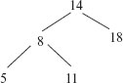

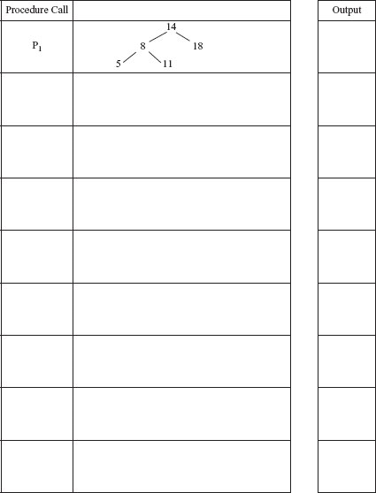
(6)
(ii) What does the procedure P describe?
................................................................................................................
(2)
(Total 9 marks)

Q24.
A firm selling double glazing employs three sales staff. Each person is given a sales target for each of the four quarters of the year.
• Quarter 1 January – March
• Quarter 2 April – June
• Quarter 3 July – September
• Quarter 4 October – December
Based on all the sales made, the data in Table 1 is produced showing whether or not each sales person achieved their target sales for each quarter. Each value is stored as a single character ‘Y’ (sales target met) or ‘N’ (sales target not met).

The columns represent each quarter, each row represents a salesperson.
Table 1
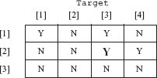
(a) What data structure could be used in a programming language for organising the data shown in Table 1?
.........................................................................................................................
(1)

(b) One of the data values in Table 1 has been emboldened. What does this value represent?
.........................................................................................................................
(1)

(c) The following algorithm processes the data shown in Table 1. Trace the execution of the algorithm by completing Table 2.
For Quarter  1 To 4
Do NewArray [Quarter] 0
End For
For Person 1 To 3
Do
For Quarter 1 To 4
Do
If Target[Person, Quarter] = ’N’
Then NewArray [Quarter] NewArray [Quarter] + 1
End If
End For
End For

Table 2

 | Person | Quarter | Target[Person, Quarter] | NewArray  [1] &nb sp;[2] [3] [4]
 |  | 1

(6)

(d) Explain what numbers are being calculated and stored in the NewArray data structure.
.........................................................................................................................
.........................................................................................................................
(2)
(Total 10 marks)

Q25.
A binary search tree is used by software to store and then search for user names on a college network.
The following are the first seven user names to join the tree:
PollardJ, AtkinsP, RogersG, AbbottJ, SearleF, CollinsK, RuddleA

(a) Sketch the tree structure.

(2)

(b) The tree is to be searched for various user names.
(i) The task is to search for the user name CollinsK. List in order the nodes visited.
................................................................................................................
(1)

(ii) A second search is done to find the user name RuddleA. How many comparisons does this require?
................................................................................................................
(1)
(Total 4 marks)

Q26.
A binary tree has the following functions defined
RootValue(T) Returns the contents of the root node of the tree T
LeftChild(T) Returns the left child of the root node of the tree T
RightChild(T) Returns the right child of the root node of the tree T

A recursively-defined procedure P with a tree as a parameter is defined below.
Procedure P(T)
If RightChild(T) Exists
Then P(RightChild(T))
Output RootValue(T)
If LeftChild(T) Exists
Then P(LeftChild(T))
EndProc

(a) What is meant by a recursively-defined procedure?
.........................................................................................................................
.........................................................................................................................
(1)

(b) (i) Complete the table below by dry running the procedure call P(T) for the tree T given below
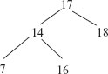

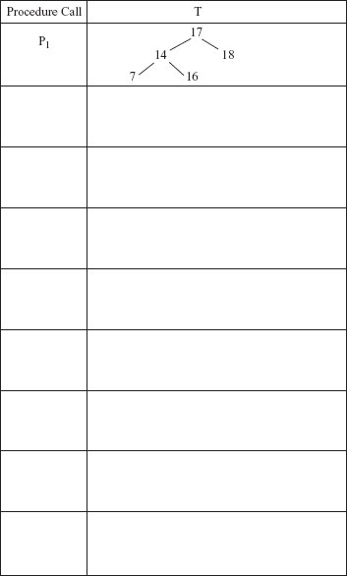
(7)

Output

(ii) What does the procedure P describe?
................................................................................................................
(2)
(Total 10 marks)

Q27.
A queue may be implemented by using either an array or a linked list.
(a) Give a disadvantage of
(i) an array implementation.
................................................................................................................
(1)
(ii) a linked list implementation.
................................................................................................................
(1)

(b) As items are added and removed in the array implementation the queue will gradually move along the array. How can the program deal with the situation when the end of the array is reached?
.........................................................................................................................
.........................................................................................................................
(1)

(c) A queue is implemented with the following operations:
AddItem – add an item to the queue
RemoveItem – remove an item from the queue
FrontItem – obtain the item at the front of the queue
IsQueueEmpty – return true if the queue is empty, otherwise return false.
What additional operation is required if the queue is implemented using an array?
.........................................................................................................................
(1)
(Total 4 marks)

Q28.
A list data structure can be represented using an array.
The pseudocode algorithm in the diagram below can be used to carry out one useful operation on a list.
p ← 1
If ListLength > 0 Then
While p
p ← p + 1
EndWhile
For q ← ListLength DownTo p Do
List[q + 1] := List[q]
EndFor
EndIf
List[p] ← New
ListLength ← ListLength + 1

(a) The initial values of the variables for one particular execution of the algorithm are shown in the trace table below.
Complete the trace table for the execution of the algorithm.

 |  |  |  |  | List
 | ListLength | New | p | q | [1] | [2] | [3] | [4] | [5]
 | 4 | 38 | - | - | 9 | 21 | 49 | 107

(4)

(b) Describe the purpose of the algorithm the diagram above.
........................................................................................................................
........................................................................................................................
(1)

(c) A list implemented using an array is a static data structure. The list could be implemented using a linked list as a dynamic data structure instead.
(i) Describe one difference between a static data structure and a dynamic data structure.
...............................................................................................................
...............................................................................................................
...............................................................................................................
(1)

(ii) If the list were to be implemented as a dynamic data structure, explain what the heap would be used for.
...............................................................................................................
...............................................................................................................
(1)
(Total 7 marks)

Q29.
The table below shows an adjacency matrix representation of a directed graph (digraph).
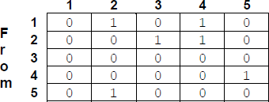
(a) Complete this unfinished diagram of the directed graph.
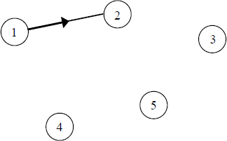
(2)

(b) Directed graphs can also be represented by an adjacency list.
Explain under what circumstances an adjacency matrix is the most appropriate method to use to represent a directed graph, and under what circumstances an adjacency list is more appropriate.
........................................................................................................................
........................................................................................................................
........................................................................................................................
(2)

(c) A tree is a particular type of graph.
What properties must a graph have for it to be a tree?
........................................................................................................................
........................................................................................................................
........................................................................................................................
(2)

(d) Data may be stored as a binary tree.
Show how the following data may be stored as a binary tree for subsequent processing in alphabetic order by drawing the tree in the space below. Assume that the first item is the root of the tree and the rest of the data items are inserted into the tree in the order given.
Data items: Jack, Bramble, Snowy, Butter, Squeak, Bear, Pip

(3)

(e) A binary tree such as the one created in part (d) could be represented using one array of records or, alternatively, using three one-dimensional arrays.
Describe how the data stored in the array(s) could be structured for one of these two possible methods of representation.
........................................................................................................................
........................................................................................................................
........................................................................................................................
........................................................................................................................
........................................................................................................................
........................................................................................................................
........................................................................................................................
........................................................................................................................
(3)
(Total 12 marks)

Q30.
Reverse Polish Notation is an alternative to standard infix notation for writing arithmetic expressions.
(a) Convert the following Reverse Polish Notation expressions to their equivalent infix expressions.

 | Reverse Polish Notation | Equivalent Infix Expression
 | 45 6 +
 | 12 19 + 8 *

(2)

(b) State one advantage of Reverse Polish Notation over infix notation.
........................................................................................................................
........................................................................................................................
(1)

(c) The pseudo-code algorithm below can be used to calculate the result of evaluating a Reverse Polish Notation expression that is stored in a string. The algorithm is designed to work only with the single digit denary numbers 0 to 9. It uses procedures and functions listed in the table below, two of which operate on a stack data structure.

StringPos ← 0
Repeat
StringPos ← StringPos + 1
Token ← GetCharFromString(InputString, StringPos)
If Token = ‘+’ Or Token = ‘-’ Or Token = ‘/’ Or Token = ‘*’
Then
Op2 ← Pop()
Op1 ← Pop()
Case Token Of
‘+’: Result ← Op1 + Op2
‘-’: Result ← Op1 - Op2
‘/’: Result ← Op1 / Op2
‘*’: Result ← Op1 * Op2
EndCase
Push(Result)
Else
IntegerVal ← ConvertToInteger(Token)
Push(IntegerVal)
EndIf
Until StringPos = Length(InputString)
Output Result

 | Procedure/Function | Purpose | Example(s)
 | GetCharFromString  (InputString:String, StringPos:Integer): Char | Returns the character at position StringPos within the string InputString.  Note that the leftmost letter is position 1, not position 0. | GetCharFromString  ("Computing", 1) would return the character style='font-family:Courier New;font-size:10pt'>'C'.  GetCharFromString  ("Computing", 3) would return the character style='font-family:Courier New;font-size:10pt'>'m'.
 | ConvertToInteger  (ACharacter: Char):  Integer | Returns the integer equivalent of the character in ACharacter. | ConvertToInteger('4') would return the integer value style='font-family:Courier New;font-size:10pt'>4.
 | Length style='font-family:Courier New;font-size:10pt'>(AString: String): Integer | Returns a count of the number of characters in the string AString. | Length("AQA") would return the integer value 3.
 | Push style='font-family:Courier New;font-size:10pt'>(ANumber: Integer) | Puts the number in ANumber onto the stack. | Push(6) would put the number 6 on top of the stack.
 | Pop style='font-family:Courier New;font-size:10pt'>(): Integer | Removes the number from the top of the stack and returns it. | X ← Pop() would remove the value from the top of the stack and put it in X.

(d) Complete the table below to trace the execution of the algorithm when InputString is the string: 64+32+*
In the Stack column, show the contents of the stack once for each iteration of the Repeat..Until loop, as it would be at the end of the iteration.
The first row and the leftmost column of the table have been completed for you.

 | StringPos | Token | IntegerVal | Op1 | Op2 | Result | Stack
 | 0 | - | - | - | - | - | 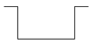
 | 1 |  |  |  |  |  | 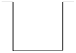
 | 2
 | 3
 | 4
 | 5
 | 6
 | 7

(5)

Final output of algorithm: ...............................................................................
(1)

(e) A programmer is going to implement the algorithm above in a programming language that does not provide built-in support for a stack data structure.
The programmer intends to simulate a stack by using a fixed length array of 20 integers named StackArray with indices running from 1 to 20 and an integer variable TopOfStackPointer which will be initialised to 0.
Write a pseudo-code algorithm for the Push operation to push a value stored in the variable ANumber onto the stack.
Your algorithm should cope appropriately with any potential errors that might occur.
........................................................................................................................
........................................................................................................................
........................................................................................................................
........................................................................................................................
........................................................................................................................
........................................................................................................................
........................................................................................................................
........................................................................................................................
(4)
(Total 13 marks)

Q31.
A graph can be drawn to represent a maze. In such a graph, each graph vertex represents one of the following:
• the entrance to or exit from the maze
• a place where more than one path can be taken
• a dead end.
Edges connect the vertices according to the paths in the maze.

Diagram 1 shows a maze and Diagram 2 shows one possible representation of this maze.
Position 1 in Diagram 1 corresponds to vertex 1 in Diagram 2 and is the entrance to the maze. Position 7 in Diagram 1 is the exit to the maze and corresponds to vertex 7.
Dead ends have been represented by the symbol in Diagram 2.
Diagram 3 shows a simplified undirected graph of this maze with dead ends omitted.

Diagram 1
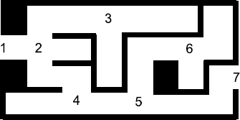

 | Diagram 2 | Diagram 3
 | 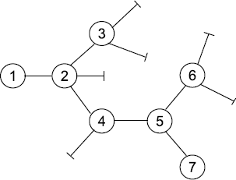 | 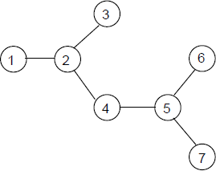
 | Representation of maze  including dead ends | Graph representing maze  with dead ends omitted

(a) The graph in Diagram 3 is a tree.
State one property of the graph in Diagram 3 that makes it a tree.
........................................................................................................................
........................................................................................................................
(1)

(b) The graphs of some mazes are not trees.
Describe a feature of a maze that would result in its graph not being a tree.
........................................................................................................................
........................................................................................................................
(1)

(c) Complete the table below to show how the graph in Diagram 3 would be stored using an adjacency matrix.

(2)

(d) (i) What is a recursive routine?
...............................................................................................................
...............................................................................................................
(1)

(ii) To enable the use of recursion a programming language must provide a stack.
Explain what this stack will be used for and why a stack is appropriate.
...............................................................................................................
...............................................................................................................
...............................................................................................................
...............................................................................................................
(2)

Diagram 3 is repeated here so that you can answer Question (e) without having to turn pages.
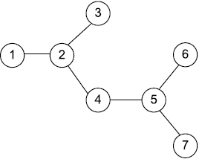

(e) A recursive routine can be used to perform a depth-first search of the graph that represents the maze to test if there is a route from the entrance (vertex 1) to the exit (vertex 7).
The recursive routine in the diagram below is to be used to explore the graph in Diagram 3. It has two parameters, V (the current vertex) and EndV (the exit vertex).
Procedure DFS(V, EndV)
Discovered[V] ← True
If V = EndV Then Found ← True
For each vertex U which is connected to V Do
If Discovered [U] = False Then DFS(U, EndV)
EndFor
CompletelyExplored[V] ← True
EndProcedure
Complete the trace table below to show how the Discovered and CompletelyExplored flag arrays and the variable Found are updated by the algorithm when it is called using DFS(1,7).
The details of each call and the values of the variables V, U and EndV have already been entered into the table for you. The letter F has been used as an abbreviation for False. You should use T as an abbreviation for True.

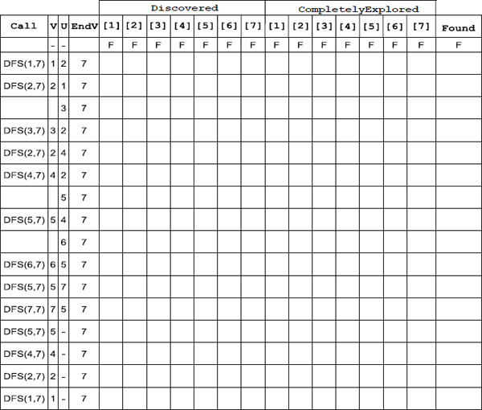
(5)
(Total 12 marks)

Q32.
An interactive operating system maintains a list of the processes that are currently waiting to execute (run). The processes are stored in order of the priority that is associated with their execution. This priority can be set as "High", "Normal" or "Low".
Figure 1 and Figure 2 below show two different ways in which the storage of the process list could be implemented.

 | Figure 1 |  | Figure 2
 | Static implementation: as an  ordered list using a fixed size array.  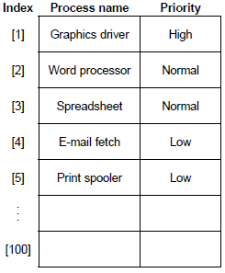 |  | Dynamic implementation: as a  linked list using dynamic memory  allocation.  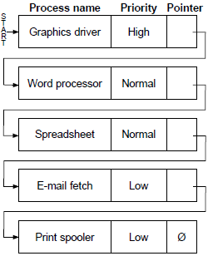

The process at the start of the list will be run next. In Figure 1 and Figure 2, this is the "Graphics driver" process.
When a new process is initiated it is inserted into the list immediately after the last process of the same priority. A "Computer game" process with "High" priority would be inserted into the list in Figure 1 and Figure 2 between the "Graphics driver" and "Word processor" processes.
When a process is completed it is deleted from the list.
(a) Explain two differences between a dynamic data structure and a static data structure.
Difference 1: ..................................................................................................
........................................................................................................................
Difference 2: ..................................................................................................
........................................................................................................................
(2)

(b) The static implementation is less efficient at inserting new items into the list than the dynamic implementation.
Explain why this is the case.
........................................................................................................................
........................................................................................................................
........................................................................................................................
........................................................................................................................
........................................................................................................................
(2)

(c) At a higher level of abstraction, the process list maintained by the operating system could be viewed as a type of queue.
What type of queue?
........................................................................................................................
(1)

Figure 2 is repeated below so that you can answer the remaining question parts without having to turn back in the question booklet.
Figure 2 (repeated)

Dynamic implementation: as a
linked list using dynamic memory
allocation.

(d) Consider the dynamic implementation in Figure 2.
(i) What will the heap be used for in this implementation?
...............................................................................................................
...............................................................................................................
(1)

(ii) In Figure 2 pointers are shown as arrows.
When the linked list is created in a programming language, what will the integer value stored in a pointer represent?
...............................................................................................................
...............................................................................................................
(1)

(iii) Write an algorithm of the steps that would be involved in inserting a new process "Database" with priority "Normal" into the dynamic implementation linked list in Figure 2.
The algorithm will need to:
• find the correct position to insert the new process at, then
• make the necessary changes to insert the information about the new process.
You may wish to use a Current Node Pointer and a Previous Node Pointer in your response.
Your algorithm only needs to cater for a list that already contains some processes at each priority level.
...............................................................................................................
...............................................................................................................
...............................................................................................................
...............................................................................................................
...............................................................................................................
...............................................................................................................
...............................................................................................................
...............................................................................................................
...............................................................................................................
...............................................................................................................
...............................................................................................................
...............................................................................................................
...............................................................................................................
...............................................................................................................
...............................................................................................................
...............................................................................................................
...............................................................................................................
(7)
(Total 14 marks)

Q33.
A tree can be used to represent a mathematical expression. This is known as an expression tree. Figure 1 is an expression tree for the infix expression 4 + 9 * 6.
Figure 1
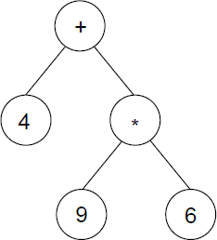
(a) An expression tree is an example of a rooted tree.
State the contents of the root node: .....................................................
List the contents of all of the leaf nodes: ..............................................
(2)

(b) The expression tree in Figure 1 could be represented using three one-dimensional arrays named A, B and C. Figure 2 shows a representation of Figure 1 together with the array indices.
Figure 2
Arrays
 | Index | A |  | B |  | C
 | [1] | + |  | 2 |  | 3
 | [2] | 4 |  | 0 |  | 0
 | [3] | * |  | 4 |  | 5
 | [4] | 9 |  | 0 |  | 0
 | [5] | 6 |  | 0 |  | 0

Describe the role of each of the arrays A, B and C.
A: ....................................................................................................................
B: ....................................................................................................................
C: ....................................................................................................................
(3)

(c) What does an entry of 0 in array B indicate?
........................................................................................................................
........................................................................................................................
(1)

(d) The procedure in Figure 3 describes a type of tree traversal that can be carried out on the representation of the tree shown in Figure 2.
Figure 3
Procedure Traverse(Pos:Integer)
If B[Pos] > 0 Then Traverse(B[Pos])
If C[Pos] > 0 Then Traverse(C[Pos])
Output A[Pos]
End Procedure
Using the table below, trace the execution of the procedure when it is called using Traverse(1). You may not need to use all of the lines provided in the table.

 | Pos | Output

(4)

(e) Which type of tree traversal does the procedure Traverse carry out?
........................................................................................................................
(1)

(f) What does the output of the procedure represent?
........................................................................................................................
(1)
(Total 12 marks)

Q34.
A computer program is being developed to allow commuters to plan journeys on the London Underground railway network which connects together over 250 stations.
The program needs to store a representation of the network so that the shortest route (ie shortest distance) between any two stations can be found.
Figure 1 is a map of central London, showing the location of ten of the stations on the London Underground. The locations of the underground railway lines are not shown. Note that nine of the stations are indicated by the symbol but Charing Cross has a different symbol because it is a combined underground and overground station.
Figure 1
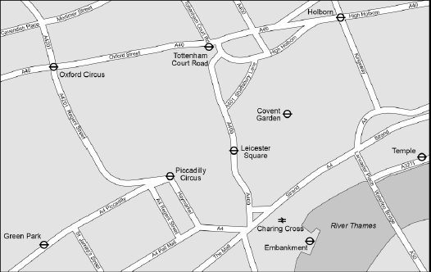

Figure 2 is a map of part of the underground railway network, showing the same ten stations. This map does not show the streets above ground but instead shows the underground railway lines that connect the stations together.
Figure 2

Due to copyright restrictions we are unable to show this image. Please use the link below to find the appropriate section of the tube map.
Standard Tube map - Transport for London

Figure 2 can be used in conjunction with a table of distances between adjacent stations to calculate the shortest route between any two stations on the network.

The map of the entire underground railway network (not just the parts shown in Figure 1 and Figure 2) together with the full table of distances can be represented logically as a graph.
(a) The representation of the underground railway network as a graph is an abstraction.
Explain what an abstraction is.
........................................................................................................................
........................................................................................................................
........................................................................................................................
(1)

(b) Write a detailed description of:
• how the underground railway network and table of distances could be represented as a graph, and,
• how this representation could be implemented as either an adjacency matrix or an adjacency list (describe one of these alternatives only), using array(s) in a programming language that does not have a built-in data structure for graphs.
Your implementation should store all the details that are required to calculate the shortest distance between any two stations, but you do not need to describe how the shortest distance would be worked out.
In your answer you will be assessed on your ability to use good English, and to organise your answer clearly in complete sentences, using specialist vocabulary where appropriate.

You may use diagrams to help clarify your description, but as you are being assessed on your ability to use good English, you must ensure that all diagrams are fully explained.
........................................................................................................................
........................................................................................................................
........................................................................................................................
........................................................................................................................
........................................................................................................................
........................................................................................................................
........................................................................................................................
........................................................................................................................
........................................................................................................................
........................................................................................................................
........................................................................................................................
........................................................................................................................
........................................................................................................................
........................................................................................................................
........................................................................................................................
........................................................................................................................
........................................................................................................................
........................................................................................................................
........................................................................................................................
........................................................................................................................
........................................................................................................................
........................................................................................................................
........................................................................................................................
........................................................................................................................
........................................................................................................................
........................................................................................................................
(8)
(Total 9 marks)

Q35.
A computer program is being developed to allow commuters to plan journeys on the London Underground railway network which connects together over 250 stations.
The program needs to store a representation of the network so that the shortest route (ie shortest distance) between any two stations can be found.
Figure 1 is a map of central London, showing the location of ten of the stations on the London Underground. The locations of the underground railway lines are not shown. Note that nine of the stations are indicated by the symbol but Charing Cross has a different symbol because it is a combined underground and overground station.
Figure 1

Figure 2 is a map of part of the underground railway network, showing the same ten stations. This map does not show the streets above ground but instead shows the underground railway lines that connect the stations together.
Figure 2

Due to copyright restrictions we are unable to show this image. Please use the link below to find the appropriate section of the tube map.
Standard Tube map - Transport for London

Figure 2 can be used in conjunction with a table of distances between adjacent stations to calculate the shortest route between any two stations on the network.

The map of the entire underground railway network (not just the parts shown in Figure 1 and Figure 2) together with the full table of distances can be represented logically as a graph.
(a) The representation of the underground railway network as a graph is an abstraction.
Explain what an abstraction is.
........................................................................................................................
........................................................................................................................
........................................................................................................................
(1)

(b) Write a detailed description of:
• how the underground railway network and table of distances could be represented as a graph, and,
• how this representation could be implemented as either an adjacency matrix or an adjacency list (describe one of these alternatives only), using array(s) in a programming language that does not have a built-in data structure for graphs.
Your implementation should store all the details that are required to calculate the shortest distance between any two stations, but you do not need to describe how the shortest distance would be worked out.
In your answer you will be assessed on your ability to use good English, and to organise your answer clearly in complete sentences, using specialist vocabulary where appropriate.

You may use diagrams to help clarify your description, but as you are being assessed on your ability to use good English, you must ensure that all diagrams are fully explained.
........................................................................................................................
........................................................................................................................
........................................................................................................................
........................................................................................................................
........................................................................................................................
........................................................................................................................
........................................................................................................................
........................................................................................................................
........................................................................................................................
........................................................................................................................
........................................................................................................................
........................................................................................................................
........................................................................................................................
........................................................................................................................
........................................................................................................................
........................................................................................................................
........................................................................................................................
........................................................................................................................
........................................................................................................................
........................................................................................................................
........................................................................................................................
........................................................................................................................
........................................................................................................................
........................................................................................................................
........................................................................................................................
........................................................................................................................
(8)
(Total 9 marks)

M1.
(a)
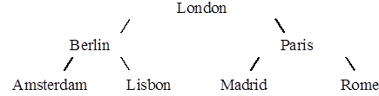
1 mark for correct position of London,
1 mark for correct position of Berlin and Paris,
1 mark for Amsterdam and Lisbon correct,
1 mark for Madrid and Rome correct
No follow through in this part of the question
If consistent mirror image give marks
Note (b) and (c) must follow on
4

(b) Root node marked correctly
Tick by question
1
(c) London, Paris Madrid; in correct order
1
[6]

M2.
(a) Tail(Ports) - [Barcelona, Athens, Alexandria, Tunis, Lisbon]
square brackets needed
1
Head(Tail(Tail(Ports))) – Athens (2)
[Athens] (1)
2
Empty(T(T(T(T(T(T(Ports))))))) – True (2)
True [ ] (1)
[True] (0)
2

(b) Recursively defined
A definition which is defined in terms of itself/contains within its body a reference to itself/calls itself ;
A re-entrant; (In specimen papers 2001/2, but refers specifically to a procedure)
1

(c) Stack necessary
The state of the machine/contents of appropriate registers/ return address // saved each time the procedure is called (1) and retrieved in reverse order from the stack as control is progressively returned (1)
OR
Different value of parameters /local variables (1) must be available each time procedure is called (1)
OR
P must be re-entrant (In specimen papers 2001/2 )(2)
2

(d) Lisbon first (1)
Southampton last(1)
All 6 in order (1)
No punctuation (1)
i.e. Lisbon Tunis Alexandria Athens Barcelona Southampton;
4

(e)
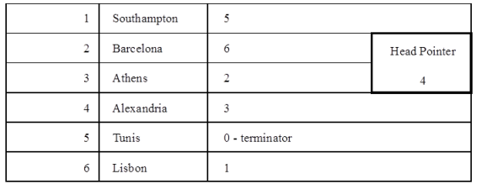
2
[14]

M3.
(a)
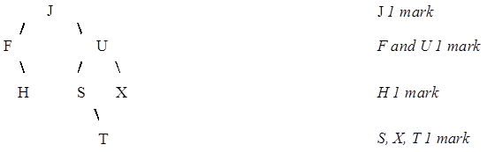
A mirror image (this time)
4

(b) ‘T’ 4; ‘U’;
‘T’ 5; ‘S’;
‘T’ 7; ‘T’;
No penalty if candidate gets ‘item’ wrong
Ignore ‘item’ column
6
[10]

M4.
(a)
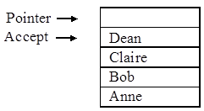
2
Dean accessed first
Pointer / arrow
 |  | Dean | Claire | Bob | Anne

End pointer ↑ Start pointer ↑
Anne accessed first;
Named pointers correct;
2

(b)
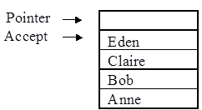

correct item replaced;
 | Eden | Dean | Claire | Bob

Eden Start pointer ↑
pointer
↑
Correct item retrieval & input;
Correct moving of pointers
3

(c) In a linear queue data is static, so queue ‘moves’ through storage/
In a FIFO structure storage locations are only used once;(1)
In a circular queue, the locations will be re-used;(1)
Thus a circular queue has a more efficient use of memory;(1)
1 mark for each of 2 points
2
[9]

M5.
(a) +3x;
1
(b) 3+x;
1
(c) 3x+;
1
[3]

M6.
(a) (i) Data must be in given order
1 pheasant 2
2 teal 3
3 widgeon 5
START 4 partridge 1
5 woodpigeon 0
//
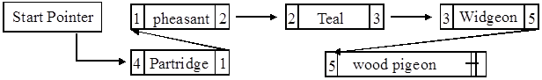
End Pointer can be blank
1 for correct START and END pointers;
1 for correctly numbered nodes and correct pointers (Need all birds);

(ii) 1 pheasant 7
2 teal 3
3 widgeon 5
4 partridge 1
5 woodpigeon 0
START 6 grouse 4
7 snipe 2
// correctly amended diagram
1 for grouse and snipe physically at end;
1 for correct pointers (if not as ms than clear and logical);
2

(b) The amount of memory taken up can vary;
// The size / length of the structure / linked list can vary;
1 mark
at run time;
1 mark
2

(c) A heap / stack/ a pool of available locations;
A pointer holds the address of the allocated block / next available location;
2
[8]

M7.
(a) Root, (1)
Branch (1)
Leaf node(1)
Must circle!
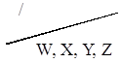
3

(b) Left sub-tree (1)
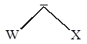
Right sub-tree(1)
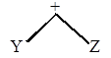
2

(c) W-X / Y+Z
1 1 1
A column vector
Spurious punctuation (1)
3
[8]

M8.
(a) Head (Tail ( Days)) = Mon
R [Mon], MON (1)
Tail([Head(Days)]) = [ ] (1)
Empty(Tail(Tail(Tail(Days))))=False (1)
3

(b) Elements in a list can only be accessed sequentially;
elements in an array can be accessed directly;
using the subscript;
Any 2 points
2
[5]

M9.
(a) It calls itself / is defined in terms of itself / is re-entrant / contains within its body a reference to itself;
Ensure ‘it’ refers to procedure, if meaning program or object no mark
1

(b) The current state of the machine must be saved/preserved so can return correctly to previous invocation of B;
OR
Return address / procedure parameter / status register / other register values / local variables must be saved/preserved so can return correctly to previous invocation of B);
1

(c)
 | Call Number | Parameter
 | 1 | 53
 | 2 | 26
 | 3 | 13
 | 4 | 6 | ;
 | 5 | 3 | ;
 | 6 | 1 | ;

Printed Output: 1 1 0 1 0 1;;;
1 mark for each correct pair of bits
Mark from left and stop marking when error encountered ignore punctuation. if more than 6 bits give a max of 2 marks
6

(d) Conversion (of a denary number) into binary;
1
[9]

M10.
(a) Last In First Out;
1
(b) (i)
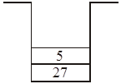
1
(ii)
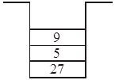
1

(iii)
1
(iv)
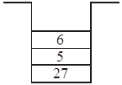
1

(c) To reverse elements/ pass parameters/ store volatile environment;
A store return address
1
[6]

M11.
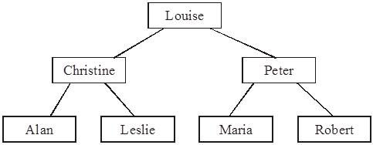
(a) Correct position of Louise;
Correct position of Christine and Peter;
Correct position of Alan and Leslie;
Correct position of Maria and Robert;
(If consistent mirror image give full marks)
4

(b) Root node marked correctly;
1
(c) Louise, Peter, Maria in correct order (allow follow through from (a));
1
[6]

M12.
(a) It calls itself / is defined in terms of itself / contains within its body a reference to itself;
Ensure ‘it’ refers to procedure, if meaning program or object no mark
1

(b) The current state of the machine is saved/preserved;
So can return correctly (to previous invocation/call of Process);
OR
Return address / procedure parameter / status register / other register values / local variables must be saved/preserved;
So can return correctly to “correctly’ can be implied (previous invocation of Process);
2

(c) Printed Output:
1; 3; 5, Bird; Bremner; 4, Fortune, Jones; 2, Smith;
Mark from left and stop marking when error encountered
Ignore punctuation.
6

(d) (in-order) traversal of a tree; A printing of tree (elements in order)
I wrong order
1
[10]

M13.
(a) (i) First In First Out;
or by description
(ii) Last In First Out;
or by description
2

(b)
 |  | FIFO | LIFO
 | Queue
 | Stack

2

(c) Reverse the contents of a queue/list;
Push all contents of queue/list onto stack then pop them off into a new queue/list;
Procedure/function calls;
Local variables;
Parameters;
Return Address;
Volatile environment; A register contents State 1 Describe 1
2

(d) List of elements inserted into tree;
To allow rapid/fast searching of the data;
To output sorted/ordered data;
2
[8]

M14.
(a) A procedure/routine that calls itself/ is defined in terms of itself;
A Function instead of procedure
R re-entrant
R program
R iteration
1

(b) (i)
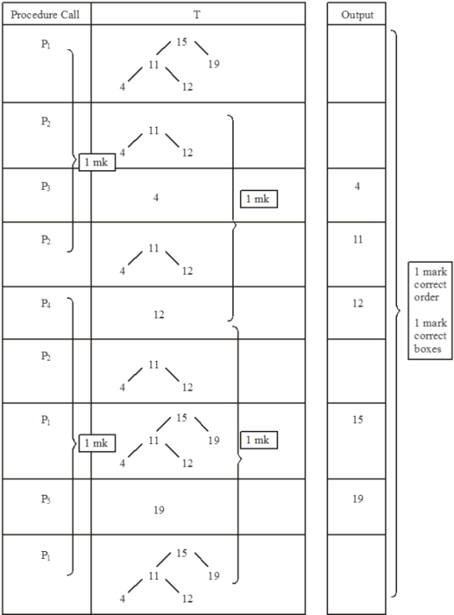
6
(ii) In order; (tree) traversal
2
[9]

M15.
(a) (i) Empty entries waste space // Maximum/fixed/static size
A stack may overflow
1
(ii) Space used by pointers // more complex to program;
1

(b) (i) The size of the stack /amount of data is known/limited/predictable
Memory saved since no pointers (if not given in a (ii))
R easier to program
1
(ii) The size of the stack is unknown//
The stack is volatile/ number of items fluctuates widely;
1
[4]

M16.
(a) (i) • poorly structured code;
• uses GoTo statements;
• the flow of control jumps out of a loop;
• nothing reported to the user when no matching name found;
• abbreviated variable for ‘position’ variable;
• ReadLn is better than Read;
• Program only iterates once / considers only the first array element;
• (if duplicates) only the first matching surname is found;
• (loop terminates at 20) does not allow for additional array /name entries;
A poor layout - excessive indentation used;
I. variable declaration // reference to the syntax
Max 2

(ii) All statements must have correct identifier name correct data type (String / Text // Integer / Byte / Word / Int / Shortint / Short as appropriate)
In addition, either array must have brackets to indicate an ‘array’ 19/20 to indicate a range;
Max 2

(b) Intialisation of counter or Boolean variable
P := 1 / P := 0 / For P := 1 to 20 // IsFound := False;
Looping
LOOP UNTIL // DO WHILE // WHILE DO // REPEAT UNTIL and used at the beginning/end of a code block as appropriate;
Some loop condition is met
(P = 20/21) OR IsFound = TRUE / P = 20/21 // IsFound = TRUE / IsFound;
IF with use of the array
IF NoOfClaims [P];
Selection condition
>4 / >=5;

Loop counter incremented
P = P+1
Final output
Correct logic followed with OUTPUT ‘Yes’
A multiple times
Final output
Correct logic followed with OUTPUT ‘No’
R Multiple times
R ‘Prose’ scores 0
5
[9]

M17.
(a) Salesperson 7;
April /month 4;
The number of storecards ‘taken out’;
Max 2
(b) StoreCards + sensible subscripts [1..10, 1..6] / (1 to 10, 1 to 6) / [0..10, 0..6] / (0 to 10, 0 to 6) / (10,6) / [10] 6];
StoreCards + Integer / Byte;
2

(c) StoreCards (8, 1);
= 13 / := 13 / ← 13;
Must be an assignment statement
2
(d) Key in / Input the employee number; the program calculates the total number of store cards for a single person // print/outputs/displays the total for a single person; over six months;
Max 2

(e) (i) Single / real / float;
R Floating point / Double
1
(i) Boolean /Yes-No / True-False; R Y/N / T/F
1
(iii) Integer/ byte;
1
[11]

M18.
(a)
 | Number | Lower | Upper | Current
 | 12 | 1 | 9
 |  |  | 5 | 5
 |  | 3 |  | 3
 |  | 4 | 4 | 4

 | Value returned | 4

1 mark for 1st row (12, 1, 9)
2 marks for second row (1 mark for each 5)
2 marks for 3rd row (3 and 3)
2 marks for 4th row (1 mark for Lower = 4, 1mark for upper = 4)
1 mark for correct return value
8

(b) Find the position of 12/ a number in the array// search for 12/ a number in the array;
1
[9]

M19.
(a) Temp ← Front;
Front ← Temp.Next//Front ← Temp^.Next;
Dispose (Temp); A Free(Temp)
Alternative
Temp ← Front.Next// Temp ← Front^.Next;
Dispose (Front); A Free(Temp)
Front ← Temp;
3

(b) AddItem//Add;
1

(c) (i) Full/FullQueue;
1
(ii) No memory used for pointers;
I Faster
R Easier to program
1
(iii) Size is limited by array size;
memory wasted when not full;
2
[8]

M20.
(a) Next item to be added is at position/location/address (Tail + 1);
Position/location/address Tail is the last item in the queue ;
R ‘points to the end of the queue’
Max 1

(b) Cat // item at position Head ;
1

(c)
 |  | 6
 | Tail | 5 | ‘Shark’
 |  | 4 | ‘Eel’
 |  | 3 | ‘Snake’
 | Head | 2 | ‘Frog’
 |  | 1 | ‘Dog’
 |  | 0 | ‘Cat’

Snake + Eel + Shark at positions 3,4,5 ;(1)
Tail points to 5 ;(1)
Head points to 2 ;(1)
I. Dog and Cat crossed through
3

(d) Tail will eventually reach position 99 (A 100) ;
Head will eventually reach 99 (A 100);
Memory/queue will become full ;
Space is not re-useable ;
Max 2
[7]

M21.
(a) Last (item) in, is the first (item) out / first (item) in is the last (item) out ;
R LIFO / FILO
1

(b) (i)
 | 600 | ‘A’
 | 601 | ‘V’
 | 602 | ‘E’
 | 603 | ‘R’
 | 604 | ‘Y’ ;
 | 605

All items in the correct locations
1

(ii)
 | 599
 | 600 | ‘A’
 | 601 | ‘V’
 | 602 | ‘E’ ;
 | 603
 | 604
 | 605

Correct three items // ft from an incorrect (i) including 605 as the first location used ;
A ‘R’ and ‘Y’ entries indicated in some way as ‘deleted’
1

(iii)
 | 600 | ‘A’
 | 601 | ‘V’
 | 602 | ‘E’
 | 603 | ‘S’
 | 604 | ‘P’ ;
 | 605

Correct list of five items // ft from an incorrect (i) + a correct ft (ii) including 605 as the first location used ;
1

(c) (i) Queue ;
A First In – First Out FIFO / LILO
1
(ii) Items are removed/popped from the stack (one at a time) (and items are then added to the queue);
1
(iii) Items leave the queue on a ‘first in-first out’ basis ; A from the front of the queue
1
(iv) ‘Y’, ‘R’, ‘E’, ‘V’, ‘A’ on the queue ;
Y’, ‘R’, ‘E’, ‘V’, ‘A’ on the final stack ;
A using 701 for the first queue location
2
[9]

M22.
(a) (i) String / Text / Char ;
R alpha / alpha-numeric / character
1
(ii) Integer / Date (and Time) ;
A String
1
(iii) Boolean ;
R Yes/No
1

(b) (i) Book ;
1
(ii) False / F / No // f/t from the (a) (iii) answer e.g. stated as integer - value 0/1
1
(iii) True / T / Yes // f/t from the (a) (iii) answer e.g. stated as integer - value 1/0
(Max 1 for (ii) and (iii) if no indication of meaning when integer used)
1

(c) (i) T76542 ; 1 ;
2
(ii) T ;
I. the quote marks (i) and (ii)
1
(iii)
 | NextAvailableCode | Book | LocationLetter
 | 1 | 1 | ‘T’
 | 2 | 2 | ‘T’
 | 3 | 3 | (gap not required)
 | 4 | 4 | ‘M’
 | (in sequence – possible repeat of 3 and/or 4 | 5 | Penalty -1 if the first ‘M’ is followed by either ‘T’ or ‘X’
 |  | 6

Figure 2

 |  | Location |  |  | NewCode
 | [1] | ‘Torrington’ |  | [1] | 1
 | [2] | ‘Torrington’ |  | [2] | 2
 | [3] |  |  | [3]
 | [4] | ‘Morristown’ |  | [4] | 3
 | [5] |  |  | [5]

Figure 3 Figure 4
6
[15]

M23.
(a) A procedure/routine that calls itself/ is defined in terms of itself;
A Function instead of procedure
R re-entrant R program R iteration
1

(b) (i)
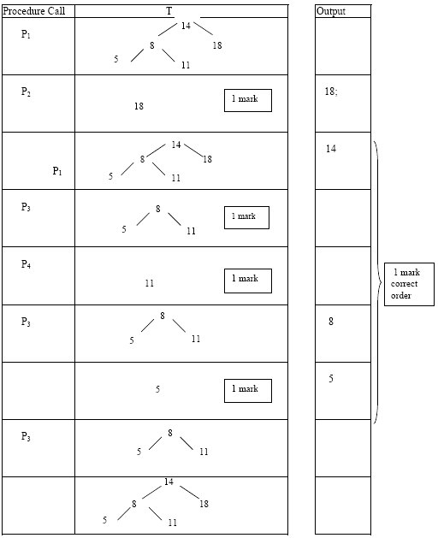
6
(ii) Reverse Inorder// Reverse order; (tree) traversal;
2
[9]

M24.
(a) 2–D array;
1
(b) Shows that sales person 2; did meet their target; for Quarter 3 /July – September;
Max 1

(c)
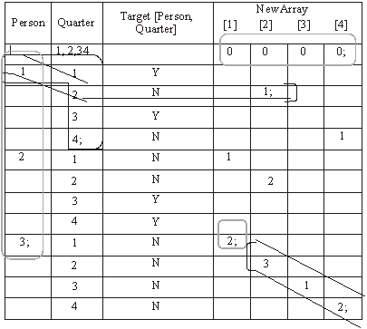
NewArray initial values all 0;
1
Person loop counter 1 to 3;
1
Person 1 – is followed by quarters 1 to 4 in sequence;
1
NewArray[2] = 1 for person = 1 and Quarter = 2;
1
Final NewArray[1] = 2;
1
Final NewArray[2 and 3 and 4] values are correct;
1

(d) Stores the (total) number of sales staff who did not meet their target // the(total) number of sales targets not met;
for each quarter;
2
[10]

M25.
(a)
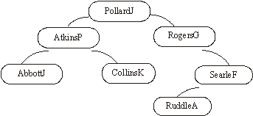
Correct root + left subtree;
Correct root + right subtree;
I. identification of PollardJ as the root
A a complete ‘left-right’ mirrored image.
2

(b) (i) PollardJ, AtkinsP, CollinsK
from a correctly drawn left sub-tree;
1
(ii) 4 from a correctly drawn right sub-tree;
1
[4]

M26.
(a) A procedure/routine that calls itself/ is defined in terms of itself;
A Function instead of procedure
R re-entrant
R program iteration (TO)
1

(b) (i)
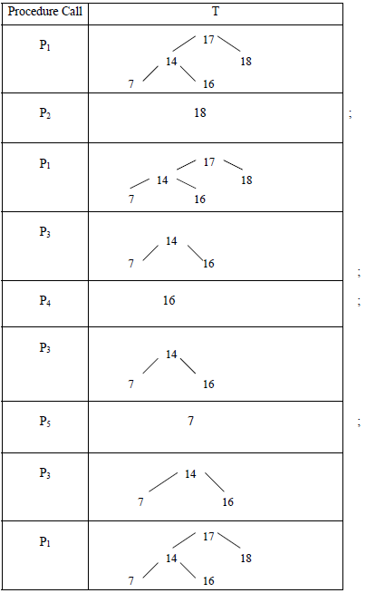
7
 | Output | 18; | 17; | 16 | 14 | 7;

(ii) Reversed Inorder; Tree traversal;
I Sort/ Re-arrange
2
[10]

M27.
(a) (i) Empty entries waste memory // Maximum size// fixed size;
1
(ii) Memory used by pointers//takes more time to add / delete nodes// indirect access takes more time;
R programming difficulties
1

(b) Place next item in first location/ location 0/ location 1//
Implement a circular array/queue // allow wraparound;
1
(c) IsFull/IsQueueFull;
1
[4]

M28.
(a)
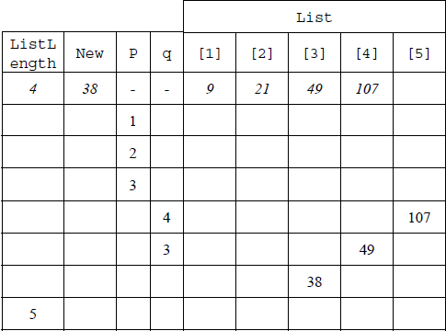
4,5 in sequence for ListLength;
1,2,3 in sequence for p;
4,3 in sequence for q;
Final list in array is 9, 21, 38, 49, 107;
Do not award a mark if additional values indicated e.g. 4 for p
4

(b) Inserts an item/variable New into list at correct position/preserving order//into sorted list (or equivalent);
1

(c) (i) Static structures have fixed (maximum) size whereas size of dynamic structures can change // Size of static structure fixed at compile-time whereas size of dynamic structure can change at run–time;
Static structures can waste storage space/memory if the number of data items stored is small relative to the size of the structure whereas dynamic structures only take up the amount of storage space required for the actual data;
Dynamic data structures (typically) require memory to store pointer(s) to the next item(s) which static structures do not need;
A just one side of points, other side is by implication
Max 1

(ii) Heap is pool of free/unused/available memory;
Memory allocated/deallocated at run-time (to dynamic data structure);
Max 1
[7]

M29.
(a)
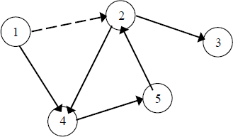
1 mark for all 5 lines correctly drawn
1 mark for all 5 arrowheads pointing in correct directions
Max 1 if more than 5 lines drawn by candidate (note that dotted arrow is given in question)
A arrowheads at any position on line
2

(b) Adjacency matrix appropriate when there are many edges between vertices // when edges may be frequently changed // when presence/absence of specific edges needs to be tested (frequently)
Adjacency list appropriate when there are few edges between vertices // when graph is sparse // when edges rarely changed //when presence/absence of specific edges does not need to be tested (frequently)
A alternative words which describe edge e.g. connection, line
2

(c) Connected // There is a path between each pair of vertices;
Undirected // No direction is associated with each edge;
Has no cycles // No (simple) circuits // No closed chains // No closed paths in which all the edges are different and all the intermediate vertices are different // No route from a vertex back to itself that doesn’t use an edge more than once or visit an intermediate vertex more than once;
Alternative definitions:
Graph with no cycles, and a simple cycle is formed if any edge is added to it;;
Graph which is connected, and it is not connected anymore if any edge is removed from it;;
Graph in which any two vertices can be connected by a unique simple path;; (Note: not just adjacent vertices)
Graph which is connected and has n - 1 edges where n is no of vertices;;
Graph which has no simple cycles and has n - 1 edges where n is no of vertices;;
Max 2

(d)
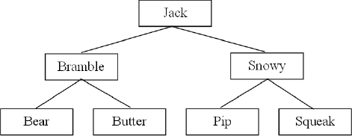
1 mark for Jack as root
1 mark for Bramble and Snowy as children of Jack
1 mark for four correct children of Bramble and Snowy
DPT if arrows drawn instead of lines
DPT if any node has more than 2 child nodes
A “mirror image” answers which are consistent.
3

(e) For solution with 3 arrays:
One array stores data items;
One array for left child pointers;
One array for right child pointers;
Pointers stored at same location in arrays as corresponding data item;
For solution with 1 array of records:
Record created to store data item and pointers;
One pointer to left child;
One pointer to right child;
For either of the above solutions:
Rogue value (allow example) used to indicate no child;
Variable indicates position in array(s) of root node // Root node stored at first location/start of array(s);
If answered as diagram:
Column for data with at least three correct data items in it;
Use of rogue value for a node that does not have child;
Correct value for a start pointer variable indicating position of root node in the array (not drawn as an arrow, array indices must be labelled);
Column for left child pointers*;
Column for right child pointers*;
* = To get these marks, there must be a sufficient number of pointers to demonstrate that the data structure is a representation of a binary tree, but it is not necessary for every item to be shown. Also the array indices must be shown.
Max 3
[12]

M30.
(a)
 | Reverse Polish Notation | Equivalent Infix Expression
 | 45 6 + | 45 + 6  R 6 + 45
 | 12 19 + 8 * | (12 + 19) * 8  R 12+19*8, (19+12)*8  A x for *

2

(b) Simpler for a machine / computer to evaluate // simpler to code algorithm
A easier R to understand
Do not need brackets (to show correct order of evaluation/calculation);
Operators appear in the order required for computation;
No need for order of precedence of operators;
No need to backtrack when evaluating;
A RPN expressions cannot be ambiguous as BOD
1

(c)
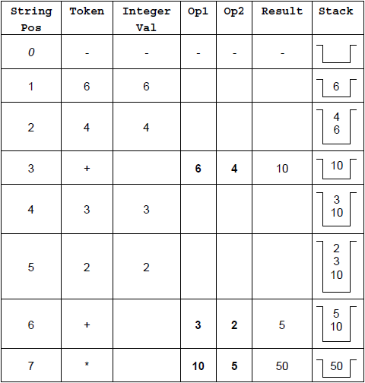

Output : 50
1 mark for each of rows 1–3
1 mark for rows 4 and 5 together
1 mark for rows 6 and 7 together
1 mark for correct final output
Values of Op1 and Op2 MUST be assigned in rows 3, 6 and 7 to award the marks for these rows. They cannot be inferred from incorrectly entered previous values.
I values in empty cells, even if they are incorrect.
6

(d) If StackArray is full
Then Stack Full Error
Else
Increment TopOfStackPointer
StackArray [TopOfStackPointer]
ANumber
EndIf
1 mark for appropriate If structure including condition (does not need both Then and Else) – Do not award this mark if ANumber is put into StackArray outside the If.
1 mark for reporting error in correct place
1 mark* for incrementing TopOfStackPointer
1 mark* for storing value in ANumber into correct position in array
* = if the store instruction is given before the increment instruction OR
the If structure then award Max 1 of these two marks UNLESS the item is inserted at position TopOfStackPointer+1 so the code would work.
I initialisation of TopOfStackPointer to 0
A TopOfStackPointer=20/>=20 for Stack is full
A Logic of if structure reversed i.e. If stack is not full / TopOfStackPointer<20 / <>20/!=20 and Then, Else swapped
A Any type of brackets or reasonable notation for the array index
DPT If candidate has used a different name any variable then do not award first mark but award subsequent marks as if correct name used.
Refer answers where candidate has used a loop to find position to insert item into stack to team leaders.
4
[13]

M31.
(a) Connected // There is a path between each pair of vertices;
Undirected // No direction is associated with each edge;
Has no cycles // No (simple) circuits // No closed chains // No closed paths in which all the edges are different and all the intermediate vertices are different // No route from a vertex back to itself that doesn’t use an edge more than once or visit an intermediate vertex more than once;
A no loops
Alternative definitions:
A simple cycle is formed if any edge is added to graph;
Any two vertices can be connected by a unique simple path;
Max 1

(b) No route from entrance to exit / through maze;
Maze contains a loop/circuit ;
A more than one route through maze;
Part of the maze is inaccessible / enclosed;
R Responses that clearly relate to a graph rather than the maze
Max 1

(c)
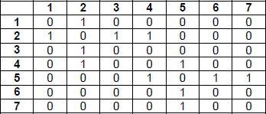
(allow some symbol in the central diagonal to indicate unused)
or
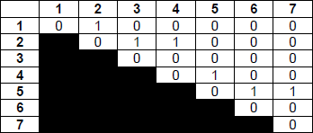
(with the shaded portion in either half – some indication must be made that half of the matrix is not being used. This could just be leaving it blank, unless the candidate has also represented absence of an edge by leaving cells blank)
1 mark for drawing a 7x7 matrix, labelled with indices on both axis and filled only with 0s and 1s, or some other symbol to indicate presence/absence of edge. e.g. T/F. Absence can be represented by an empty cell.
1 mark for correct values entered into matrix, as shown above;
2

(d) (i) Routine defined in terms of itself // Routine that calls itself;
A alternative names for routine e.g. procedure, algorithm
NE repeats itself
1

(ii) Stores return addresses;
Stores parameters;
Stores local variables; NE temporary variables
Stores contents of registers;
A To keep track of calls to subroutines/methods etc.
Max 1
Procedures / invocations / calls must be returned to in reverse order (of being called);
As it is a LIFO structure;
A FILO
As more than one / many return addresses / sets of values may need to be stored (at same time) // As the routine calls itself and for each call/invocation a new return address / new values must be stored;
Max 1
2

(e)
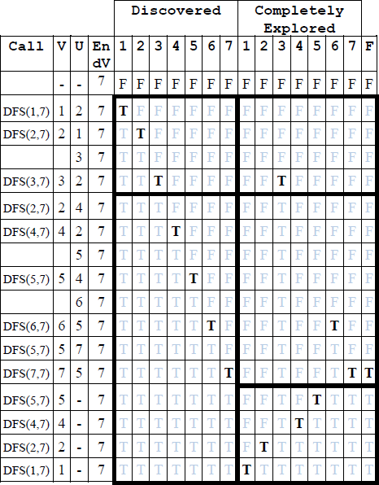
1 mark for having the correct values changes in each region highlighted by a rectangle and no incorrect changes in the region. Ignore the contents of any cells that are not changed.
A alternative indicators that clearly mean True and False.
A it is not necessary to repeat values that are already set (shown lighter in table)
5
[12]

M32.
(a) Static structures have fixed (maximum) size whereas size of dynamic structures can change // Size of static structure fixed at compile-time whereas size of dynamic structure can change at run-time;
Static structures can waste storage space / memory if the number of data items stored is small relative to the size of the structure whereas dynamic structures only take up the amount of storage space required for the actual data;
Dynamic data structures (typically) require memory to store pointer(s) to the next item(s) which static structures (typically) do not need // Static structures (typically) store data in consecutive memory locations, which dynamic data structures (typically) do not;
Max 2
A just one side of points, other side is by implication
NE Dynamic data structures use pointers
2

(b) Not possible to simply insert item into middle of list;
Must move all items that should come after the new process down in the array;
NE move all data
Moving items is time consuming;
In a dynamic implementation, insertion achieved by adjusting pointers;
Max 2
2

(c) Priority (queue);
1

(d) (i) Memory allocated / deallocated at run-time / for new items (to dynamic data structure);
(Provides a) pool of free / unused / available memory;
NE to store new items
Max 1
1

(ii) (Memory) address // memory location // position in memory;
NE position or location without reference to memory
R index
1

(iii) OVERALL GUIDANCE:
Solutions should be marked on this basis:
• Up to 4 marks for correctly locating the position to insert the new process at.
• Up to 4 marks for creating a new node and storing the correct data into it and the associated pointers.
Some marks can be awarded for this even if the locating process is incorrect / missing.
The full 7 marks should only be awarded for a complete fully working solution. If any steps are missed out, then award a Maximum of six marks (Max 6).
The addition of any unnecessary steps that do not stop the algorithm working should not result in a reduction in marks.
Responses should be accepted in pseudo-code or structured English.
If you are unsure about the correctness of a solution please refer it to a team leader. Also, responses in prose should be referred to team leaders.

SPECIFIC MARKING POINTS
Correctly locating insertion point (Max 4):
1 Initialising current node pointer to start pointer;
2 Use of loop to attempt to move through list (regardless of correct terminating condition);
3 Advancing current node pointer within loop;
4 Correctly maintaining a pointer to the node before the position that the new node should be inserted at;
5 Sensible condition to identify place to insert (suitable terminating condition for loop or condition in selection statement);

Correctly inserting new process (Max 4):
6 Create a new node / obtain new node from heap;
7 Store new process name and priority (in new node);
8 Update NextNodePointer of node before newly inserted one to point to new node;
9 Set NextNodePointer of new node to point to node after it;

Mark point 2 can only be awarded if, within the loop, current node pointer is being changed (even if not correctly changed).
Mark point 4 can only be awarded if mark point 3 had been awarded.
Mark point 5 can be awarded if there is a sensible condition, even if current node pointer is not correctly updated.
Mark points 8 and 9 can only be awarded if the correct insertion point has been found.

For any solution:
A use of either while or repeat loops, as long as logic is correct.
A storage of values into new node in any order, and regardless of whether the node has been created or not.
A use of ^ symbol to indicate the value stored at an address referenced by a pointer, for example CurrentNodePointer^. Priority indicates the value stored in the Priority field of the node pointed to by the pointer CurrentNodePointer.
A use of alternative variable names so long as the meaning is clear.

EXAMPLE SOLUTIONS AND MARKS:
These four examples show where marks should be awarded in some possible solutions (subject to a maximum mark of 7):

Example 1:
CurrentNodePointer = StartPointer;
Repeat
PreviousNodePointer =
CurrentNodePointer;
CurrentNodePointer =
NextNodePointer of current node;
Until priority of process in current node < priority of process to add
//
priority = "Low";;
Create new node;
Store new process name (and priority)
in new node;
New node’s NextNodePointer = Next
NodePointer of item at position
PreviousNodePointer;
NextNodePointer of item at position
PreviousNodePointer = Address of new
node;

Example 2:
This is an alternative way of expressing Example 1:
1 Load the Start Pointer value into the Current Node Pointer;
2 Copy value from Current Node Pointer into Previous Node Pointer;
3 Set Current Node Pointer to Next Node Pointer of current node;
4 If the priority of the data item at the current node is higher than or the same as the priority of the process to be added; then go back to step 2;
5 Create a new node;
6 Store the name of the new process (and its priority) in the new node;
7 Copy value from Next Node Pointer of list entry at position stored in Previous Node Pointer into the Next Node Pointer of the new node;
8 Set the Next Node Pointer of the list entry at position stored in the Previous Node Pointer to point to the new node;

Example 3:
CurrentNodePointer = StartPointer;
Inserted = False
While; Inserted = False Do
If Current Node’s priority < new item
priority // = "Low"; Then
Create new node;
Store new process name (and priority)
in new node;
New node’s NextNodePointer =
CurrentNodePointer;
NextNodePointer of item at position
PreviousNodePointer = Address of new
node;
Inserted=True
End If
PreviousNodePointer = CurrentNodePointer;
CurrentNodePointer =
NextNodePointer of current node;
End While

Example 4:
CurrentNodePointer = StartPointer;
While; not at end of list // While
CurrentNodePointer <> Nil // While
priority of process at CurrentNodePointer
>= priority of process to add Do
If Current Node’s priority is the required
priority // = "Normal"; Then
LastNodeOfCurrentPriorityPointer =
CurrentNodePointer;
End If
CurrentNodePointer =
NextNodePointer of current node;
End While
Create new node;
Store new process name (and priority)
in new node;
New node ’s NextNodePointer = Next
NodePointer of item at position
LastNodeOfCurrentPriorityPointer;
NextNodePointer of item at position
LastNodeOfCurrentPriorityPointer = Address
of new node;
7
[14]

M33.
(a) +;
4, 9, 6; (in any order)
2

(b) A Store the data / value (in the vertices / nodes);
A: holds the expression
B: Left pointer // points to the left child / left sub tree;
C: Right pointer // points to the right child / right sub tree;
A “indicates”, "index" or other synonym for “points” / “pointer”
R Stores left / right subtree
3

(c) The node has no left child / sub tree;
A there is nothing to the left
A this is a null pointer
1

(d) One mark for each area outlined with a dark rectangle. Lines that are not outlined can be missed out.
Alternative 1Alternative 2
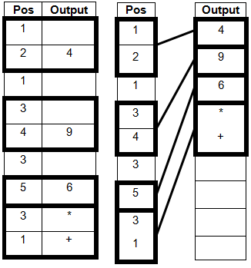
Mark against whichever alternative gives the highest mark.
Stop marking as soon as incorrect output is given.
4

(e) Post-order;
A Depth-first
A Depth-first search as BOD
TO Depth-first pre / in-order
1

(f) ( 4 + 9 * 6 in) Reverse Polish (Notation) // Postfix (Notation) // RPN;
1
[12]

M34.
(a) Omitting unnecessary details (from a representation) / / Storing only those details which are necessary (in the context of the problem being solved);
R responses that do not refer to abstraction in the context of data or modelling
1

(b) SUBJECT MARKING POINTS:
Representation as a graph:
Vertex / node represents a station; A junction between railway lines
Edge / arc / line represents a (direct) connection / railway line between two stations; R vector
Graph must be weighted / / edges have weights;
Distance between two stations must be written on edge / / stored with edge / / weights will be distances;
Could be more than one direct route between two stations; in which case shortest of the distances would be stored as the weight;
Graph would be undirected as trains can travel in both directions between each station;
OR
Graph would be directed as some lines may only be traversable in one direction;
Note: Only accept one of the above two points about whether the graph would be directed or undirected. Must have reason.
Implementation as array:
Each station assigned a (unique) number (to be used as array index); - This mark available regardless of how the rest of the implementation is done
Using an adjacency matrix:
The (adjacency) matrix would be a two-dimensional array (of numbers);
Array contains one row and one column for each station / / An n x n array is required to represent n stations; A rows and columns labelled with stations for BOD mark
If there is a (direct) connection between the two stations, store the distance between the two stations at the intersection of the row / column for the stations;
If there is no (direct) connection between the two stations, store a value to indicate this at the intersection of the row / column for the stations; A examples of values eg 0, ∞, NULL that could not be valid distances including any alphanumeric indicator
Using an adjacency list as a 2d array of numbers:
Adjacency list could be stored in a two-dimensional array (of records or similar);
In one dimension there would have to be n rows / columns for n stations / / one row / column per station;
In the other dimension the number of columns / rows would be determined by the highest degree of any vertex / / the maximum number of neighbours a vertex has / / the maximum number of (direct) connections that any station has;
If a station is (directly) connected to another station then in the row / column for the first station, a new entry (record) would be made consisting of the number of / / an identifier for the second station and the distance to it; NE just to state identifier, must have distance as well
Note: Also accept implementation in two two-dimensional arrays, with one storing the stations and the other the distances, as long as made clear station identifiers and distances stored in corresponding positions.
Using an adjacency list as a 1d array of strings:
Adjacency list could be stored in a (one-dimensional) array of strings;
One row per station;
The string for a station contains, for each station that it is connected to, the station identifier / name and distance;
Use of a delimiter between values;
REFER ANY OTHER WORKABLE SOLUTION TO A TEAM LEADER
If comparison made between adjacency matrix and adjacency list (not asked for):
Adjacency list might be more efficient (in terms of storage space) as graph is likely to be sparse / / as few edges between vertices / / as most stations only (directly) connected to a small number of other stations;
Adjacency matrix might be more efficient (in terms of speed) as shortest route finding algorithm is likely to need to lookup many distances when computing a route;
Note on use of diagrams: Candidates may choose to use diagrams to help clarify their responses. When marking, use may be made of such diagrams to help clarify understanding of the written description, however as this question assesses quality of written communication, marks should be awarded for the written description, not directly for the diagrams themselves.
8

HOW TO AWARD MARKS:
Mark Bands and Description
To achieve a mark in this band, candidates must meet the subject criterion (SUB) and all 5 of the quality of written communication criteria (QWCx).

 | SUB | Candidate has covered the graph representation and array implementation in detail and all or almost all of the required detail for an implementation is present. The candidate has made at least seven subject-related points.
 | QWC1 | Text is legible.
 | QWC2 | There are few, if any, errors of spelling, punctuation and grammar. Meaning is clear.
 | QWC3 | The candidate has selected and used a form and style of writing appropriate to the purpose and has expressed ideas clearly and fluently.
 | QWC4 | Sentences (and paragraphs) follow on from one another clearly and coherently.
 | QWC5 | Appropriate specialist vocabulary has been used.

7-8

To achieve a mark in this band, candidates must meet the subject criterion (SUB) and 4 of the 5 quality of written communication criteria (QWCx).

 | SUB | Candidate has covered both the graph representation and array implementation, making some valid points for each, but the level of detail may not be sufficient to implement. The candidate has made at least five subject-related points.
 | QWC1 | Text is legible.
 | QWC2 | There may be occasional errors of spelling, punctuation and grammar. Meaning is clear.
 | QWC3 | The candidate has, in the main, used a form and style of writing appropriate to the purpose, with occasional lapses. The candidate has expressed ideas clearly and reasonably fluently.
 | QWC4 | The candidate has used well-linked sentences (and paragraphs).
 | QWC5 | Appropriate specialist vocabulary has been used.

5-6

To achieve a mark in this band, candidates must meet the subject criterion (SUB) and 4 of the 5 quality of written communication criteria (QWCx).

 | SUB | Candidate has made some relevant points but the description is either lacking in detail or only covers one of the graph representation or array implementation.
 | QWC1 | Most of the text is legible.
 | QWC2 | There may be some errors of spelling, punctuation and grammar but it should still be possible to understand most of the response.
 | QWC3 | The candidate has used a form and style of writing which has many deficiencies. Ideas are not always clearly expressed.
 | QWC4 | Sentences (and paragraphs) may not always be well-connected.
 | QWC5 | Specialist vocabulary has been used inappropriately or not at all.

1-4

Candidate has made no relevant points.
0

Note: Even if English is perfect, candidates can only get marks for the points made at the top of the mark scheme for this question.
If a candidate meets the subject criterion in a band but does not meet the quality of written communication criteria then drop mark by one band, providing that at least 4 of the quality of language criteria are met in the lower band. If 4 criteria are not met then drop by two bands.
[9]

M35.
(a) Omitting unnecessary details (from a representation) / / Storing only those details which are necessary (in the context of the problem being solved);
R responses that do not refer to abstraction in the context of data or modelling
1

(b) SUBJECT MARKING POINTS:
Representation as a graph:
Vertex / node represents a station; A junction between railway lines
Edge / arc / line represents a (direct) connection / railway line between two stations; R vector
Graph must be weighted / / edges have weights;
Distance between two stations must be written on edge / / stored with edge / / weights will be distances;
Could be more than one direct route between two stations; in which case shortest of the distances would be stored as the weight;
Graph would be undirected as trains can travel in both directions between each station;
OR
Graph would be directed as some lines may only be traversable in one direction;
Note: Only accept one of the above two points about whether the graph would be directed or undirected. Must have reason.
Implementation as array:
Each station assigned a (unique) number (to be used as array index); - This mark available regardless of how the rest of the implementation is done
Using an adjacency matrix:
The (adjacency) matrix would be a two-dimensional array (of numbers);
Array contains one row and one column for each station / / An n x n array is required to represent n stations; A rows and columns labelled with stations for BOD mark
If there is a (direct) connection between the two stations, store the distance between the two stations at the intersection of the row / column for the stations;
If there is no (direct) connection between the two stations, store a value to indicate this at the intersection of the row / column for the stations; A examples of values eg 0, ∞, NULL that could not be valid distances including any alphanumeric indicator
Using an adjacency list as a 2d array of numbers:
Adjacency list could be stored in a two-dimensional array (of records or similar);
In one dimension there would have to be n rows / columns for n stations / / one row / column per station;
In the other dimension the number of columns / rows would be determined by the highest degree of any vertex / / the maximum number of neighbours a vertex has / / the maximum number of (direct) connections that any station has;
If a station is (directly) connected to another station then in the row / column for the first station, a new entry (record) would be made consisting of the number of / / an identifier for the second station and the distance to it; NE just to state identifier, must have distance as well
Note: Also accept implementation in two two-dimensional arrays, with one storing the stations and the other the distances, as long as made clear station identifiers and distances stored in corresponding positions.
Using an adjacency list as a 1d array of strings:
Adjacency list could be stored in a (one-dimensional) array of strings;
One row per station;
The string for a station contains, for each station that it is connected to, the station identifier / name and distance;
Use of a delimiter between values;
REFER ANY OTHER WORKABLE SOLUTION TO A TEAM LEADER
If comparison made between adjacency matrix and adjacency list (not asked for):
Adjacency list might be more efficient (in terms of storage space) as graph is likely to be sparse / / as few edges between vertices / / as most stations only (directly) connected to a small number of other stations;
Adjacency matrix might be more efficient (in terms of speed) as shortest route finding algorithm is likely to need to lookup many distances when computing a route;
Note on use of diagrams: Candidates may choose to use diagrams to help clarify their responses. When marking, use may be made of such diagrams to help clarify understanding of the written description, however as this question assesses quality of written communication, marks should be awarded for the written description, not directly for the diagrams themselves.
8

HOW TO AWARD MARKS:
Mark Bands and Description
To achieve a mark in this band, candidates must meet the subject criterion (SUB) and all 5 of the quality of written communication criteria (QWCx).

 | SUB | Candidate has covered the graph representation and array implementation in detail and all or almost all of the required detail for an implementation is present. The candidate has made at least seven subject-related points.
 | QWC1 | Text is legible.
 | QWC2 | There are few, if any, errors of spelling, punctuation and grammar. Meaning is clear.
 | QWC3 | The candidate has selected and used a form and style of writing appropriate to the purpose and has expressed ideas clearly and fluently.
 | QWC4 | Sentences (and paragraphs) follow on from one another clearly and coherently.
 | QWC5 | Appropriate specialist vocabulary has been used.

7-8

To achieve a mark in this band, candidates must meet the subject criterion (SUB) and 4 of the 5 quality of written communication criteria (QWCx).

 | SUB | Candidate has covered both the graph representation and array implementation, making some valid points for each, but the level of detail may not be sufficient to implement. The candidate has made at least five subject-related points.
 | QWC1 | Text is legible.
 | QWC2 | There may be occasional errors of spelling, punctuation and grammar. Meaning is clear.
 | QWC3 | The candidate has, in the main, used a form and style of writing appropriate to the purpose, with occasional lapses. The candidate has expressed ideas clearly and reasonably fluently.
 | QWC4 | The candidate has used well-linked sentences (and paragraphs).
 | QWC5 | Appropriate specialist vocabulary has been used.

5-6

To achieve a mark in this band, candidates must meet the subject criterion (SUB) and 4 of the 5 quality of written communication criteria (QWCx).

 | SUB | Candidate has made some relevant points but the description is either lacking in detail or only covers one of the graph representation or array implementation.
 | QWC1 | Most of the text is legible.
 | QWC2 | There may be some errors of spelling, punctuation and grammar but it should still be possible to understand most of the response.
 | QWC3 | The candidate has used a form and style of writing which has many deficiencies. Ideas are not always clearly expressed.
 | QWC4 | Sentences (and paragraphs) may not always be well-connected.
 | QWC5 | Specialist vocabulary has been used inappropriately or not at all.

1-4

Candidate has made no relevant points.
0

Note: Even if English is perfect, candidates can only get marks for the points made at the top of the mark scheme for this question.
If a candidate meets the subject criterion in a band but does not meet the quality of written communication criteria then drop mark by one band, providing that at least 4 of the quality of language criteria are met in the lower band. If 4 criteria are not met then drop by two bands.
[9]

E1.
This was usually answered correctly, with a few candidates getting some of the nodes wrong. Some candidates did not answer part (c) correctly by knowing about traversal of binary trees (which is not in the specification of CPTI) and then applying this rather than the straightforward binary search. Many candidates did not mention the final node in their list of data items accessed. This was accepted this time, but will not gain credit in future years. Clearly, the final node has to be accessed to see that the search has been successful.

E2.
(a) This part asked what result would have been returned by the specified function calls. So Tail (Ports) would have returned [Barcelona, Athens, Alexandra, Tunis, Lisbon] with the brackets being part of the correct answer. Head(Tail(Tail(Ports))) would have returned Athens, without brackets and the answer to the last part was True, not [True] or True [ ].

(b) Most candidates could say what recursively defined was, although some answers were barely sufficient and ‘It calls itself’ was deemed insufficient.

(c) Explanations of why a stack was necessary to execute procedure P recursively frequently missed the point.

(d) Full marks were gained for this part by an answer of:
Lisbon Tunis Alexandria Barcelona Southampton,
or even of:
LisbonTunisAlexandriaBarcelonaSouthampton,
as no punctuation was printed. A list of:
• Lisbon
• Tunis
• Alexandria
• Barcelona
• Southampton
was also accepted.

(e) Candidates who did not score full marks for 10(e) mainly numbered the ports in alphabetical order, rather than using the pointers to point to the next port in the list, or gave inadmissible or absent end-of-list markers.

E3.
(a) The tree was generally well created. A few candidates produced mirror images, which were accepted this time. However, candidates need to be aware that a binary search tree stores lower values in the left sub-tree and higher values in the right sub-tree. A few candidates produced a balanced binary tree with each node having two sub nodes, which was not correct.

(b) Only the better candidates seemed to score full marks here. Dry-running an algorithm does not seem to have received sufficient attention in the preparation of a number of candidates. The fact that ‘Item’ did not change its value seemed to be noticed by only a few candidates. Candidates did not appear to appreciate that the algorithm was using the binary search tree, which the candidates had drawn in part (a).

E4.
This focused on stacks and queues. Again, marks were lost through lack of care in the diagrams. Two vertical columns of names, with Dean at the top of one and Anne at the top of the other were insufficient to show how this data would be stored in these two different data structures. Full marks were gained by two groups of locations, either vertical or horizontal, with pointers to show the top of the stack and the front and rear of the queue. Most candidates did successfully remove and input the correct items in part (b). In part (c), many seemed to think that pointers were only used in circular queues, and that queues were usually implemented in this way so that ‘once an item is retrieved and processed it can be placed back into the queue by adding it at the rear’. Good answers noted that a queue is a ‘Last In First Out’ structure. Data is removed from the front and added to the rear, so current data in a linear queue will ‘move’ through memory. In a circular queue, the locations in the front of the queue, which are no longer current, will be re-used. A circular queue thus makes more efficient use of memory.

E5.
This question was on binary tree traversal. A large number of candidates gained full marks for this question.

E6.
This question referred to the loading of data into a linked list. No marks were given if the items had not been loaded in the given order. Binary trees were not credited.
In part (a), nodes should have been numbered with correct links. A start pointer was expected with some indication of the last item. In (ii) ‘snipe’ and ‘grouse’ had to be added at the end of the list and the pointers amended correctly to incorporate them.

In (b), many candidates correctly said that in a dynamic structure the amount of memory required would vary but few gained the second mark here by stating that this would be at run time. Size was an acceptable alternative to amount of memory required, but it was insufficient to say that ‘items could be added or deleted’. Incorrect answers included the ability to sort items.
In (c), answers that memory is allocated from a heap or pool of available locations and pointers hold the address of the next free location or of the last allocated block gained both marks.

E7.
This was well answered by many candidates, although here again, marks were lost through lack of care in carrying out the clearly written instructions. The instructions in part (a) were to circle and label the three parts of the tree. An un-circled, or (more rarely) unlabelled part was not credited. Very few candidates were unable to draw the left and right sub-trees correctly, and most could perform in-order traversal.

E8.
Parts (a) (i) and (a) (iii) were answered correctly by most candidates as Mon and False respectively, (not [Mon]). However, in (a) (ii) [Head(Days)} is the list [Sun] and the tail of this list is the empty set [ ]. Had these data been stored in a one dimensional array, instead of in a list, each element could have been accessed directly using the subscript, rather than having to be found through a sequential search or using the Head / Tail functions defined.

E9.
Those candidates who clearly understood recursion scored high marks in this question, but a worrying number of candidates could not explain that a procedure is recursively defined when it is defined in terms of itself. A stack is needed so that register values such as return address and parameter values can be saved and can be returned to in the correct order. Most candidates managed to complete the trace table correctly but many did not give the correct printed output. Many candidates did not provide the correct number of digits, or in reverse order. A large majority wrongly thought that procedure B described a binary search. Interestingly, some of the candidates who got the printed output wrong still stated the correct purpose of the procedure: converting the denary number provided as parameter into binary.

E10.
(a) Many candidates scored very well on this question. The term LIFO was very well understood.
(b) Many candidates managed to perform the pushes and pops correctly. Some candidates failed to perform the operations in sequence, taking each part as a new problem. It is essential that candidates read the question carefully.
(c) Few candidates were able to give a suitable example of the use of a stack.

E11.
(a) It was pleasing to see the number of candidates that were able to draw a correct tree.
(b) Those candidates that were able to draw a tree were generally able to identify the root correctly.
(c) Those candidates that drew the tree were generally able to identify the data items that needed to be accessed. There were a number of candidates who failed to include Maria. It is not possible to know that you have found the correct node without accessing it.

E12.
Part (a) and (b) have been asked many times before. However, many candidates were unable to explain how a stack is used in the execution of a recursive procedure. Correct responses included that the return address (held in the program counter) and other register values are saved so control can return correctly to the previous invocation of the procedure. Many candidates gained full marks for stating, correctly, the printed output after dry-running the procedure. However, many others could not even get the first few printed items in the correct order.
Many candidates correctly spotted that the procedure described an in-order traversal of a tree.

E13.
(a) Many candidates scored very well on this question. The terms FIFO and LIFO were very well understood.
(b) Again, a high scoring part of the question. Most candidates managed to place the ticks in the correct boxes.

(c) Quite a few candidates were able to state a suitable example of the use of a stack but few were able to describe it satisfactorily. It should be stressed that candidates should give computing examples. A significant number of answers referred to stacks of plates, books etc.
(d) Once again, many candidates obtained a mark for stating a suitable example but few were able to describe it satisfactorily.

E14.
This was another question which most candidates found difficult, if not impossible. However, some good candidates produced very good answers.
Most candidates were able to answer part (a).

The examiners only rarely awarded full marks for the trace table. A lot of candidates abandoned the trace once they realised that the numbers were being output in ascending order. This limited their reward to two or three marks at best since half of the marks depended on the trace being completed. Many candidates had difficulty logging the procedure calls even when they made a good attempt at showing the tree in the T column.
Some candidates got the two marks for part (b)(ii) without attempting the trace while others who showed the right output in (i) called the procedure a search or a bubble sort.

E15.
Although a short question, it proved difficult for most candidates. Many missed the point that both part (a) and part (b) were about the implementation of a stack, and in part (b) gave answers that were about applications that were suitable for a linked list or an array. However, we can note one particularly lucid answer to part (a)(i): “This is a static data structure with a finite pre-declared capacity.”

E16.
(a) (i) The use of GoTo statements has not previously been examined on this paper and most candidates struggled to suggest a single reason why this was poorly designed code, despite a large number of acceptable answers. The most common correct answers were that the use of GoTo statements gives rise to code which is difficult to follow and trace; there is no output produced when the SearchName value is not found; when there is more than one occurrence of SearchName in the PolicyHolder array, the program will output the number of claims value for the first occurrence of the name only.
(ii) Few marks were obtained here with most candidates failing to give the bounds of the array for PolicyHolder or NoOfClaims, or omitting a data type for the identifier.

(b) Candidates should be able to write small amounts of program code in a unit that has the word ‘programming’ in its title. Knowledge of loops other than a For loop was rare. It was hoped that candidates would have constructed a Repeat – Until or While loop which terminated when a NoOfClaims value of 5 or more was found. Candidates who used a For loop were, however, still able to score the maximum 5 marks.

Examiners were not looking for the correct use of exact syntax for the language as stated by the candidate.
The use of IF statements was better understood, but this often did not extend to using an array index for the NoOfClaims as part of the IF statement. Very many candidates used the maths operator incorrectly, e.g. ≥ or more usually =>. Quite a few candidates reversed the logic testing for <5 and gave appropriate output for which they gained marks. Most popular languages seen were Pascal and Visual Basic but the candidates that used C on the whole answered the question very well indeed.

E17.
This was the first question paper on which two-dimensional arrays had been set and the answers seen were encouraging.
(a) Most candidates correctly described that this was the issues figure for salesperson 7 in month 4. Some candidates described the figure as the highest sales figure for April which gained no credit.

(b) Only better candidates wrote an acceptable declaration statement which required the correct identifier StoreCards with the correct subscripts in the correct order.
(c) Few acceptable statements were seen.

(d) Encouragingly, this was well answered, with most candidates able to describe the purpose of the algorithm. Answers which did little more that re-write statement(s) from the given algorithm into a narrative form - e.g. “person total set to zero” - which was little different, did not gain credit. The common error was stating that the algorithm calculated a total for ‘each’ salesperson.

(e) Somewhat surprisingly – despite similar questions on previous papers - candidates were often unable to state a correct data type, which would suggest the fundamental concept in programming that “identifiers will have a stated or implied data type” is not understood.
For (ii) almost all gave Boolean, with every possible phonetic spelling, and some gave integer for (iii). Real/Float or other acceptable alternatives for (i) were rare.

E18.
Very few candidates did not get some marks for the trace and many returned full marks for this part of the question. Some candidates who did achieve full marks on part (a) could not say what the algorithm does. Many candidates seemed to make a wild guess.

E19.
This question discovered that most candidates did not really understand the concept of a queue as a data structure. Throughout the question many candidates referred to insert/delete operations thus showing a lack of understanding of the operation of a queue. Part (a) was quite beyond the ability of most candidates and this suggested that they had never attempted to program a queue using a linked data structure. Very few candidates recognised that the value of Front had to be stored in a temporary variable in order to free the memory used. The answers to part (c) suggested that they had not programmed a queue using an array either. Most candidates, however, managed to obtain some marks on this question, most frequently parts (c)(i) and (c)(ii). Many marks were lost in part (c)(iii) due to inadequate descriptions.

E20.
This was the first time this topic was assessed with a question like this, but it was well understood by most candidates.
(a) This mark proved elusive for the majority, as an answer which suggested the pointer indicated a location or address value was required. The majority of answers seen simply suggested that “it indicates the end of the queue” and was considered insufficient.
(c) The diagram generally scored well. A common error was to leave the head pointer at address 0.

(d) This was another question where candidates were often let down by their poor expression; the examiner often suspected that the candidate knew that continual addition would result in the queue running out of space, but the candidate was unable to express this. Answers which vaguely stated that the queue ‘runs of out addresses’ were considered insufficient.
Weaker candidates simply said that continually changing the pointer values would prove difficult to keep track of, with the implication that this was a human task and not performed by the computer. Some candidates suggested wrongly that head and tail could reach the same value at which point the queue would become unusable.

E21.
(a) The majority of candidates were able to describe a stack structure as a ‘first in last out’ or ‘last in first out’ operation.

(b) The weaker answers seen here moved values to a different memory location once additions and deletions occurred, or used location 605 as the first available and so qualified for a maximum of two (only) ‘follow through’ marks.

(c) Many candidates were clear about the basic operation which was taking place but then their communication skills let them down in the descriptions required for (ii) and (iii). For (ii) the answer looked for was the idea that items leave the stack one after the other. For (iii) a description was required for the principle of operation of a queue.

E22.
In general the dry run was poorly answered and left completely blank on too many scripts.
(a) Many candidates scored the maximum three marks for identifying the data types. Some candidates lost a mark for suggesting that ‘yes/no’ or a ‘check box’ was an acceptable data type. This comes from their practical experience with database design software and a visual programming language, but candidates should appreciate they are not acceptable names for programming language data types.
(b) This was a different style of question from that previously seen. Candidates seemed to cope well with being asked to ‘fill in the blanks’ in the algorithm.
(c) (ii) Answers were often incorrect, but then inexplicably candidates were able to use the same function correctly in part (iii).

E23.
Most candidates obtained the mark for part (a). It was also very pleasing to see the number of candidates who were able to correctly trace the algorithm. Many candidates obtained good marks on this question. Although many candidates did go wrong with the trace, very few candidates failed to attempt it.

E24.
It has been commented on in previous papers how the standard of candidates’ answers for this question has improved and this continued with this paper.
In part (c) a nested loop (given for the first time) was the key control structure and the majority of candidates identified this. Some confused the nesting, although were still able to secure 5 of the available 6 marks. The most commonly lost mark was at the start of the algorithm for the failure to initialise the array.

Generally part (d) was well answered. Where a mark was lost the suspicion was that it was through poor expression, not lack of understanding of the algorithm. Incorrect answers often stated the numbers for individual sales staff or started to include the concept of target setting, etc.

E25.
Despite what was considered to be a straightforward question, the range of the quality of answers seen was huge. Many failed even to appreciate what was meant by a binary tree (as was apparent by the suggested diagram!). Some answers correctly drew the structure for the tree but then failed to attempt (b)(i) or (b)(ii) – which is strange as both the 'list of comparisons' and the 'number of comparisons' had been asked for on previous papers. The most common error was not to include the final name in the list, and candidates who did not score for (b)(ii), then often incorrectly quoted 3 as their answer for (b)(ii).

E26.
It was pleasing to see the number of candidates that scored highly on this question. Most candidates were able to obtain the mark for part (a) and a large number did very well on part (b). It must be emphasised that candidates were asked to dry run the algorithm and complete the trace table. A small number of candidates were able to produce the correct output but did not produce a satisfactory trace. Marks were given for the trace and so it is essential that candidates fill this in correctly. Although most candidates obtained one mark for part (b)(ii), few obtained two. Candidates must realise that correct technical terminology should be used.

E27.
This question produced many disappointing responses. The question was specifically about a queue but many candidates failed to grasp this. There were a large number of responses that showed that the candidate was concerned about the difficulties of inserting or removing items from the middle of the queue. There was a mixed response to part (a). Many candidates were well prepared and were able to give satisfactory responses. However, a large number of candidates were unable to express themselves clearly and there was a sizeable minority who seemed to be unprepared for this question.
In part (b) it was pleasing to see the large number of candidates who understood that a circular implementation was required. There were a number of misconceptions, in particular a number of candidates suggested looking for empty spaces in the middle of the array where items had been removed.
Part (c) was badly answered with many wild guesses showing a lack of comprehension. Few candidates showed that they understood that the array was being used to implement a queue and that a queue operation was required. Even fewer recognised that the array is finite and that this will affect the implementation of the queue.

E28.
Part (a): This question part was very well answered with the many candidates getting full marks.

Part (b): The algorithm inserted an item into an ordered list at the correct position. Some candidates lost marks by failing to refer to the ‘correct position’. Others stated that a sort was performed which was not true, as the order of the items in the existing list was not changed.

Part (c): For part (i), around half of the candidates were able to explain that a static data structure has a fixed size which could not change at compile time, whereas the size of a dynamic data structure can change at runtime.

There were few correct answers to part (ii). The heap is a pool of available memory locationsand as the linked list grew, memory would be allocated to it from the heap and deallocated memory would be returned to it. Some candidates erroneously believed that the heap would be used as a temporary store or that the pointers in the linked list would be stored in the heap.

E29.
Part (a): The use of the adjacency matrix was clearly well understood with all but a few candidates achieving full marks.

Part (b): There were some good responses to this question part, but also quite a lot of confused answers. An adjacency matrix is more appropriate when there are many edges in a graph, or if these edges need to be checked or updated frequently. An adjacency list is appropriate for graphs with few edges (sparse graphs) or where the edges are not checked / updated frequently.
Neither the number of vertices in a graph nor the available memory would influence the choice.
There was confusion over the use of terminology with some candidates apparently using the term vertex to mean edge.

Part (c): This question part was poorly answered, with only a third of candidates scoring any marks. A tree is a graph that is connected, undirected and has no cycles. Some candidates gave responses that referred only to specific types of tree, either rooted trees or binary trees.
These responses did not gain credit.

Part (d): The vast majority of candidates knew how to construct a binary search tree. The most common cause of error appeared to be candidates forgetting the order of the letters in the alphabet rather than forgetting the principles that should be used to construct the tree. A small number of candidates mistakenly drew arrows instead of lines between nodes.

Part (e): There were some good responses to this question part but many were disappointing and a surprising number of candidates did not write a response at all. Many candidates who did answer chose to use a diagram to illustrate their response which was quite acceptable, so long as the diagram included enough detail to make clear that it was a representation of a binary tree.

E30.
Part (a): This question part was very well answered with the majority of candidates getting both marks. The only common mistake was to miss out the brackets in the expression that should be (12+19)*8.

Part (b): As with part (a), this question part was also well answered. The most common correct response was that brackets are not required. It would have been nice to see some more detailed explanations of this point, rather than just a brief statement of it. A common incorrect answer was that RPN was easier for a computer to understand. The word “understand” is not appropriate in this context.

Part (c): Responses to this question part were excellent, with relatively few errors made. The majority of candidates got full marks which is unusual for a question involving a trace table. The only two recurring mistakes were to pop the numbers off the stack in the wrong order, resulting in the transposition of the values in Op1 and Op2 and forgetting to push 50 back onto the stack at the very end.

Part (d): This question was well answered, with most candidates getting some marks and a significant number more than half marks. The most common mistake was to increment the TopOfStackPointer in the wrong place – either before the If construct which tested for the stack full condition or after the value in ANumber was stored into the StackArray. Some candidates implemented solutions that used a loop to find the first empty position in the array to insert the number into. These were awarded credit if they would have worked, but many failed to test properly for the stack being full. It is important that candidates use the correct variable names when they are given on the question paper.

E31.
Part (a): Two thirds of students were able to identify one property that a graph must have to be a tree. A small number confused a tree with a rooted tree and made assertions such as that a tree must have a root, which is incorrect.

Part (b): This question part tested students’ understanding of the method being used to represent a maze as a graph. The majority of students correctly identified a feature of the maze that would stop its graph being a tree. The most commonly seen correct response identified that there could be a loop in the maze. Other possibilities included that part of the maze could be inaccessible or that part of the maze might only be traversable in one direction. Some students failed to achieve the mark because they re-answered part (a), discussing a feature of a graph that would stop it being a tree, rather than a feature of a maze.

Part (c): Students were asked to represent the graph of the maze as an adjacency matrix. Three quarters of students scored both marks for this question part. Responses where symbols other than 0s and 1s were used in the matrix were accepted, as long as they could be viewed as an accurate representation of the graph.

Part (d)(i): The vast majority of students were able to identify that a recursive routine would call itself. A small number asserted that a recursive routine would repeat itself, which was not considered to be enough for a mark as this could equally have been a description of iteration.

Part (d)(ii): Most students scored some marks for this question part, but less than a fifth achieved both. The most widely understood point was that the data would need to be removed from the stack in the reverse of the order that it was put onto it so that the recursion could be unwound. Less well understood was the types of data that would be stored, such as return addresses and local variables.

Part (e): Most students achieved some marks on this question part and around a quarter achieved all five for a fully complete trace. The most commonly made mistake was to update, incorrectly, the Completely Explored array as the recursive calls were made, as opposed to when the recursion unwound.

E32.
For (a), about three quarters of the candidates achieved one or two marks for this question part. The most common creditworthy response was that the size of a dynamic data structure could change at run time whereas a static data structure's size was fixed at compile time. Some candidates missed out on this mark by making the vaguer statement that a dynamic structure could change at run time whereas a static structure could not, without any reference to size. Some candidates lost a mark by just giving opposite sides of the same point.

Question (b) was well answered. Some candidates missed out on one mark scheme point by writing that all elements in the array would have to be moved down, without making clear that it was only the elements below the insertion point that needed to move. Many of this group of candidates nevertheless achieved full marks by making other valid points. A small but surprising number of students wrote about deleting an item when the question was about inserting one.
For part (c), just over half of the candidates correctly identified that this was a priority queue.

For part (d)(i), only about a quarter of the candidates offered a reasonable explanation of what the heap would be used for. Many stated that it would be used to store the list or to store pointers. Some asserted that it would be used to store new items, which was a better response but was not creditworthy as the suggestion was that the new items would be stored in the heap. Good responses recognised that when a new item was added, memory would be claimed from the heap to store the new item.
Part (d)(ii) was poorly answered with only about a third of the candidates recognising that the pointer value was a memory address. Answers referring to a value being an index or location were not enough for a mark without further explanation that made clear that this was to a memory location.

In part (d)(iii), this algorithm was the most complex one that candidates have been asked to write on a COMP3 paper. Answers given in pseudo-code or structured English were acceptable and all reasonable styles of syntax were marked as we are aware that candidates will have used different programming languages. Responses written in prose were acceptable if they included clear steps and showed how the variables would be updated. There were very few prose answers, but they often scored poorly due to being too general.

There were some very good responses and marks were awarded later on in the algorithms even if earlier parts were not working, although this was not always possible as sometimes whether or not later parts of the given algorithm worked depended fundamentally on earlier parts.
The most common misconception was to treat the linked list as if it were a list stored at sequential locations in an array and to adjust the CurrentNodePointer by adding one onto it inside a loop rather than by setting its value to the NextNodePointer of the current node. It remained possible to pick up some marks for this type of implementation by, for example having a suitable loop.
Very few candidates, even those achieving almost full marks, included the step of actually claiming the memory from the heap to store the new item in.
A small number of candidates produced recursive solutions which were also accepted.

E33.
For part (a) almost all candidates were able to identify the content of the root node correctly. Leaf nodes were more problematic, with many candidates believing that all of the nodes that were not the root were leaves, and thus mistakenly included “+" in the list of contents of leaf nodes. Nevertheless just over half of the candidates achieved full marks for this question part.

Part (b) was poorly tackled, with only a third of candidates getting more than one mark. The most common error was to state that arrays B and C were used to store the left / right hand subtrees. Candidates needed to make clear that the arrays were storing pointers to these subtrees to be awarded the marks.
For (c), responses were disappointing with many candidates showing no understanding of the purpose of the entry 0 in the array. Others stated that it indicated that a node was a leaf node, or had no children, when in fact the 0 in array B only related to the left hand subtree so nothing could be told from it about whether or not a node had children without also consulting array C.

Part (d): candidates usually find recursive traces to be quite difficult. On this occasion, about half of them got at least one mark for the trace, and a quarter achieved all four marks.
For part (e), about a third of candidates made the expected response, but a disappointingly large number wrote answers that were not even types of tree traversal.
For part (f), almost all of the candidates who had correctly completed the trace table and obtained the output recognised that this was the Reverse Polish Notation equivalent of the infix expression in the expression tree.

E34.
(a) More than half of the candidates were able to correctly define abstraction in this part. The question was asked in the context of data representation, so an appropriate definition would have been to store only those details of a problem / model that were required in the context of the problem being solved. Common mistakes were to state that unnecessary complexity would be hidden from the user, rather than being removed from the model altogether, or to define a simulation instead of abstraction.
(b) This part was the question that assessed quality of written communication. As such, it was particularly important the candidates used technical terms accurately when writing their responses. Almost all candidates covered both aspects of the question: the representation as a graph and the representation using arrays as an adjacency matrix or list.
In almost all responses, the graph part of the answer was better than the array representation part, with most students being able to correctly explain how the underground railway network could be represented as a graph. Some students lost marks by not using the correct terminology or by drawing diagrams but not explaining points such as that a station would be represented as a node.
As the question paper stated, diagrams needed to be fully explained if they were used. A common mistake was to state that stations would be represented by nodes and that railway tracks would be represented by vertices; vertex in a synonym for node but was being mistakenly used instead of the term edge or arc. A small but not insignificant number of students misinterpreted the term graph and explained how the network might be represented as a bar chart or scatter graph.
The part of the question relating to the representation using arrays as an adjacency matrix or list was poorly tackled. Many students discussed how the representation could be drawn out as a grid or list on paper instead of how it could be represented using arrays in a programming language, or described solutions that were not really either an adjacency matrix or list.
Those who decided to represent the data as an adjacency matrix often suggested that the station names would be written into the array rather than that stations would be associated with a number that would be used as an index into the array. That said, pleasingly, most students who suggested a matrix representation recognised that the distances would be filled into the array at the appropriate location and that a null value would be used where there was no route. Some students used an array containing only 0s and 1s instead of distances.
Students who chose to present an adjacency list solution rarely explained how this would be achieved in a programming language, focussing instead on how it could be depicted diagrammatically. Another common mistake was to talk about pointers, without explaining how these would work in the context of the array.

E35.
(a) More than half of the candidates were able to correctly define abstraction in this part. The question was asked in the context of data representation, so an appropriate definition would have been to store only those details of a problem / model that were required in the context of the problem being solved. Common mistakes were to state that unnecessary complexity would be hidden from the user, rather than being removed from the model altogether, or to define a simulation instead of abstraction.
(b) This part was the question that assessed quality of written communication. As such, it was particularly important the candidates used technical terms accurately when writing their responses. Almost all candidates covered both aspects of the question: the representation as a graph and the representation using arrays as an adjacency matrix or list.
In almost all responses, the graph part of the answer was better than the array representation part, with most students being able to correctly explain how the underground railway network could be represented as a graph. Some students lost marks by not using the correct terminology or by drawing diagrams but not explaining points such as that a station would be represented as a node.
As the question paper stated, diagrams needed to be fully explained if they were used. A common mistake was to state that stations would be represented by nodes and that railway tracks would be represented by vertices; vertex in a synonym for node but was being mistakenly used instead of the term edge or arc. A small but not insignificant number of students misinterpreted the term graph and explained how the network might be represented as a bar chart or scatter graph.
The part of the question relating to the representation using arrays as an adjacency matrix or list was poorly tackled. Many students discussed how the representation could be drawn out as a grid or list on paper instead of how it could be represented using arrays in a programming language, or described solutions that were not really either an adjacency matrix or list.
Those who decided to represent the data as an adjacency matrix often suggested that the station names would be written into the array rather than that stations would be associated with a number that would be used as an index into the array. That said, pleasingly, most students who suggested a matrix representation recognised that the distances would be filled into the array at the appropriate location and that a null value would be used where there was no route. Some students used an array containing only 0s and 1s instead of distances.
Students who chose to present an adjacency list solution rarely explained how this would be achieved in a programming language, focussing instead on how it could be depicted diagrammatically. Another common mistake was to talk about pointers, without explaining how these would work in the context of the array.

