Q1.
In a particular programming language, the correct syntax for a real number is defined by the syntax diagrams in the diagram below.
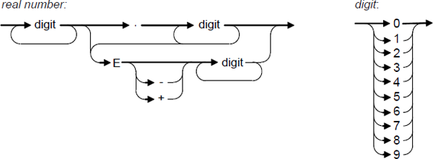
(a) Write Yes or No in the spaces in the empty column of the table below to identify whether or not the numbers listed in the table are valid real numbers which conform to the correct syntax for this language.

 | Real number | Valid? (Yes / No)
 | 203.412
 | -12.87
 | 12.43E-12

(3)

(b) In the same language:
A digit is defined as any single numeric symbol from this list: 0, 1, 2, 3, 4, 5, 6, 7, 8, 9.
A whole number is defined as a sequence of one or more digits.
An integer is defined as a whole number or a + or a – symbol followed by a whole number.
Write Backus-Naur Form (BNF) production rules for digit, whole number and integer.
........................................................................................................................
........................................................................................................................
........................................................................................................................
........................................................................................................................
(3)
(Total 6 marks)

Q2.
Regular expressions can be used to search for strings.
(a) For each of the following regular expressions, describe the set of strings that they would find.
(i) a+b
...............................................................................................................
...............................................................................................................
(1)

(ii) a?b
...............................................................................................................
...............................................................................................................
(1)

(iii) (ab)*
...............................................................................................................
...............................................................................................................
(1)

(b) Write regular expressions that match:
(i) either Clare or Claire.
...............................................................................................................
(1)

(ii) any non-empty string that:
• starts with 10
• has zero or more occurrences of any combination of 0 or 1 in the middle
• ends with 01
Example strings that the expression should match are 1001, 100010101,
101111010101001.
...............................................................................................................
(2)
(Total 6 marks)

Q3.
Reverse Polish Notation is an alternative to standard infix notation for writing arithmetic expressions.
(a) Convert the following Reverse Polish Notation expressions to their equivalent infix expressions.

 | Reverse Polish Notation | Equivalent Infix Expression
 | 45 6 +
 | 12 19 + 8 *

(2)

(b) State one advantage of Reverse Polish Notation over infix notation.
........................................................................................................................
........................................................................................................................
(1)

(c) The pseudo-code algorithm below can be used to calculate the result of evaluating a Reverse Polish Notation expression that is stored in a string. The algorithm is designed to work only with the single digit denary numbers 0 to 9. It uses procedures and functions listed in the table below, two of which operate on a stack data structure.

StringPos ← 0
Repeat
StringPos ← StringPos + 1
Token ← GetCharFromString(InputString, StringPos)
If Token = ‘+’ Or Token = ‘-’ Or Token = ‘/’ Or Token = ‘*’
Then
Op2 ← Pop()
Op1 ← Pop()
Case Token Of
‘+’: Result ← Op1 + Op2
‘-’: Result ← Op1 - Op2
‘/’: Result ← Op1 / Op2
‘*’: Result ← Op1 * Op2
EndCase
Push(Result)
Else
IntegerVal ← ConvertToInteger(Token)
Push(IntegerVal)
EndIf
Until StringPos = Length(InputString)
Output Result

 | Procedure/Function | Purpose | Example(s)
 | GetCharFromString  (InputString:String, StringPos:Integer): Char | Returns the character at position StringPos within the string InputString.  Note that the leftmost letter is position 1, not position 0. | GetCharFromString  ("Computing", 1) would return the character style='font-family:Courier New;font-size:10pt'>'C'.  GetCharFromString  ("Computing", 3) would return the character style='font-family:Courier New;font-size:10pt'>'m'.
 | ConvertToInteger  (ACharacter: Char):  Integer | Returns the integer equivalent of the character in ACharacter. | ConvertToInteger('4') would return the integer value style='font-family:Courier New;font-size:10pt'>4.
 | Length style='font-family:Courier New;font-size:10pt'>(AString: String): Integer | Returns a count of the number of characters in the string AString. | Length("AQA") would return the integer value 3.
 | Push style='font-family:Courier New;font-size:10pt'>(ANumber: Integer) | Puts the number in ANumber onto the stack. | Push(6) would put the number 6 on top of the stack.
 | Pop style='font-family:Courier New;font-size:10pt'>(): Integer | Removes the number from the top of the stack and returns it. | X ← Pop() would remove the value from the top of the stack and put it in X.

(d) Complete the table below to trace the execution of the algorithm when InputString is the string: 64+32+*
In the Stack column, show the contents of the stack once for each iteration of the Repeat..Until loop, as it would be at the end of the iteration.
The first row and the leftmost column of the table have been completed for you.

 | StringPos | Token | IntegerVal | Op1 | Op2 | Result | Stack
 | 0 | - | - | - | - | - | 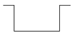
 | 1 |  |  |  |  |  | 
 | 2
 | 3
 | 4
 | 5
 | 6
 | 7

(5)

Final output of algorithm: ...............................................................................
(1)

(e) A programmer is going to implement the algorithm above in a programming language that does not provide built-in support for a stack data structure.
The programmer intends to simulate a stack by using a fixed length array of 20 integers named StackArray with indices running from 1 to 20 and an integer variable TopOfStackPointer which will be initialised to 0.
Write a pseudo-code algorithm for the Push operation to push a value stored in the variable ANumber onto the stack.
Your algorithm should cope appropriately with any potential errors that might occur.
........................................................................................................................
........................................................................................................................
........................................................................................................................
........................................................................................................................
........................................................................................................................
........................................................................................................................
........................................................................................................................
........................................................................................................................
(4)
(Total 13 marks)

Q4.
Regular expressions can be used to search for strings. For example, de(f|g)*h+ matches any string that starts with de and is followed by zero or more instances of either f or g followed by one or more instances of h.
Write regular expressions that will match:
(a) any string that starts with a letter a, ends with a letter c and has one or more occurrences of the letter b in the middle of it, ie the expression should match the strings abc, abbc, abbbc and so on.
........................................................................................................................
(1)

(b) any string that starts with either a 0 or a 1, followed by zero or more occurrences of the digit 1 ie the expression should match the strings 0, 1, 01, 11, 011 and so on.
(1)
(Total 2 marks)

Q5.
The diagram below shows some production rules that have been used to define the syntax of valid mathematical expressions in a particular programming language.
<expression> ::= <factor> | <factor> * <factor> | <factor> / <factor>
<factor> ::= <term> | <term> + <term> | <term> - <term>
<term> ::= - <expression> | <number>
<number> ::= <digit> | <digit> <number>
<digit> ::= 0 | 1 | 2 | 3 | 4 | 5 | 6 | 7 | 8 | 9
(a) What notation method has been used in the diagram above?
........................................................................................................................
(1)

(b) Complete the table below by writing Yes or No in the empty column to indicate whether or not the strings are valid examples of the statement types from the diagram above.

 | Statement type | String | Valid (Yes / No)
 | <number> | 129.376
 | <factor> | 23 + 17

(2)

(c) A tree can be used to demonstrate that an <expression> is valid. This is known as a parse tree.
Complete the parse tree below to show that 8 * 4 + 21 is a valid <expression>.
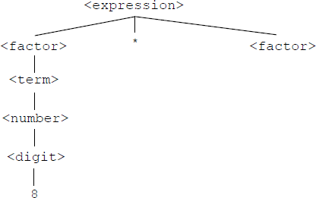

(3)
(Total 6 marks)

Q6.
In a particular programming language, the correct syntax for four different constructs is defined by the syntax diagrams in Figure 1.
Figure 1

procedure-def:
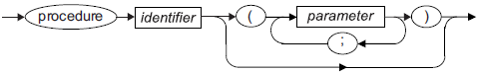
parameter:
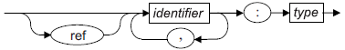
identifier:
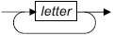
type:
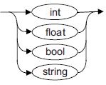
A letter is any alphabetic character from "a" to "z" or "A" to "Z".

In this language an example of a valid identifier is loopCount and an example of a valid type is int.
(a) For each row in the table below, write Yes or No in the empty column to identify whether or not the Example is a valid example of the listed Construct.

 | Construct | Example | Valid?  (Yes / No)
 | identifier | Player2name
 | parameter | x,y:bool
 | procedure-def | procedure square(s:real)
 | procedure-def | procedure rect(w:int,h:int)

(4)

(b) A student has written Backus-Naur Form (BNF) production rules that are supposed to define the same constructs as the syntax diagrams in Figure 1. Their BNF rules are shown in Figure 2.
Figure 2
<procedure-def> ::= procedure <identifier> ( <paramlist> )
<paramlist> ::= <parameter> | <parameter> ; <paramlist>
<parameter> ::= <identlist> : <type> |
ref <identlist> : <type>
<identlist> ::= <identifier> | <identifier> , <identlist>
<identifier> ::= <letter> | <letter> <identifier>
<type> ::= int | float | bool | char | string
A <letter> is any alphabetic character from "a" to "z" or "A" to "Z".
(i) The BNF production rules in Figure 2 contain two errors. These errors mean that they do not represent the same statement types as the syntax diagrams in Figure 1.
Describe the two errors.
Error 1: ..............................................................................................
...........................................................................................................
Error 2: ..............................................................................................
...........................................................................................................
(2)

(ii) The production rule for a <paramlist> is recursive.
Explain why recursion has been used in this production rule.
...............................................................................................................
...............................................................................................................
...............................................................................................................
...............................................................................................................
(1)
(Total 7 marks)

Q7.
Regular expressions can be used to search for strings.
(a) For each of the following regular expressions, describe the set of strings that they would match.
(i) b*c
...............................................................................................................
...............................................................................................................
(1)

(ii) b?c
...............................................................................................................
...............................................................................................................
(1)

(b) Write a regular expression that matches the letter b, followed by zero or more occurrences of the string cd followed by either a single letter e or the string fg.
........................................................................................................................
........................................................................................................................
(2)
(Total 4 marks)

M1.
(a)
 | Real number | Yes / No
 | 203.412 | Yes
 | –12.87 | No
 | 12.43E–12 | Yes

1 mark per correct Yes / No
A other indicators that clearly mean Yes / No e.g. True/False, Tick / Cross.
3

(b) <digit> ::= 0 | 1 | 2 | 3 | 4 | 5 | 6 | 7 | 8 | 9
<whole-number> ::= <digit> | <digit> <whole-number>
<integer> ::= <whole-number> | + <whole-number> |
- <whole-number>
1 mark for each correct rule
Alternative for integer (1 mark, accept in either order):
<symbol> ::= + | -
<integer> ::= <whole-number> | <symbol> <whole-number>
A <whole-number> defined with recursion other way around, i.e. <whole-number> ::= <digit> | <whole-number> <digit>
A non-terminal names e.g. digit not enclosed in <> signs
A spaces in non-terminal names e.g. whole number
A terminal names enclosed in quotation marks e.g. “0”, ‘0’.
A any sensible symbol for assignment e.g. ←, :=, =, :
A ; as end-of-rule marker;
A any type of slash e.g. / for alternatives but R "or"
A use of EBNF extensions for repetition and optional terms:
<whole-number> ::= <digit> { <digit> }
<integer > ::= [ + | - ] <whole-number> A () for [] but R {}
R rules that have additional options e.g. more than ten digits
DPT addition of chevrons or other symbols such as brackets to terminal symbols/rules unless they make meaning unclear
3
[6]

M2.
(a) (i) One or more a’s followed by (a/one) b;
A answers by example but must be at least ab, aab, aaab and show that the sequence continues.
1

(ii) The strings ab or b // zero or one a’s followed by (a / one) b
1

(iii) A sequence of 0 or more occurrences of ab.
A answers by example but must be at least the empty string, ab, abab, ababab and show that the sequence continues.
1

(b) (i) Clai?re // Clare|Claire
A other valid possibilities e.g. Cla(ir|r)e, Cl(air|ar)e
A use of different types of brackets
1

(ii) 10(0|1)*01
1 mark for the 10 at the start and 01 at the end
1 mark for (0|1)* in the middle to produce a correct expression
A use of different types of brackets
Award 2 marks for any other expression that would work
2
[6]

M3.
(a)
 | Reverse Polish Notation | Equivalent Infix Expression
 | 45 6 + | 45 + 6  R 6 + 45
 | 12 19 + 8 * | (12 + 19) * 8  R 12+19*8, (19+12)*8  A x for *

2

(b) Simpler for a machine / computer to evaluate // simpler to code algorithm
A easier R to understand
Do not need brackets (to show correct order of evaluation/calculation);
Operators appear in the order required for computation;
No need for order of precedence of operators;
No need to backtrack when evaluating;
A RPN expressions cannot be ambiguous as BOD
1

(c)
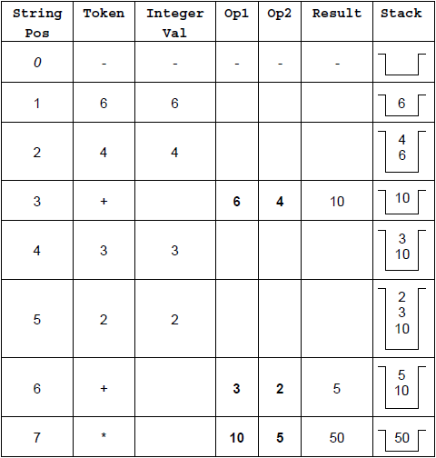

Output : 50
1 mark for each of rows 1–3
1 mark for rows 4 and 5 together
1 mark for rows 6 and 7 together
1 mark for correct final output
Values of Op1 and Op2 MUST be assigned in rows 3, 6 and 7 to award the marks for these rows. They cannot be inferred from incorrectly entered previous values.
I values in empty cells, even if they are incorrect.
6

(d) If StackArray is full
Then Stack Full Error
Else
Increment TopOfStackPointer
StackArray [TopOfStackPointer]
ANumber
EndIf
1 mark for appropriate If structure including condition (does not need both Then and Else) – Do not award this mark if ANumber is put into StackArray outside the If.
1 mark for reporting error in correct place
1 mark* for incrementing TopOfStackPointer
1 mark* for storing value in ANumber into correct position in array
* = if the store instruction is given before the increment instruction OR
the If structure then award Max 1 of these two marks UNLESS the item is inserted at position TopOfStackPointer+1 so the code would work.
I initialisation of TopOfStackPointer to 0
A TopOfStackPointer=20/>=20 for Stack is full
A Logic of if structure reversed i.e. If stack is not full / TopOfStackPointer<20 / <>20/!=20 and Then, Else swapped
A Any type of brackets or reasonable notation for the array index
DPT If candidate has used a different name any variable then do not award first mark but award subsequent marks as if correct name used.
Refer answers where candidate has used a loop to find position to insert item into stack to team leaders.
4
[13]

M4.
(a) ab ⁺ c // abb * c // ab * bc;
I ^ at start, $ at end of expression
1

(b) (0|1)1* // (1|0)1* // [01]1*// [10]1* // [0|1]1* // [1|0]1* // 0 | (0?1⁺)
I ^ at start, $ at end of expression
1
[2]

M5.
(a) Backus-Naur (Form);
A Backus Normal (Form), BNF, Extended Backus-Naur (Form), Augmented
Backus-Naur (Form), ABNF
A Misspellings of Backus-Naur
A Format for Form and the word “Notation”
R BN
1

(b)
 | Statement Type | String | Valid (Yes / No)
 | <number> | 129.376 | No;
 | <factor> | 23 + 17 | Yes;

A Alternative clear indicators of Yes or No e.g. Y / N, Tick / Cross, Valid / Invalid, True / False
2

(c)
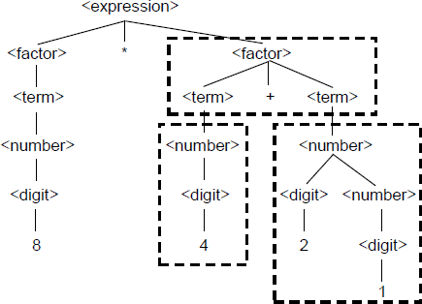
1 mark for each area surrounded by a rectangle
A missing chevrons
DPT Arrows drawn instead of lines
3
[6]

M6.
(a) One mark per correct response.

 | Construct | Example | Valid?
 | identifier | Player2name | No;
 | parameter | x, y:bool | Yes;
 | procedure-def | procedure  square(s:real) | No;
 | procedure-def | procedure  rect(w:int,h:int) | No;

A alternative clear indicators of Yes / No such as Y / N, True / False and Tick / Cross.
4

(b) (i) The <type> rule has an extra type char;
The <procedure-def> rule does not allow a procedure without parameters // cannot be just an identifier;
A answers comparing the figures the other way around, i.e.
• The type rule does not allow a char
• The procedure does not have to have parameters / can be just an identifier
2

(ii) Required as there can be a list of parameters // required as there can be more than one parameter;
BNF does not support iteration // BNF can only achieve iteration through recursion // would need infinite number of rules otherwise // recursion allows for more than one parameter;
Max 1
A Input for parameter
NE Rule needs to loop
1
[7]

M7.
(a) (i) Zero or more bs followed by a / one c;
A answers by example but must be at least c, bc, bbc and indicate the sequence continues.
1

(ii) Zero or one bs followed by (a / one) c / / the strings c or bc;
1

(b) Correct expression: b(cd)*(e|fg)
A use of incorrect bracket types
A accept brackets around fg
A (cd)⁺? for (cd)*
I ^ at start, $ at end of expression
2 marks for the full correct expression.
1 mark for including either (cd)* or (e|fg) in an incorrect expression.
2
[4]

E1.
Part (a): The vast majority of candidates scored full marks for this question part, correctly identifying whether or not the numbers were syntactically valid.

Part (b): There were some good responses to this question part, although some candidates clearly found it quite difficult. This is the first question that has been asked on this topic so, on this occasion, we were lenient when faced with minor syntactical errors. A small number of candidates confused Backus-Naur Form with regular expressions.

E2.
For question parts (a)(i) to (a)(iii) answers by example were accepted so long as they included a sufficient number of examples to show the pattern clearly and (when appropriate) there was some indication that the pattern continued beyond the examples listed.

Part (a)(i): This regular expression would match strings consisting of one or more “a” characters followed by a single “b”. In responses to this type of question, candidates should ensure that their answers make the order of characters explicit. “Strings containing one or more as and a b,” does not make clear that the “a” characters must be before the “b”.

Part (a)(ii): This regular expression would match the strings “ab” and “b”. Some candidates mistook the ? symbol to be a wildcard that would match any single character between an “a” and a “b”.

Part (a)(iii): This regular expression would match a sequence of zero or more occurrences of “ab”. The response, “any number of as and bs,” was not sufficient to be awarded a mark as it did not make clear that the “a” and “b” characters must come in pairs. Candidates who answered by example also have to make clear that the empty string would be accepted.

Part (b)(i): This was the best answered part of question, with most candidates correctly writing a regular expression that would work.

Part (b)(ii): Most candidates achieved one mark for this question part – for the correct start and end of the string. Writing a correct expression for the middle part of the string was more difficult. The correct regular expression was 10(0 | 1)*01. Candidates who wrote an expression that would match the same set of strings, such as 10(0?1?)*01 or 10(0 | 1 | 01 | 10)*01 also gained full credit.

E3.
Part (a): This question part was very well answered with the majority of candidates getting both marks. The only common mistake was to miss out the brackets in the expression that should be (12+19)*8.

Part (b): As with part (a), this question part was also well answered. The most common correct response was that brackets are not required. It would have been nice to see some more detailed explanations of this point, rather than just a brief statement of it. A common incorrect answer was that RPN was easier for a computer to understand. The word “understand” is not appropriate in this context.

Part (c): Responses to this question part were excellent, with relatively few errors made. The majority of candidates got full marks which is unusual for a question involving a trace table. The only two recurring mistakes were to pop the numbers off the stack in the wrong order, resulting in the transposition of the values in Op1 and Op2 and forgetting to push 50 back onto the stack at the very end.

Part (d): This question was well answered, with most candidates getting some marks and a significant number more than half marks. The most common mistake was to increment the TopOfStackPointer in the wrong place – either before the If construct which tested for the stack full condition or after the value in ANumber was stored into the StackArray. Some candidates implemented solutions that used a loop to find the first empty position in the array to insert the number into. These were awarded credit if they would have worked, but many failed to test properly for the stack being full. It is important that candidates use the correct variable names when they are given on the question paper.

E4.
Both question parts were well attempted, with approximately four-fifths of students getting the mark for part (a) and two thirds for part (b). Almost all students knew how a regular expression should be formed. The most common mistake was to confuse the use of the * and + operators.

E5.
Part (a): Approximately three quarters of students correctly recognised that Backus-Naur Form had been used. There was a considerable variation in the spelling of the term but, as long as the meaning was clear, spelling mistakes were not penalised in this question part.

Part (b): The vast majority of students correctly identified which of the two statements was valid.

Part (c): This question part introduced the idea of using a parse tree to demonstrate that an expression was valid. How the parse tree was built was explained in the question and the tree was partially completed to further aid students. Most students made a reasonable attempt at completing the rest of the tree, with nearly half achieving at least two of the three available marks. The most commonly made error was to treat “21” a single digit instead of decomposing it into two digits.

E6.
Candidates demonstrated a pleasing understanding of the use of syntax diagrams and Backus Naur Form to specify language syntax.
For (a), the overwhelming majority of candidates scored at least three of the four available marks. Candidates had most trouble identifying that the third example procedure square (s:real) was not valid, perhaps because they just assumed that real was a valid type rather than checking it against the diagrams.

For (b)(i), the majority of candidates recognised that the BNF definitions incorrectly included a new “char“ data type and almost half also identified that the BNF definitions did not allow for a procedure to have no parameters.

Part (b)(ii) was well answered with most candidates achieving a mark for recognising that there could be any number of parameters. Pleasingly, some also went on to explain that recursion had to be used because BNF does not support iteration. The most commonly seen incorrect response was to simply define what recursion was instead of addressing the specific question.

E7.
Overall, students demonstrated a good understanding of the use of regular expressions.
(a) For this part, students needed to explain that the expression would accept any string that consisted of zero or more b characters followed by a c. Common mistakes were to confuse the + and * operators and therefore to state that one or more b characters would be required, and to apply the * operator to the c to its right rather than the b to its left. Some students wrote “any number of b characters” which was not enough for a mark. It had to be made clear that zero or more characters were required to achieve the mark.
(b) For this part, students needed to explain that the expression would accept any string that consisted of zero or one b characters followed by a c. Many candidates simply listed the two strings that would be accepted, which were bc and b, which was an acceptable alternative response. Some candidates confused the meaning of the ? operator with either the + or the | operators.

