Riverside Community Garden
Annual report for the members' meeting, October 2026

A good year
This year the garden grew more than ever before. Forty-two members looked after eighteen raised beds, a herb spiral and a small orchard. The pumpkin patch was the surprise of the season. Please read the notes on watering before next spring.
More about the garden on riverside-garden.example.

What we grew
- Tomatoes, in six varieties
- Beans and peas
- Squash and pumpkins
- Herbs
- Basil, parsley and mint

Plans for next year
- Build a second greenhouse
- Start a seed library
- Open the garden on two Sundays a month
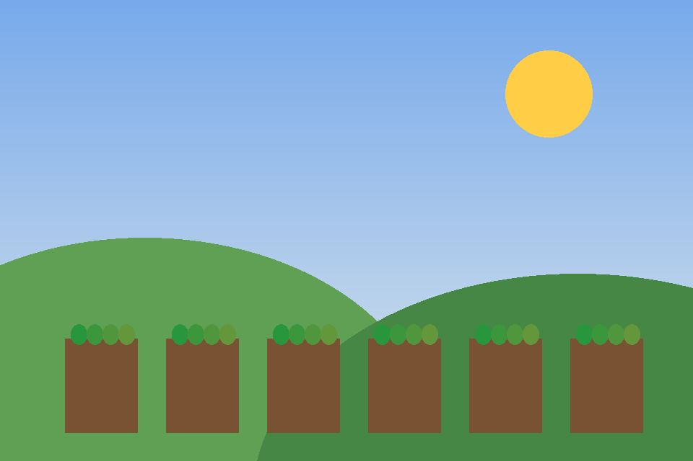
The beds in June, drawn by a member.

Harvest
Crop | Beds | Harvest (kg) | Notes
Tomatoes | 4 | 212 | Best year so far
Beans | 3 | 64 | Second sowing after the frost
Peas | 2 | 38
Squash | 2 | 150 | Shared with the food bank
Pumpkins | 2 | 190 | One weighed 21 kg
Potatoes | 3 | 240
Onions | 1 | 45 | Kept well into winter
Carrots | 1 | 30 | Some lost to slugs
Lettuce | 1 | 28 | Sown every three weeks
Herbs | 1 | 12 | Dried for the winter market
Strawberries | 1 | 22 | Mostly eaten on the spot
Apples | 0 | 85 | From the four young trees

Volunteers
Volunteers met every Saturday morning from March to October. The new rain barrels collected enough water for most of the summer. Children from the school next door planted a row of sunflowers by the gate. We shared seeds with two other gardens in the district.
The new rain barrels collected enough water for most of the summer. Children from the school next door planted a row of sunflowers by the gate. We shared seeds with two other gardens in the district. The compost bays were rebuilt with wood from an old fence.
Children from the school next door planted a row of sunflowers by the gate. We shared seeds with two other gardens in the district. The compost bays were rebuilt with wood from an old fence. Most weeks, someone brought tea and the radio for the long afternoons.
We shared seeds with two other gardens in the district. The compost bays were rebuilt with wood from an old fence. Most weeks, someone brought tea and the radio for the long afternoons. A late frost in April cost us the first beans, but the second sowing did well.
The compost bays were rebuilt with wood from an old fence. Most weeks, someone brought tea and the radio for the long afternoons. A late frost in April cost us the first beans, but the second sowing did well. Volunteers met every Saturday morning from March to October.
Most weeks, someone brought tea and the radio for the long afternoons. A late frost in April cost us the first beans, but the second sowing did well. Volunteers met every Saturday morning from March to October. The new rain barrels collected enough water for most of the summer.
A late frost in April cost us the first beans, but the second sowing did well. Volunteers met every Saturday morning from March to October. The new rain barrels collected enough water for most of the summer. Children from the school next door planted a row of sunflowers by the gate.
Volunteers met every Saturday morning from March to October. The new rain barrels collected enough water for most of the summer. Children from the school next door planted a row of sunflowers by the gate. We shared seeds with two other gardens in the district.
The new rain barrels collected enough water for most of the summer. Children from the school next door planted a row of sunflowers by the gate. We shared seeds with two other gardens in the district. The compost bays were rebuilt with wood from an old fence.
Children from the school next door planted a row of sunflowers by the gate. We shared seeds with two other gardens in the district. The compost bays were rebuilt with wood from an old fence. Most weeks, someone brought tea and the radio for the long afternoons.
We shared seeds with two other gardens in the district. The compost bays were rebuilt with wood from an old fence. Most weeks, someone brought tea and the radio for the long afternoons. A late frost in April cost us the first beans, but the second sowing did well.
The compost bays were rebuilt with wood from an old fence. Most weeks, someone brought tea and the radio for the long afternoons. A late frost in April cost us the first beans, but the second sowing did well. Volunteers met every Saturday morning from March to October.
Most weeks, someone brought tea and the radio for the long afternoons. A late frost in April cost us the first beans, but the second sowing did well. Volunteers met every Saturday morning from March to October. The new rain barrels collected enough water for most of the summer.
A late frost in April cost us the first beans, but the second sowing did well. Volunteers met every Saturday morning from March to October. The new rain barrels collected enough water for most of the summer. Children from the school next door planted a row of sunflowers by the gate.

हिन्दी में सार
इस साल हमारे बगीचे में बहुत सारी सब्ज़ियाँ उगीं। सभी स्वयंसेवकों का धन्यवाद।

Watering rota
Week | Mon | Tue | Wed | Thu | Fri | Sat | Sun
Week 1 | Ben | Chloe | Dev | Elena | Femi | Gita | Asha
Week 2 | Chloe | Dev | Elena | Femi | Gita | Asha | Ben
Week 3 | Dev | Elena | Femi | Gita | Asha | Ben | Chloe
Week 4 | Elena | Femi | Gita | Asha | Ben | Chloe | Dev
Week 5 | Femi | Gita | Asha | Ben | Chloe | Dev | Elena
Week 6 | Gita | Asha | Ben | Chloe | Dev | Elena | Femi

