Name | TypeData | Not Null | PK | FK | DEFAULT | COMMENT
LogID | int |  | YES
UserID | int |  | NO
Action | varchar |  | NO
Details | text |  | NO
IPAddress | varchar |  | NO
Timestamp | timestamp |  | NO
activity_log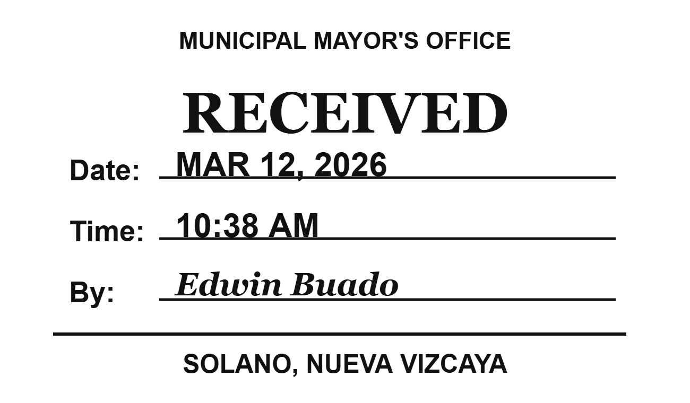

admin_profile
Name | TypeData | Not Null | PK | FK | DEFAULT | COMMENT
AdminID | int |  | YES
FullName | varchar |  | NO
ContactNumber | varchar |  | NO
ProfilePic | varchar |  | NO
qr_code_image | longblob |  | NO

amenities
Name | TypeData | Not Null | PK | FK | DEFAULT | COMMENT
AmenityID | int |  | YES
Name | varchar |  | NO
Icon | varchar |  | NO

beds
Name | TypeData | Not Null | PK | FK | DEFAULT | COMMENT
BedID | int |  | YES
RoomID | int |  | NO
BedLabel | varchar |  | NO
IsAvailable | tinyint |  | NO
BedImage | varchar |  | NO
Price | decimal |  | NO

favorites
Name | TypeData | Not Null | PK | FK | DEFAULT | COMMENT
FavoriteID | int |  | YES
UserID | int |  | NO
PropertyID | int |  | NO
CreatedAt | timestamp |  | NO

notifications
Name | TypeData | Not Null | PK | FK | DEFAULT | COMMENT
NotificationID | int |  | YES
UserID | int |  | NO
Title | varchar |  | NO
Message | text |  | NO
IsRead | tinyint |  | NO
CreatedAt | timestamp |  | NO
Link | varchar |  | NO

owners_profile
Name | TypeData | Not Null | PK | FK | DEFAULT | COMMENT
OwnerID | int |  | YES
FullName | varchar |  | NO
ContactNumber | varchar |  | NO
ProfilePic | varchar |  | NO
fblink | varchar |  | NO

password_resets
Name | TypeData | Not Null | PK | FK | DEFAULT | COMMENT
id | int |  | YES
user_id | int |  | NO
token | varchar |  | NO
expiry | datetime |  | NO
used | tinyint |  | NO
created_at | timestamp |  | NO

properties
Name | TypeData | Not Null | PK | FK | DEFAULT | COMMENT
PropertyID | int |  | YES
OwnerID | int |  | NO
Name | varchar |  | NO
Address | text |  | NO
Description | text |  | NO
PropertyType | enum |  | NO
IsAvailable | tinyint |  | NO
PropertySubtype | varchar |  | NO
ContractDuration | enum |  | NO
PriceRange | varchar |  | NO
LocationLink | text |  | NO
IsVerified | tinyint |  | NO
DateListed | timestamp |  | NO
image_url | varchar |  | NO
gallery | text |  | NO
ProofOfPayment | varchar |  | NO
PermitFiles | longtext |  | NO

