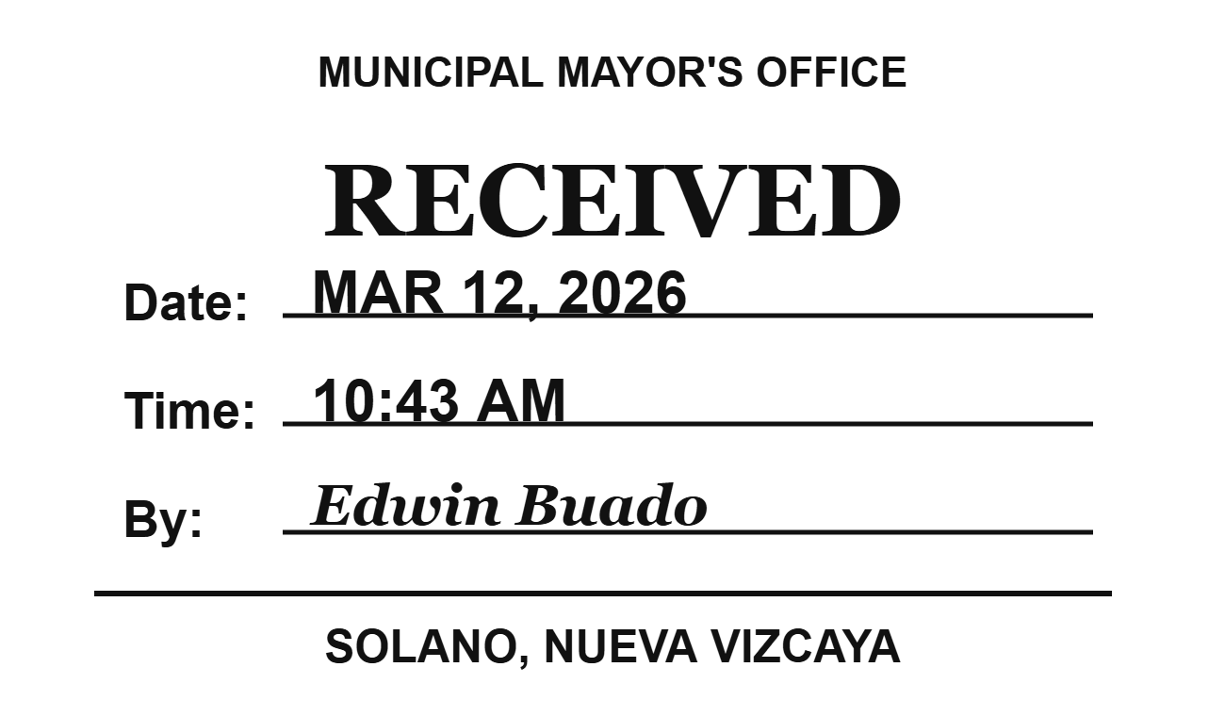
DOCUMENT MANAGEMENT SYSTEM(DMS)
1. SYSTEM OVERVIEW
- The proposed Document Management System (DMS) is a secure, web-based platform developed exclusively for LGU Solano to digitally manage incoming and outgoing documents across municipal offices.
- Since some LGU offices are located far from the main municipal building, the system will be deployed through secure online hosting rather than localhost. This ensures controlled remote access for authorized personnel while maintaining centralized monitoring and management.
2. PURPOSE AND OBJECTIVES
The system aims:
- Digitalize the document receiving and routing process.
- Improve the efficiency and inter-office coordination
- Ensure transparency and accountability
- Implement structured approval workflows
- Provide real-time document tracking
- Maintain a complete audit trail of all actions
3. ROLE-BASED ACCESS CONTROL
The system uses Role-based access control, ensuring that each user can only access features appropriate to their role
User roles include:
- Front desk Officer
- Admin
- Secretary (Super admin/Mayor’s Office)
- Department Head (Each Department)
- Mayor or Authorized Representative (or his secretary)
Each role has designated permissions and system visibility
4. DOCUMENT RECEIVING PROCESS (Front desk)
- The Front desk officer verifies the document format before acceptance.
- Once validated, a digital ‘RECEIVED’ stamp can be dragged and placed anywhere on the document, depending on the document layout.
- the officer manually inputs the Date and Time, “Received By: name
- Upon official receiving:
- The system generates a unique Control Number(Included on the Received Stamp)
- The official receiving timestamp is recorded.
- The document enters the active workflow.
The document is considered officially recorded only after validation and receiving confirmation to ensure legal traceability.
5. DOCUMENT WORKFLOW PROCESS
Step 1 – Admin Review
- Admin manually assigns required department/s based on document content. (Department Heads will notify).
- Documents that are invalid or unnecessary is archived.
Step 2 - Department Review
Department Heads may:
- Approved (using E-Signature)
- Reject (with required remarks such as “Returned for Revision”)
If rejected:
- The document returns to admin for compliance or follow-up
- Once corrected, it re-enters Department Review.
Step 3 – Mayor Review (Mandatory Stage)
All documents undergo review by the Mayor or authorized representative.
The Mayor may:
- Sign “E-Signature” (Final Approval)
- Mark as “For Information” (Cased Closed – Completed)
- Assign “For Comment” to a specific department head that needed his/her comment.
- Assign “For Attendance” to a specific department head that needed to attend.
If marked “For Infro”, the cased is automatically closed and marked as Completed.
6. WORFLOW FLEXIBILITY
The system supports:
- Single-step approval (Mayor only)
- Multi-level sequential approvals
- Conditional routing based on document needs
Routing decisions are manually assigned by authorized personnel and to ensure accuracy and compliance with alignment with LGU internal processes.
7. SECURITY AND HOSTING
Since the system is exclusive for LGU Solano, security is a top priority
Hosting
- Deployed on secure online hosting (not localhost)
- Enables remote access for authorized offices
- Accessible only via secured login credentials
Security Features
- Role-based access control
- Secure authentication system
- Encrypted password
- Full audit trail logging (who, when, action taken)
- Document action history tracking
- Controlled E-signature access
- Restricted user registration (Admin-created accounts only)
Only authorized LGU personnel can access the system.
8. Tracking and Transparency
The system provides real-time tracking including:
- Current department handling the document
- Date and time of arrival per office
- Approval or rejection status
- Action history log
- Control number reference
This ensures accountability and transparency across LGU.

