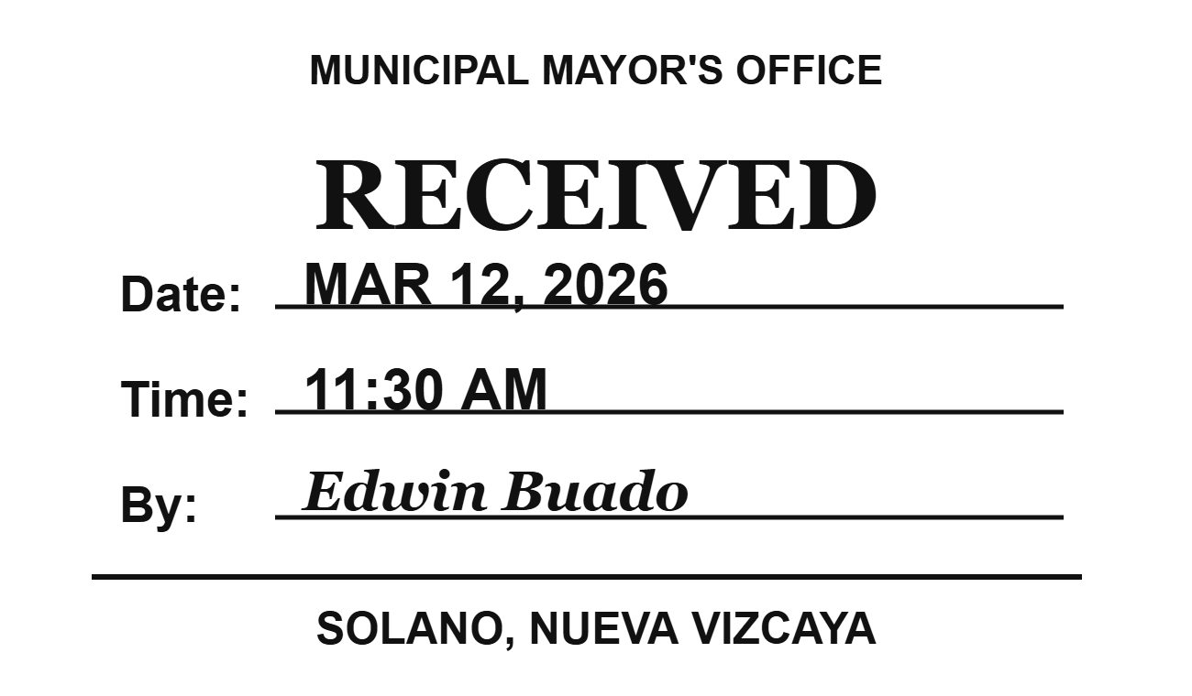
Faffwff wfas sad gfawdwd

