Nama : Nathalia Minoque

NIM : 0706022010020

**GitHub**

Backend: <https://github.com/NathaliaMinoque/certification_backend>

App: <https://github.com/NathaliaMinoque/certification_app>

File testing ada di github app

**ERD**

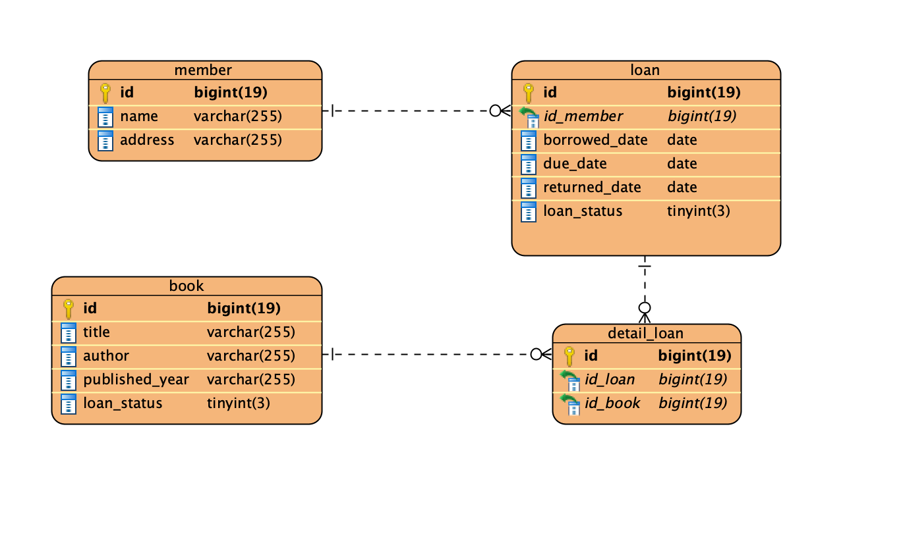

**Class Diagram**

