Chenchen He
December 2nd 2013
Project Title: Coffee Shop Vender System

- Project Significance:
This software is used by coffee shops like Starbucks, Best Seattle, the Cups and so on. It also could be used in snack bars and even fast food restaurant (we modified the prices and updated the menu according to the customer’s need)

- Goal of this project
- learning and practicing in HTML web design language
including JavaScript and CSS3
- learning and practicing in PHP programming language (including combine PHP with mySQL to manipulating with data)
- using mySQL --- create database, create tables, create attributes and insert values. Deleting and updates data in tables.
Connecting the specific database and query in specific table

- implementation
- Creating an database coffeeshop by in compile prompt and creating a table called staff ,insert value into staff ( name, title and password)
- Creating interface (homepage) for coffee shop staff or manager to login ( Using HTML language).
- Connecting homepage to next page by method= ‘post’ and action = ‘ XXX.php’.
- Using query statement in php file to find out whether the UserID and password that people entered are matching.
- If matching, goes to menu page.
- Choose beverage, the page can functioning as do add or minus operation. And to show the finally price.
- Click to pay
- It goes to check out and it will ask you to pay by cash or credit card
- Choose the payment method and then click

- Reference:
- <<Internet & World Wide Web How to Program>> 5th edition
- http://www.w3schools.com/
- Handout from CSC 450 Software Engineer

- Conclusion:
This is a term-project that I spent approximately 4 months to accomplish. During the process, I did research online and practice a lot on PHP, HTML and javascript. I have learned several functions and methods in those languages. For example, image link, POST method, creating and designing tables(HTML), implementing submit button(format), creating database, table and attributes(mySQL), connecting database with PHP, login in with authentication etc. Sometimes there are several ways to implement the same function; I have to distinguish the most efficient one or simplest one.
In a word, I become more familiar with common function in PHP and HTML language by doing this project. It contributes to me with on hand working experiences of front-end design and programming.

Screen Shot:
Database table staff 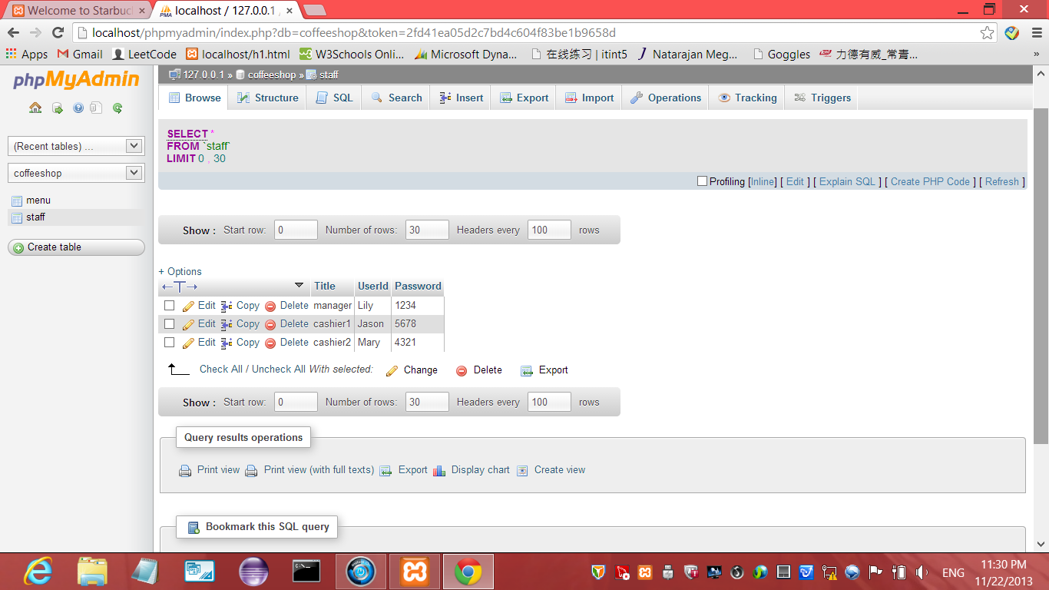

- starbucks homepage

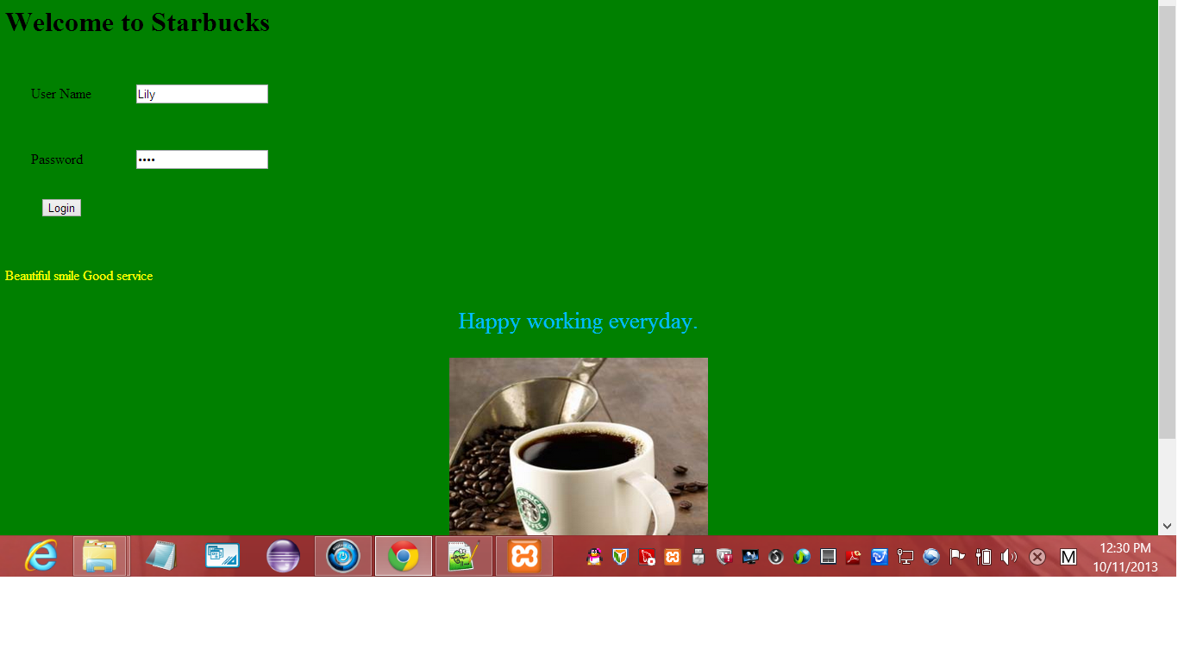

- log in the system successfully

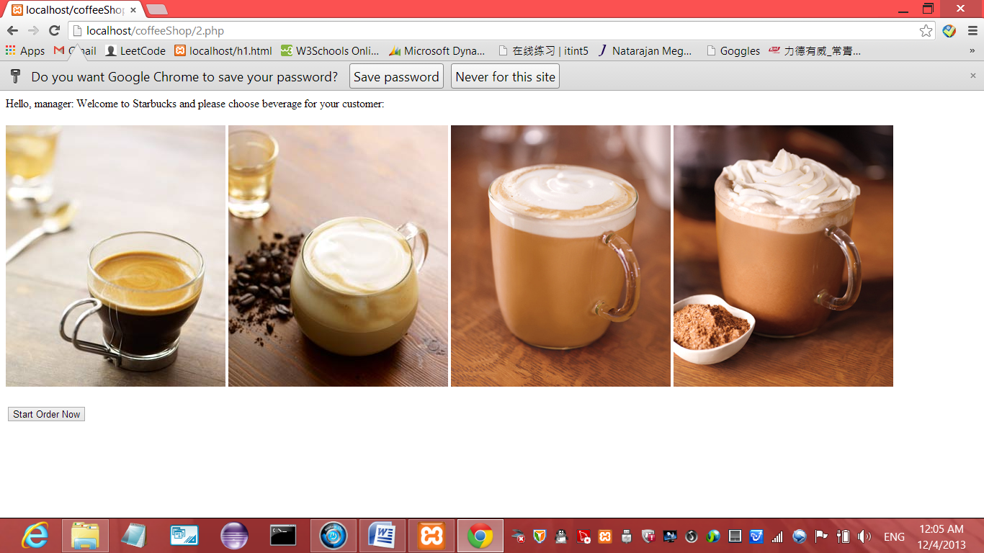

- Login unsuccessfully:
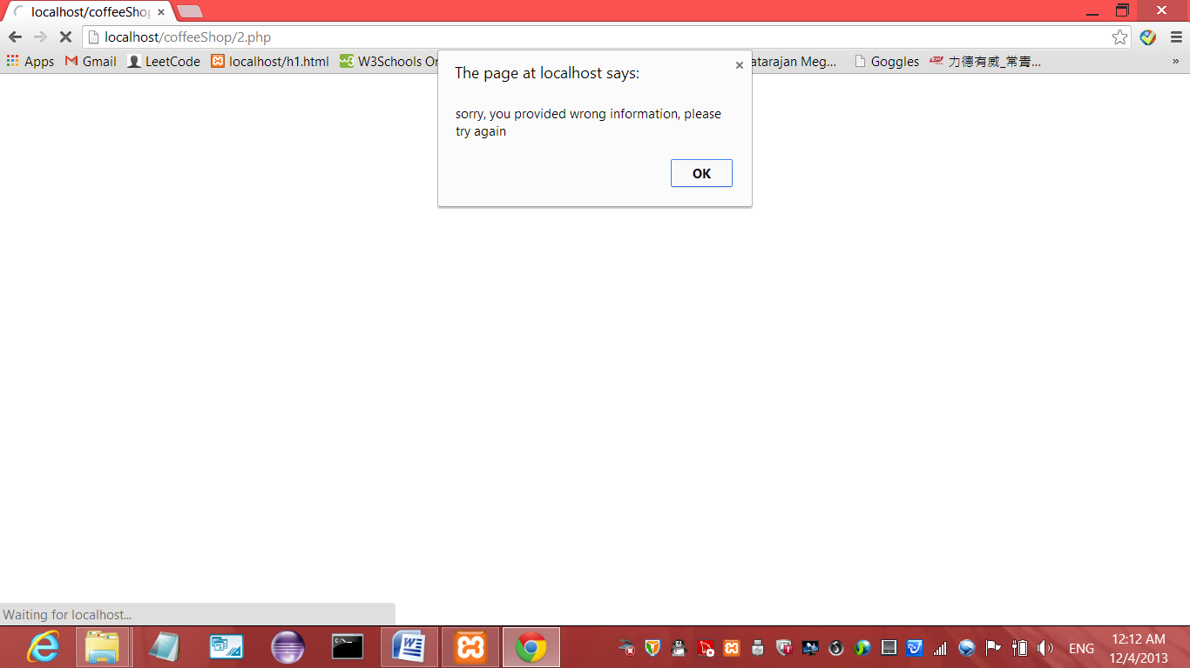

- selecting the beverage:

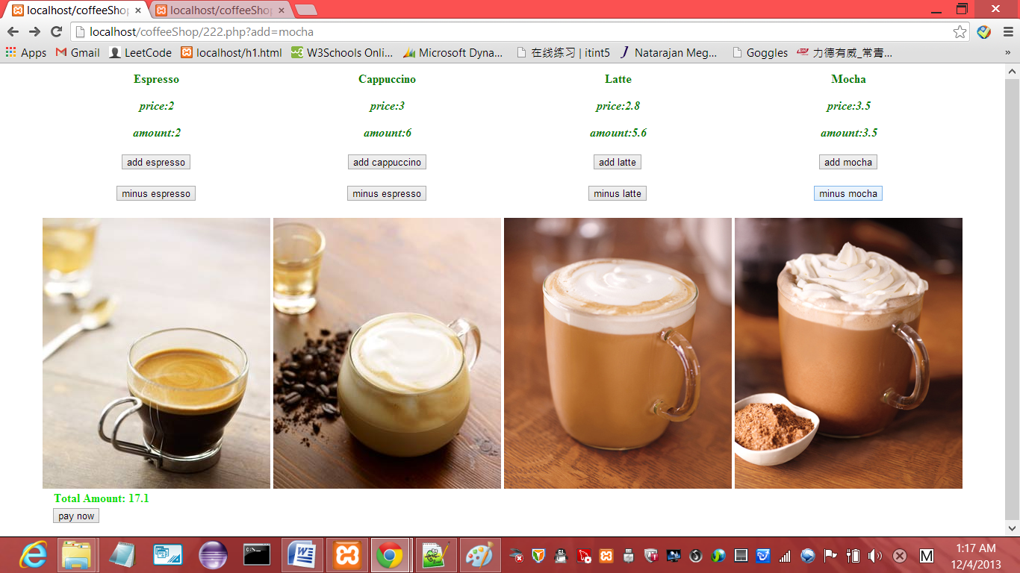

- payment page
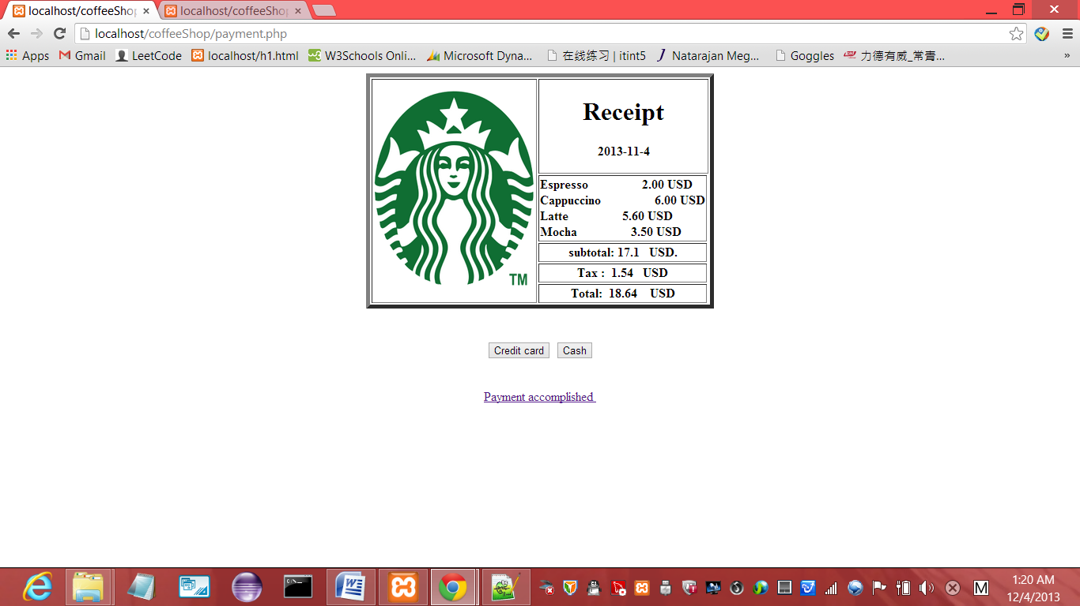

- Thankyou page:
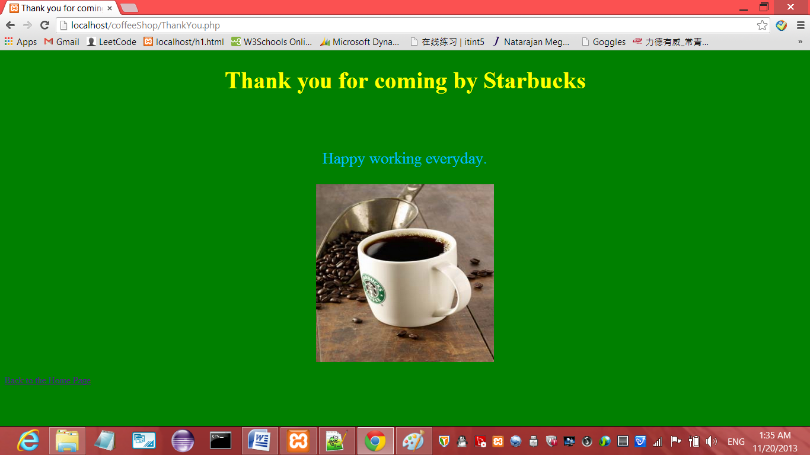

Coding:

1.Starbucks.html

<!DOCTYPE html>
<html>
<head>
<meta http-equiv="Content-Type" content="text/html; charset=ISO-8859-1">
<title>Welcome to Starbucks</title>
</head>
<body bgcolor="green">
<h1> Welcome to Starbucks </h1>
<form method="post" action="2.php">
<table cellspacing="10" cellpadding="20">
<tr>
<td>User Name</td>
<td><input type="text" name="username" /></td>
</tr>
<tr>
<td>Password</td>
<td><input type="password" name="password" /></td>
</tr>
</table>
<span style="margin-left:40px"></span><input type="submit" name="Request" value="Login" />
</form>
<br></br>
<p style="color:yellow;">Beautiful smile Good service</p>
<p style="font-size: 20pt; color: deepskyblue;text-align:center"> Happy working everyday.
</p>
<p>
<div style="text-align:center;"><img src="starbucks.jpg" width="300" height="300">
</p>
</div>
</body>
</html>

2 . 2.php (login page)
<html>
<head>
</head>
<body>
<?php
$host = "localhost";
$user = "root";
$pass = "";
$dbname = "coffeeshop";
$var_user = $_POST['username'];
$var_pw = $_POST['password'];
$connection = mysql_connect($host,$user,$pass);
if(!$connection) echo "Could not open connection to host!";
$db = mysql_select_db($dbname,$connection);
if(!$db) echo "Database selection failed!";
$query = null;
$result = null;
$query = "select * from Staff m where ((m.UserId = '$var_user')&&(m.Password = '$var_pw'))";
$result = mysql_query($query);
$num = mysql_numrows($result);

if($num<1) {

echo "<script>alert('sorry, you provided wrong information, please try again'); history.go(-1);</script>";

}

else {
mysql_close();

$i=0;
echo "<table cellpadding=\"0\" cellspacing=\"10\">";
while($i < $num) {
$Title = mysql_result($result,$i, "Title");

echo "<tr>Hello, $Title: Welcome to Starbucks and please choose beverage for your customer: </tr>";$i++;}

echo "</table>";
if($num = 0) echo "No results.";
}

?>

<tr>
<td>
<img src="espresso.jpg" />
</td>
<td>
<img src="cappuccino.jpg" />
</td>
<td>
<img src="latte.jpg" />
</td>
<td>
<img src="mocha.jpg" />
</td>
</tr>
</table>

<br><br>
<a href="222.php"><input type="button" value="Start Order Now"></a>

</body>
</html>

3 222.php
<html>
<head>
</head>
<body>

<?php
$espressoAmount=0;
$cappuccinoAmount=0;
$latteAmount=0;
$mochaAmount=0;

if(isset($_POST["espressoAmount"])){
$espressoAmount=$_POST["espressoAmount"];
}
if(isset($_POST["cappuccinoAmount"])){
$cappuccinoAmount=$_POST["cappuccinoAmount"];
}
if(isset($_POST["latteAmount"])){
$latteAmount=$_POST["latteAmount"];
}

if(isset($_POST["mochaAmount"])){
$mochaAmount=$_POST["mochaAmount"];
}

$espressoPrice=2;
$cappuccinoPrice=3;
$lattePrice=2.8;
$mochaPrice=3.5;

if(isset($_GET["add"])){
$add=$_GET["add"];
if($add=="espresso"){
$espressoAmount=$espressoAmount+$espressoPrice;
}
if($add=="cappuccino"){
$cappuccinoAmount=$cappuccinoAmount+$cappuccinoPrice;
}
if($add=="latte"){
$latteAmount=$latteAmount+$lattePrice;
}

if($add=="mocha"){
$mochaAmount=$mochaAmount+$mochaPrice;
}
}
if(isset($_GET["minus"])){
$minus=$_GET["minus"];
if($minus=="espresso"){
$espressoAmount=$espressoAmount-$espressoPrice;
}
if($minus=="cappuccino"){
$cappuccinoAmount=$cappuccinoAmount-$cappuccinoPrice;
}
if($minus=="latte"){
$latteAmount=$latteAmount-$lattePrice;
}

if($minus=="mocha"){
$mochaAmount=$mochaAmount-$mochaPrice;
}

}

$totalAmount=$espressoAmount+$cappuccinoAmount+$latteAmount+$mochaAmount;
?>

<table border="0" align="center" style="color:green; font-size:12pt">

<tr>
<th><b>Espresso</b>
<p><i>price:<?php echo $espressoPrice; ?></i></p>
<p><i>amount:<?php echo $espressoAmount; ?></i></p>
<form action="222.php?add=espresso" method="post">
<input type="submit" value="add espresso" />
<input type="hidden" name="espressoAmount" value="<?php echo $espressoAmount; ?>"/>
<input type="hidden" name="cappuccinoAmount" value="<?php echo $cappuccinoAmount; ?>"/>
<input type="hidden" name="latteAmount" value="<?php echo $latteAmount; ?>"/>
<input type="hidden" name="mochaAmount" value="<?php echo $mochaAmount; ?>"/>
</form>

<form action="222.php?minus=espresso" method="post">
<input type="submit" value="minus espresso" />
<input type="hidden" name="espressoAmount" value="<?php echo $espressoAmount; ?>"/>
<input type="hidden" name="cappuccinoAmount" value="<?php echo $cappuccinoAmount; ?>"/>
<input type="hidden" name="latteAmount" value="<?php echo $latteAmount; ?>"/>
<input type="hidden" name="mochaAmount" value="<?php echo $mochaAmount; ?>"/>
</form>

</th>

<th><b>Cappuccino</b>
<p><i>price:<?php echo $cappuccinoPrice; ?></i></p>
<p><i>amount:<?php echo $cappuccinoAmount; ?></i></p>
<form action="222.php?add=cappuccino" method="post">
<input type="submit" value="add cappuccino">

<input type="hidden" name="espressoAmount" value="<?php echo $espressoAmount; ?>"/>
<input type="hidden" name="cappuccinoAmount" value="<?php echo $cappuccinoAmount; ?>"/>
<input type="hidden" name="latteAmount" value="<?php echo $latteAmount; ?>"/>
<input type="hidden" name="mochaAmount" value="<?php echo $mochaAmount; ?>"/>
</form>

<form action="222.php?minus=cappuccino" method="post">
<input type="submit" value="minus espresso" />
<input type="hidden" name="espressoAmount" value="<?php echo $espressoAmount; ?>"/>
<input type="hidden" name="cappuccinoAmount" value="<?php echo $cappuccinoAmount; ?>"/>
<input type="hidden" name="latteAmount" value="<?php echo $latteAmount; ?>"/>
<input type="hidden" name="mochaAmount" value="<?php echo $mochaAmount; ?>"/>
</form></th>

<th><b>Latte</b>
<p><i>price:<?php echo $lattePrice; ?></i></p>
<p><i>amount:<?php echo $latteAmount; ?></i></p>
<form action="222.php?add=latte" method="post">
<input type="submit" value="add latte">

<input type="hidden" name="espressoAmount" value="<?php echo $espressoAmount; ?>"/>
<input type="hidden" name="cappuccinoAmount" value="<?php echo $cappuccinoAmount; ?>"/>
<input type="hidden" name="latteAmount" value="<?php echo $latteAmount; ?>"/>
<input type="hidden" name="mochaAmount" value="<?php echo $mochaAmount; ?>"/>
</form>

<form action="222.php?minus=latte" method="post">
<input type="submit" value="minus latte" />
<input type="hidden" name="espressoAmount" value="<?php echo $espressoAmount; ?>"/>
<input type="hidden" name="cappuccinoAmount" value="<?php echo $cappuccinoAmount; ?>"/>
<input type="hidden" name="latteAmount" value="<?php echo $latteAmount; ?>"/>
<input type="hidden" name="mochaAmount" value="<?php echo $mochaAmount; ?>"/>
</form></th>

<th><b>Mocha</b>
<p><i>price:<?php echo $mochaPrice; ?></i></p>
<p><i>amount:<?php echo $mochaAmount; ?></i></p>
<form action="222.php?add=mocha" method="post">
<input type="submit" value="add mocha">
<input type="hidden" name="espressoAmount" value="<?php echo $espressoAmount; ?>"/>
<input type="hidden" name="cappuccinoAmount" value="<?php echo $cappuccinoAmount; ?>"/>
<input type="hidden" name="latteAmount" value="<?php echo $latteAmount; ?>"/>
<input type="hidden" name="mochaAmount" value="<?php echo $mochaAmount; ?>"/>
</form>

<form action="222.php?minus=mocha" method="post">
<input type="submit" value="minus mocha" />
<input type="hidden" name="espressoAmount" value="<?php echo $espressoAmount; ?>"/>
<input type="hidden" name="cappuccinoAmount" value="<?php echo $cappuccinoAmount; ?>"/>
<input type="hidden" name="latteAmount" value="<?php echo $latteAmount; ?>"/>
<input type="hidden" name="mochaAmount" value="<?php echo $mochaAmount; ?>"/>
</form></th>
</tr>

<tr>
<td>
<img src="espresso.jpg" />
</td>
<td>
<img src="cappuccino.jpg" />
</td>
<td>
<img src="latte.jpg" />
</td>
<td>
<img src="mocha.jpg" />
</td>
</tr>
</table>

<b>&nbsp &nbsp &nbsp &nbsp &nbsp &nbsp &nbsp &nbsp <font color="#01DF01">Total Amount: <?php echo $totalAmount;?></font></b>

<form method="post" action="payment.php">
<b> &nbsp &nbsp &nbsp &nbsp &nbsp &nbsp &nbsp &nbsp<table cellspacing="10" cellpadding="20"></b>
<input type= "hidden" name= "nameA" value = "<?php echo $totalAmount; ?>"/>
<input type= "hidden" name= "nameEspresso" value = "<?php echo $espressoAmount;?>"/>
<input type= "hidden" name= "nameCappuccino" value = "<?php echo $cappuccinoAmount;?>"/>
<input type= "hidden" name= "nameLatte" value = "<?php echo $latteAmount; ?>"/>
<input type= "hidden" name= "nameMocha" value = "<?php echo $mochaAmount; ?>"/>

<input type= "submit" value ="pay now" />
</form>
</body>
</html>

- .payment.php
<html>
<body>
<center>
<table border = "5">

<thead>
<tr>
<th rowspan = "5">
<img src = "starbucks-logo.png" width="205"
height = "250" alt = "Starbucks" />
</th>

<th colspan = "2">
<h1>Receipt</h1>
<p>
<script type="text/javascript">
var today = new Date();
var date = today.getDate();
var day = today.getDay();
var month = today.getMonth();
var year = today.getFullYear();
document.write(year+"-"+month+"-"+date+"<br />");
</script>
</th>
</tr>

<tr>
<th align = "left">

<?php

$array[1] = $_POST['nameEspresso'];
$array[2] = $_POST['nameCappuccino'];
$array[3] = $_POST['nameLatte'];
$array[4] = $_POST['nameMocha'];
$beverageName[1]="Espresso";
$beverageName[2]="Cappuccino";
$beverageName[3]="Latte";
$beverageName[4]="Mocha";

$i=1;

while(($i<5)&&($array[$i]>0)) {

printf("%s &nbsp&nbsp&nbsp&nbsp&nbsp&nbsp&nbsp&nbsp&nbsp&nbsp&nbsp %d USD",$beverageName[$i],$array[$i]);

//printf("%20s &nbsp %-20d USD",$beverageName[$i],$array[$i]);
echo '<br>';

//echo $beverageName[$i].'&nbsp&nbsp&nbsp&nbsp&nbsp&nbsp&nbsp&nbsp';
//echo '<p align=\"right\">$array[$i]</p>';

//'USD'.'<br>';

$i++;
}

?>
</th>
</tr>

<tr>
<th> subtotal:

<?php

$b = $_POST['nameA'];

echo " $b &nbsp USD.";

?>
</th>
</tr>

<tr>
<th>Tax

<?php
$b = $_POST['nameA'];
$tax = $b*0.09;
$tax1= round($tax, 2);

echo "$tax1&nbsp&nbsp USD";
?>
</th>
</tr>

<tr>
<th>Total

<?php
$b = $_POST['nameA'];
$total = $tax1+$b;

echo "$total &nbsp&nbsp USD";
?>
</th>
</tr>

</table>

<br></br>

<button onclick="myFunction1()">Credit card</button>
<button onclick="myFunction2()">Cash</button>

<script>
function myFunction1()
{
alert("Please swipe your card on the machine");

}
</script>

<script>
function myFunction2()
{
alert("Cash box opening");
}
</script>

<p>
<!--<img src="coffeeShopBackground.jpg" alt="coffee shop" style="floating:center" width="1200" height="200"></p>
-->
<br>

<a href = "ThankYou.php"> Payment accomplished <a>
<br>
</center>
</body>

</html>
5.Thankyou.php
<html>
<head>
<meta http-equiv="Content-Type" content="text/html; charset=ISO-8859-1">
<title>Thank you for coming by Starbucks </title>
</head>

<body bgcolor="green">
<h1 style="font-size: 30pt; color: yellow;text-align:center"> Thank you for coming by Starbucks </h1>
<br></br>
<p style="font-size: 20pt; color: deepskyblue;text-align:center"> Happy working everyday.
</p>

<p>
<div style="text-align:center;"><img src="starbucks.jpg" width="300" height="300">
</p>
</div>

<p style="font-size:10;color:yellow"> </p><a href = "Starbucks.html">Back to the Home Page</a>

</body>
</html>

