

APM REALTY

LIE FINAL PROJECT

1ST Semester

SY 2024-2025

Queen- Anns Sajolga

Reynald Riego

GP1

Bachelor of Science in Information System

Kimberly Ann Palaran

Faculty , IS Department

**I. EXECUTIVE SUMMARY**

APM Realty is a real estate company that has been using traditional marketing methods, such as print ads, brochures, and word-of-mouth, to reach potential buyers and sellers. While these methods have helped them build a local presence, the company recognizes the need to modernize its marketing approach to stay competitive in an increasingly digital market. This report will examine APM Realty's current marketing process, identify its limitations, and suggest improvements that can help the company adapt to the changing landscape.

The focus of this report is also on the importance of requirement engineering in improving APM Realty’s marketing strategy. Requirement engineering, which involves gathering and managing the needs and expectations for a system, can help the company better understand what its clients want in a digital marketing platform. By applying requirement engineering principles, APM Realty can design a more efficient, customer-focused system that aligns its services with market demands, leading to better engagement and business growth.

**• PURPOSE OF THE APPLICATION**

1. Improve property listing visibility with detailed information.

2. Facilitate seamless client-agent communication.

3. Leverage real-time data analytics for strategic decision-making.

**• OBJECTIVES**

1. Develop a centralized dashboard for property and client data.

2. Integrate real-time analytics for engagement tracking.

3. Ensure secure and scalable architecture for data management.

**• MARKET / TARGET USERS**

The APM Realty Marketing Dashboard is strategically designed to cater to three primary user groups: Admins, Sellers, and Clients. These stakeholders represent distinct roles and have specific needs within the digital real estate ecosystem. Through the platform, APM Realty addresses gaps in its traditional real estate model and transitions toward a tech-enabled, customer-centric approach.

**Target Users:**

1. Admins

•System overseers who manage content, users, and the overall functionality of the platform.

•Admins are tech-savvy, detail-oriented, and responsible for ensuring smooth system operations. They require comprehensive dashboards for streamlined control.

2. Sellers

•Individuals or agents who upload property details, including media (photos and videos), and interact with potential buyers.

•Sellers are focused on marketing properties effectively and reaching a broad audience. They prioritize ease of use, quick media uploads, and engagement-driven features.

3. Clients

•Potential buyers or renters exploring property listings.

•Clients are diverse, ranging from first-time buyers to seasoned investors, with varying levels of tech proficiency. They value accessibility, responsiveness, and the ability to contact Sellers directly.

**Marketing Approach:**

The marketing strategy embedded within the dashboard capitalizes on digital engagement, streamlined interactions, and robust visibility:

1. Social Media Integration

•Listings are shareable on platforms like Facebook and TikTok, increasing visibility and attracting tech-savvy buyers.

•This integration leverages viral marketing potential and ensures listings reach broader, diverse audiences.

2. Enhanced Client-Seller Communication

•The direct redirection of Clients to Sellers via contact forms or links accelerates the decision-making process.

•Efficient communication eliminates delays typically associated with manual or fragmented interactions.

3. Modernized Property Listings

•Dynamic property presentations with rich media (photos/videos) create engaging, professional listings.

These features differentiate

•These features differentiate APM Realty from competitors still reliant on static or offline marketing.

4. Analytics-Driven Insights

•Admins and Sellers gain access to data on listing performance and user interactions, empowering them to optimize marketing strategies.

•These insights align marketing efforts with client behavior and preferences, maximizing return on investment (ROI).

**II. DESIGNING/DEVELOPMENT**

**• ENTITIES / VARIABLES INVOLVE**

1. **ENTITIES**

1.Admin- Manages property listings, assigns agents, and tracks analytics.

2.Seller- Updates property details, responds to client inquiries.

3.Client- Browses properties, submits inquiries, and contacts agents.

1. **VARIABLES**

1.Property Information- Images, location, pricing, and status.

2.Client Details- Name, contact info, and inquiries.

3.Agent Profiles- Assigned properties and contact information.

**• USER FLOW**

- create a flowchart diagram and design your user flow. What is the process of each user and when they can access your application? The user flow must correspond how many users your application is.

EXAMPLE FLOWCHART DIAGRAM BELOW:

1. USER FLOW OF USER #1 [ADMIN ]

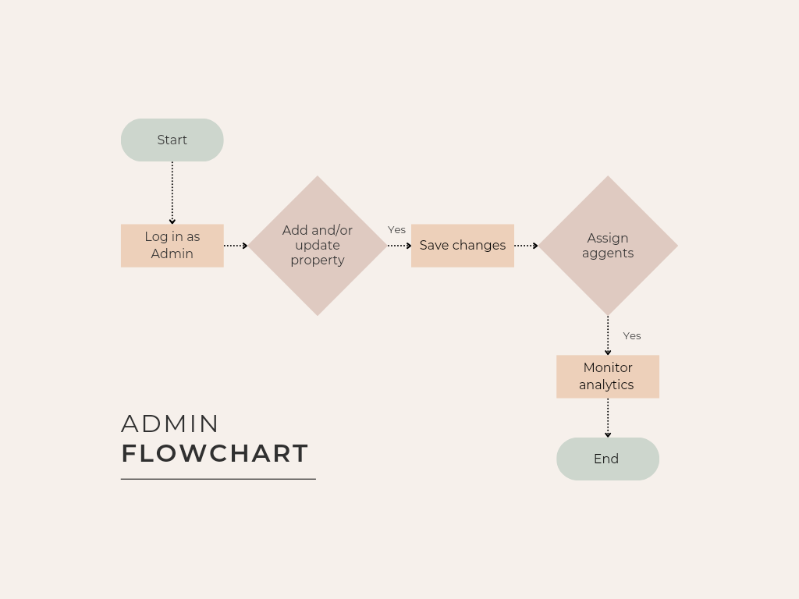

1. USER FLOW OF USER #2 [AGENT]

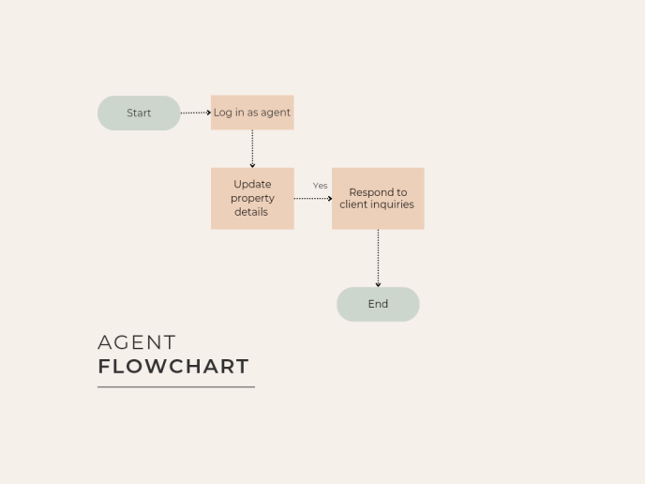

1. USER FLOW OF USER #3 [CLIENT]

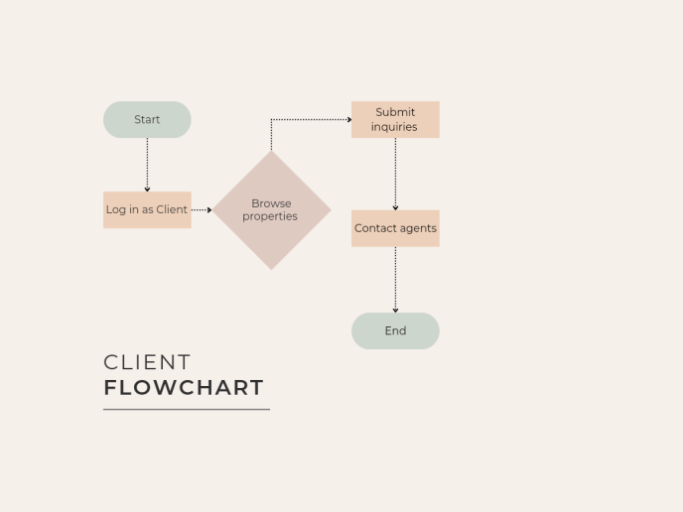

**• WIREFRAMING**

1. WEB PAGE INTERFACE

I. HOMEPAGE

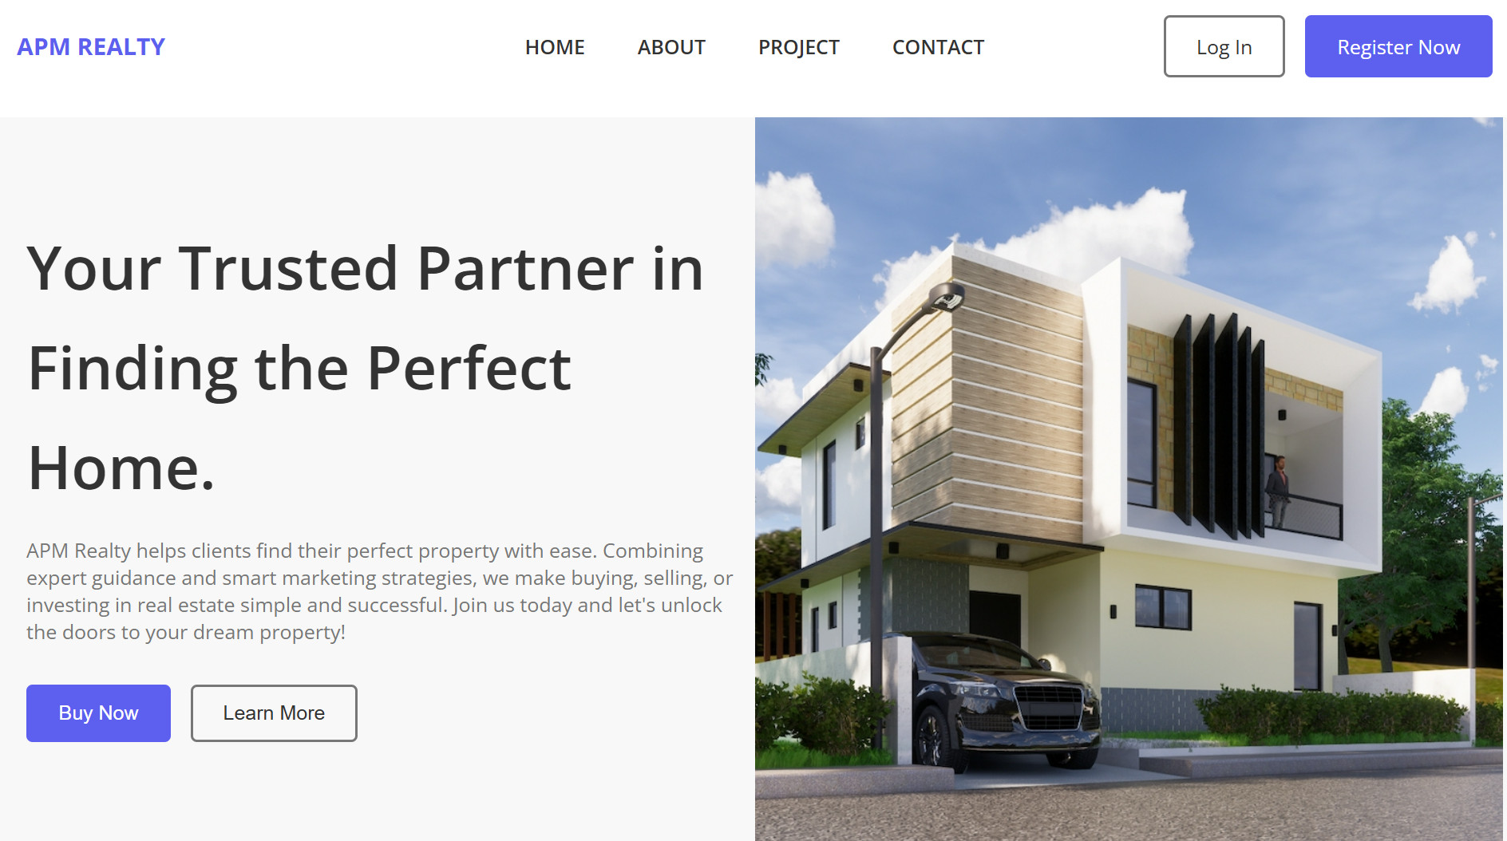

II. ABOUT US

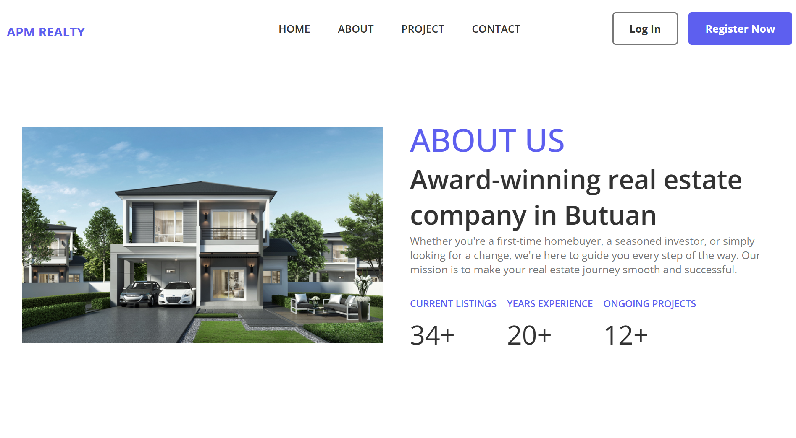

III. PROJECTS

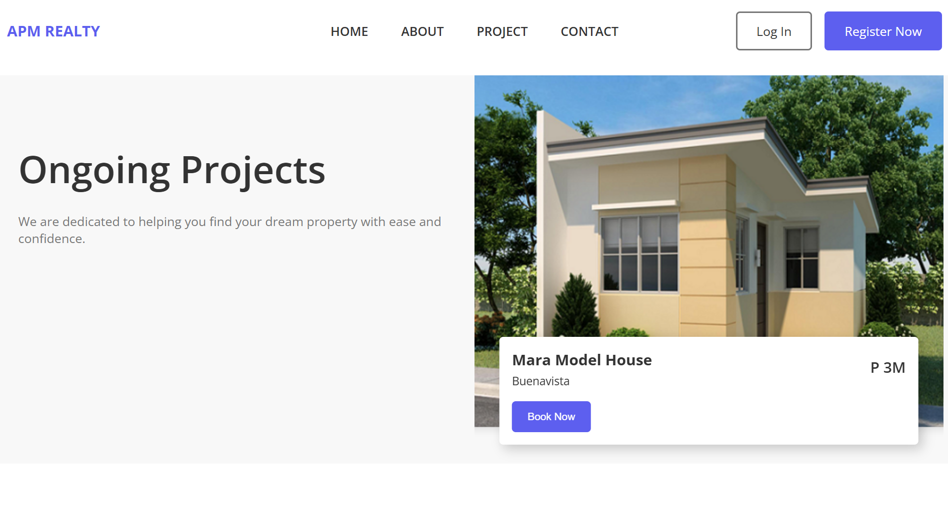

IV. CONTACT

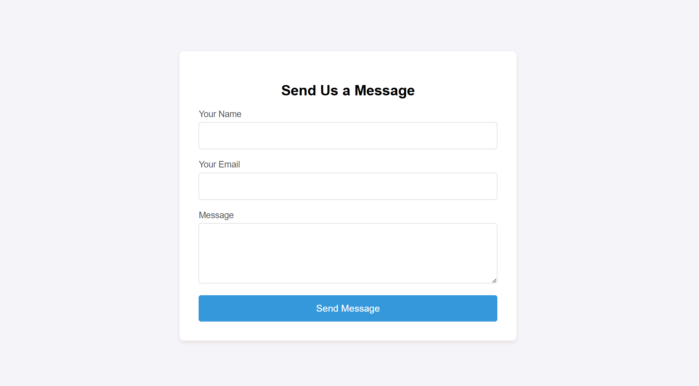

V. LOG IN PAGE

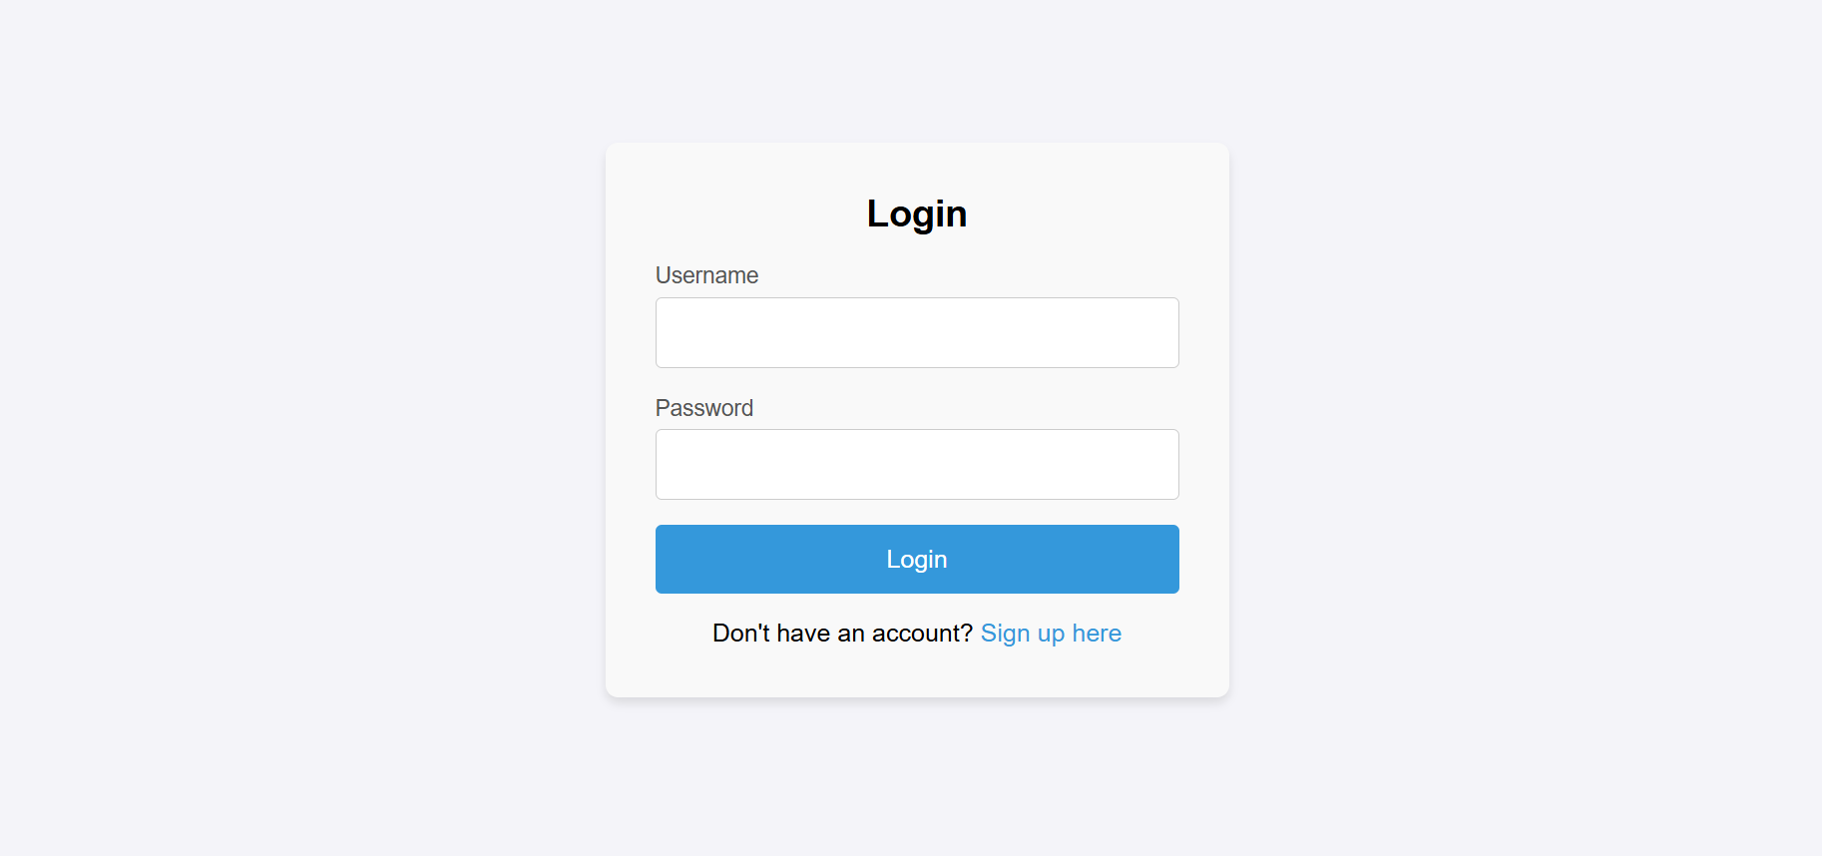

VI. REGISTRATION PAGE

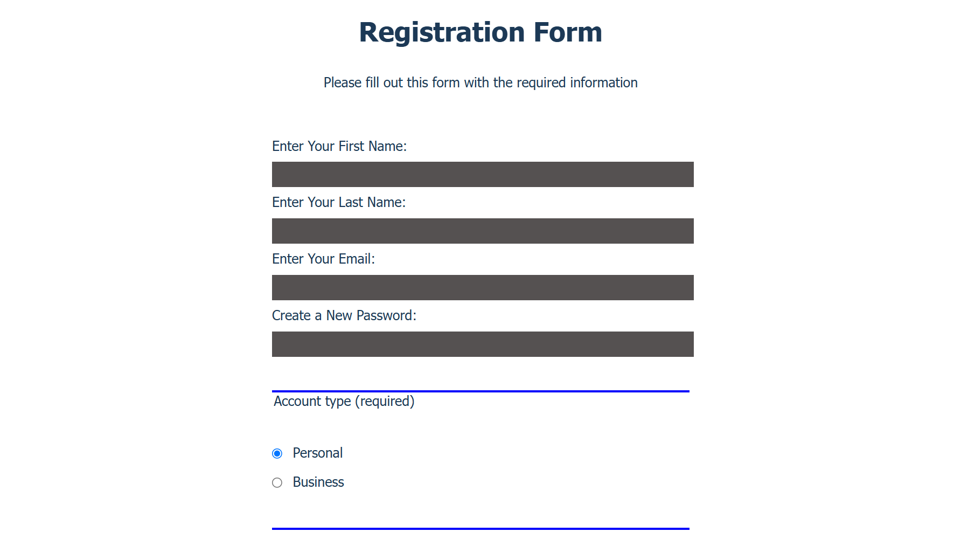

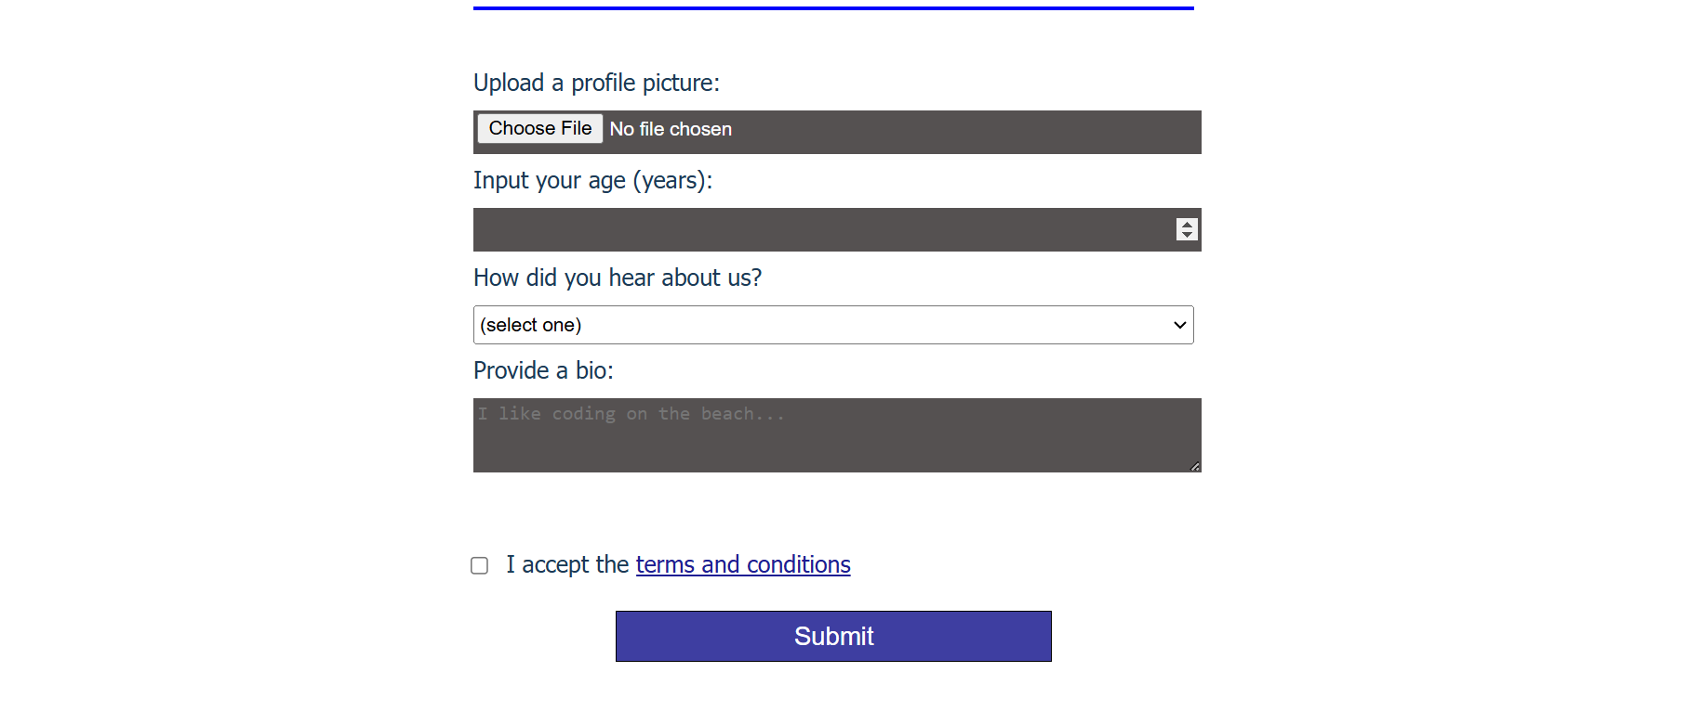

**III. Summarize the process of identifying user needs and expectations.**

The process began with analyzing the roles of the three key user groups—Admins, Sellers, and Clients—and their specific requirements within the platform. Each user's journey and expectations were mapped to identify pain points and opportunities for enhancement. The following steps were taken:

**Stakeholder Analysis:**

* Admins required robust control features, such as property management, user monitoring, and performance analytics.
* Sellers needed tools for uploading property media, managing listings, and connecting with clients seamlessly.
* Clients prioritized accessibility, intuitive browsing, and direct communication with Sellers.

· **Requirement Engineering:**

* · Conducted interviews and surveys to gather user feedback.
* Defined functional and non-functional requirements for each user group.

· **User Flow Mapping:**

* · Created detailed user flow diagrams to visualize access points, actions, and navigation paths for Admins, Sellers, and Clients.

**Prototyping:**

* Developed wireframes to outline the structure of web pages and interfaces.
* Iteratively improved prototypes based on feedback from stakeholders to ensure ease of use and clarity.

#### ****Design Process****

**Wireframes:**

**Homepage-** Central hub with navigation to key features like property listings and account access.

**About Us:** Information about APM Realty’s mission and values.

**Projects:** Showcase current and past property developments.

**Contact:** Integrated forms for inquiries.

**Login/Registration Pages:** Secure portals for account creation and access.

**Prototypes:**

* 1. High-fidelity mockups were created to represent the final user interface. These prototypes included dynamic property listings, real-time analytics dashboards, and responsive communication tools.
  2. Testing ensured smooth transitions between pages, intuitive layout, and seamless interactions.

Design Process

Wireframes:

**Homepage:** Central hub with navigation to key features like property listings and account access.

**About Us:** Information about APM Realty’s mission and values.

**Projects:** Showcase current and past property developments.

**Contact:** Integrated forms for inquiries.

**Login/Registration Pages:** Secure portals for account creation and access.

Prototypes:

High-fidelity mockups were created to represent the final user interface. These prototypes included dynamic property listings, real-time analytics dashboards, and responsive communication tools.

Testing ensured smooth transitions between pages, intuitive layout, and seamless interactions.

**Features and Functionality**

**User Registration:** Enables Admins, Sellers, and Clients to create accounts with role-specific privileges.

**Data Storage:** Centralized database for property details, client inquiries, and agent information.

Real-time updates ensure data consistency across the platform.

**Communication Channels:** Integrated contact forms and direct messaging tools facilitate smooth client-seller communication.

**Rich Media Management:** Sellers can upload property images and videos for engaging presentations.

**Real-Time Analytics:** Provides insights on user interactions, property views, and engagement metrics.

**Scalability and Performance:** Designed to handle growing user traffic and expanding data volumes efficiently.

### Data Security and Privacy

**Encryption:** All sensitive data, such as client contact information and agent profiles, is encrypted in transit and at rest.

**Role-Based Access Control (RBAC):** Admins have overarching control, while Sellers and Clients are restricted to role-specific features.

**Secure Authentication:** Multi-factor authentication (MFA) is implemented for Admin and Seller accounts to prevent unauthorized access.

**Data Anonymization:** Personally identifiable information (PII) of users is anonymized when generating analytics.

**Regular Security Audits:** The system undergoes frequent vulnerability assessments and patch updates to address emerging threats.

**Compliance:** Adheres to global data protection standards, such as GDPR, ensuring user privacy and trust.

**IV. Conclusion:**

This paper therefore highlights the APM Realty digital marketing dashboard in mitigating traditional one-to-one limitations through renovating the approach of the company. This platform, through its socially connected interface, real-time analytics, and dynamic property listings, promotes greater user interaction along with smoother communications between the client and the seller. Such a shift will make APM Realty more competitive in light of new realities, while simultaneously continuing to serve users better. The potential impacts on the target audience could be increased exposure for the sellers, great property explorations for clients, and effective system overseeing by admins; hence, APM Realty would join the ranks of customer-centric and tech-savant real estate firms.

**V. System Design (LINK)**

* Attach the actual link here to your system design
* http://127.0.0.1:8000/main