AI Reflection Log: EcoDash

Entry 1: Canvas skeleton and game loop
Prompt: Asked for a Week 1 starting point: HTML, CSS and a JavaScript Canvas game loop.
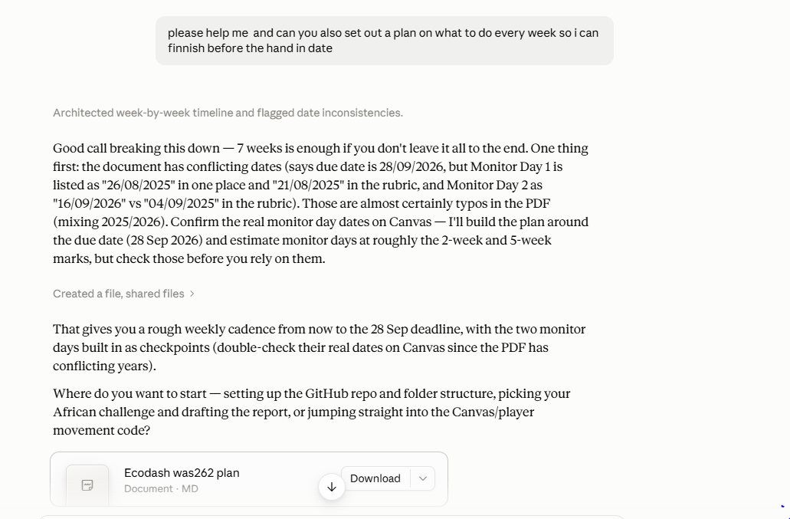
AI response: A basic index.html, style.css and main.js with requestAnimationFrame and a deltaTime calculation.
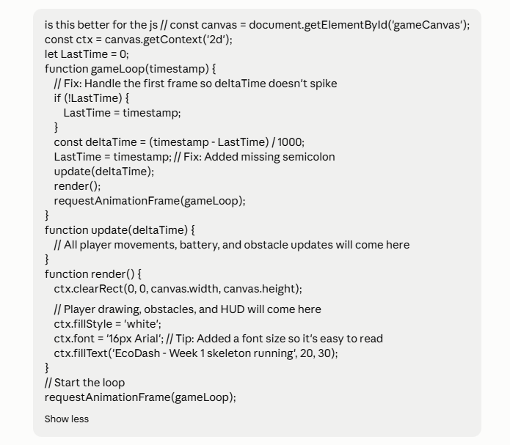
Problems identified: On the very first frame lastTime was 0, so deltaTime would spike to a huge value. The variable name LastTime also broke camelCase convention. The page also failed to load from file:// with a security-origin error in the console.
How I changed it: Added a first-frame guard (if lastTime is 0, set it to the current timestamp), renamed the variable to lastTime, set an explicit canvas font, and ran the project through VS Code Live Server instead of opening the file directly.
could not have explained it. The HTML title also said Solar Drone instead of my load-shedding theme.
How I changed it: Replaced main.js, corrected the script path, and worked through the new Vehicle class line by line (trigonometric movement with Math.cos and Math.sin, battery drain tied to deltaTime, keyboard input) until I understood it. I typed the code out myself.

Entry 2: Choosing obstacles that fit a drone
Prompt: Asked for obstacle and collision code.
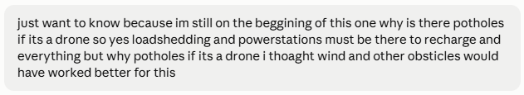AI response: Obstacle classes and circle-distance collision, with potholes as the first hazard type, taken from the examples in the brief.
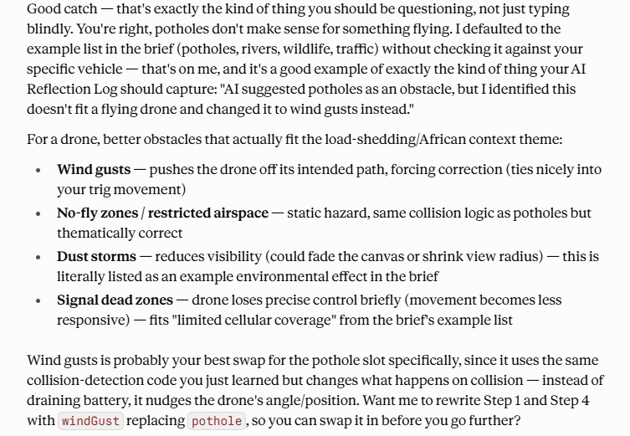Problems identified: I noticed potholes make no sense for something that flies. The suggestion had copied the brief's examples without fitting them to my vehicle.
How I changed it: I chose wind gusts, no-fly zones and signal dead zones as hazards, and added solid buildings. The AI then supplied circle-vs-circle and circle-vs-rectangle collision, so both collision methods the brief allows are used.
Entry 3: Randomising the obstacles
Prompt: Asked how to randomise hazard positions.
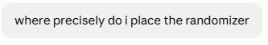
AI response: A generateObstacles function using Math.random for position and radius.
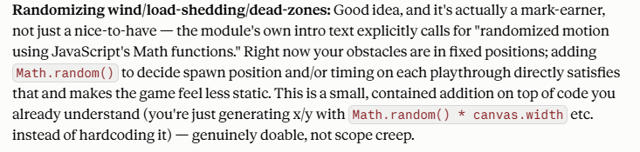Problems identified: Randomising everything would have made the layout unpredictable to debug. The obstacles variable also had to become let so restart could reassign it.
How I changed it: I kept the buildings in a fixed layout and randomised only the hazards, so the environment stays structured while the weather-like hazards change every run. Restart now calls generateObstacles.

Entry 4: Adding the delivery objective
Prompt: Asked whether the brief requires a delivery objective.
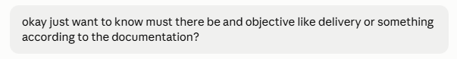AI response: Pointed to the assessment overview, which says players must complete delivery missions, and supplied a DeliveryTarget class.
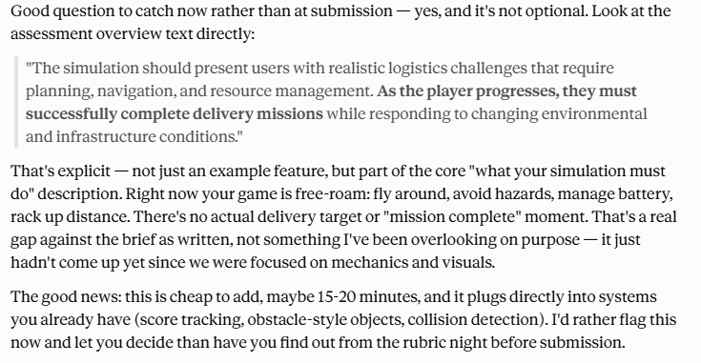Problems identified: My game was free-roam with no mission, which did not meet the brief.
How I changed it: Added the delivery target, a delivery counter to the HUD and game over screen, respawn on delivery, and reset on restart. It reuses my existing circle collision function.

Entry 5: Background music with volume control
Prompt: Asked for background music with a volume adjuster.
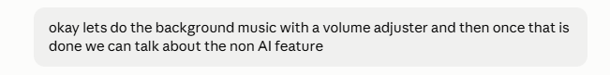AI response: An audio element, a range slider, and code to start the music from the Start button.
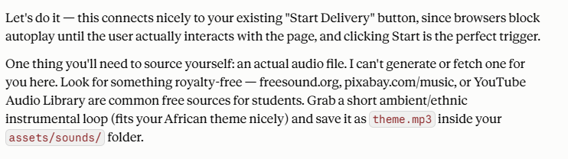Problems identified: Browsers block autoplay until the user interacts with the page.
How I changed it: Tied playback to the Start button, added pause and resume behaviour, and sourced the audio file myself. [state where you got the file]

Entry 6: Adding acceleration
Prompt: Asked whether the coding was complete.
AI response: Flagged that the brief requires acceleration, and my drone jumped straight to full speed and stopped instantly.
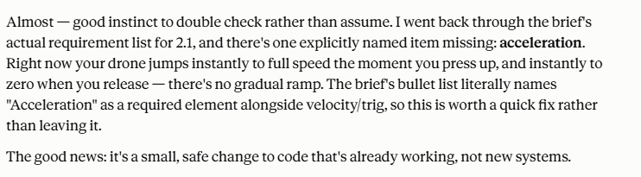Problems identified: Speed was set directly to maxSpeed, so there was no acceleration or deceleration.
How I changed it: Added an acceleration property and changed the speed update to ramp up and down each frame, capped at maxSpeed.

Entry 7: Script crash from variable order
Prompt: Shared my code and reported that the game would not start.
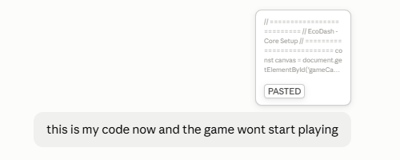
AI response: Explained that windVisuals was used inside generateObstacles before its let declaration ran, which throws an error and stops the whole script. It also noted update() did not check gameState.
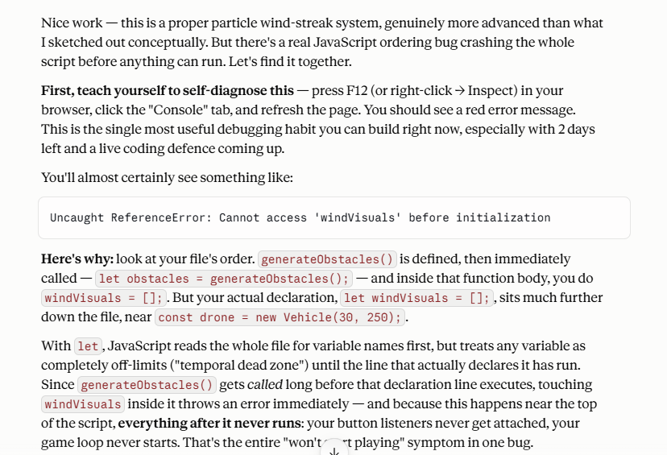Problems identified: The console error stopped every later line from running, so no buttons or game loop worked.
How I changed it: Moved the windVisuals declaration to the top of the file, removed the duplicate declaration, and added the gameState guard to update().

Entry 8: Wind particle effect (original feature)
Prompt:
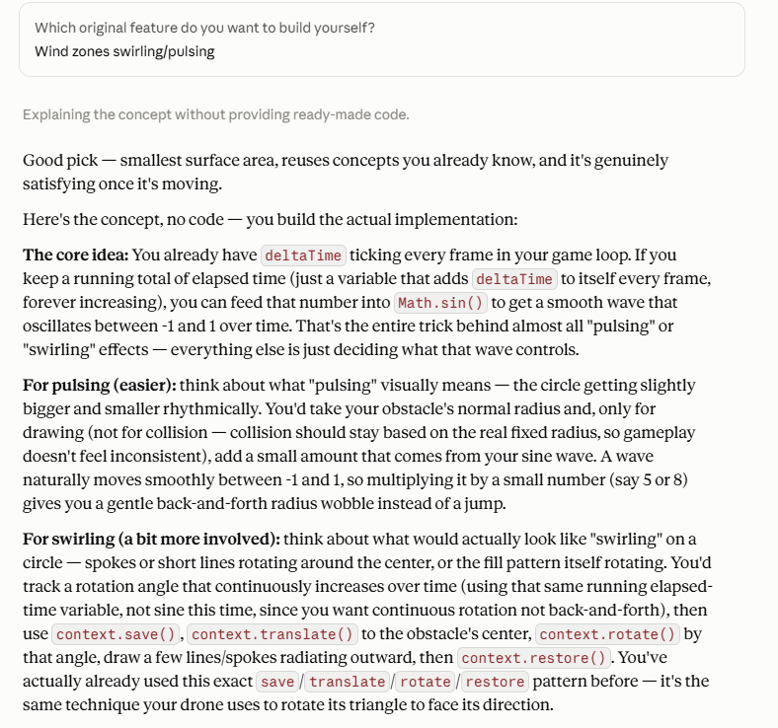
AI response: above
Problems identified: none
How I changed it: My non AI feature is the wind effect so in simple terms all of the visual natural elements are basic circles and zones and with the wind effect i gave it directional wind with streaks going in the direction its blowing and its random every restart of the game

Entry 9: Wireframe reference image
Prompt: Asked for a prompt for an image generator to show a rough wireframe of the game screen.
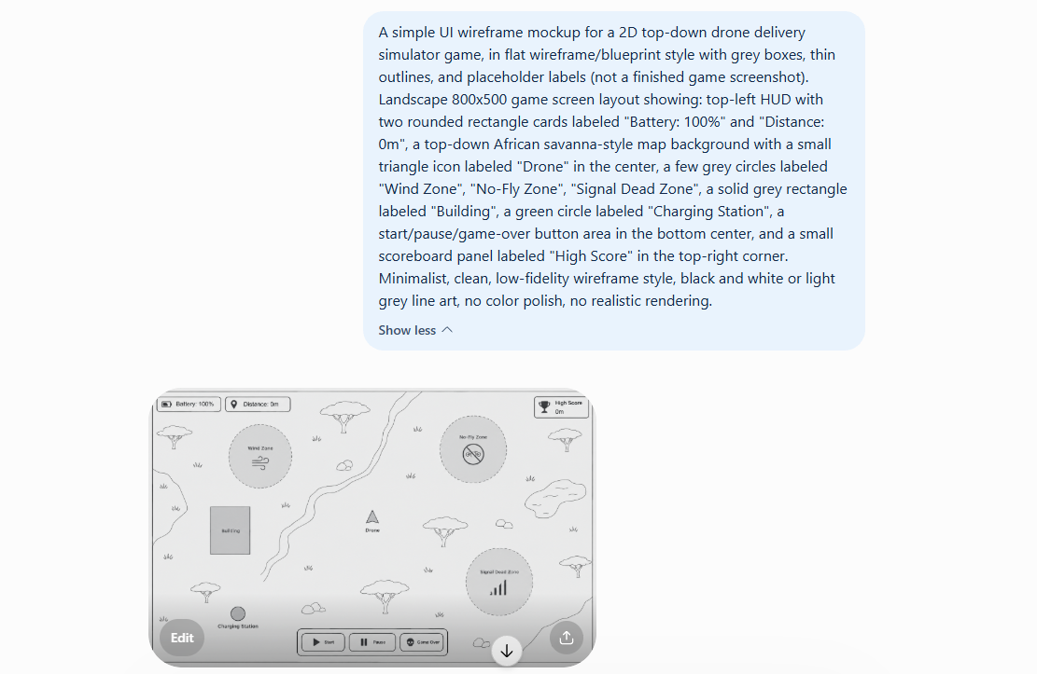
AI response: above
Problems identified: The generated image was far to basic.
How I changed it: I used it only as a layout reference, decided which parts were good to keep and in the end I drew a way to detailed picture so had to scale it back down for the game but gave me a good concept

