1. Executive Summary

The Shire of Chittering (the Shire) have partnered with a small number of Students completing the Advanced Programming Diploma, at North Metropolitan TAFE to develop an application over the course of 2024. The main goal is for the application to act as a self service portal, allowing the residents in the Chittering Shire to make rate payments, query outstanding balances and receive rate notices.

A few additional features have been discussed with our team, the Shire’s CEO, Melinda Prinsloo & Chittering Emergency Service Coordinator, Jodie Connell. Those additional features include:

- Improve the current emergency alert broadcast system
▪ Addressing the “black-spot” mobile coverage areas issues with people receiving alerts.
▪ Improve community safety in emergency conditions by ensuring alerts reach residents.
▪ Lower the costs involved with operating the current system.

- Community Event Notices & improve event awareness
▪ Creating a centralised community hub.
▪ Implementing a calendar to display upcoming events within the region.
▪ Togglable alerts to notify of upcoming events and notices.
▪ An exportable calendar that can be implemented on user’s devices.

2. Overview

In response to the Shire of Chittering, our team has been tasked with developing an application that will act as centralised platform for the residents within the Chittering Region. As discussed with CEO, Melinda Prinsloo, there is a need for more effective announcements to residents about upcoming events, a more cost effective solution for sending important alerts and a need for making payments to the Shire for services (such as rates) more accessible to all residents.
This is the third year that North Metropolitan TAFE has partnered with The Shire of Chittering. As a result of this our team will be working with an existing code base and prior implementations for features such as, Fire Danger Rating display board and a notification system using Firebase.

3. Business Requirements

3.1. High Level Objectives / Use-Cases

After our first meeting with the Shire on the 28th of March 2024, several crucial elements emerged that are fundamental for the final application.
– [Note: the following objectives will be referred to throughout the document:]
- Rate Payment System
- This objective is the most crucial, Melinda Prinsloo has highlighted the need to provide functionality that allows residents in the Chittering Region to view and make payments on their annual property rates from within the application.

- Community News
- Previously, residents in the region have spoken about how they weren't aware of events being held in the town site of Bindoon. Despite many different approaches to uplift announcements there is still a need to maximise the outreach of news and events. As discussed in our meeting with the Shire, Melinda mentioned that they require a central hub for the local community to receive news about upcoming events. This will help to provide an equal opportunity for those who live more remote than others, to be able to hear announcements on events and information.
- Emergency Alerts & Broadcasts
- Emergency Service Coordinator, Jodie Connell has expressed the importance of getting bushfire information and alerts out to the community in a timely efficient manner. With the vast rural area being abound by natural bush-land, bushfires happen frequently throughout the bushfire season. In response to harsh conditions (such as high UV forecasts), the Shire will impose Harvest-Ban and/or Total-Fire-Ban days under the instruction from the Department of Fire and Emergency Services (DFES).

- We have been tasked with creating a way to broadcast alerts whenever restrictions are in effect to users who are subscribed to the service. There is an importance to develop a creative solution for alerts to reach those in mobile "black-spot" areas as it is critical information that can carry offences if not obeyed.

- Our application needs to display the current Fire Danger Rating (FDR) system for the Swan Inland North section. The previous group was able to implement a FDR display, however their implementation was not using the greatest practices, so updating this to utilise the public Emergency WA APIs is a high priority.

- Depending on the time constraints in the projects developmental stage, the Shire has also expressed an interest to have a display active bushfire alerts as well as essential information for new residents regarding their responsibility and requirements in maintaining fire breaks for key inspections dates.

3.2. Relation to Strategic Plan

As per the Shire of Chittering’s Strategic plan, they have developed the following five strategic objectives that stem from their core community aspirations:

[see below: Figure: A]

Strategic Objectives
Figure: A | index # | Objective
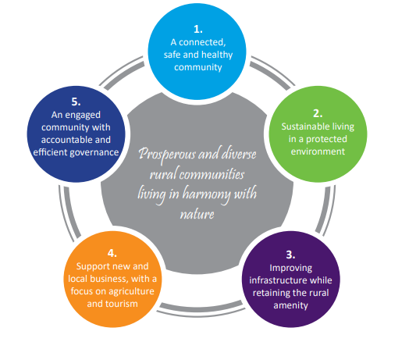 | S1. | A connected safe & healthy community.
 | S2. | Sustainable living in a protected environment.
 | S3. | Improving infrastructure while retaining the rural amenity.
 | S4. | Support new and local business, with a focus on agriculture and tourism.
 | S5. | An engaged community with accountable and efficient governance.
References
- The Shire of Chittering Corporate Business Plan (2022 - 2027) | - Community Desired Outcomes Page 25
- 2023 - 2024 Budget Project Highlights / Rates Brochure | Page 3

3.2. Strategic Key Objective Relationships

- Rate Payment System

Strategic Objective | Relation to Strategic Objective
S2. | Implementing a technology based payment system reduces the about of paper waste the Shire creates, therefore leaving a greener footprint.

- Events & Community News

Strategic Objective | Relation to Strategic Objective
S1. | Foster community connection by encouraging members living in satellite community areas to be more engaged through increasing aware of community events.

- Emergency Alerts & Broadcasts

Strategic Objective | Relation to Strategic Objective
S2. | Potential bushfire disasters are constant threat that the Shire faces. By improving year round planning and increasing resident awareness and / or compliance will help minimise the impacts, giving back a sustainable environment.

3.3. Current Systems & Infrastructure

    - Rate Payment System

Below are the currently available options that residents can use to make payments on their Rates:

- BPoint Online Payments – credit-card only
- Manual BPay – savings, cheque or credit-card (Biller-Code: 55038 & reference number
- Reoccurring BPay – savings, cheque or credit-card
- Payment via telephone BPoint – Visa or Mastercard
- In-person payments – at the Shire’s administration building (open-hours only)
- Mailing Postal Cheques – The Shire of Chittering, PO Box 70 Bindoon, WA, 6502

    - Events & Community News

Listed below are the following platforms / methods the shire currently use to spread community news and announcements:

- Facebook
- chittering.wa.gov.au
- Printed Flyers & Brochures
- Electronic Billboards (located in the Bindoon Town-site)
- Word-of-Mouth
- Community Notices (postal)

    - Emergency Alerts & Broadcasts

The Shire of Chittering currently have the following systems / services in place for emergency alerts, information and restrictions:

- Facebook Posts
- chittering.wa.gov.au – Displays the daily FDR & bushfire information for residents.
- Emergency WA – External Government site that displays all the active / predicted
Fire Danger Ratings in WA as well as any active bushfire / emergency warnings.
- An SMS Warning Registration – Telstra Integrated Messaging Service for:
▪➤ Harvest, Hot Works and Vehicle Movement Bans
▪➤ Total Fire Bans
▪➤ Changes to Restricted & Prohibited Burning Periods
▪➤ Cancellation of Fire Permits due to high ratings on the Fire Danger Index

4. Gap Analysis / Preliminary Research

4.1. Gap Analysis Table

Gap Analysis – [Figure: B]
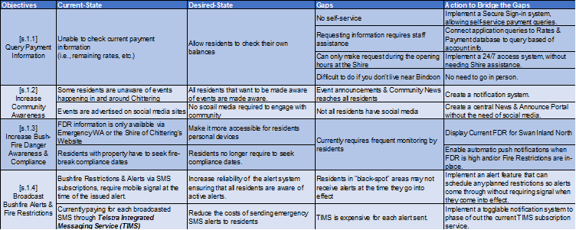
References
- Solution-1-Gap-Analysis.xlsx | - Project Gap Analysis  [Excel Spreadsheet]

4.2. Payment Gateways (Workflows)

- Payment Service / Gateway must meet PCI Compliance Checklist criteria as well as any Relevant State and Federal Rules & Regulations.

Payment Gateway Workflow Model [Figure: C]
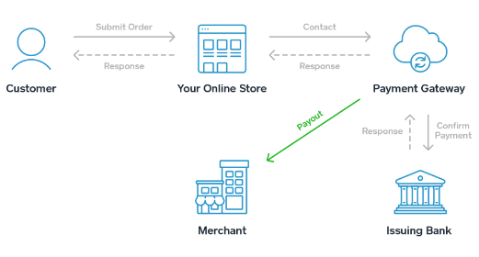
Reference : [ https://squareup.com/au ]

4.3. SWOT Analysis Table – (Payment Gateways)

Payment Gateway SWOT Table [Figure: D]
Service | Strengths | Weaknesses | Opportunities | Threats
BPoint  _{(current system)} | ▪ Customisable API  endpoints &  JavaScript  alterations. | ▪ Relies of redirecting  the user to a BPoint  payment page (out  of application). | ▪ Allows  customisation of  the payment API’s  to meet the users  needs. | ▪ Payer must  manually enter a  reference number,  which could be  entered incorrectly.
Square | ▪ Customisable  APIs & SDKs. | ▪ Requires setting up  the new system. | ▪ They offer physical  POS Hardware  solutions that can  use the same  workflow as the  online payment  service. | ▪ Could create a  centralised  ecosystem, which  can become a  financial issue if  subscription prices  increase.
Square | ▪ Easy usability &  setup. | ▪ Include surcharges
Square | ▪ Offers multiple  eCommerce  solutions | ▪ Requires the Shire  changing current  systems to use the  new APIs. | ▪ Includes analytical  tools.
Square | ▪ End-to-end  encryption with  24/7 built in  security. |  | ▪ Includes analytical  tools.
Stripe | ▪ Payments are end-to-end encrypted. | ▪ Implementing a new system that works for the shires current systems. | ▪ Ability to generate QR codes that can be included on the physical rate notice & a corresponding link in the application | ▪ Full Stripe implementation may have restrictions within Australia.
Stripe | ▪ Supports 135+ different currencies & payment methods.
Stripe | ▪ 99.999% historical service up-time. | ▪ Not Full customer support is available in Australia | ▪ Allows Embedded Financial Services (Banking as a Service API) with Stripe Treasury, allowing customers to hold funds & pay bills straight from the application.  ▪ User account  objects can be  created to link  resident accounts  to their account  balances.
Stripe | ▪ 250,000,000+ API requests per day. | ▪ Not Full customer support is available in Australia

4.4. SMS Broadcasts Financial Breakdown

Telstra Mobile Signal Coverage – [Figure: E]
3G | 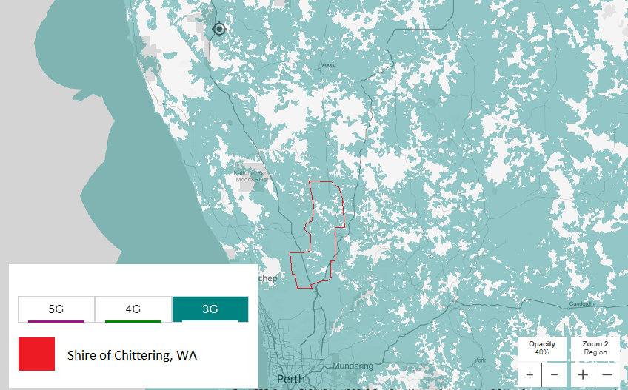
4G | 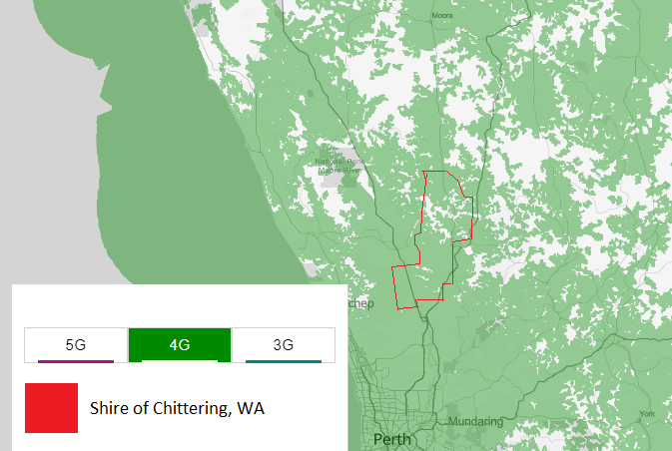
5G | 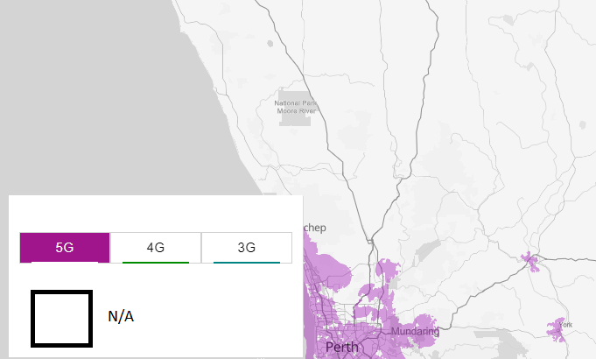
References
Telstra Coverage | - Telstra Network / Cell Coverage Map

4.5. SMS Broadcasts Financial Breakdown _{(current system)}

Telstra Integrated Messaging Service – [Figure: F]

4.6. Rates Portal – (Existing Solution Examples)
The City of Swan has implemented a Community Online Rates Portal, which contains similar features to those that Shire CEO, Melinda Prinsloo has requested. – [see Figure: G]
I have acquired a copy of their “How-To” guide to further analyse how the features and systems operate & to identify what systems work & don’t-work.
Example : A
City of Swan’s Payment Portal [Figure: G]
Key Features:

- Registering details.
▪ Customer name & activation-key.
▪ Create a password.
- Signing into the portal.
- Using the portal.
- Editing contact details.
- Viewing rate notices & manage payments.
▪ Create a direct debit.
▪ Confirm your direct debit.
▪ Create a payment arrangement.
- View current & previous notices.
References
- online-service-rates-portal.pdf |  | - The City of Swans Service Portal  (How-To Guide)

4.7. BoM Fire Weather District (AFDRS Regions)
The Australian Fire Danger Rating System (AFDRS) is a National system that calculates the risks if a fire occurred and rates it using a Fire Behaviour Index (FBI) which using factors such as wind speed, fuel type, UV, etc. to determine how a bushfire could behave if one was to occur within the current conditions. – [see Figures: I –J]

BoM Fire Weather Districts (Chittering) [Figure: H]
The AFDRS Uses Fire Weather Districts which have been established and assigned by the Bureau of Meteorology (BoM).
These regions are Typographically assigned based off their areas sub-climate, vegetation (fuel-source) and terrain. As a result the Shire of Chittering Fire Weather district happens to fall over the boundary of two different Fire Weather Districts:
District | Location (Catchment)
- Swan Inland North | - North-Eastern Region of the Shire of  Chittering
- Swan Coastal North | - The South-Western Areas within  the Shire of Chittering.
References
DFES | WA Fire Weather Districts | WA-Fire-Weather-Districts-and-Local-Government-Authorities.pdf

4.8. AFDRS Fire Behaviour Index (FBI)

The Fire Danger Rating is calculated using a 0-100+ scale called the Fire Behaviour Index (FBI) which determines the predicted fire conditions that you would likely face if a bushfire did occur. It takes into account external factors such as, weather, terrain, vegetation and temperatures converting it to a numerical scale that can then be used for statistical analysis, resource management and emergency protocol initiations.

(The higher the FBI rating is the more catastrophic the conditions are.)

Fire Behaviour Index (FBI) [Figure: I]
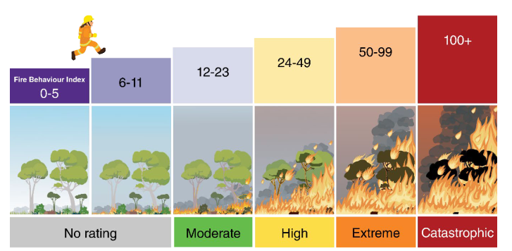
Reference: https://publications.dfes.wa.gov.au/publications/afdrs-fire-behaviour-index

FBI Feature Table [Figure: J]
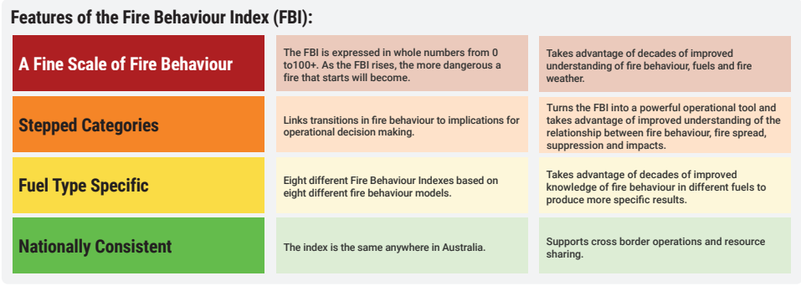
Reference: https://publications.dfes.wa.gov.au/publications/afdrs-fire-behaviour-index

5. Solutions / Proposal

In order to address the requirements being asked by the Shire of Chittering, I propose that we adhere to these following solution that cover the key objectives below:

I. | 5.1. – Rate Payment System
II. | 5,2. – Events & Community News
III. | 5.3. – Emergency Alerts & Broadcasts

5.1) Objective I. — (Rate Payment System)

To implement an effective system that benefits both residents and Shire staff, I propose a self service rates portal. To achieve this the following elements will need to be met:

Allowing residents to...
- make property rate payments, select appropriate instalment period options.
- view any outstanding rates for the financial year.
- be notified when rates are issues and/or due.
- change payment details / without the need of staff.
Objective I) Solution A.
Manage residents alerts, invoices / bills by creating unique accounts tied to the preexisting database. In order to enhance security when requesting property payments and other sensitive information, propose the following solutions:

- Users can register accounts with a one time registration process.
- Account information will be tied to each property's unique reference number &
name of the addressee.
▪ This information can be found on the issued rate notice sent to the resident.
- Users will create passwords with email verification upon registering their accounts.
▪ By implementing an email verification, residents can recover accounts if details
are lost.
- Information on account creation will be encrypted using Industry Best Practices &
Standards. (Aargon2, RSA public/private keys, salting passwords and resetting salts once authenticated)
- Once user credentials are encrypted they can be stored in either:
▪ The currently implemented database -
Note:
▪ Alterations WILL NOT impact how any of the current
Property information is stored and / or accessed by
internal & external systems & practices.
(with minimal amendments to the current table).
▪ If the need arises, the creation
of a separate database is a
minimal impact and can be
created to store account
credentials separately.
Objective I) Solution B.

Another approach is by using an embedded Banking as a Service (BaaS) that offers payment gateway solutions such as Stripe. Incorporating this in our app’s design reduces the work needed to develop a system to ensure that residents are able to sign-up to the online portal, manage their payments & plans as well as verifying accounts. Developer APIs are quite in-depth, allowing us to customise the service to meet the Shire’s requirements.

On account activation residents will be allocated an in-application wallet (like a bank account) assigned to their profile, where they can transfer funds to make payments to the Shire. This would allow residents to transfer automatic funds in smaller amounts throughout the year – prior to rate notices, or in larger single payments that put the resident in credit.

When ensuring the BaaS payment features (i.e., invoices, receipts, payments, etc.) are implemented as core elements in the User-Interface / User-Experience (UI / UX) Design, it enhances the overall payment experience & maintains a professional aesthetic.

Other features that a BaaS approach would provide is:

- Analytical tools for the Shire staff to discover patterns in resident payments.
- A display for residents whenever they log into their accounts showing their payment history.
- An end-to-end encrypted service accounting model with 24/7 customer security & help-desk support centres.
- The ability to incorporate encryption, verification and security seamlessly within the core of the application.
- The functionality to generate unique QR codes for each account that can link to invoices within the application. Allowing the Shire to include the code on rate notices or residential alerts.
*Note:
It is essential that the chosen payment gateway meets PCI Requirements as well as any relevant State, Local & Federal Laws.

5.2) Objective II. – (Events & Community News)
The second key objective raised by the Shire, is the need to maximise potential Community News & Event outreach to all residents, highlighting an importance on those who don’t live in close proximity to Bindoon Town.
As the Shire consists of multiple rural satellite towns, getting the latest news & community information can be difficult for some residents. A clear way of addressing this issue is by creating a community news hub that allows the Shire administration to post information about upcoming events and notices with ease that can reach all residents.

Objective II) Solution A.

Highlighted in the Shires Strategic-Objectives for Connecting Communities, their strategic approach illustrates the importance of supporting community events, social hubs and increasing community volunteering.

This demonstrates the need to establish an effective community outreach & engagement, and how it is an essential element to capture in the project. To support this ideology I propose we include the following elements:

- A togglable setting that allows users to opt in for notifications about upcoming events.
▪ This ensures that residents & stall-holders are aware of events as soon as they are announced.
(The previous group had started to implement alerts using Firebase, so I believe that an adaption of that service may very well be our best solution for enabling alerts, especially if our team starts to experience time constraints implementing other criteria.)
- A running `Post` feed

▪ Ensure that the Shire staff can update the latest information and news, by
creating different roles tied to accounts. This would allow staff accounts to access more features than the residents.
▪ The platform can also be used for updates & promotions, showcasing local -
Business & Shire sponsors to promote their own products & events.

- Implement easy to use built-in calendar display so that staff can schedule Important due-dates & events for the residents to see.
- An export to calendar feature allowing residents to export upcoming events straight into their personal devices.

Objective II) Solution B.

An alternative solution to encourage residential engagement and increase awareness from residents throughout the Shire is by implementing a “Happening Near You” feature. This can promote upcoming events by notifying them if they haven’t viewed an event that is happening if they are within a specified radius to the event location.
The features to implement include:

- Optional Background Location updates

▪ Use GPS location if enabled to check within a radius of the device if there
are any events going on that have not been viewed by the account signed in.
▪ A setting that toggles the feature on & off so residents give their consent to
the use of the feature.
- A loyalty reward system for residents turning out to events.
▪ By providing a sponsor platform where prize pools can be yielded as a
reward system for attending local events.

▪ Feature for the Shire to generate and link QR codes that registers resident
attendance & acts as a single raffle to win from the prize pool.

▪ The more events resident visit, the more entries they have. This will boost
both resident engagement, but also encourage small businesses to get involved.

Having worked with on my own implementations of generating unique QR codes in Python, I believe this is a very suitable and fairly simple element to implement. Where as implementing a GPS function, may be more challenging to implement.

5.3) Objective III. – (Emergency Alerts & Broadcasts)

Capturing the importance of relaying critical emergency information across to residents in the Chittering Shire, North Metropolitan TAFE has worked with the Shire of Chittering for many years now on developing solutions for displaying active Fire Danger Ratings (FDR).
Whilst in previous years, students have come up with some solutions, their methods on retrieving the data did not use industry best practices (i.e., web-scraping). Therefore continuing to develop a solution and tying it into our application is a crucial requirement. In order to achieve this our final design must include a display of the daily FDR issued for the Chittering FDR Regions. [see Fig: H]

► To ensure that we use Industry best practices we will retrieve our data
by parsing from the JSON response received by making API requests to
EmergencyWA’s API's

Note – Having already worked using the API’s for Emergency WA, I believe this change in the FDR data retrieval method should be an easy task for to implement.

Objective III) Solution A.

The Shire of Chittering being a rural area surrounded by natural bushland, means that bushfires are an annual threat to the community.

Hence forth, providing the community with bushfire information guarantees that residents are made aware of what to do in an emergency situation, as well as convey their responsibility in reducing the risks & requirements to support emergency services year round. To administer the following requirements I propose the development of the following areas:

- An information page and/or links to current sources of information for residents to view what their requirements are.
▪ This will aid in the reduction of bushfire threats & encourage resident
compliance.

- Alerts and information section to relay important information to residents
▪ Fire Restrictions come into affect
▪ Leading up to Fire-Break compliance inspection dates.

- Emergency service information.
▪ Contacts and links to services such as DFES, VFES, SES & VFS.
▪ Annual Volunteer recruitment dates

Objective III) Solution B.

As per discussion with Jodie Connell and Melinda Prinsloo, there is a need to improve the current Harvest/Total Fire Ban (TFB) Emergency SMS broadcast service.
The current system utilises the Telstra Integrated Messaging Service (TIMS), which allows the Shire to send Push-Activated SMS messages to those who are subscribed to the service. It has been in play for many years now and has improved the public knowledge of when fire restrictions are in action.

However, whilst there is a large number of residents who are subscribed to the service, there is an ongoing problem relaying messages to a reasonably large portion of them due to there being a number of “Black-Spot” (no mobile coverage) areas in the Chittering region. [see Figure: E]

Another thing worth mentioning is the price it is costing the Shire to operate the current system each year. As the year enters the fire season, the number of SMS Broadcasts can exceed 50 individual events and costs upwards of $1,500.00 per round of broadcasts and can over a total of $75,000.00 annually. [see Figure: F]
(Disclaimer: Value are a rough estimates based on previous data to give a rough idea on the frequency and prices.)

Since there is no real obvious solution for improving the current systems infrastructure, especially without disruption to current systems, it would take some out-of-the-box thinking to form a solution, hence forth I have come up with an innovative solution to this problem:

- Enable a togglable feature in the applications settings to enable/disable TFB alerts.
▪ When enabled the application will be able to act as an alternative to the
current SMS system
▪ Unlike the current system, having Alerts sent via an application will save the
Shire a drastic amount of money, especially during the fire season. This is due to the application not costing per message relayed to each device subscribed.

- Develop a feature that allows Emergency Coordinators to schedule in a TFB as soon as BoM or DFES have issues it to the public.
▪ When enabled the application will be able to act as an alternative to the
current SMS system.
▪ Allows messages to be scheduled in advance and operate from the devices
internal clock.
▪ Means that the device does not need to be in signal at the time that an
alert comes into effect.

- With the setting enabled, the device will periodically check in the background (every 15–30 minutes or so) for any new scheduled broadcasts. If the device missed the previous broadcast due to not being connected, the device will update as soon as it connects to a signal.
▪ This ensures that devices (aka. people) that are in “Black-Spot” areas,
still have access to the broadcast system if the restrictions had been planned prior.

- Ensure that the system also updates when the data updates directly from EmergencyWA.
▪ By enabling automation, it ensures that the most up-to-date information is made publicly available.

This solution offers an innovative, unique method for solving a widely common yet serious regional issue. Whilst the time needed to develop this feature may be slightly disproportionate, I believe it would be a great opportunity for all stakeholders, as it will be setting an example for other regions to follow our lead.

6. Conclusion

6.1. Solution Evaluation

Solution Evaluation Table [Figure: K]
 | Solution | Business Impacts | Ability to Implement | Effectiveness  (to project) | Industry Standards/ Best Practices
Rates Payment System | I.  (A) | The creation of a separate database will have no impact on business operations and dependent systems. | We should have no issues implementing this system as it only requires minimal amendments to the current table, or the creation of a local database for storing encrypted user credentials. | This solution is a simplistic, yet effective way to allow residents to sign-in securely, view invoices &,manage rate payments. | Data will be encrypted using Industry Best Practices & Standards, such as encryption using Aargon2, RSA public/private keys, salting passwords and resetting salts once authenticated.
Rates Payment System | I.  (B) | Provide staff with analytical tools, helping improving customer support by discovering patterns. | By adopting this solution, it would reduce the amount of work-load needed to develop a functioning and secure sign-in system. | Adopting a preexisting solution such as Stripe will allow us to customise the service to meet the Shires requirement. | When choosing a payment gateway, it must meet the PCI Requirements as well as any relevant State, Local & Federal Laws.
Events & Community News | II.  (A) | Creating this community hub application will help the Shire meet their Strategic Objective for Connecting Communities. | The previous group had started to implement alerts using Firebase, so I believe that an adaption of that service may very well be our best solution for enabling alerts, especially if our team starts to experience time constraints implementing other criteria. | The Shire raised the need to maximise community outreach within the Chittering region (especially those in satellite communities). By creating a community news & event hub, it allows more people out of the Bindoon town-site to hear about events. | N/A
Events & Community News | II.  (B) | Creation of a sponsor platform where prize pools can be yielded as a reward system for attending local events. The more events residents visit, the more entries they have. This will boost both resident engagement, but also encourage small businesses to get involved. | Having worked with on my own implementations of generating unique QR codes in Python, I believe this is a very suitable and fairly simple element to implement. Where as implementing a GPS function, may be more challenging to implement. | Encourage residential engagement and increase awareness from residents throughout the shire is by implementing a “Happening near you” feature. | When developing a setting that toggles alerts on & off must ensure that it asks the residents first to be positive that they give their consent to the use of the feature.

(Continued...)
Solution Evaluation Table [Figure: K]
 | Solution | Business Impacts | Ability to Implement |  | Effectiveness  (to project) | Industry Standards/Best Practices
Emergency Alerts & Broadcasts | III.  (A) | May encourage more residents to comply with bushfire ready dates, as well as increase the number of residents volunteering for emergency services. | Having already worked using the API’s for Emergency WA, I believe this change in the FDR data retrieval method should be an easy task for to implement. | Effective in spreading community awareness and requirements. However, doesn’t improve the emergency broadcast system |  | To ensure that we use Industry best practices we will retrieve our data by parsing from the JSON response received by making API requests to EmergencyWA’s API's.
Emergency Alerts & Broadcasts | III.  (B) | Has the potential to save the Shire of Chittering upwards of $75,000.00 a year, as well as improve the number of people that receive alerts. | A much more challenging solution than others. However, in my opinion may be the best solution to address the issue of black spot areas. | This solution covers all the requirements and problems outlined by the Shire. |  | Unknown.  Further analysis required.

6.1. Final Conclusion

After conducting an analysis on the solutions I have provided, I have tailored a solution for each of the 3 key objectives.

I. Rates Payment System:

By ensuring that the residents are issued unique accounts tied to their Rates Reference Number, we can streamline requests and payments. To keep sign-in details simplistic, residents will require a one time account set-up verification via their email address. Using their email for account verification allows for a point of contact if accounts credentials are lost and need to be reset. Once verified, residents can then assign themselves a username and password to their account. These details will then be encrypted and stored using Argon2 with salting and stored in a separate database table to where the current Rates information is stored.

If we implement an embedded banking payment gateway, resident’s accounts will be assigned individual banking accounts, so that automatic payments and invoicing can all happen directly within the application. On top of this embedded banking offers a stylish professional UI/UX design along with 24/7 customer support & built in security.

II. Events & Community News:

Since news and events aren’t a priority to this project, if we keep the platform as simple as possible it will ensure that we don’t spend too much of our time developing it. However, I think having a News & Events Hub is an important element to capture the Shire’s vision on a Connected Community. I also think implementing a feature where residents can download the in-app events calendar onto their local device is a good idea to help residents remember dates with events that are scheduled.

III. Emergency Alerts & Broadcasts:

Highlighting the importance of including the daily AFDRS into the design is an essential element, which will be implemented using Industry Best Practices from government API’s, (DFES, BoM, EmergencyWA, EMWA.training, DGov, etc).
In order to address the “black-spot” Mobile Coverage issue, I believe it is in the best interest for all parties that we should go ahead with the in application alert system that allows the Shire & Emergency Services to schedule Fire Restrictions and Alerts. Once a solid framework is established for sending & receiving alerts, the rest of the work required to implement this will be really manageable and its uses can be expanded to better suit other Emergency Broadcasts if needed.

7. Supervisor Sign-Off Form

Name | Position Title | Signature | Date
- ___________________ | - ________________ | - ________________ | - _____________

