plateGuard

Heavy Machinery

Nathan Burgess, Michael Nutt

NathanBurgess@my.unt.edu, MichaelNutt2@my.unt.edu

Version 1.0

*[09/14/2018]*

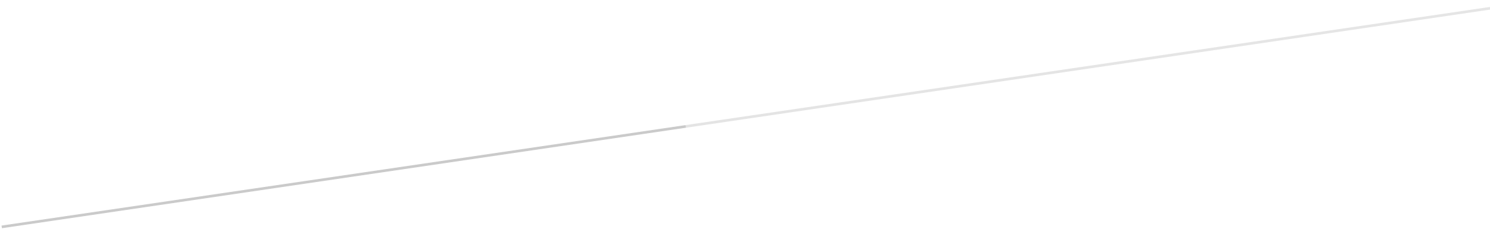

**Requirements Document**

Version 1.0

Contents

A. Project Overview 2

B. Current Problems and Proposed Solutions 2

C. Requirements 2

1.Functional Requirements 2

2.Non-Functional Requirements 3

3.Constraints *3*

# Project Overview

Our system is a security system that has been built to recognize plates in saved videos and encrypt the plate area with the license plate as the key to allow for authorized decryption.

# Current Problems and Proposed Solutions

With existing technology individual privacy is at risk through the mass gathering of unsecured footage of license plates of cars that pass red light and other traffic cameras on a daily basis. With no encryption currently in place that data could easily be gathered by malicious actors and searched by computers to identify the owners of the cars recorded. Our goal is to make this task harder for malicious actors while still keeping the data usable by authorized parties by identifying the license plate area for each car in the stored videos and encrypting those areas using the license plate as the key.

# Requirements

## Functional Requirements

|  |  |
| --- | --- |
| **Functional Requirements** | **Team Member Responsible** |
| Read in video stream/saved video | Nathan/Michael |
| Encrypt whole video and transmit to server | Nathan/Michael |
| Decrypt video for plate recognition | Nathan/Michael |
| Recognize license plates | Nathan/Michael |
| Extract plate number | Nathan/Michael |
| Save coordinate and plate meta data to the image | Nathan/Michael |
| Encrypt license plates | Nathan/Michael |
| Save encrypted image as .png | Michael/Nathan |
| Read in encrypted image | Michael/Nathan |
| Decrypt target plate area | Michael/Nathan |
| Search for target plate number | Michael/Nathan |

## Non-Functional Requirements

|  |  |
| --- | --- |
| **Non-Functional Requirements** | **Team Member Responsible** |
| Multi-threading | Michael/Nathan |
| Graphical user interface | Michael/Nathan |
| Track license plate area to reduce image recognition calls | Michael/Nathan |
| Separated Red Light System | Nathan/Michael |
| Separated Security Camera System | Nathan/Michael |
| Combine exported .png files into video | Nathan/Michael |
| Create Installer package | Nathan/Michael |

## Constraints

1. *Storage space*
   * *file output will be individual .png files, this will likely take up a lot of storage space quickly.*
2. *Processing time*
   * *Image recognition is processor intensive and on embedded systems would take an extended period of time, this will be mitigated by transferring the files to the server prior to license plate encryption*
3. *Embedded CPU clock rate*
   * *Processor of the embedded system will need to be able to efficiently handle reading in video, encrypting the video and sending it to the server*
4. *Image Recognition*
   * *Image recognition is not perfect, there is a chance of mis-recognition that will need to be accounted for during encryption of the plate area.*
5. *Wi-Fi Range*
   * *The embedded system will be placed remote from the server, we will need a method of transmitting the data from the system to the server to allow image recognition and encryption.*