Version 1.0
October 10th , 2018
Plateguard
Heavy Machinery
Nathan Burgess, Michael Nutt
nathanburgess@my.unt.edu, michaelnutt2@my.unt.edu
Specifications Document
Version 1.0
Contents
A.Project Overview 3
B.Current Problems and Proposed Solutions 3
C.Requirements 4
1.Functional Requirements 4
2.Non-Functional Requirements 4
3.Constraints 5
D.Specifications 6
1.Functional Requirements Specifications 6
2.Non-Functional Requirements Specifications 6
E.Preliminary Design 7
1.Use Case 7
2.Class Diagrams 8
3.Sequence Diagrams 9
4.State Diagrams 10

Project Overview
Our system is a security system that has been built to recognize plates in saved videos and encrypt the plate area with the license plate as the key to allow for authorized decryption. The system is comprised of four programs that make up the PlateGuard system, ImageEncrypt, ImageDecrypt, PlateEncrypt, PlateDecrypt. The ImageEncrypt captures video from an embedded system and encrypts the image using Stream Cipher and then transmits it to a server. ImageDecrypt receives the encrypted image and decrypts it, then transfers it to PlateEncrypt. PlateEncrypt isolates the plate area of the image and encrypts it using the plate number. PlateDecrypt reads in the saved encrypted video and decrypts the plate area.

Current Problems and Proposed Solutions
With existing technology individual privacy is at risk through the mass gathering of unsecured footage of license plates of cars that pass red light and other traffic cameras on a daily basis. With no encryption currently in place that data could easily be gathered by malicious actors and searched by computers to identify the owners of the cars recorded. Our goal is to make this task harder for malicious actors while still keeping the data usable by authorized parties by identifying the license plate area for each car in the stored videos and encrypting those areas using the license plate as the key.

Requirements

Functional Requirements

ID | Functional Requirements | Team Member Responsible
1 | Read in video stream/saved video | Nathan/Michael
2 | Encrypt whole video and transmit to server | Nathan/Michael
3 | Decrypt video for plate recognition | Nathan/Michael
4 | Recognize license plates | Nathan/Michael
5 | Extract plate number | Nathan/Michael
6 | Save coordinate and plate meta data to the image | Nathan/Michael
7 | Encrypt license plates | Nathan/Michael
8 | Save encrypted image as .png | Michael/Nathan
9 | Read in encrypted image | Michael/Nathan
10 | Decrypt target plate area | Michael/Nathan
11 | Search for target plate number | Michael/Nathan
12 | Minimum fps of video playback at 15 fps | Michael/Nathan

Non-Functional Requirements

ID | Non-Functional Requirements | Team Member Responsible
1 | Multi-threading | Michael/Nathan
2 | Graphical user interface | Michael/Nathan
3 | Track license plate area to reduce image recognition calls | Michael/Nathan
4 | Separated Red Light System | Nathan/Michael
5 | Separated Security Camera System | Nathan/Michael
6 | Combine exported .png files into video | Nathan/Michael
7 | Create Installer package | Nathan/Michael
8 | Port to C++ for optimization | Nathan/Michael

Constraints

- Storage space
  - file output will be individual .png files, this will likely take up a lot of storage space quickly.
- Processing time
  - Image recognition is processor intensive and on embedded systems would take an extended period of time, this will be mitigated by transferring the files to the server prior to license plate encryption
- Embedded CPU clock rate
  - Processor of the embedded system will need to be able to efficiently handle reading in video, encrypting the video and sending it to the server
- Image Recognition
  - Image recognition is not perfect, there is a chance of mis-recognition that will need to be accounted for during encryption of the plate area.
- Wi-Fi Range
  - The embedded system will be placed remote from the server, we will need a method of transmitting the data from the system to the server to allow image recognition and encryption.

Specifications

Functional Requirements Specifications

ID | Functional Requirement Specification | Team Member Responsible
1, 8, 9 | OpenCV v3 | Nathan/Michael
2, 3, 6, 7, 10, 11, 12 | Propriety code  Python 3 | Nathan/Michael
2 | Wifi/ethernet connection | Nathan/Michael
4, 5 | OpenALPR v2.3.0 | Nathan/Michael
1-12 | Ubuntu 16.04 | Nathan/Michael
1-12 | Raspberry Pi 3 model B+ | Nathan/Michael
1 | USB Camera Module | Nathan/Michael
1-12 | Server  Software: Ubuntu 16.04  Hardware: i5 CPU, 8 GB RAM, 500 GB HDD | Nathan/Michael

Non-Functional Requirements Specifications

ID | Non-Functional Requirement Specification | Team Member Responsible
3 | OpenCV v3 | Nathan/Michael
4, 5 | Raspberry Pi 3 model B+ | Nathan/Michael
4 | IR Sensor module | Nathan/Michael
1, 2, 6, 7 | Python 3 | Nathan/Michael
8 | C++ | Nathan/Michael

Preliminary Design

Use Case
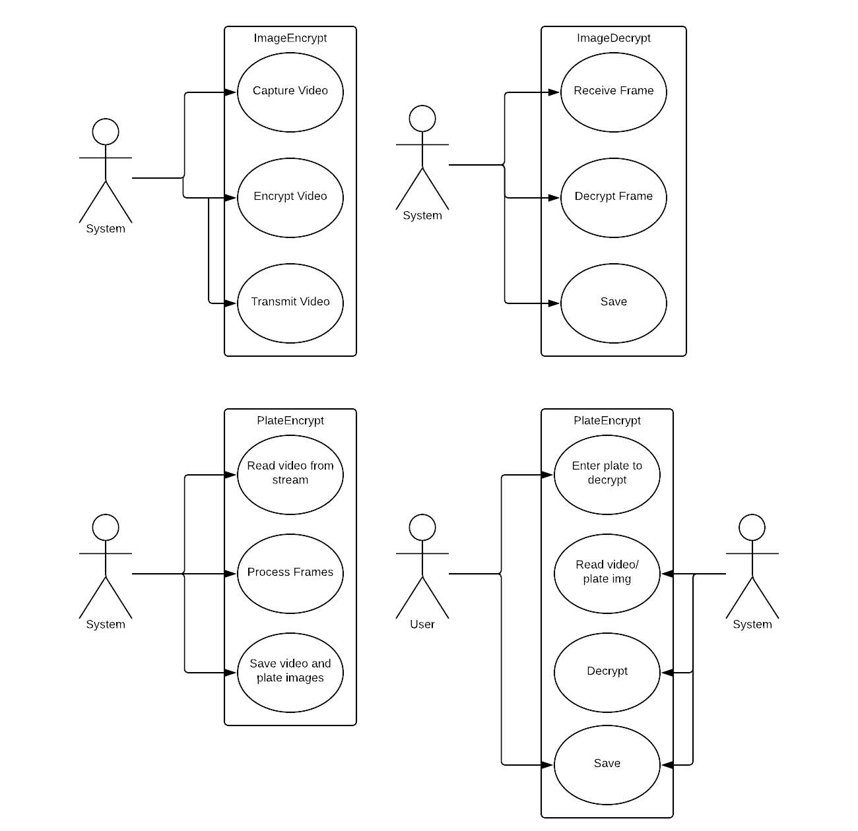

Class Diagrams
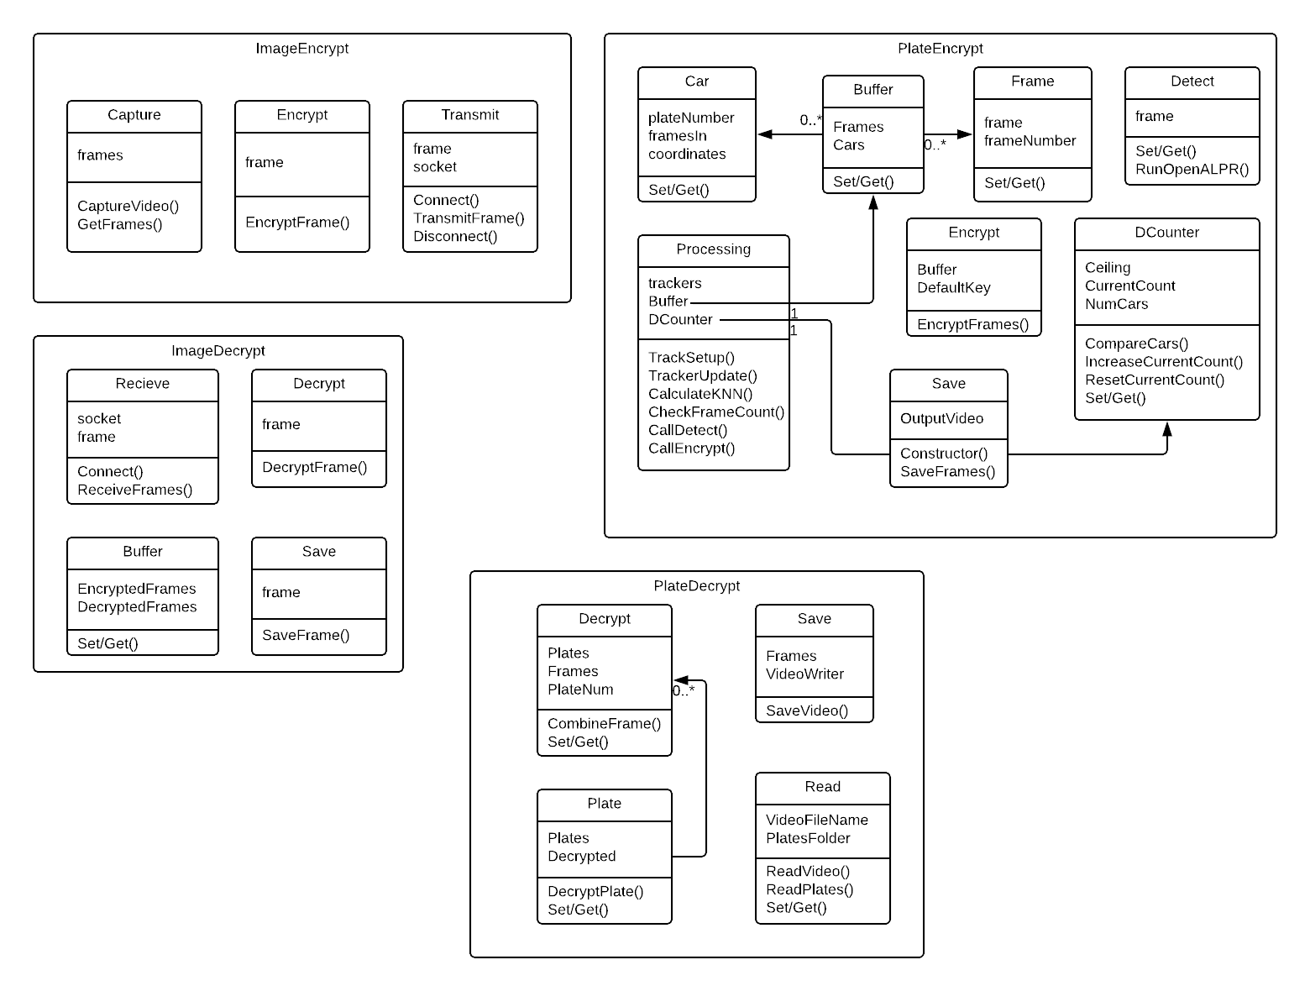

Sequence Diagrams
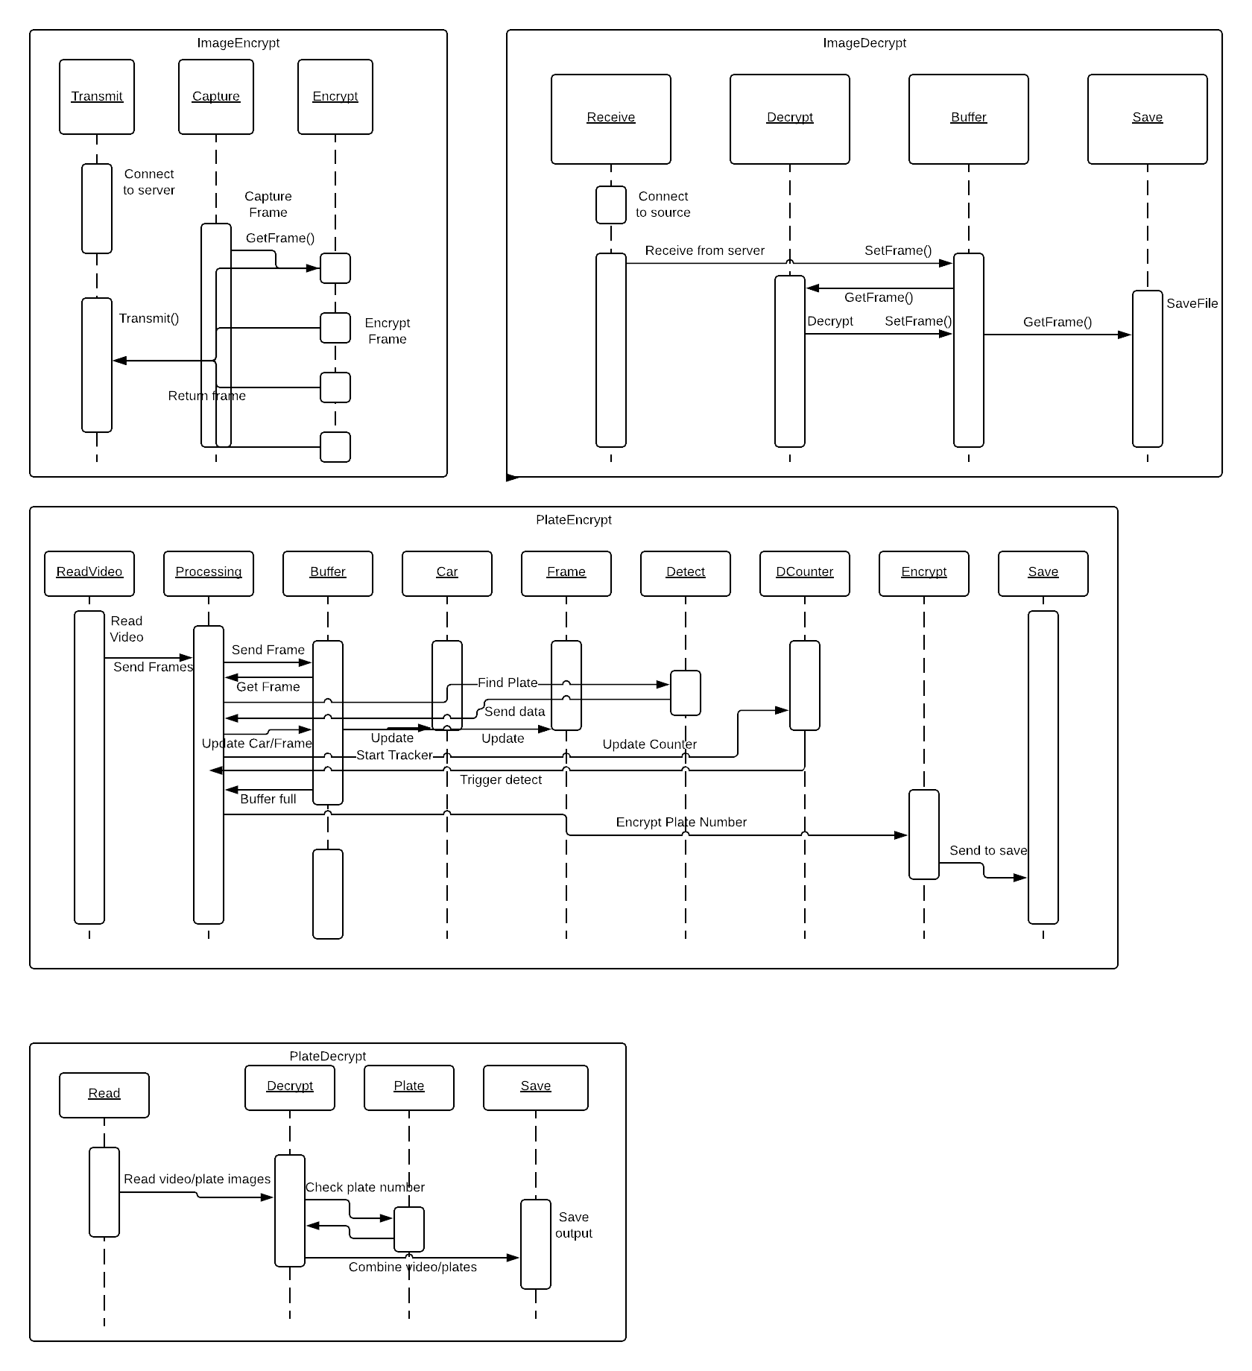

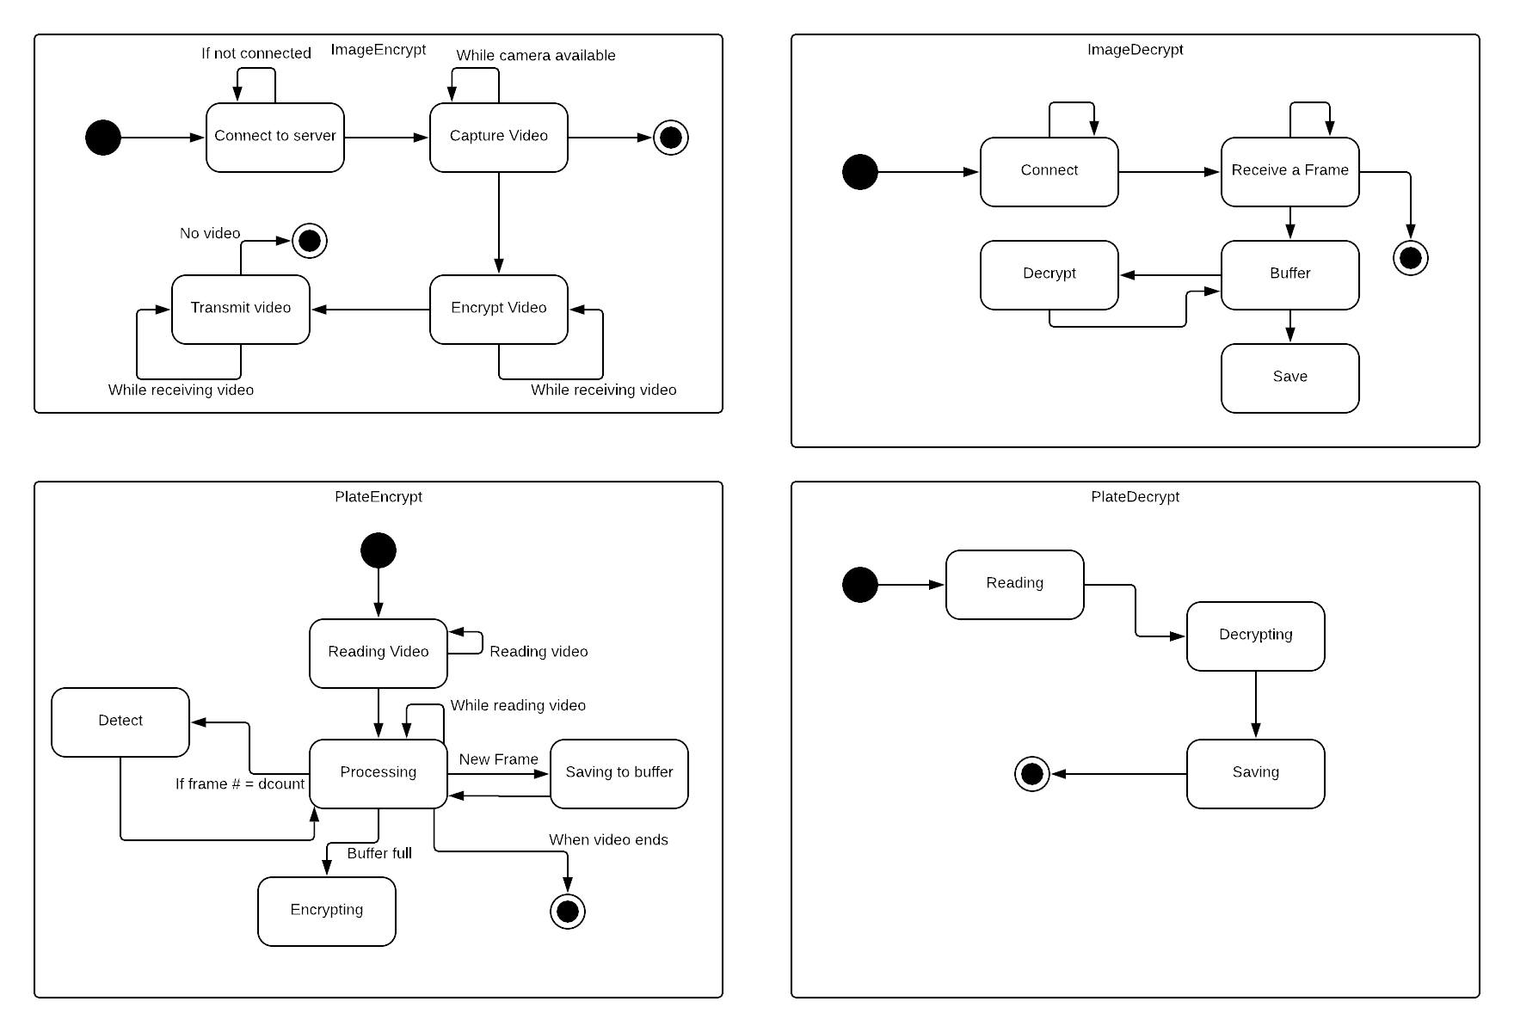
State Diagrams

