Nathan Burlison
CS230 – Operating Platforms
Module 1 Assignment

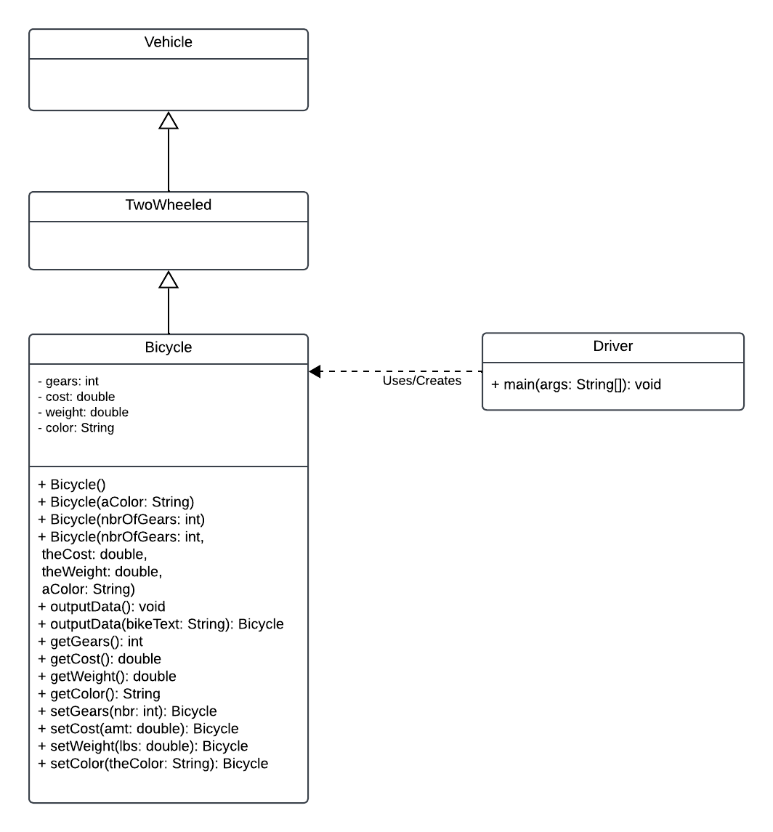

Object Oriented Principles Illustrated

The UML class diagram demonstrates several object-oriented programming principles. Inheritance is shown through the relationship between Vehicle, TwoWheeled, and Bicycle. Bicycle inherits from TwoWheeled, while TwoWheeled inherits from Vehicle, creating an “is-a” relationship between the classes. Encapsulation is demonstrated in the Bicycle class because its gears, cost, weight, and color attributes are private and are accessed or modified through public getter and setter methods. Polymorphism is illustrated through method and constructor overloading. The Bicycle class contains multiple constructors with different parameter lists and two versions of the outputData method. The Vehicle and TwoWheeled classes also represent general categories in the class hierarchy, allowing the program to organize objects from general vehicle types to the more specific Bicycle class.

