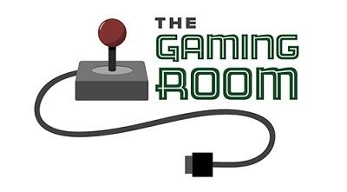

Draw It or Lose It

CS 230 Project Software Design Template
Version 1.1

Table of Contents

CS 230 Project Software Design Template 1
Table of Contents 2
Document Revision History 2
Executive Summary 3
Requirements 3
Design Constraints 3
System Architecture View 3
Domain Model 3
Evaluation 4
Recommendations 5

Document Revision History

Version | Date | Author | Comments
1.1 | 07/24/2026 | Nathan Burlison | Revised the required sections.

Executive Summary
The Gaming Room wants to turn Draw It or Lose It into a web-based game that works across different devices. The design uses one shared GameService to manage games and unique IDs, while the Game, Team, and Player classes keep the data organized. This structure supports unique names, multiple teams and players, and future growth.

Requirements
Each game must have at least one team, and each team can include multiple players. Game, team, and player names must be unique, and every object needs its own numeric ID. One GameService instance will manage the data, while iterator-based searches will check for existing names or IDs before anything new is added.

Design Constraints
Because the game will run in a web-based distributed environment, the main game logic must work independently of the user's device or operating system. Additions and searches should go through GameService so names and IDs stay consistent. The design must also handle network interruptions and use shared storage if the application later runs on more than one server.

System Architecture View
Please note: There is nothing required here for these projects, but this section serves as a reminder that describing the system and subsystem architecture present in the application, including physical components or tiers, may be required for other projects. A logical topology of the communication and storage aspects is also necessary to understand the overall architecture and should be provided.

Domain Model
The UML model uses Entity as the parent class for Game, Team, and Player, allowing them to share the id and name fields through inheritance. A Game contains teams, and each Team contains players, which matches the client's required structure. GameService manages the game list, assigns IDs, and uses the singleton and iterator patterns to prevent duplicates and locate existing objects. Private fields and public methods demonstrate encapsulation, while ProgramDriver and SingletonTester run the application and confirm that only one GameService instance is used.

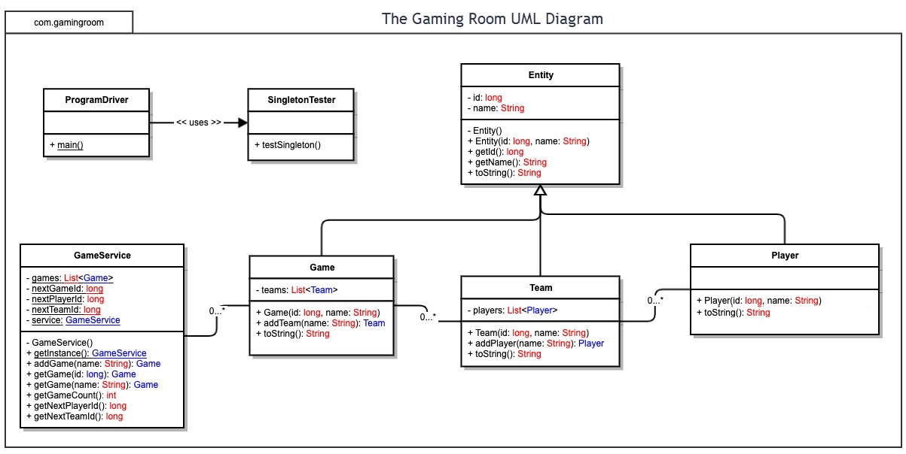

Evaluation

Using your experience to evaluate the characteristics, advantages, and weaknesses of each operating platform (Linux, Mac, and Windows) as well as mobile devices, consider the requirements outlined below and articulate your findings for each. As you complete the table, keep in mind your client’s requirements and look at the situation holistically, as it all has to work together.

In each cell, remove the bracketed prompt and write your own paragraph response covering the indicated information.

Development Requirements | Mac | Linux | Windows | Mobile Devices
Server Side | <Evaluate Mac for its characteristics, advantages, and weaknesses for hosting a web-based software application.> | <Evaluate Linux for its characteristics, advantages, and weaknesses for hosting a web-based software application.> | <Evaluate Windows for its characteristics, advantages, and weaknesses for hosting a web-based software application.> | <Evaluate Mobile Devices for their characteristics, advantages, and weaknesses for hosting a web-based software application.>
Client Side | <Determine the software development considerations (cost, time, expertise) that are necessary for supporting multiple types of clients as they pertain to Mac.> | <Determine the software development considerations (cost, time, expertise) that are necessary for supporting multiple types of clients as they pertain to Linux.> | <Determine the software development considerations (cost, time, expertise) that are necessary for supporting multiple types of clients as they pertain to Windows.> | <Determine the software development considerations (cost, time, expertise) that are necessary for supporting multiple types of clients as they pertain to Mobile Devices.>
Development Tools | <Identify the relevant programming languages and tools (IDEs and other tools) that are used to build this type of software for deploying on Mac.> | <Identify the relevant programming languages and tools (IDEs and other tools) that are used to build this type of software for deploying on Linux.> | <Identify the relevant programming languages and tools (IDEs and other tools) that are used to build this type of software for deploying on Windows.> | <Identify the relevant programming languages and tools (IDEs and other tools) that are used to build this type of software for deploying on Mobile Devices.>

Recommendations

Analyze the characteristics of and techniques specific to various systems architectures and make a recommendation to The Gaming Room. Specifically, address the following:

- Operating Platform: <Recommend an appropriate operating platform that will allow The Gaming Room to expand Draw It or Lose It to other computing environments.>

- Operating Systems Architectures: <Describe the details of the chosen operating platform architectures.>

- Storage Management: <Identify an appropriate storage management system to be used with the recommended operating platform.>

- Memory Management: <Explain how the recommended operating platform uses memory management techniques for the Draw It or Lose It software.>

- Distributed Systems and Networks: <Knowing that the client would like Draw It or Lose It to communicate between various platforms, explain how this may be accomplished with distributed software and the network that connects the devices. Consider the dependencies between the components within the distributed systems and networks (connectivity, outages, and so on).>

- Security: <Security is a must-have for the client. Explain how to protect user information on and between various platforms. Consider the user protection and security capabilities of the recommended operating platform.>

