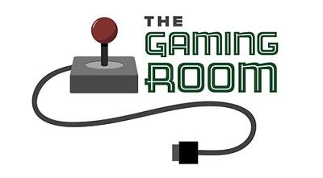

Draw It or Lose It

CS 230 Project Software Design Template
Version 2.0

Table of Contents

CS 230 Project Software Design Template 1
Table of Contents 2
Document Revision History 2
Executive Summary 3
Requirements 3
Design Constraints 3
System Architecture View 3
Domain Model 3
Evaluation 4
Recommendations 7

Document Revision History

Version | Date | Author | Comments
1.0 | 07/24/2026 | Nathan Burlison | Completed the Executive Summary, Requirements, Design Constraints, and Domain Model sections.
2.0 | 08/02/2026 | Nathan Burlison | Completed the Evaluation section for Mac, Linux, Windows, and mobile platforms.

Instructions
Fill in all bracketed information on page one (the cover page), in the Document Revision History table, and below each header. Under each header, remove the bracketed prompt and write your own paragraph response covering the indicated information.

Executive Summary
The Gaming Room wants to expand Draw It or Lose It into a web-based game that can support users on different types of devices. The proposed design uses one shared GameService object to manage games and identifiers, while separate Game, Team, and Player classes organize the application data. This approach gives the client a clear foundation for enforcing unique names, supporting multiple teams and players, and expanding the application into a distributed environment.

Requirements
Each game must support one or more teams, and each team must support multiple players. Game, team, and player names must be checked before a new object is added so duplicate names are not created. Every game, team, and player must also receive a unique numeric identifier. The application must use the singleton pattern so only one GameService instance manages the data in memory, and iterator-based searches must be used to locate existing objects by name or identifier.

Design Constraints
The application must be designed for a web-based distributed environment, so the core game logic cannot depend on one specific client operating system. All requests that create or locate games, teams, and players must go through a controlled service so name checks and identifier assignment stay consistent when several users access the application. The singleton pattern controls the service inside one running application, but a future deployment across multiple servers would require shared persistent storage or another coordination method to keep data synchronized. The design must also account for network delays or outages without creating duplicate records or leaving incomplete game data.

System Architecture View
Please note: There is nothing required here for these projects, but this section serves as a reminder that describing the system and subsystem architecture present in the application, including physical components or tiers, may be required for other projects. A logical topology of the communication and storage aspects is also necessary to understand the overall architecture and should be provided.

Domain Model
The UML diagram centers on Entity, a base class that stores the id and name shared by Game, Team, and Player. These three classes inherit the common fields and behaviors from Entity, which demonstrates inheritance and reduces repeated code. Game contains a list of Team objects, and Team contains a list of Player objects, creating the required one-to-many relationships. GameService maintains the collection of games, generates the next identifiers, and provides methods to add or retrieve game data. Its private constructor and static getInstance() method demonstrate the singleton pattern, while iterator-based searches support uniqueness checks without exposing the internal lists. Private attributes with public access methods demonstrate encapsulation. ProgramDriver runs the application, and SingletonTester confirms that repeated requests return the same GameService object.

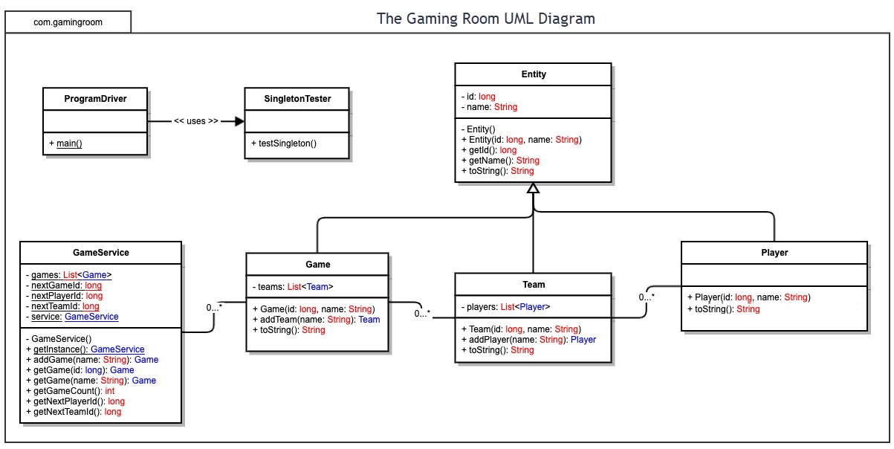

Evaluation

Using your experience to evaluate the characteristics, advantages, and weaknesses of each operating platform (Linux, Mac, and Windows) as well as mobile devices, consider the requirements outlined below and articulate your findings for each. As you complete the table, keep in mind your client’s requirements and look at the situation holistically, as it all has to work together.

In each cell, remove the bracketed prompt and write your own paragraph response covering the indicated information.

Development Requirements | Mac | Linux | Windows | Mobile Devices
Server Side | A Mac can host the Java web application using Apache, Nginx, or the server built into Dropwizard. It would work well for development or a smaller test setup. There is no separate macOS license to buy because it comes with the computer. The downside is that macOS has to run on Apple hardware, and Apple no longer offers macOS Server as a full server product. That makes it harder and more expensive to add a large number of servers. For a game that may have thousands of players, Mac is possible, but it is not the most practical choice for the main server. | Linux is a good match for the server side of Draw It or Lose It. Java, Dropwizard, Apache, Nginx, Docker, and most cloud services all work well with it. The Gaming Room could begin with one server and add more servers later as the number of players grows. Most Linux versions do not have a license fee, although paid support is available when the company wants it. Linux also runs with fairly low system overhead. The main drawback is that someone on the team needs to be comfortable with command-line tools, permissions, updates, networking, and server security. | Windows Server can host the game through IIS, a reverse proxy, or the Dropwizard application server. It may be easier for a company that already uses Microsoft tools, Active Directory, or Azure. The graphical management tools are also familiar to many administrators. The bigger issue is cost. Windows Server uses paid licensing, and extra client-access or external-user licensing may be needed depending on how it is set up. It also uses more system resources than a basic Linux installation. Windows can handle a large deployment, but it would probably cost more to operate for this project. | Phones and tablets are not realistic production servers for this game. iOS and Android limit background processes, open network ports, and long-running services. Mobile devices also move between networks, run on batteries, and may pause an app when it is not on the screen. A phone could run a small local server for testing, but it would not be dependable or secure enough for real players. It also could not scale to thousands of users. Mobile devices should be treated as clients that connect to a server hosted in a data center or cloud environment.
Client Side | Mac users should be able to open the game in Safari, Chrome, or Firefox without installing a separate program. The team can use the same HTML, CSS, and JavaScript as the other clients, but Safari still needs its own testing because it sometimes handles layouts, sound, and browser features differently. Testing should also cover Retina displays, different window sizes, keyboard use, and accessibility. This does not require a separate Mac development team. It does require access to Mac hardware and at least one developer or tester who knows Safari's developer tools. | Linux users can play through Firefox, Chrome, or Chromium, so most of the work is already covered by the shared browser version. The site should stay away from operating-system-specific plug-ins and use regular web standards. Linux comes in many distributions and desktop setups, which makes it unrealistic to test every possible combination. The team should focus on common browsers, screen sizes, fonts, audio, and graphics settings. Supporting Linux should not add a large amount of development time, but someone with Linux experience will help when small browser or display problems show up. | Windows will probably make up a large part of the desktop audience. Players can use Edge, Chrome, or Firefox with the same responsive website used on Mac and Linux. The main challenge is the wide range of Windows computers, screen resolutions, display-scaling settings, and input devices. The team should use automated browser tests, but it should also test the game on several real computers. A browser-based version is still cheaper and faster than building a separate Windows desktop app. Most of the added effort will be testing and fixing small layout, sound, or timing issues. | Mobile will take more hands-on testing than the desktop platforms. The layout needs to work on small screens, in portrait and landscape, with buttons that are easy to tap. The team should test Safari on iPhones and iPads and Chrome on Android phones and tablets. It also needs to check slower connections, dropped connections, the on-screen keyboard, sound, timers, and reconnecting to a game. One responsive website is much cheaper than building separate native apps, but emulators are not enough by themselves. Several real devices and testers with mobile web experience will still be needed.
Development Tools | The Mac version can be built with the same Java and web tools used on the other platforms. That includes the JDK, Dropwizard, Maven or Gradle, HTML, CSS, JavaScript or TypeScript, Git, VS Code, IntelliJ IDEA, and Eclipse. Safari Web Inspector is useful for browser testing, and Xcode includes the iOS Simulator. Many of these tools are free, although some IntelliJ editions cost money. The team will need at least one Mac for Safari and iOS testing. A paid Apple developer membership is only needed later if the game is packaged for an Apple app store. | Linux supports nearly the entire project tool set without extra licensing costs. Developers can use the JDK, Dropwizard, Maven or Gradle, VS Code, IntelliJ IDEA, Eclipse, Git, Docker, Apache, and Nginx. It is also useful because the development and testing setup can closely match the production server. Most of the software is free or open source. The team does not need a separate Linux coding group, but someone should know shell commands, services, permissions, package management, and network setup. That person could also help with deployment, updates, and server security. | Windows developers can use the JDK, Dropwizard, Maven or Gradle, VS Code, IntelliJ IDEA, Eclipse, Git, PowerShell, Docker, and Windows Subsystem for Linux. Visual Studio and IIS are available when Microsoft-specific tools are helpful, but they are not required for the shared web application. Many tools have free versions. Paid Windows licenses, Visual Studio editions, or enterprise Microsoft services could add cost. Using the same Git repository, build scripts, and containers across all platforms will keep the project from splitting into separate codebases or separate development teams. | The mobile browser version still uses HTML, CSS, JavaScript or TypeScript, and the same Java REST back end. Chrome DevTools and Android Studio can be used for Android testing. Xcode, the iOS Simulator, and Safari Web Inspector are used for Apple devices. Android Studio and Xcode are free, but Xcode only runs on a Mac, so the team must budget for Apple hardware. Separate Kotlin and Swift developers are not needed for the current browser-based plan. They would only become necessary if The Gaming Room later decides to build full native apps or use device-specific features.

Recommendations

Analyze the characteristics of and techniques specific to various systems architectures and make a recommendation to The Gaming Room. Specifically, address the following:

- Operating Platform: <Recommend an appropriate operating platform that will allow The Gaming Room to expand Draw It or Lose It to other computing environments.>

- Operating Systems Architectures: <Describe the details of the chosen operating platform architectures.>

- Storage Management: <Identify an appropriate storage management system to be used with the recommended operating platform.>

- Memory Management: <Explain how the recommended operating platform uses memory management techniques for the Draw It or Lose It software.>

- Distributed Systems and Networks: <Knowing that the client would like Draw It or Lose It to communicate between various platforms, explain how this may be accomplished with distributed software and the network that connects the devices. Consider the dependencies between the components within the distributed systems and networks (connectivity, outages, and so on).>

- Security: <Security is a must-have for the client. Explain how to protect user information on and between various platforms. Consider the user protection and security capabilities of the recommended operating platform.>

