**GUI Project Test Cases  
By Nathan Dean, Jamie Concannon, Steven Derrig.**

**Booking page- Steven Derrig testing**

Taking user inputs and storing them.

Test 1

Input details

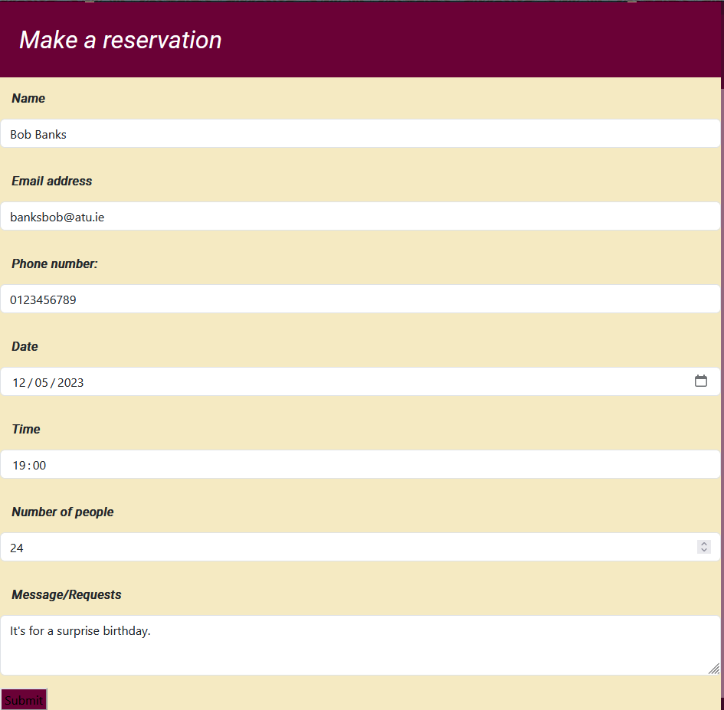

Confirmation of booking.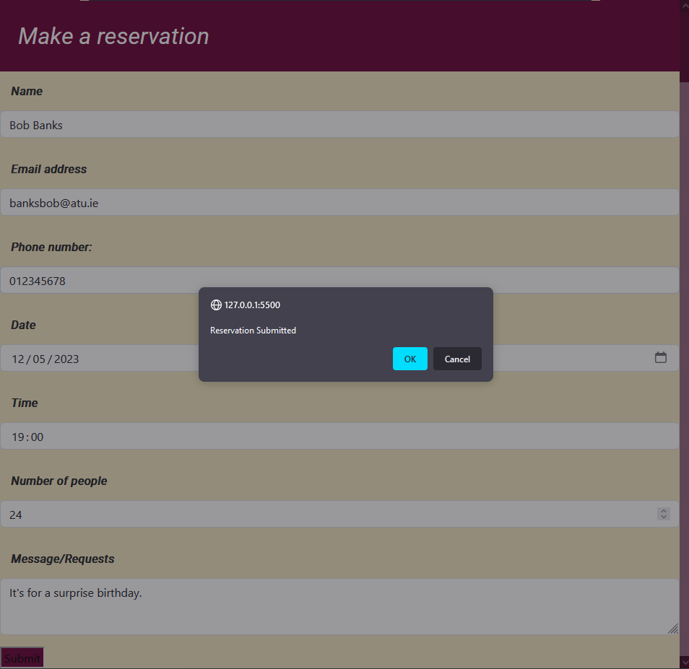

Booking stored in Local Storage.

Test 2

Input details

Confirmation of booking.

Booking stored in Local Storage.

Test 3

Input details

Booking with email not formatted correctly.

Had to swap around the booking confirmation alert and the email format checker.  
As upon submit it would say that it was submitted even though the email was inputted incorrectly.

Amended email address. With booking confirmation.

Booking stored in Local Storage.

