**GUI Project Test Cases  
By Nathan Dean, Jamie Concannon, Steven Derrig.**

**Booking page**

Taking user inputs and storing them.

Test 1

Input details

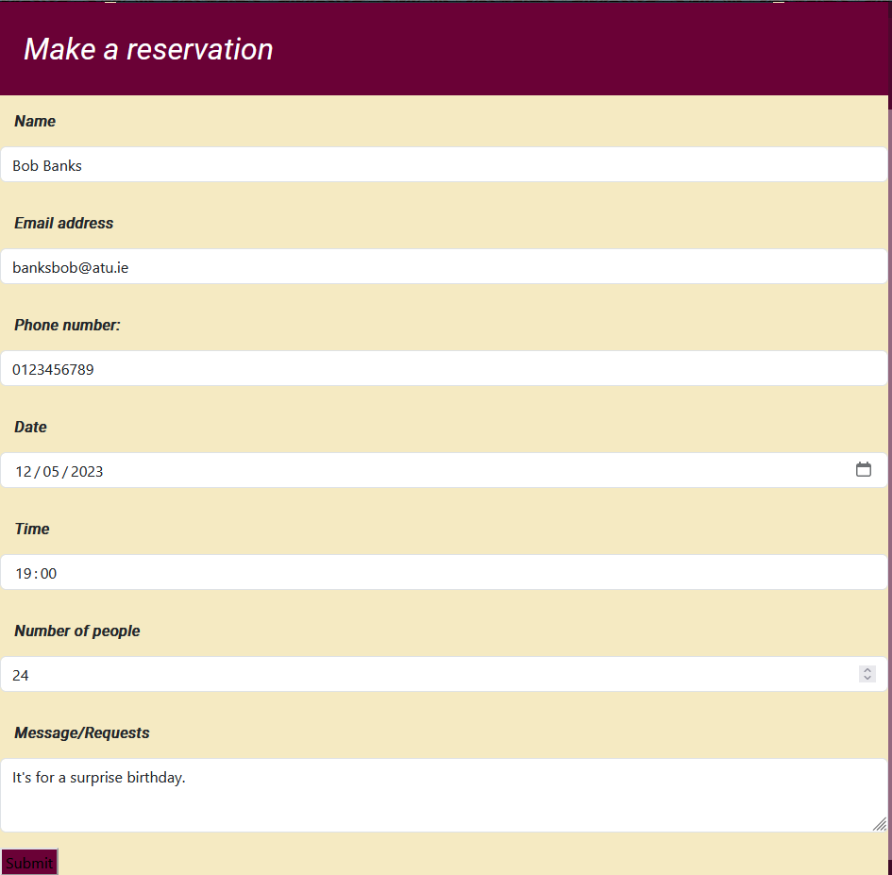

Confirmation of booking.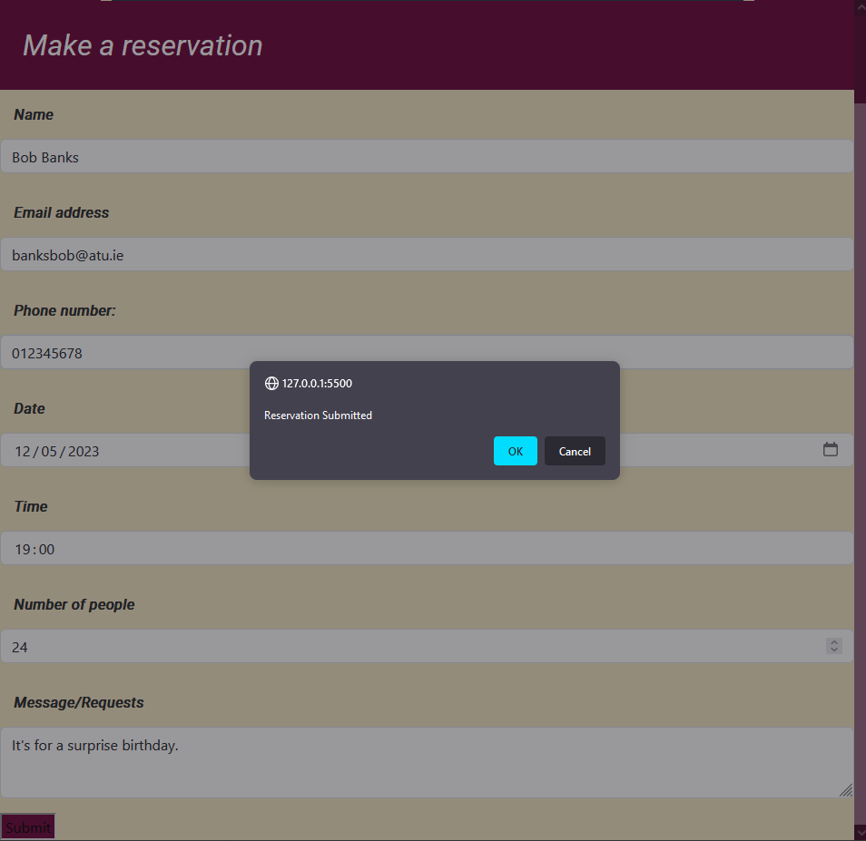

Booking stored in Local Storage.

Test 2

Input details

Confirmation of booking.

Booking stored in Local Storage.

