**Project: 40363**

For Learner Use:

|  |  |
| --- | --- |
| Surname of Learner | Dwashu |
| Name of Learner | Nathan |
| Learner ID | 9908305529088 |
| Student Number | ISCTICT20:NDWASHU |
| Date of Project Given | 5 April 2021 |
| Location / Branch | Cape Town |

For Assessors Use:

|  |  |
| --- | --- |
| Name of Branch | Cape Town |
| Name of Facilitator | Collin America |
| Name of Assessor | Collin America (RAS/01/2016/0042) |
| Mark Allocation | 60 |
| Mark Obtained |  |
| Competency Status ( C / NYC) |  |

|  |  |
| --- | --- |
| Unit Standards |  |

|  |  |  |  |
| --- | --- | --- | --- |
| Candidates Signature |  | Date Submitted | 13 April 2021 |
| Assessors Signature |  | Date  Marked |  |

1. Discuss at least two ways in which you could navigate from one webpage to another within the same website. [2]

|  |
| --- |
| * You can use hyperlinks to navigate through specific pages. * You can also use buttons to go to pages you want. |

1. Name the three types of cascading style sheets used to display HTML elements, using your own words briefly describe the differences between the three CSS. [6]

|  |
| --- |
| **Inline Style Sheet:** The Inline style sheet overrides all other style sheet settings made by the other style sheets and it is also embedded in html.  **Internal Style Sheet:** The Internal style sheet settings overrides the external style sheet settings but cannot override the inline style sheet settings and it exist within the page but separate from html.  **External Style Sheet:** The External style sheetcannot override the other style sheets and it also has its own separate page. |

1. Write an HTML code to embed an image into a web page. [1]

|  |
| --- |
| <img src = “tree.jpg”/> |

1. Write an HTML code to create a table with 5 rows and two columns [3]

|  |
| --- |
| <table>  <tr>  <td>Cell 1</td>  <td>Cell 2</td>  </tr>  <tr>  <td>Cell 3</td>  <td>Cell 4</td>  </tr>  <tr>  <td>Cell 5</td>  <td>Cell 6</td>  </tr>  <tr>  <td>Cell 7</td>  <td>Cell 8</td>  </tr>  <tr>  <td>Cell 9</td>  <td>Cell 10</td>  </tr>  </table> |

1. Explain the following terms: [3]

Elements

Attribute

Page event

|  |
| --- |
| **Elements:** Elements consists of start tags, attributes, end tags and all the content between them. All html files are made up of elements. It is responsible for creating the webpages and the content in it.  **Attribute:** Attributes are properties that change the behaviour of an element. Each element can have attributes. They are placed inside the starting tag after the element name.  **Page event:** A page event is an alert that indicate a change in the webpage. |

1. Use the marking key below as guidance to assist in creating a basic webpage using notepad. Use the marking key below to assist with the requirements for this question.

* You may choose any topic to code on.
* You may add more content to your page but ensure you include the assessed items below.

**Note:** include screenshots below of your designed page, and also include your txt file with your submission. [25]

|  |  |  |  |
| --- | --- | --- | --- |
| **Webpage design** | **Description** | **Mark Allocation (Screenshot)** | **Mark Allocation (Code)** |
| 1. Head | 1 | 1 |
| 1. Title | 1 | 1 |
| 1. Heading / s | 1 | 1 |
| 1. Paragraph / s | 1 | 1 |
| 1. Image | 1 | 1 |
| 1. Styling – colour | 1 | 1 |
| 1. Styling – font | 1 | 1 |
| 1. Styling – Alignment | 1 | 1 |
| 1. Dropdown List | 1 | 2 |
| 1. Marquee | 1 | 2 |
| 1. iFrame with video | 1 | 2 |
| 1. Usable Textbox | 1 | 2 |
| 1. Appropriate content | 1 | 0 |
| 1. Logical Page Layout | 1 | 0 |
| **Sub Totals** | | **14** | **16** |
| **Total** | | **30** | |

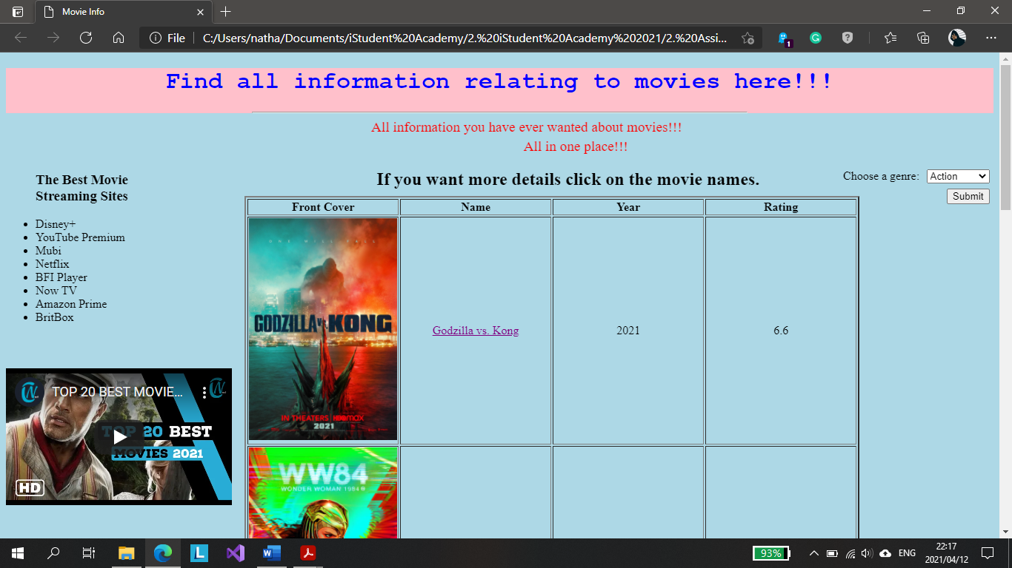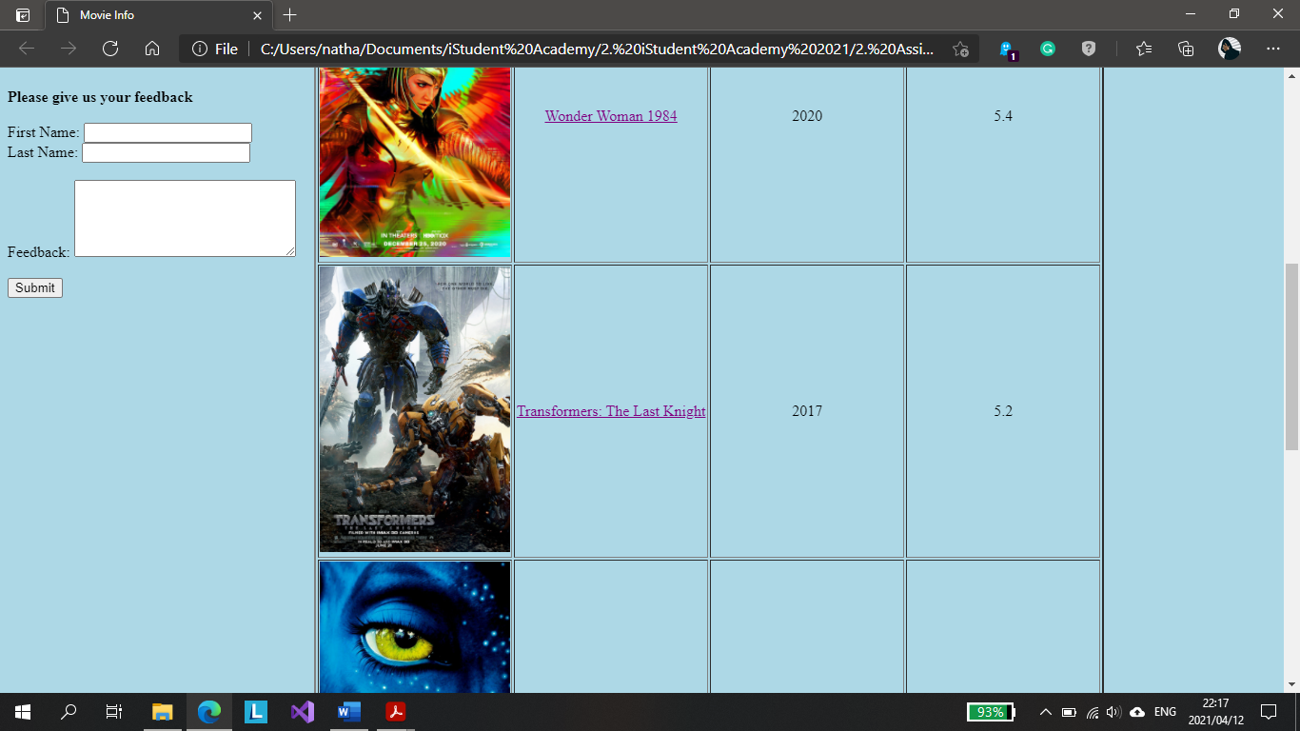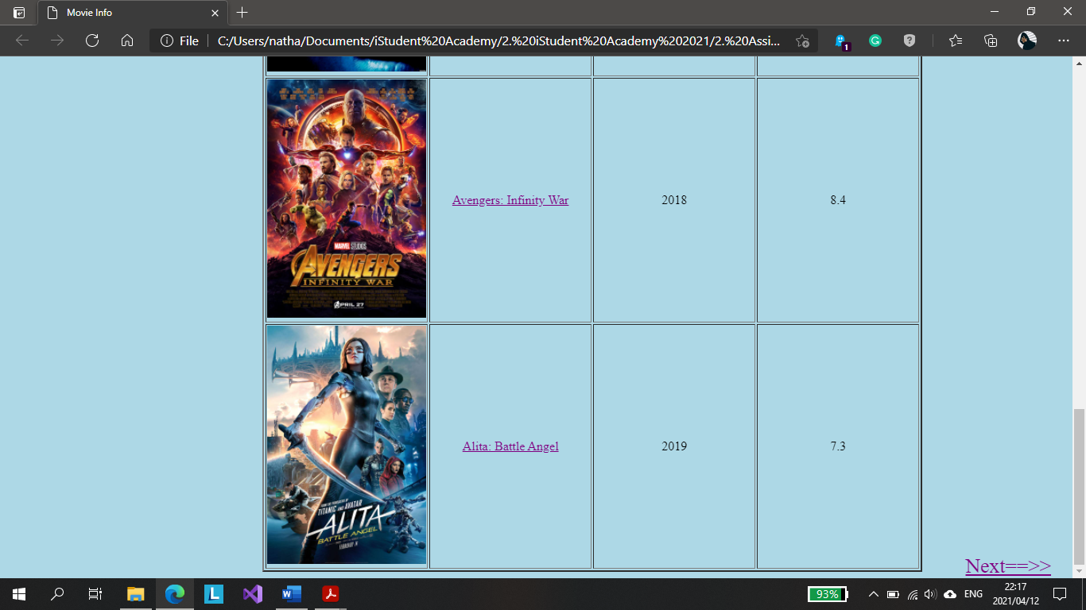

*\*\*END OF ASSESSMENT\*\**