**Coefficient matrix A**: [1, 1], [1, -1], [2, 1]

**Augmented matrix B**: [1, 1, 5], [1, -1, 3], [2, 1, 8]

**Reduced row echelon form**:

(Matrix([

[1, 0, 0],

[0, 1, 0],

[0, 0, 1]])

The system is inconsistent because the reduced row form includes the equation 0x+0y=1z, which can not be true

**Approximate solution**: (26/7, 6/7)

A · x-> = [32/7, 20/7, 58/7], - b-> = [-3/7, -1/7, 2/7]

Vector x is orthogonal as multiplying it with the columns of A equals [0, 0, 0]



**Coefficient matrix A**: [1, 1], [1, 4], [1, 5]

**Augmented matrix B**: ([[1, 1, 4], [1, 4, 2], [1, 5, 1]])

**Reduced row echelon form**:

(Matrix([

[1, 0, 0],

[0, 1, 0],

[0, 0, 1]])

The system is inconsistent because the reduced row form includes the equation 0x+0y=1z, which can not be true

**Approximate solution**: (62/13, -19/26)

A * x-> = [105/26, 24/13, 29/26], - b-> = [1/26, -2/13, 3/26]

Vector x is orthogonal as multiplying it with the columns of A equals [0, 0, 0]



**Coefficient matrix A**: [2, -1], [3, -4], [-1, 3]

**Augmented matrix B**: [2, -1, 7], [3, -4, 5], [-1, 3, 4]

**Reduced row echelon form**:

(Matrix([

[1, 0, 0],

[0, 1, 0],

[0, 0, 1]])

The system is inconsistent because the reduced row form includes the equation 0x+0y=1z, which can not be true

**Approximate solution**: (79/15, 43/15)

A * x-> = [23/3, 13/3, 10/3], - b-> = [2/3, -2/3, -2/3]

Vector x is orthogonal as multiplying it with the columns of A equals [0, 0, 0]

*Multiply columns of matrix A by vector X, subtract vector b, should equal 0 to prove that each equation is orthogonal*

*Output number 3 is the augmented matrix B,*

*For orthogonality, take result of A*x-b, and use the formula: (A1*x1)+(A2*x2)+(A3*x3) = should equal 0*

*Redo Ax-b just in case*



**Coefficient matrix A**: [1, -1], [1, 0], [1, 1], [1, 2], [1, 3]

**Augmented matrix B**: [1, -1, -2], [1, 0, 2], [1, 1, 1], [1, 2, 3], [1, 3, 4]

The system is inconsistent because the reduced row form includes the equation 0x+0y=1z, which can not be true

**Approximate solution**: (3/10, 13/10)

**Graph**:

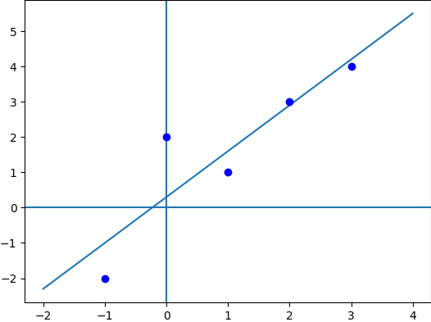



**Coefficient matrix A:** [1, -1], [1, 2]

**Augmented matrix B**: [1, -1, -2], [1, 2, 3]

**Approximate solution**: (-1/3, 5/3)

**Graph**: 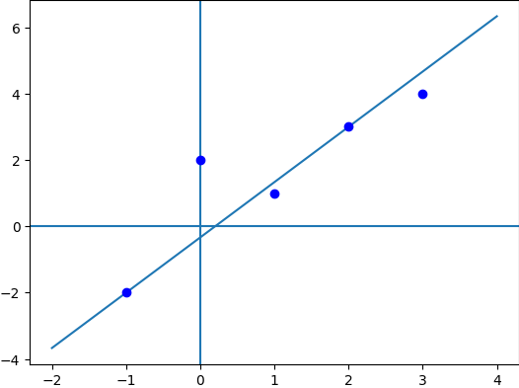

The length of Ax-b = 2.07364413533277

The length of Ay-b = 2.44948974278318

Ax-b is the smaller vector



**Coefficient matrix A**: [1, -1, 1], [1, 0, 0], [1, 1, 1], [1, 2, 4], [1, 3, 9]

**Augmented matrix B**: [1, -1, 1, -2], [1, 0, 0, 2], [1, 1, 1, 1], [1, 2, 4, 3], [1, 3, 9, 4]

**Reduced row echelon form:**

(Matrix([

[1, 0, 0, 0],

[0, 1, 0, 0],

[0, 0, 1, 0],

[0, 0, 0, 1],

[0, 0, 0, 0]])

The system is inconsistent because the reduced row form includes the equation 0w+0x+0y=1z, which can not be true

**Approximate solution**: (18/35, 121/70, -3/14)

**Graph**:

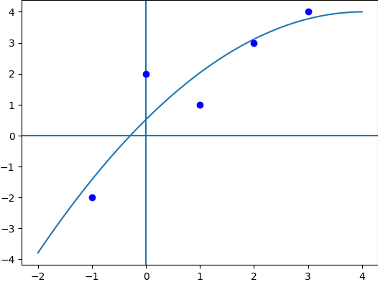



**Coefficient matrix A**: [1, -1, 1, -1], [1, 0, 0, 0], [1, 1, 1, 1], [1, 2, 4, 8], [1, 3, 9, 27]

**Augmented matrix B**: [1, -1, 1, -1, -2], [1, 0, 0, 0, 2], [1, 1, 1, 1, 1], [1, 2, 4, 8, 3], [1, 3, 9, 27, 4]

**Reduced row echelon form**:

(Matrix([

[1, 0, 0, 0, 0],

[0, 1, 0, 0, 0],

[0, 0, 1, 0, 0],

[0, 0, 0, 1, 0],

[0, 0, 0, 0, 1]])

The system is inconsistent because the reduced row form contains the equation 0+0+0+0=1 which can not be true

**Approximate solution**: (46/35, 67/42, -17/14, 1/3)

**Graph**:

