PROJECT KALAVATHI · PROTOTYPE 1 · TEAM BRIEF
What We Demonstrate
The expo build — what the judges see, what every part does, and how the table is laid out.

For | ECS internal expo, then the external expo at VIT-AP
Purpose | Show the idea working, visually. Not a deployable product.
Team | 4 people, four roles at the booth
Equipment | Two team laptops, two team phones. No external screens.
Hardware to buy | Rs. 2,930
Build time | 7 weeks — the last week is testing only, no new features
Companion document | Prototype 1 — Seven Weeks (the timeline)

The one sentence everyone on the team must be able to say
"When someone has a heart attack, the family usually drives them to hospital themselves. That car has no siren and no priority — it waits at every red light. We built a device that lets that car ask for priority, and a way to stop people lying about it."
Everything on the table exists to make that sentence visible in three minutes.

1. What Prototype 1 is, and what it is not
P1 is a demonstrator. Its job is to make a mentor understand the idea and see it work. P2, after the expo, is the deployable system. Different goals, different engineering — and being explicit about this scores better than pretending otherwise.
 | Prototype 1 (the expo) | Prototype 2 (after)
Judged on | Can a mentor understand it in 3 minutes and see it work? | Does it hold up when someone tries to break it?
Optimised for | Legibility and reliability of the demonstration | Completeness and correctness
Fails if | Something does not light up while a judge is watching | There is a loophole someone can name
Environment | Indoor table, no car, no sky, bad venue WiFi, 50 repeat runs in a day | Real vehicle, real mobile network, real hospital

1.1 Three decisions that follow from that

We use WiFi, not the mobile network
The GSM module was chosen because a car needs mobile data. An expo table does not. GSM indoors is unreliable, power-hungry and temperamental, and it is the single most likely thing to fail while a judge is standing in front of us. Laptop 1 runs a WiFi hotspot and everything joins it. GSM returns in P2.

GPS will not get a fix indoors, so we do not pretend it will
Concrete roof, no sky. Instead we record a video outdoors in Week 6 — the device in a real car, GPS locking, position updating live on the dashboard — and play it on loop at the booth. Indoors the position comes from a recorded track while a team member slides the toy car along in sync. The poster says this openly. Judges respect that; a GPS that fails live is much worse.

The demo must survive fifty runs and reset in thirty seconds
People will walk up all day and want to see it. There is a physical RESET button that puts everything back to the start state — counter restored, junctions red, dashboard cleared — in under thirty seconds. Without it we spend the day rebooting instead of talking.

What the poster says we are NOT doing
Mobile network — WiFi is more reliable on a table. Comes in P2.
Live GPS at the booth — no satellite fix indoors. Validated outdoors on video.
Real traffic signals — needs a traffic authority partnership. P2, through the NTCIP adapter.
Learned scheduler — the rule-based version is enough to show the concept. P2.
Stating these plainly is a strength. Every judge has seen a project that claimed more than it had.

2. The three-minute demonstration
This is the script. Learn it. The wording matters less than the order — but steps 4 and 5 are where the marks are, and those two should be word-perfect.
Time | What you say and do | What they see
0:00–0:30  THE PROBLEM | "When someone in India has a heart attack, the family usually doesn't wait for an ambulance — they drive. That car has no siren and no priority. It waits at every red light like everyone else." | Nothing yet. Just you. Let them look at the table.
0:30–1:00  PRESS | "Watch what happens when we press this." Press the button on the Kalavathi Unit. | Amber LED and a beep on the unit. Phone 1 shows "Going to City Hospital — 15 s to change". The request appears on Laptop 1, marked self-declared.
1:00–1:30  HOSPITAL CONFIRMS | "The hospital decides how serious it is — not the driver." A team-mate taps CONFIRM on Phone 2 and selects cardiac. | Trust tier on Laptop 1 jumps to hospital-verified. Unit LED turns green. Junctions J1 to J4 turn green in sequence as the toy car advances.
1:30–2:15  THE ABUSE TEST | "But if anyone could do this, everyone would." Press six times — the sixth is refused. Then plug in the laptop and reflash the entire chip in front of them. Press again. | Still refused. The counter is still at six. This is the moment that separates this project from every other booth.
2:15–2:45  AT SCALE | "That's one car. Here are fifty at once, on a real city map." Point at Laptop 2. | Two SUMO runs side by side: same map, same traffic. Without the system 14 minutes; with it 9.
2:45–3:00  THE LIMIT | "We never interfere with any other vehicle. We only change signals. And the priority expires the moment they arrive." | Laptop 1 shows the expiry conditions. Junctions return to normal timing.

Two rules for the script
Never say the system gives legal right of way. It makes a request to the traffic authority. If asked, say exactly that.
Never explain the technology before the problem. Every judge who hears "ESP32" before they hear "heart attack" will grade you lower.

3. Components, layer by layer
Green rows are P1 CORE — they must work at the expo. Amber rows are P1 ADD-ON — build them only if the core is finished and tested. Everything else waits for P2.

3.1 Layer 1 — the device on the table
Component | What it does at the expo | Hardware | Software
CORE Emergency button | The one thing the judge presses. Large, obvious, no menus. | 22 mm momentary push button | Debounce, long-press to cancel
CORE ESP32-C3 controller | Runs the device: reads the button, signs the request, posts it to the backend over WiFi. | ESP32-C3 DevKitM-1 | Arduino IDE or ESP-IDF, HTTP client
CORE ATECC608A secure element | Signs every request and holds the tamper-proof counter. This is the star of step 4 of the demo. | ATECC608A breakout, I2C | CryptoAuthLib, ECDSA P-256, hardware counter
CORE Status indicator | Amber = pending, green = granted, red = refused. Visible from where the judge stands. | RGB LED, piezo buzzer | State machine in firmware
CORE Reset button | Returns the whole demo to its start state in under 30 seconds. | Second push button | Reset routine in firmware plus a backend endpoint
ADD-ON GPS module | Not used indoors. Fitted, and filmed working outdoors for the video that plays on loop. | NEO-6M with antenna | TinyGPS++ NMEA parsing

3.2 Layer 2 — the phones
Component | What it does at the expo | Hardware | Software
CORE Driver page (Phone 1) | Shows the destination hospital with a 15-second CHANGE window, live status, and a cancel button. | A team member's Android phone | Plain mobile web page served by the backend — no app install
CORE Hospital page (Phone 2) | Shows the incoming request together with the device's own usage history, and offers CONFIRM, APPROVE OVER-LIMIT and REDIRECT. | A second team phone | Same — a web page, opened in the browser
ADD-ON Native app + BLE | Only if everything else is finished. Adds nothing to the demo that the web page does not. | — | Flutter or Kotlin

Why web pages and not an app: an app has to be installed, updated and debugged on someone's phone on expo morning. A web page opens in any browser on the local WiFi and looks identical to the judge. Build the app in P2, when it buys something real.

3.3 Layer 3 — the backend, on Laptop 1
Component | What it does at the expo | Hardware | Software
CORE Request gateway | Receives every request, verifies the signature, rejects anything forged. Powers the "send a fake request from a laptop" answer if a judge asks. | Laptop 1 | Python, FastAPI, uvicorn, python-cryptography
CORE Credibility ledger | Holds the device's public key, presses used, and the outcome of every past request. Decides the automatic tier. | Laptop 1 | SQLite (not PostgreSQL — one less thing to install)
CORE Hospital portal | The page on Phone 2. Confirm with a severity class, approve over-limit, redirect. | Laptop 1 serves it | FastAPI + Jinja2 templates
CORE Control room dashboard | The live map on Laptop 1. Shows the vehicle, its trust tier, and which junctions are reserved. | Laptop 1 | Leaflet map, WebSocket, plain HTML/JS
ADD-ON Hospital directory + diversion | Lets a hospital redirect a case it cannot treat. A good extra scene if there is time. | Laptop 1 | Small JSON hospital list with capability tags
ADD-ON Token service | Signed tokens with explicit expiry conditions. Makes step 6 of the script concrete. | Laptop 1 | Python, Ed25519 signing

3.4 Layer 4 — the traffic side
Component | What it does at the expo | Hardware | Software
CORE Rule-based scheduler | Decides which junctions to hold green and in what order as the vehicle advances. Hand-written weights — no machine learning in P1. | Laptop 1 | Python
CORE Safety guardrails | Minimum green time and a maximum hold. Shown on the poster as the thing a model may never override. | Laptop 1 | Python rules
CORE Model junction rig | Four junctions, twelve LEDs, on the foam board. Wired to Laptop 1 by USB — deliberately not over WiFi, because a cable cannot drop out. | Arduino Nano, 12 LEDs, resistors | Arduino C++, simple serial protocol
ADD-ON Route and ETA predictor | Predicts which junction is next rather than following a fixed script. Nice, not necessary. | Laptop 1 | Python, simple graph model

3.5 Layer 5 — the simulation, on Laptop 2
Component | What it does at the expo | Hardware | Software
CORE SUMO comparison video | Two runs side by side on a real city map: same traffic, one without the system and one with it. Plays on loop all day. | Laptop 2 | Eclipse SUMO, OpenStreetMap import, screen recording
ADD-ON Concurrency scenarios | 5, 20 and 50 simultaneous emergencies, showing the scheduler cope and showing where it breaks. | Laptop 2 | SUMO + TraCI, Python

The single highest-scoring item on the table
The SUMO before-and-after video. One number against another number, same map, same traffic: 14 minutes without, 9 minutes with.
It does more for the marks than any piece of hardware, it never breaks, and it keeps playing while you are talking to someone else. Produce it early — Week 5 — not in the last week.

4. What we buy, and how it connects

4.1 Bill of materials — Rs. 2,930
Item | Qty | Rs. | Note
ESP32-C3 DevKitM-1 | 1 | 400 | Buy 2 if budget allows — a pre-flashed spare saves the demo
ATECC608A secure element breakout | 1 | 350 | The star of the abuse test
NEO-6M GPS module with antenna | 1 | 450 | For the outdoor video only
Emergency push button, 22 mm | 1 | 80 | Big and obvious
RGB LED, buzzer, resistors | 1 set | 60
Reset push button | 1 | 40 | Non-negotiable
Arduino Nano | 1 | 250 | Drives the junction LEDs over USB
LEDs (4 junctions x red/amber/green) + resistors | 12 | 120
Foam board, A2 | 2 | 160 | The city
A2 road map print | 1 | 120 | Design it yourself, print at any shop
Toy car | 1 | 100 | Any die-cast car
Perfboard, jumper wires, headers | — | 250
Enclosure for the unit | 1 | 200 | 3D printed, or a plastic project box
A1 poster print | 1 | 350 | Highest value per rupee on this list
TOTAL |  | 2,930

Not bought: no external monitors, no travel router, no SIM card, no GSM module. Laptops and phones are our own. USB power comes from the laptops.

4.2 The network — read this carefully
Venue WiFi will not work. Assume it is absent, saturated, or blocks device-to-device traffic. We never depend on it.
Link | How | Why this way
Laptop 1 | Runs a WiFi hotspot (Windows Mobile Hotspot, or hostapd on Linux). Also runs the backend. | One machine is both the network and the server, so there is one thing to restart, not two.
ESP32 to backend | Joins Laptop 1's hotspot. Fixed IP for the backend, hardcoded in firmware. | No DNS, no mDNS, no discovery to go wrong.
Phone 1 and Phone 2 | Join the same hotspot, open the backend's page in the browser. | No app install, no Play Store, no version mismatch on the morning.
Arduino junction rig | USB serial cable to Laptop 1. | A cable cannot lose signal. The junctions are the most visual part — they must never drop.
Laptop 2 | Completely standalone, playing the SUMO video on loop. | It is not on the network at all, so nothing that goes wrong elsewhere can stop it.
Fallback | If the hotspot fails, the ESP32 switches to its own Access Point mode and the phones join that instead. | Tested in Week 7, not discovered on the day.

5. On the day

5.1 Four people, four roles
Role | Who does what
Presenter | Speaks the three-minute script and presses the button. Never touches a keyboard. Never debugs.
Hospital operator | Holds Phone 2 and taps CONFIRM on cue. Also answers the second visitor while the presenter is busy.
Systems | Watches Laptop 1. Handles the reset between runs. Fixes anything that breaks, quietly, without interrupting the presenter.
Floater | Manages the queue, hands out the one-page summary, and explains the poster to whoever is waiting. This role matters more than it sounds — a queue that gets bored walks away.

Rotate roles between runs so everyone can do all four by the external expo. Judges sometimes ask a specific team member to explain something.

5.2 The failure playbook
The golden rule
Never debug in front of a judge. Switch to the recorded video, keep talking, and fix it in the next gap.
A team that recovers smoothly looks more competent than a team whose demo never broke.
If this breaks | Do this
WiFi hotspot drops | Systems restarts the hotspot. Presenter switches to the recorded run video on Laptop 1 and keeps narrating over it.
ESP32 stops responding | Swap in the pre-flashed spare — under 60 seconds. This is why we buy two.
Junction rig goes dark | Keep going. The dashboard shows junction state on screen. Mention that the LEDs are a model of what the dashboard is already doing.
Laptop 1 dies | Laptop 2 holds a full clone of the backend and the database. Swap roles: Laptop 2 runs the system, the SUMO video moves to a phone.
Secure element misbehaves | Skip the reflash demonstration and describe it instead. Have the video of it working ready on a phone.
Everything fails at once | Full recorded walkthrough video, on both laptops and both phones. Narrate it live. Nobody has ever lost marks for this.

Required deliverable, Week 6
A screen recording of one complete, successful three-minute run — device, phones, dashboard, junctions and SUMO.
Copied onto both laptops and both phones before we leave for the venue.
This is insurance, and it is also what we submit if the demonstration slot is cut short.

6. The questions judges will ask
These come up every time. Agree the answers now so that all four of us say the same thing.
Question | The answer
"Isn't this already done? Ambulances get green signals." | Yes — for authorised ambulances, and it is an international standard called NTCIP 1211. It has never been opened to the public, because there was no way to stop people lying. That is what we built.
"What stops everyone pressing the button in traffic?" | Three things. A limit held in tamper-proof hardware — we can show you it survives a full firmware wipe. Every request is signed, so misuse is permanently traceable to one device. And GPS cancels it automatically if you are not actually driving toward a hospital.
"What if someone genuinely has more emergencies than the limit?" | They are never refused outright. The request goes out carrying the device's own usage record, and a hospital decides. A clean history gets instant renewal; a bad one gets a human review.
"Can you make other cars move?" | No, and we deliberately do not try. We change traffic signals. Remotely controlling someone else's vehicle would cause more deaths than it prevents, and there is no legal basis for it.
"Does this give the car legal right of way?" | No. Under the Motor Vehicles Act a private car is not an emergency vehicle. This makes a request to the traffic authority, which has discretion over its own signals. No other driver is under any obligation.
"Is this real or simulated?" | Point at the poster. The device, the signing, the counter, the backend and the scheduler are real. Position indoors is a recorded track — here is the GPS working outdoors on video. The junctions are a model. Fifty simultaneous emergencies are simulated in SUMO.
"Where is the AI?" | Not in P1 — the scheduler here is rule-based on purpose, because it is the baseline. In P2 two models replace the hand-picked weights: one that ranks competing emergencies and one that decides how many corridors the city can carry. The novelty is that our model takes trustworthiness as an input, which no existing traffic model does.
"Why is the device not smart?" | Deliberately. A safety-critical trigger should be auditable, not learned. A hospital must be able to ask why a request was refused and get a real answer.

7. The diagrams
Three diagrams follow on landscape pages. This page explains what each one is for, so you can talk through them without reading them.

Diagram 1 — Booth layout
A top-down view of the demonstration table as the judge sees it. It fixes where every device sits, which way it faces, and where the judge stands. Set the table up exactly like this every time so that muscle memory takes over on the day — the presenter should never have to look for the reset button.
Note three things in it: the poster stands behind the table and does the talking whenever all four of us are busy; the foam-board city is dead centre because it is the thing people look at; and the two laptops face outward, not toward us.

Diagram 2 — The three-minute demonstration
A swimlane chart. Each row is one device; each column is one step of the script. The shaded cells are what the judge should be looking at during that step. Use it to rehearse: the hospital operator can see exactly when their cue comes, and the systems person can see when nothing is expected of them.
The two darkest columns are steps 4 and 5 — the abuse test and the SUMO comparison. Those are where the marks are.

Diagram 3 — What is built when
The same five-layer architecture at three levels of completeness. Green is P1 core and must work at the expo. Amber is a P1 add-on, built only after the core is finished and tested. Purple is P2, after the expo.
The point of this diagram is that nothing is thrown away between P1 and P2. Every green box stays; the amber and purple boxes are added on top of it. Show this to a judge who asks how far the project goes — it answers the question better than any sentence.

Print these three
Put Diagram 1 in the team group so the table can be set up by anyone.
Print Diagram 2 at A4 and keep it face-down on the table as a prompt sheet.
Diagram 3 belongs on the poster.

Diagram 1 · Booth layout
Top-down view of the demonstration table. Set it up exactly like this, every time.
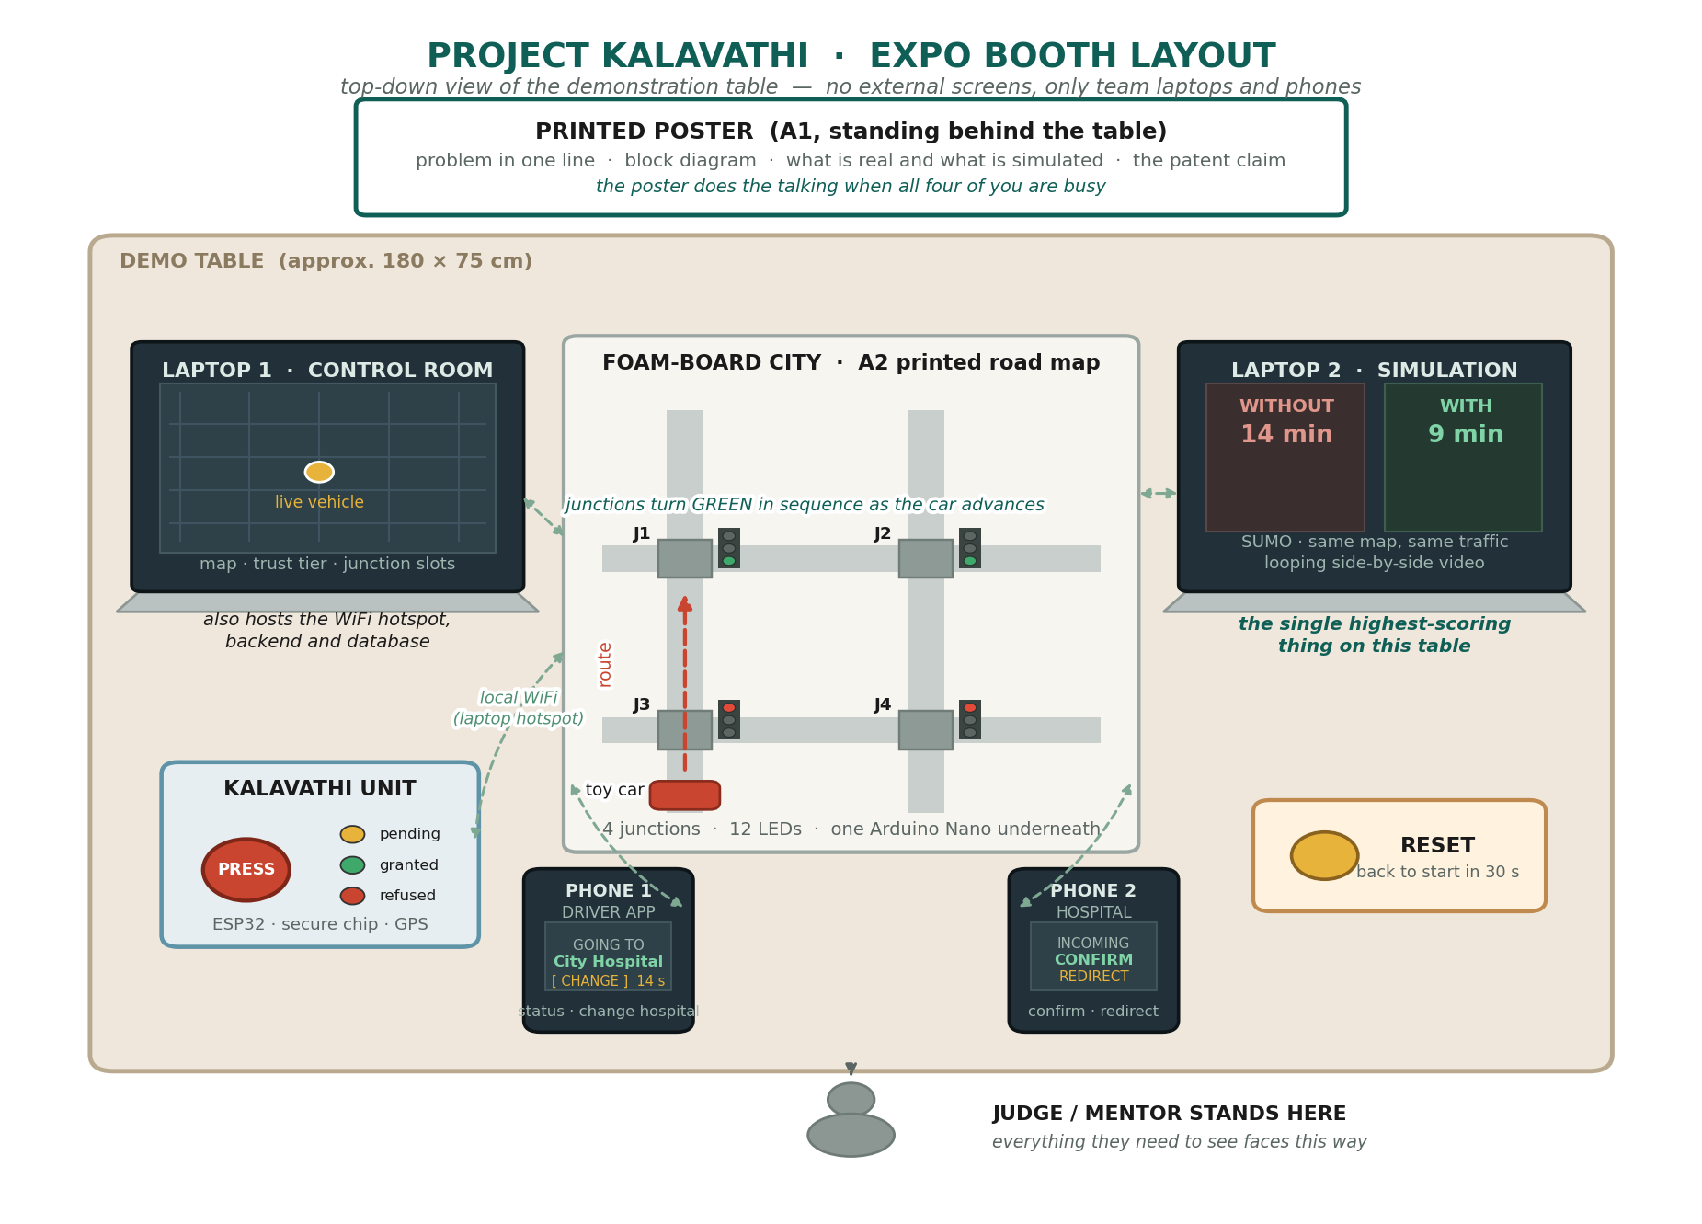

Diagram 2 · The three-minute demonstration
Each row is a device; each column is a step. Shaded cells are what the judge should be looking at.
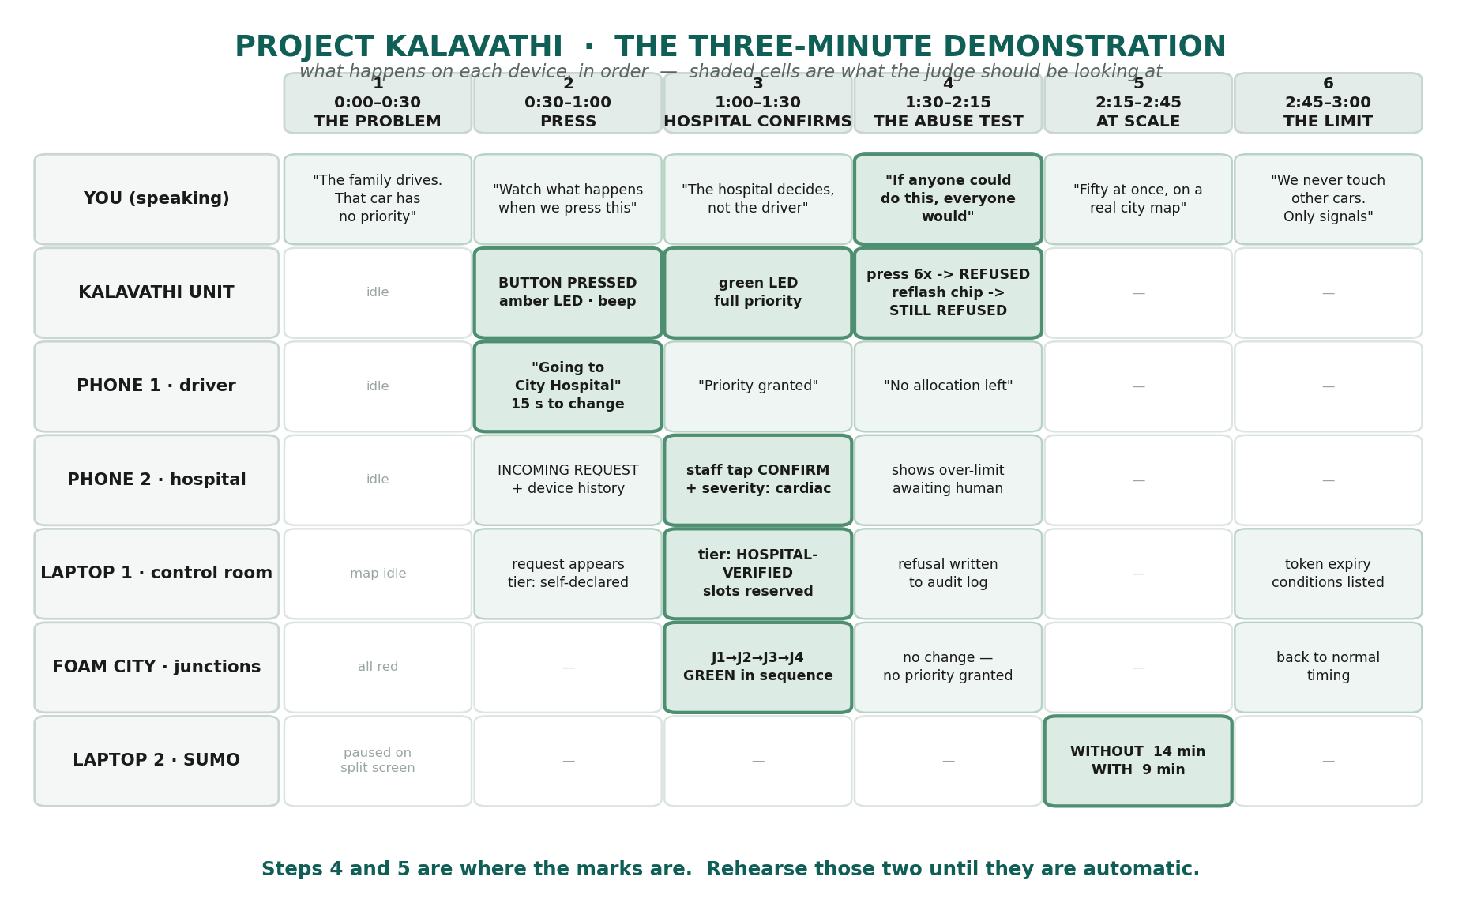

Diagram 3 · What is built when
The same architecture at three levels of completeness. Nothing is thrown away — each level is added on top of the last.
